A BRIEF HISTORY OF THE FUTURE – EXECUTIVE PRODUCED BY KATHRYN MURDOCH, ARI WALLACH, WENDY SCHMIDT, AND DRAKE’S DREAMCREW – SET TO PREMIERE
APRIL 3, 2024, ON PBS

NEW SIX-PART PBS SERIES EXPLORES INNOVATIVE WAYS TO THINK ABOUT THE FUTURE; FUTURIST ARI WALLACH CHALLENGES DYSTOPIAN VISION, LOOKING AT HOW RE-THINKING TOMORROW
CAN BRING LONG-TERM CHANGE
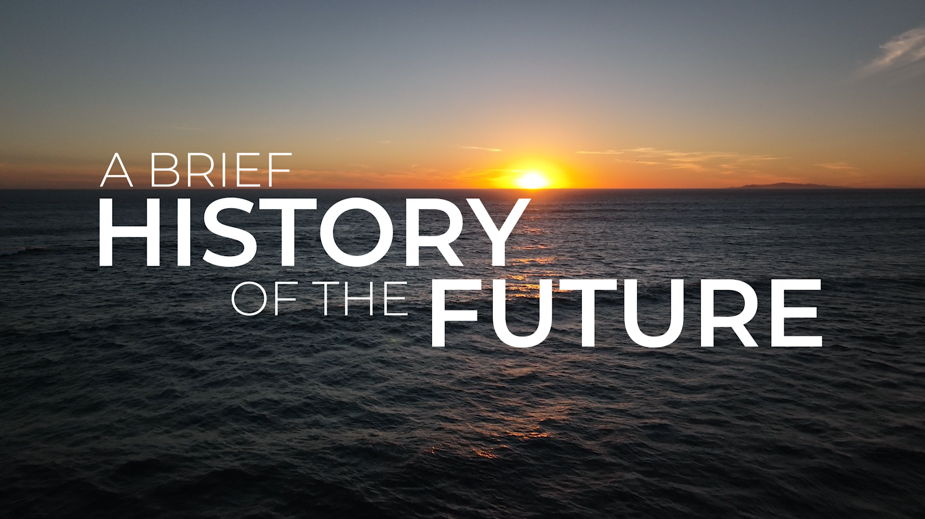

Arlington, VA – October 26, 2023 – A BRIEF HISTORY OF THE FUTURE, a new six-part documentary series produced by Zach Morgan of UNTOLD, Kathryn Murdoch and Ari Wallach’s newly-launched Futurific Studios, and executive produced by Drake’s Emmy Award-winning non-traditional entertainment company DreamCrew – as well as philanthropist Wendy Schmidt, Kathryn Murdoch and Ari Wallach – will premiere Wednesdays, April 3 -May 8, 2024, at 9:00 p.m. ET on PBS (check local listings), PBS.org and the PBS App, the network announced today.

This non-fiction documentary series will help viewers imagine – and work toward – a better tomorrow. Hosted by futurist Ari Wallach, the series challenges the dystopian framework embraced by popular culture by offering a refreshing take on the future exploring potential solutions to our existential threats. The program invites viewers to imagine a world that is full of discovery, hope, and possibility – inspiring each of us to understand our power to shape the future that future generations need us to so they can flourish.

A BRIEF HISTORY OF THE FUTURE weaves together history, science, and unexpected storytelling to expand our understanding about the impact that the choices we make today will have on our tomorrows. Each episode follows those who are working to solve our greatest challenges. The series also features valuable insights from a wide range of thinkers, scientists, developers and storytellers including French President Emmanuel Macron, U.S. Secretary of Transportation Pete Buttigieg, U.S. Surgeon General Vivek Murthy, sailor Dame Ellen MacArthur, musician Grimes, architect Bjarke Ingels, climate scientist Katharine Hayhoe, legendary soccer player Kylian Mbappé, and more.

“Showing what the future can be is critical to getting there. People need to have hope and to understand what we’re capable of,” said executive producer Kathryn Murdoch. “From AI to floating cities, restoring coral reefs to deliberative democracy, there are so many exciting futures to explore.”

“We want to create an inspiring counterpoint to the doomerism and dystopia that dominates much of today’s public discourse about the future,” said host Ari Wallach, a renowned futurist, author, and founder of Longpath Labs.

"As long as humanity has existed, so has hope," said executive producer Wendy Schmidt, president of the Schmidt Family Foundation and co-founder with her husband Eric of Schmidt Futures and Schmidt Ocean Institute. "When we recall the builders of ancient monuments who never lived to see the final product, the Indigenous communities who imagined the world seven generations ahead, and the activists who fight for human rights through decades of war, we realize that we are always working for a better future, and we can only create it if we can envision it."

“At PBS we are focused on storytelling that highlights solutions,” said Paula Kerger, President and CEO of PBS. “We want to share how people can make a difference, and together build a brighter and better future. By opening a window to the worlds of possibilities, we seek not just to educate our audiences, but also to inspire and empower them. In this spirit, we are excited to share A BRIEF HISTORY OF THE FUTURE with our viewers.”

“Full of heart and humanity, A BRIEF HISTORY OF THE FUTURE will take viewers on an adventure as Ari Wallach travels the world in search of humanity’s many paths forward,” said writer and director Andrew Morgan. “Interwoven in this exploration of ‘protopias’ – the term Wallach uses to describe realistic, improved visions of tomorrow – will be insight into the multiple social, artistic, economic, and philosophical issues that impact the many decisions required to ensure that all life on Earth can continue to thrive for generations to come.”

A BRIEF HISTORY OF THE FUTURE asks us all – how can we become the great ancestors the future needs us to be?

Descriptions and premiere dates for each of the six episodes are provided below:

“Beyond the Now”
Wednesday, April 3, 2024 at 9:00 p.m. ET (Series Premiere)
Join Ari Wallach on his journey to seek the individuals and ideas that can shape a better, more sustainable future for each generation to build upon.

“Chaos & Complexity”
Wednesday, April 10, 2024 at 9:00 p.m. ET
Why are many of us feeling overwhelmed and afraid in this historically transformational moment in time? Ari Wallach explores how it offers unprecedented possibilities for new and needed futures we can create together.

“Once Upon a Time”
Wednesday, April 17, 2024 at 9:00 p.m. ET
How do stories shape the boundaries of belief about what is possible? Ari Wallach dives into the fundamental role storytelling plays in our lives and their potential to unleash the power of human imagination and creativity moving forward.

“Human”
Wednesday, April 24, 2024 at 9:00 p.m. ET
Ari Wallach investigates the human ability to increase empathy and compassion, what values we are instilling into artificial intelligence technologies, and creating a better world for human life to flourish on this planet.

“Together”
Wednesday, May 1, 2024 at 9:00 p.m. ET
Throughout history, humans’ unique capacity for cooperation has set us apart. Ari Wallach explores the internal changes we enact that have the potential to impact those around us, our broader communities, and societies.

“Tomorrows”
Wednesday, May 8, 2024 at 9:00 p.m. ET
Ari Wallach examines the ways we often see the concept of the future, the crucial need to think much, much bigger about what could come next, and how we all have more personal agency than we realize.

A BRIEF HISTORY OF THE FUTURE will premiere April 3, 2024, at 9:00-10:00 p.m. ET (check local listings) on PBS, PBS.org and the PBS App. The series will be available to stream on all station-branded PBS platforms including PBS.org, the PBS App, available on iOS, Android, Roku streaming devices, Apple TV, Android TV, Amazon Fire TV, Samsung Smart TV, Chromecast and VIZIO. A BRIEF HISTORY OF THE FUTURE will also be available to stream on PBS Passport and the “PBS Documentaries Prime Video Channel”. For more information about PBS Passport, visit the PBS Passport FAQ website.

A BRIEF HISTORY OF THE FUTURE was written and directed by Andrew Morgan and produced by Zach Morgan of UNTOLD. The series was executive produced by Kathryn Murdoch, Ari Wallach, Wendy Schmidt, and DreamCrew. The series was edited by ​​Tyler Pharo, Joseph Volpe, and Meryl Goodwin. Bill Gardner is Executive in Charge for PBS. Fremantle is the international distributor for A BRIEF HISTORY OF THE FUTURE.

A BRIEF HISTORY OF THE FUTURE was made possible by Rosalind P. Walter Foundation and by public television viewers.

ABOUT PBS
PBS, with more than 330 member stations, offers all Americans the opportunity to explore new ideas and new worlds through television and digital content. Each month, PBS reaches over 42 million adults on linear primetime television, more than 15 million users on PBS-owned streaming platforms, and 56 million people view PBS content on social media, inviting them to experience the worlds of science, history, nature, and public affairs; to hear diverse viewpoints; and to take front-row seats to world-class drama and performances. PBS’s broad array of programs has been consistently honored by the industry’s most coveted award competitions. Teachers of children from pre-K through 12th grade turn to PBS LearningMedia for digital content and services that help bring classroom lessons to life. As the number one educational media brand, PBS KIDS helps children 2-8 build critical skills, enabling them to find success in school and life. Delivered through member stations, PBS KIDS offers high-quality content on TV — including a PBS KIDS channel — and streaming free on pbskids.org and the PBS KIDS Video app, games on the PBS KIDS Games app, and in communities across America. More information about PBS is available at PBS.org, one of the leading dot-org websites on the internet, Facebook, Instagram, or through our apps for mobile and connected devices. Specific program information and updates for press are available at pbs.org/pressroom or by following PBS Communications on Twitter.
PBS Contact: Meredith Tiger, mjtiger@pbs.org
DKC Contact: PBSSeries@dkcnews.com

About DreamCrew Entertainment
DreamCrew Entertainment is a non-traditional film, TV and digital production company and studio (EUPHORIA, TOP BOY, SPREE) headed by Drake and Adel ‘Future’ Nur. The company’s primary focus is culture and telling stories that peel back the curtain, shine light into shadows and transport audiences to places unseen.
DreamCrew Contact: Melissa, melissa@tagpr.com

About Futurific
Futurific is the production studio that helps creators imagine better tomorrows. Founded by Kathryn Murdoch and Ari Wallach, we bring together storytellers, technologists, artists, and scientists to share the stories that will inspire us all to become great ancestors. Futurific is launching a six-part documentary series, A BRIEF HISTORY OF THE FUTURE, in April 2024 on PBS to showcase the brilliant minds and brave pioneers shaping our collective futures.
Futurific Contact: briefhistory@ssmandl.com

About UNTOLD
UNTOLD is an award-winning film and creative studio with a broad range of work across documentary and scripted storytelling for original films, series, and new media projects. Produced and distributed around the world for platforms including HBO, Hulu, Netflix, and Amazon Prime Video, The New York Times described the work as “gentle, humane investigations,” and Vogue wrote it is “evidence that each of us can act as a catalyst for change within our own lives and work together towards a greater good.”
UNTOLD Contact: info@untold.la

About Schmidt Futures
Schmidt Futures bets early on exceptional people making the world better. Founded by Eric and Wendy Schmidt, Schmidt Futures is a philanthropic initiative that brings talented people together in networks to prove out their ideas and solve hard problems in science and society. To learn more about their method and the diverse types of capital and tools deployed, visit:
Schmidt Futures Contact: sfmedia@hstrategies.com

About Ari Wallach
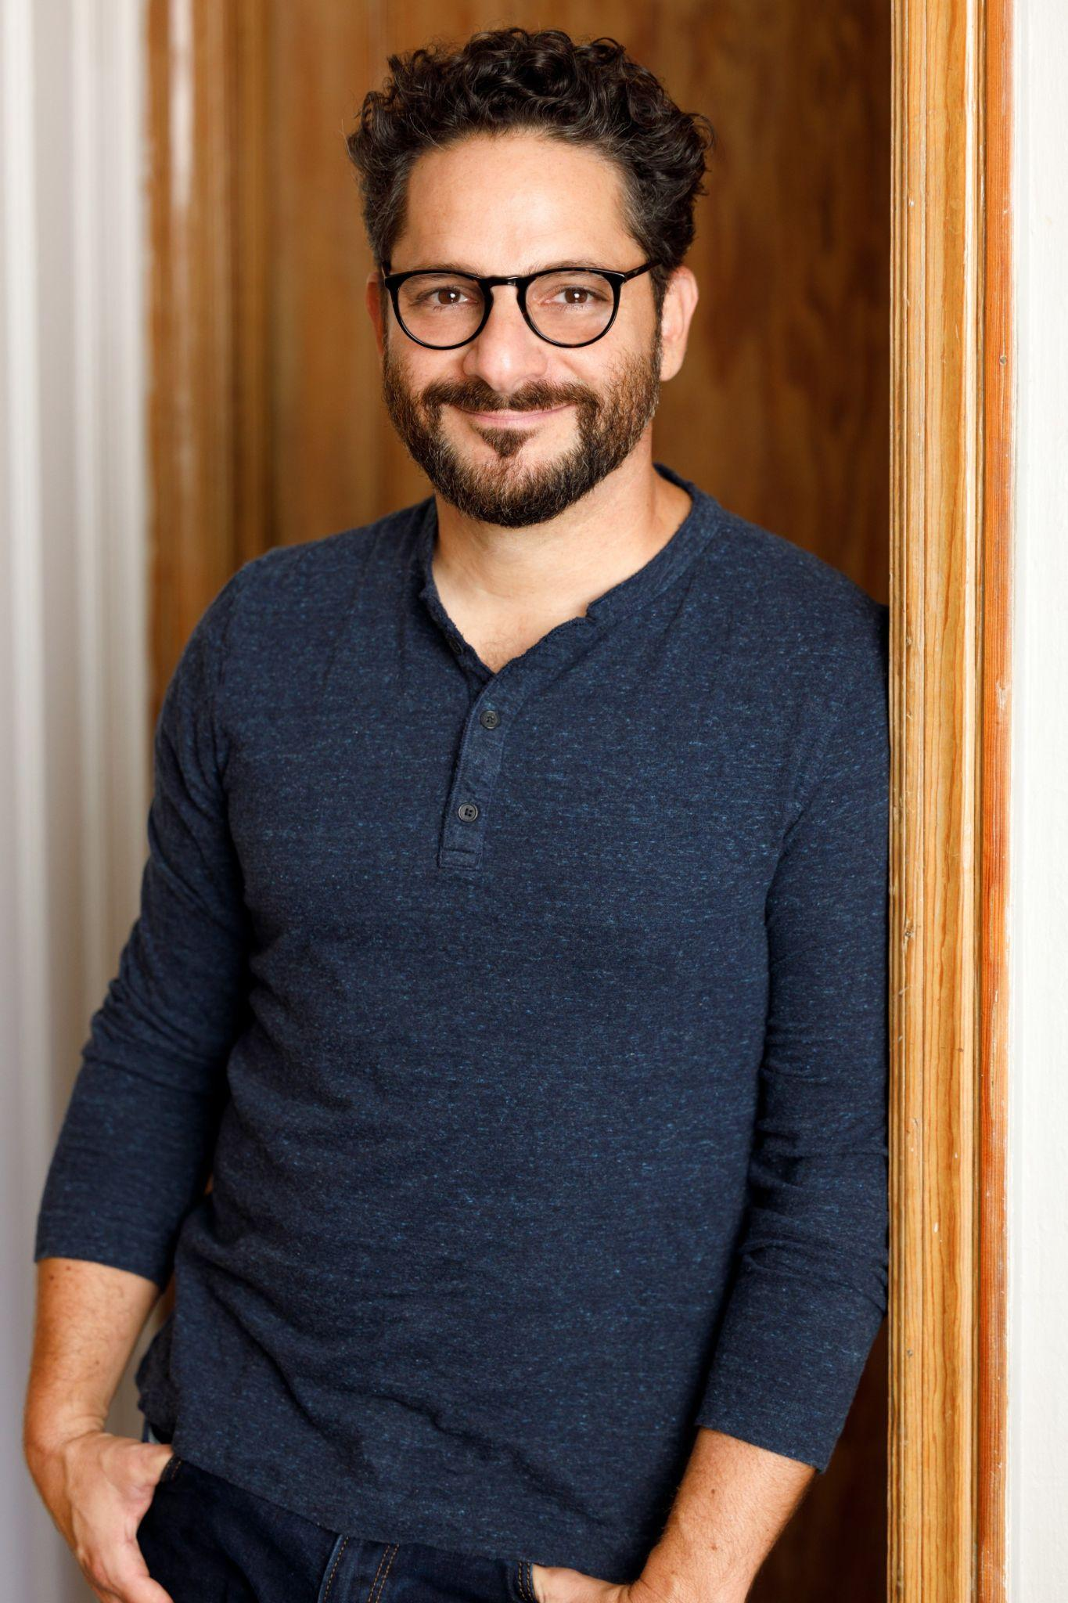
Ari Wallach is a futurist, author, and host of the upcoming PBS docuseries, A BRIEF HISTORY OF THE FUTURE. In 2023, he co-founded Futurific, a production studio that creates positive, hopeful stories about our collective future. Futurific premieres a six-part documentary series, A BRIEF HISTORY OF THE FUTURE, in April 2024 on PBS. Ari is the founder and executive director of Longpath Labs, which helps people and organizations implement future-focused shifts in thinking, decision-making, and behavior. His TED talk on his “Longpath” vision has been viewed over 2.7 million times and translated into 19 languages. Ari is the author of Longpath: Becoming the Great Ancestors Our Future Needs, published by HarperOne. A graduate of UC Berkeley, Ari was also an adjunct associate professor at Columbia University’s School of International and Public Affairs.
Contact: briefhistory@ssmandl.com

###

