AMERICAN HEART IN WWI: A CARNEGIE HALL TRIBUTE
Premieres Veterans Day, Tuesday, November 11,
on PBS and Streaming on PBS.org and the PBS app

Electrifying Theatrical Event Brings America’s World War I Story to Life through the Lens of F. Scott Fitzgerald’s The Great Gatsby and Five Real- Life Figures from the War

Created and Narrated by Historian John Monsky, Directed by Tony Award-Winner Michael Mayer, and Produced for Television by Academy Award-Winning RadicalMedia

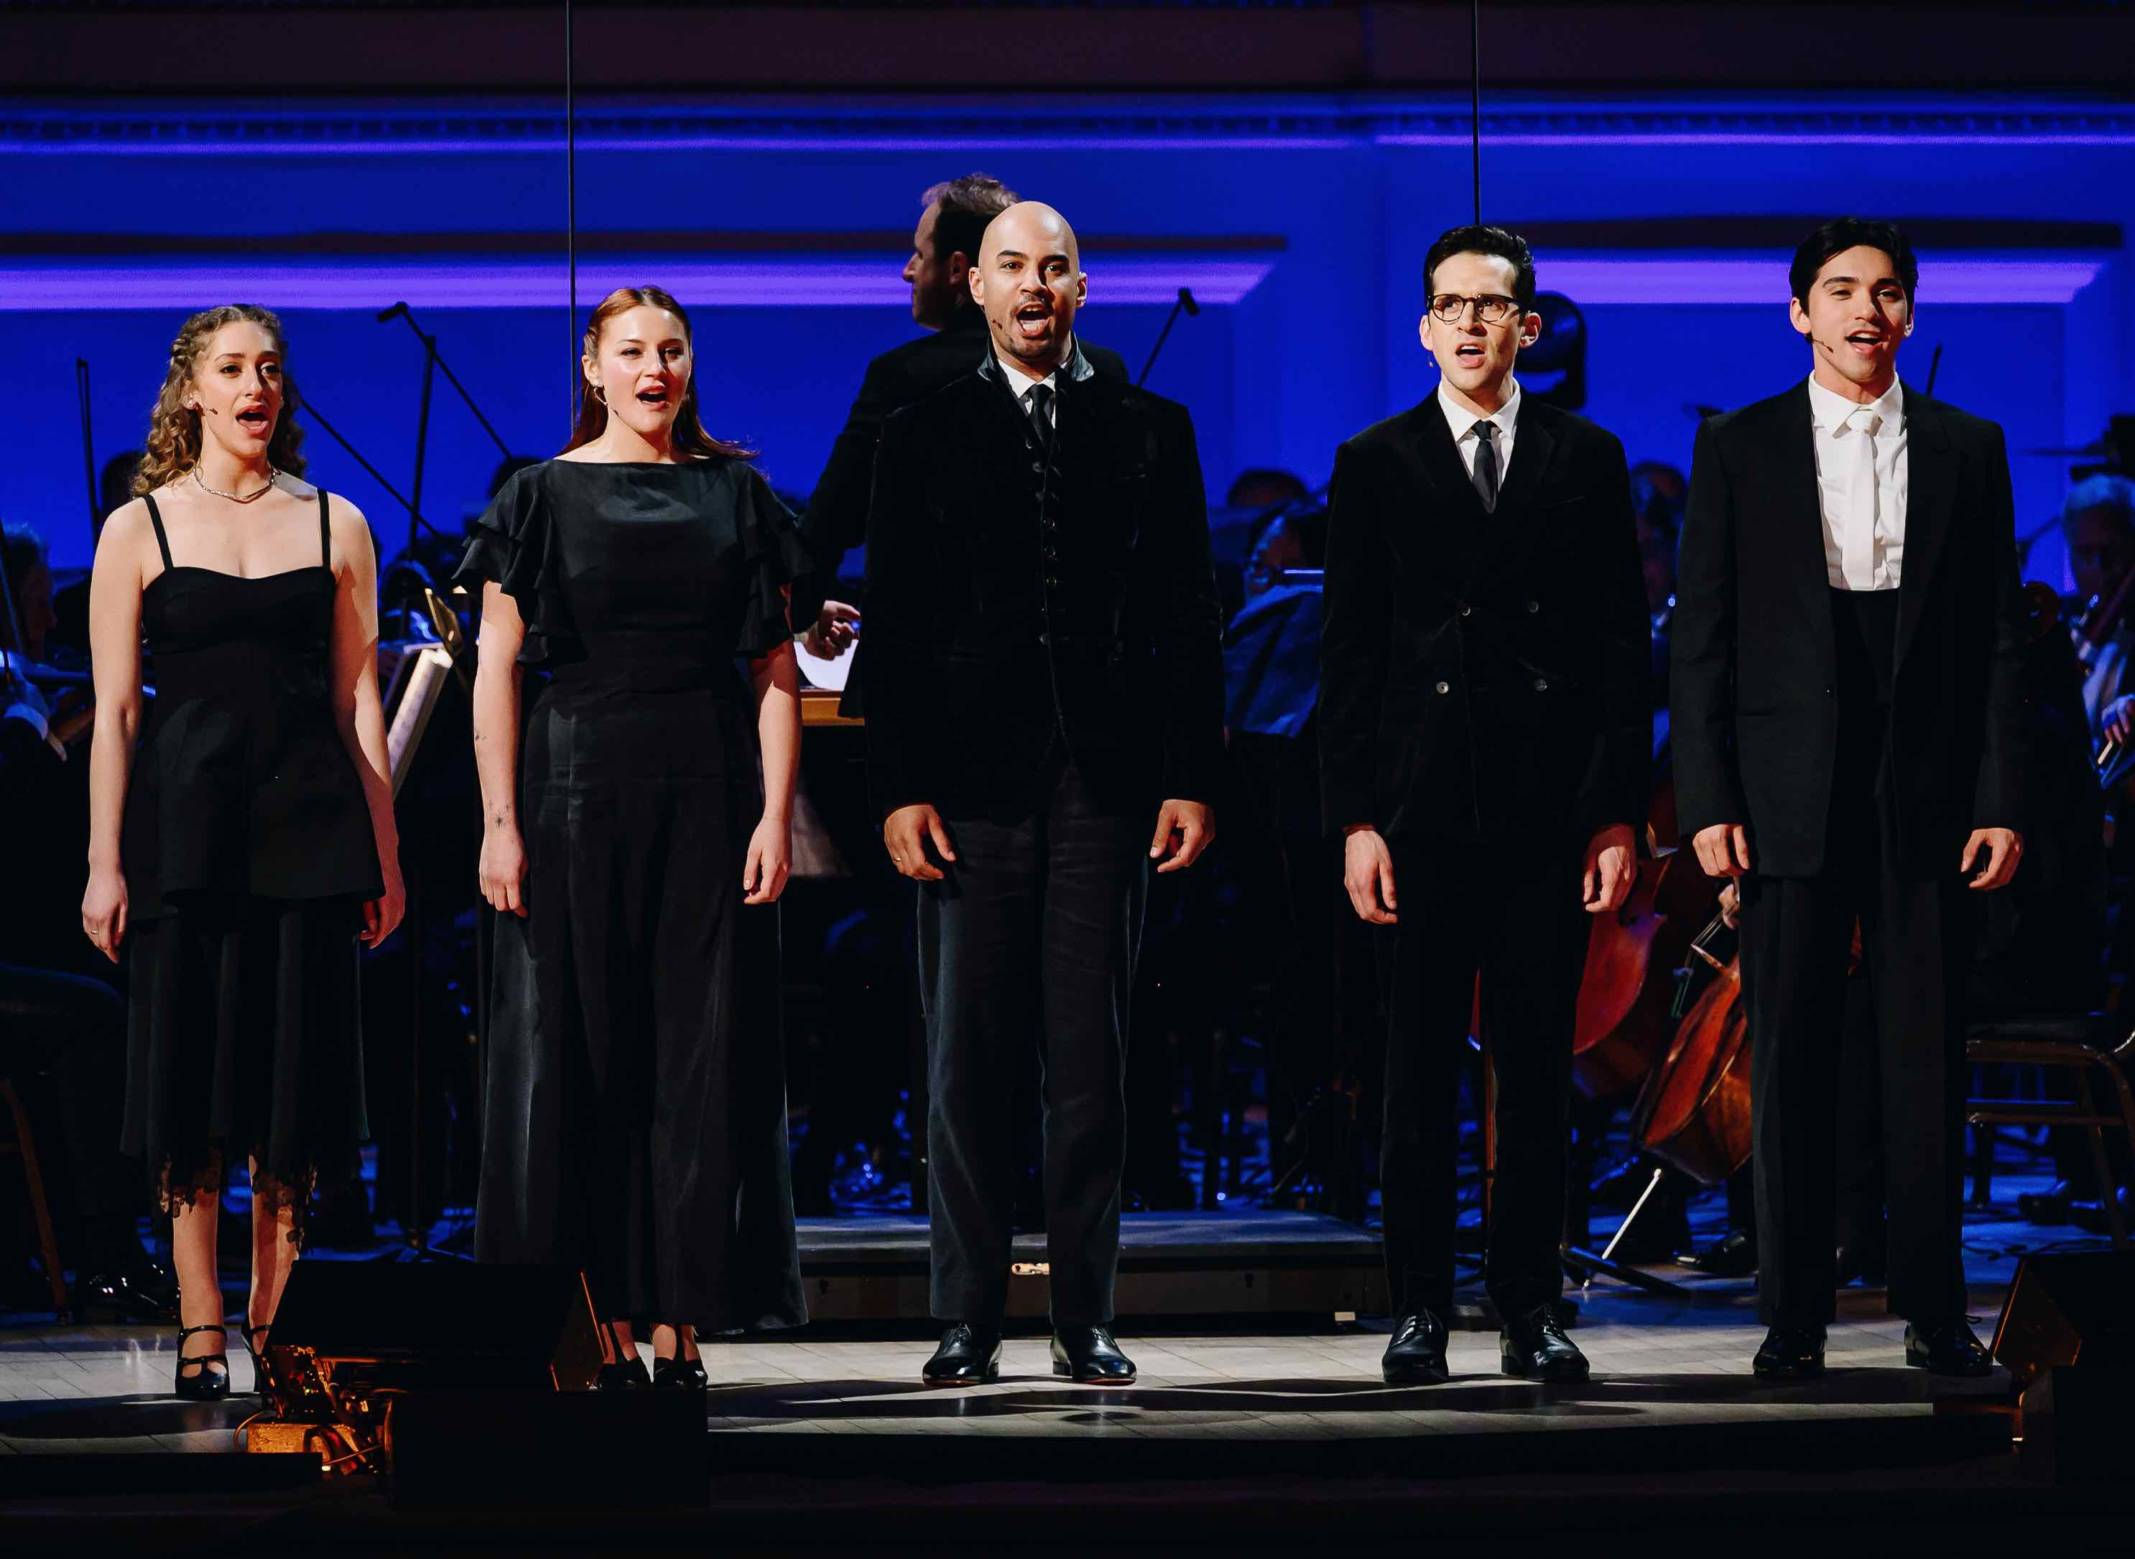
Left to right: Micaela Diamond, Gracie McGraw, Nicholas Christopher, Adam Chanler-Berat and Diego Andres Rodriguez.
Credit: Nina Westervelt

ARLINGTON, VA; Oct. 16, 2025 –
Powerful storytelling, breathtaking music, rare and iconic archival film and images, unforgettable characters, and meticulously researched history all come together in AMERICAN HEART IN WWI: A CARNEGIE HALL TRIBUTE, a panoramic musical and visual account that brings America’s World War I story to life. Created, written and narrated by historian John Monsky and directed for the stage by Tony Award winner Michael Mayer (Spring Awakening), this tribute to those who fought, and those they left behind, premieres Veterans Day, Tuesday, November 11, 2025, 8:00-10:00 p.m. ET (check local listings) on PBS, PBS.org and the PBS app.

Filmed at Carnegie Hall in April 2025 by the Academy Award-winning RadicalMedia, this living documentary features the 60-piece Orchestra of St. Luke’s and a stellar cast — Adam Chanler-Berat (Next to Normal), Nicholas Christopher (Hamilton, Chess), Micaela Diamond (Parade), Gracie McGraw (BABE) and Diego Andres Rodriguez (Sunset Boulevard, Evita), conducted by music supervisor and arranger Ian Weinberger (Hamilton, Chess).

Bursting with dozens of songs from the period by composers Irving Berlin, James Reese Europe, George M. Cohan and others; rare archival film of American soldiers and WWI figures; historic flags from the period and a narrative rich with twists and turns, AMERICAN HEART captures the voice of a generation set adrift, forever changed and looking for answers.

Using F. Scott Fitzgerald’s The Great Gatsby as a framework, which marked its 100th year since publication this year, Monsky guides the audience from the war’s origins through its harrowing climax, as seen through the wartime experiences of Fitzgerald’s fictional veterans Jay Gatsby and Nick Carraway, as well as five real-life figures from the war: soldier and music pioneer James Reese Europe, a civil rights trailblazer and Harlem Hellfighter; Vera Brittain, an Oxford student and young nurse who loses everything in the war; Charles Whittlesey, a shy New York lawyer who leads a melting pot of soldiers trapped under fire in the single biggest battle in American history; combat pilot Quentin Roosevelt, son of President Theodore Roosevelt, in love with debutante and future philanthropist Flora Payne Whitney.

A bold re-envisioning of Monsky’s critically acclaimed original 2023 production, The Great War & The Great Gatsby, AMERICAN HEART IN WWI: A CARNEGIE HALL TRIBUTE offers fresh insights, newly uncovered research, and additional musical selections, creating a vivid and emotionally powerful journey for this uniquely electrifying theatrical experience.

AMERICAN HEART IN WWI: A CARNEGIE HALL TRIBUTE will stream simultaneously with broadcast and be available on all station-branded PBS platforms, including PBS.org and the PBS app, which is available on iOS, Android, Roku, Apple TV, Amazon Fire TV, Android TV, Samsung Smart TV, Chromecast and VIZIO.

AMERICAN HEART IN WWI: A CARNEGIE HALL TRIBUTE is produced for television by RadicalMedia and for the stage by American History Unbound. Executive producers are Jon Kamen, John Monsky, Dave Sirulnick, Meredith Wagner and Karla Zambrano. John Monsky is the creator, writer, historian, and narrator. Michael John Warren directs the television production, and it was directed for the stage by Michael Mayer. Ian Weinberger serves as music supervisor, conductor, and arranger. Declan Quinn serves as director of photography and Spencer Averick as editor. Lighting design by Mike Baldassari.

Major funding for AMERICAN HEART IN WWI: A CARNEGIE HALL TRIBUTE was provided by the generous support of Kenneth C. Griffin.

Additional funding for AMERICAN HEART IN WWI: A CARNEGIE HALL TRIBUTE was provided by Screaming Comet Foundation, Denis & Britta Nayden, Karen & William Osborne, Jerry Speyer & Katherine Farley, James & Susan Rosener, Lizanne & Barry Rosenstein, Robert & Lynn DuCommun, Tracy Stein, Daniel & Alisa Doctoroff, Barry & Nancy Barnett, Suzanne Peck & Brian Friedman, and Walter & Gail Harris.

ABOUT JOHN MONSKY
John Monsky is the creator, writer, and narrator of the American History Unbound series. His historical productions premiere annually as part of the Carnegie Hall Presents series. Meticulously researched, Monsky’s works include 60-piece orchestras, leading Broadway vocalists, archival photography and film, and rare flags drawn from his nationally recognized collection.

In addition to Carnegie Hall, he has performed at Boston’s Symphony Hall, The Kennedy Center, Miami’s New World Center, New Orleans’ Orpheum Theatre, and in his hometown at the Jacksonville Center for the Performing Arts. His most notable productions include We Chose to Go to the Moon, The Eyes of the World: From D-Day to VE Day and The Great War & The Great Gatsby (now titled American Heart in WWI: A Carnegie Hall Tribute). In December 2024, Monsky was asked to bring his acclaimed performance of The Eyes of the World to the White House for a special performance for the President. The Eyes of the World with the Boston Pops is currently streaming on PBS.org.

Monsky’s flag collection—which he began in his boyhood—is nationally recognized and has been featured in The New Yorker and Art & Antiques Magazine. His productions originated in his living room over a decade ago, with “Flag Day Parties,” entertaining his four children, and family and friends with his first lectures, and his wife, Jennifer Weis, at the piano.

A lawyer and partner at an investment firm, Monsky is a lecturer at The New York Historical. After Yale College and Harvard Law School and working as a law clerk, he served as an attorney for the U.S. Senate Congressional Committee that investigated the Iran-Contra affair.

About PBS
PBS, with more than 330 member stations, offers all Americans the opportunity to explore new ideas and new worlds through television and digital content. Each month, PBS reaches over 36 million adults on linear primetime television, 16 million users on PBS-owned streaming platforms, 56 million viewers on YouTube, and 10 million followers on social media, inviting them to experience the worlds of science, history, nature, and public affairs and to take front-row seats to world-class drama and performances. PBS’s broad array of programs has been consistently honored by the industry’s most coveted award competitions. As the number one educational media brand, PBS KIDS helps children 2-8 build critical skills, enabling them to find success in school and life. Delivered through member stations, PBS KIDS offers high-quality content on TV — including a PBS KIDS channel — and streaming free on pbskids.org and the PBS KIDS Video app, games on the PBS KIDS Games app, and in communities across America. Teachers of children from pre-K through 12th grade turn to PBS LearningMedia for digital content and services that help bring classroom lessons to life. More information about PBS is available at PBS.org, one of the leading dot-org websites on the internet, Facebook, Instagram, or through our apps for mobile and connected devices. Specific program information and updates for press are available at pbs.org/pressroom or by following PBS Communications on X.

– PBS –

CONTACTS:

Atiya Frederick, PBS, anfrederick@pbs.org

Cara White / Mary Lugo, CaraMar, Inc.
cara.white@mac.com; lugo@negia.net

For images and additional up-to-date information on this and other PBS programs, visit PBS PressRoom at pbs.org/pressroom.

