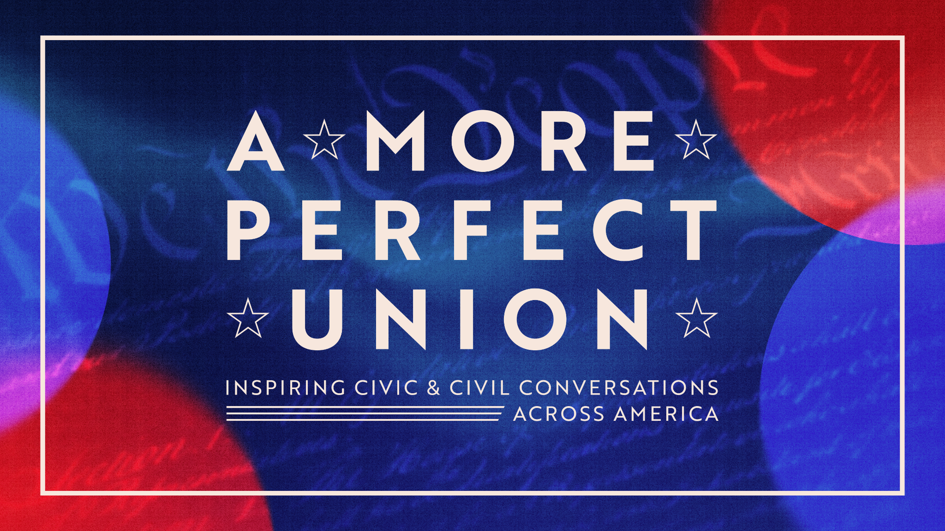
“A MORE PERFECT UNION,” A NEW PBS SPECIAL,
TO PREMIERE ON NOVEMBER 24, 2025
Featuring Ken Burns, Sarah Botstein, and Yuval Levin, moderated by
Jeffrey Rosen and Melody Barnes

Special to accompany Ken Burns series, THE AMERICAN REVOLUTION
Washington, DC, November 3, 2025 — A MORE PERFECT UNION: INSPIRING CIVIC & CIVIL CONVERSATIONS ACROSS AMERICA, a new one-hour special exploring the themes of liberty, equality, and democracy, will premiere on November 24 at 9:00 p.m. ET (check local listings) on PBS. It will also stream at PBS.org and on the PBS App.
A MORE PERFECT UNION examines how we think about America’s founding and how the ideas and values articulated 250 years ago remain relevant to conversations about governance today. This special engages Americans through a renewed civic conversation rooted in the founding principles of the Declaration of Independence and the Constitution.
Recorded at the National Constitution Center in Philadelphia and produced by WETA, A MORE PERFECT UNION features Ken Burns and Sarah Botstein, co-directors of THE AMERICAN REVOLUTION, and Yuval Levin, Director of Social, Cultural, and Constitutional Studies at the American Enterprise Institute, in conversation with co-moderators Jeffrey Rosen, President and CEO of the NCC, and Melody Barnes, Executive Director of the University of Virginia’s Karsh Institute of Democracy.
Following the week-long premiere of Burns’s film, THE AMERICAN REVOLUTION (PBS, November 16-21), the special includes clips from the documentary focused on the founding era and the politics and ideas of the period, with a broader discussion about how the founders thought about executive and legislative power and the role of the judiciary.
“It was a thrill to join Ken, Sarah, Yuval, and Melody for such a rich conversation about the enduring relevance of our founding principles,” said Jeffrey Rosen, president and CEO of the National Constitution Center. “At the National Constitution Center, we’re bringing those principles to life in our America at 250 Civic Toolkit and we’re looking forward to working with Ken and Sarah to spark a national conversation about the American idea heading into 2026.”
“Jeff Rosen and the National Constitution Center were wonderful partners as Sarah Botstein, David Schmidt, and I thought through the ideas associated with the American Revolution and how we could engage the public in a broad conversation about our founding,” said Ken Burns. “Sarah and I were very excited to join Jeff, Melody, and Yuval in this important conversation. We hope viewers have a chance to watch following the broadcast of our film, and continue to discuss these issues through the 250th anniversary of the country next year and beyond.”
“PBS is so pleased to further the conversation about America’s 250th anniversary with this timely special,” said Sylvia Bugg, Chief Programming Executive and General Manager, General Audience Programming at PBS. “A MORE PERFECT UNION beautifully complements THE AMERICAN REVOLUTION, and we are proud to bring programming to audiences that can deepen their connection to the nation's founding ideals. Together, these programs exemplify PBS’s mission to inspire understanding, dialogue, and civic engagement.”

A MORE PERFECT UNION is part of a slate of new programming for PBS America @ 250, a multiyear celebration of U.S. history, culture, and children’s programming that pays homage to America’s Semiquincentennial in 2026. As part of the largest national and local engagement effort in its history, PBS member stations are activating events in more than 75 markets nationwide. In addition to tentpole programming like THE AMERICAN REVOLUTION from Florentine Films, PBS KIDS, PBS LearningMedia, PBS Digital Studios, and PBS member stations are exploring these topics at a national and local level. PBS America @ 250 programming will span across History, Music and Culture, plus programming from PBS KIDS. Visit the PBS America @ 250 Explore Page at www.pbs.org/explore/pbs-america-at-250 for more program information and PBS LearningMedia resources.

THE AMERICAN REVOLUTION examines how America’s founding turned the world upside-down. Thirteen British colonies on the Atlantic Coast rose in rebellion, won their independence, and established a new form of government that radically reshaped the continent and inspired centuries of democratic movements around the globe. The series premieres Sunday, November 16 and airs for six consecutive nights through Friday, November 21, 2025, at 8:00-10:00 p.m. ET on PBS (check local listings). The full series will be available to stream beginning Sunday, November 16 at PBS.org and on the PBS App. More information is available at pbs.org.

THE AMERICAN REVOLUTION is a production of Florentine Films and WETA Washington, D.C. Directed by Ken Burns, Sarah Botstein and David Schmidt. Written by Geoffrey C. Ward. Produced by Sarah Botstein, David Schmidt, Salimah El-Amin and Ken Burns. Edited by Tricia Reidy, Maya Mumma, Charles E. Horton, and Craig Mellish. Co-Produced by Megan Ruffe and Mike Welt. Cinematography by Buddy Squires. Narrated by Peter Coyote. The executive in charge for WETA was John F. Wilson (who passed away in November of 2024). Executive producer is Ken Burns.

Corporate funding for THE AMERICAN REVOLUTION was provided by Bank of America. Major funding was provided by The Better Angels Society and its members Jeannie and Jonathan Lavine with the Crimson Lion Foundation; and the Blavatnik Family Foundation. Major funding was also provided by David M. Rubenstein; The Robert D. and Patricia E. Kern Family Foundation; Lilly Endowment Inc.; and the following Better Angels Society members: Eric and Wendy Schmidt; Stephen A. Schwarzman; and Kenneth C. Griffin with Griffin Catalyst. Additional support for THE AMERICAN REVOLUTION was provided by: The Arthur Vining Davis Foundations; The Pew Charitable Trusts; Gilbert S. Omenn and Martha A. Darling; Park Foundation; and the following Better Angels Society members: Gilchrist and Amy Berg; Perry and Donna Golkin; The Michelson Foundation; Jacqueline B. Mars; Kissick Family Foundation; Diane and Hal Brierley; John H. N. Fisher and Jennifer Caldwell; John and Catherine Debs; The Fullerton Family Charitable Fund; Philip I. Kent; Gail Elden; Deborah and Jon Dawson; David and Susan Kreisman; The McCloskey Family Charitable Trust; Becky and Jim Morgan; Carol and Ned Spieker; Mark A. Tracy; and Paul and Shelley Whyte. THE AMERICAN REVOLUTION was made possible, in part, with support from the Corporation for Public Broadcasting.

A MORE PERFECT UNION: INSPIRING CIVIC & CIVIL CONVERSATIONS ACROSS AMERICA is a production of WETA Washington, D.C. Moderated by Jeffrey Rosen and Melody Barnes. Produced by Sandy Petrykowski. Directed by Stephanie Cristancho. Edited by Paige Smith Lee. The line producer and production supervisor is Daniel Yang. The production designer is Dylan Wilbur. The technical producer is John Nash. The lighting designer is Charlie Ide. Executive Producer is Joe DePlasco. Executive Producer is Kate Kelly.

Major funding was provided by The Pew Charitable Trusts. Funding was also provided by The Travelers Companies, Inc., the Charles F. Kettering Foundation and viewers like you.

The public can join the conversation by using #MorePerfectUnionPBS.

About WETA
WETA is the leading public broadcaster in the nation’s capital, serving Virginia, Maryland and the District of Columbia with educational initiatives and high-quality programming on television, radio and digital. WETA Washington, D.C., is the second-largest producing station for public television, with news and public affairs programs including PBS News Hour, PBS News Weekend and Washington Week with The Atlantic; films by Ken Burns and Florentine Films, such as The American Buffalo and the forthcoming documentary The American Revolution; series and documentaries by Dr. Henry Louis Gates, Jr., including Finding Your Roots with Henry Louis Gates, Jr. and Great Migrations: A People on the Move; performance specials including National Memorial Day Concert and A Capitol Fourth; and health content from Well Beings, a multiplatform campaign. Sharon Percy Rockefeller is president and CEO. More information on WETA and its programs and services is available at weta.org. Visit facebook.com/wetatvfm on Facebook.

About PBS
PBS, with more than 330 member stations, offers all Americans the opportunity to explore new ideas and new worlds through television and digital content. Each month, PBS reaches over 42 million adults on linear primetime television, more than 15 million users on PBS-owned streaming platforms, and 56 million people view PBS content on social media, inviting them to experience the worlds of science, history, nature, and public affairs; to hear diverse viewpoints; and to take front-row seats to world-class drama and performances. PBS’s broad array of programs has been consistently honored by the industry’s most coveted award competitions. Teachers of children from pre-K through 12th grade turn to PBS LearningMedia for digital content and services that help bring classroom lessons to life. As the number one educational media brand, PBS KIDS helps children 2-8 build critical skills, enabling them to find success in school and life. Delivered through member stations, PBS KIDS offers high-quality content on TV — including a PBS KIDS channel — and streaming free on pbskids.org and the PBS KIDS Video app, games on the PBS KIDS Games app, and in communities across America. More information about PBS is available at PBS.org, one of the leading dot-org websites on the internet, Facebook, Instagram, or through our apps for mobile and connected devices. Specific program information and updates for press are available at pbs.org/pressroom or by following PBS Communications on X (formerly Twitter).

About the National Constitution Center
The National Constitution Center in Philadelphia brings together people of all ages and perspectives, across America and around the world, to learn about, debate, and celebrate the greatest vision of human freedom in history, the U.S. Constitution. A private, nonprofit organization, we serve as America’s leading platform for constitutional education and debate, fulfilling our congressional charter “to disseminate information about the United States Constitution on a nonpartisan basis in order to increase awareness and understanding of the Constitution among the American people.” As the Museum of We the People, we bring the Constitution to life for visitors of all ages through interactive programs and exhibits. As America’s Town Hall, we convene leading thought leaders from across the political and jurisprudential spectrum to debate the Constitution on all media platforms. As a Headquarters for Civic Education, we offer the best educational programs and online resources that inspire and engage all Americans in learning about the U.S. Constitution.
MEDIA CONTACT: DKCAmRev@dkcnews.com
For images and additional up-to-date information on this and other PBS programs, visit PBS PressRoom at pbs.org/pressroom.

