American Experience Presents Encore Broadcasts of LBJ and Reagan, Two Biographies from the Peabody Award-winning Collection
The Presidents

Acclaimed Films Scheduled on Thursdays, September 12 to October 3
With Streaming on PBS.org and the PBS app

(Boston, MA) — Scheduled in conjunction with the upcoming presidential election, American Experience presents encore broadcasts of LBJ and Reagan, two award-winning biographies from The Presidents collection. The four-hour biographies, each scheduled over two nights, premiere on four consecutive Thursdays, September 12–October 3, 2024, 8:00-10:00 p.m. ET (check local listings) on PBS and streaming on PBS.org and the PBS app.
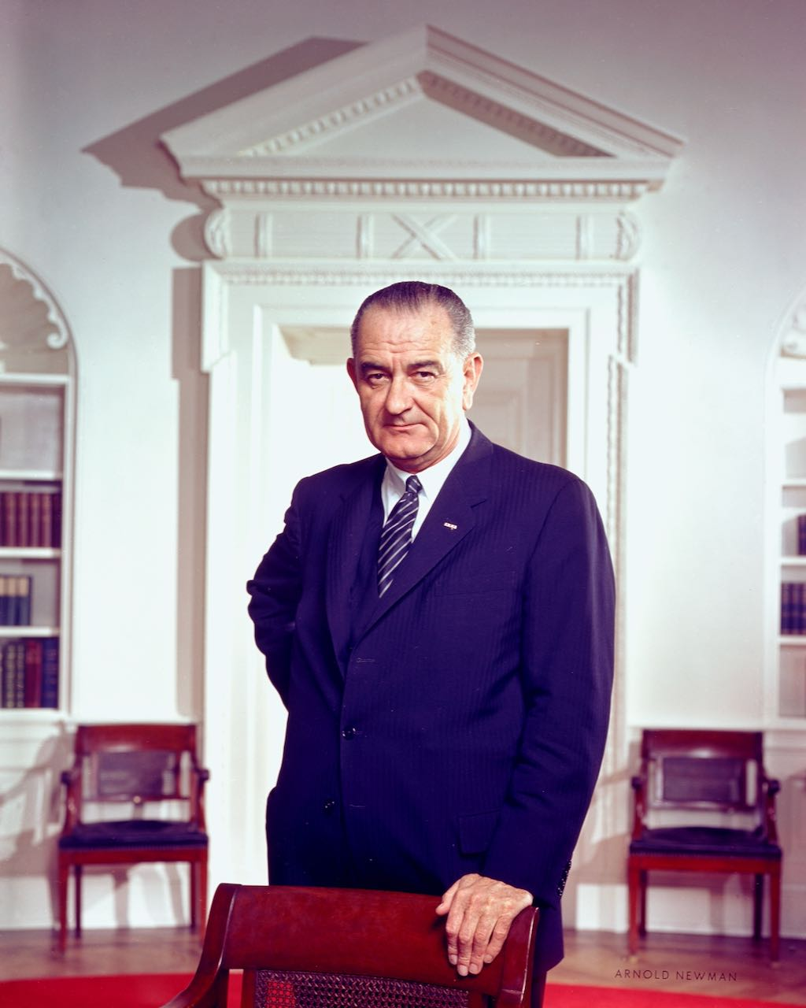
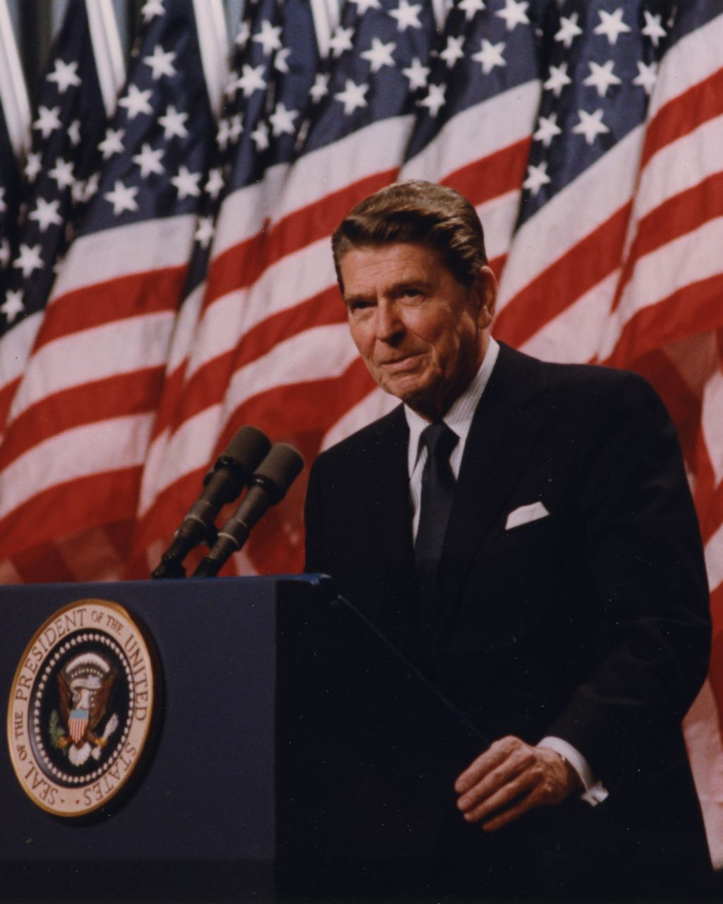
Top: President Lyndon Johnson.
Credit: Arnold Newman.
Bottom: President Ronald Reagan.
Credit: Ronald Reagan Presidential
Library.

LBJ and Reagan feature insight and commentary from America’s leading presidential historians, including Doris Kearns Goodwin and Robert Dallek, and interviews with world leaders, including Mikhail Gorbachev and Margaret Thatcher, family members including Nancy Reagan and Lady Bird Johnson, and political insiders who worked in the White House and cabinets of both presidents.

The broadcast schedule follows. All titles will be streaming on PBS.org and the PBS app.

LBJ – Thursdays, September 12 and 19, 8:00-10:00 p.m. ET
Lyndon Baines Johnson was one of the most astute, effective, and perplexing politicians in modern American history. An “accidental” president but a master legislator, he was determined to “out-Kennedy the Kennedys” by pushing through historic social legislation on a scale that rivaled FDR’s New Deal. A Southerner who championed civil rights, LBJ put into motion many of the programs that would continue to shape American life throughout the 1960s and 70s, a package of reforms known as the “Great Society.”

But as his authority was undermined by an increasingly unpopular commitment of U.S. forces to Vietnam, his presidency began to unravel. Opposition to the war spurred protest movements and a youthful counterculture. In 1968, he stunned the nation by announcing he would not seek reelection. A larger-than-life figure in his day, LBJ is appreciated for his vast domestic accomplishments, but his presidency continues to be overshadowed by his failure to end the war in Vietnam. LBJ is produced, written and directed by David Grubin.

Reagan – Thursdays, September 26 and October 3, 8:00-10:00 p.m. ET
The life of the actor, governor, and president who saw America as “a shining city on a hill” is recalled by those who knew him best: wife Nancy Reagan and three of his children. Also interviewed are those in his inner political circle and his counterparts on the world stage, former British Prime Minister Margaret Thatcher and Soviet leader Mikhail Gorbachev, who negotiated historic arms agreements with Reagan.

America’s most ideological president in his rhetoric, Reagan was pragmatic in his actions. He believed in balanced budgets but never submitted one; hated nuclear weapons but built them by the thousands; preached family values but presided over a dysfunctional family. His vision of America divided the nation, yet no matter what people thought of him politically, Reagan always won them over personally. A seemingly simple man, Ronald Reagan was consistently underestimated by his opponents; one by one, he overcame them all. Reagan is produced by Austin Hoyt and written and produced by Adriana Bosch and Hoyt.

American Experience LBJ and Reagan will stream for free simultaneously with broadcast on all station-branded PBS platforms, including PBS.org and the PBS App, available on iOS, Android, Roku, Apple TV, Amazon Fire TV, Android TV, Samsung Smart TV, Chromecast and VIZIO. The film will also be available for streaming with closed captioning in English and Spanish.

About American Experience

For over 35 years, American Experience has been television’s most-watched history series, bringing to life the incredible characters and epic stories that have shaped America’s past and present. American Experience documentaries have been honored with every major broadcast award, including 30 Emmy Awards, five duPont-Columbia Awards and 19 George Foster Peabody Awards. PBS’s signature history series also creates original digital content that innovates new forms of storytelling to connect our collective past with the present. Cameo George is the series executive producer. American Experience is produced for PBS by GBH Boston. Visit pbs.org/americanexperience and follow us on Facebook, Twitter, Instagram and YouTube to learn more.

Major funding for American Experience provided by Liberty Mutual Insurance, Carlisle Companies and by the Alfred P. Sloan Foundation. Additional funding for LBJ provided by the National Endowment for the Humanities: Democracy demands wisdom and by Humanities Texas. Additional funding for American Experience provided by the Robert David Lion Gardiner Foundation, The American Experience Trust, the Corporation for Public Broadcasting and public television viewers.

* * *
Contacts: CaraMar Publicity
Mary Lugo 770-851-8190 lugo@negia.net
Cara White 843-881-1480 cara.white@mac.com

For further information and photos visit http://www.pbs.org/pressroom

LBJ originally premiered on September 30, 1991.
Reagan originally premiered on February 23-24, 1998.

