American Experience Hard Hat Riot
Premieres Tuesday, September 30, 2025
on PBS and Streaming on PBS.org

New Documentary Explores the Beginning of the Class Divide that Defines American Politics, Through the 1970 Riot in Downtown New York City

(Boston, MA) — On May 8, 1970, “the Hard Hat Riot” erupted in lower Manhattan. At midday, construction workers, including those building the World Trade Center, violently clashed with students demonstrating against the Vietnam War. It was soon clear that something larger was happening — the workmen, who came to be known as “hardhats,” were at the cutting edge of a new kind of class war. With the war in Vietnam raging on, it was the sons of the working class who were doing most of the fighting. Workmen saw the protesting students as privileged “draft dodgers” disparaging the country and those who fought for it. On the other side, many student activists saw the workers as pawns, unwilling to see the changes that America needed.
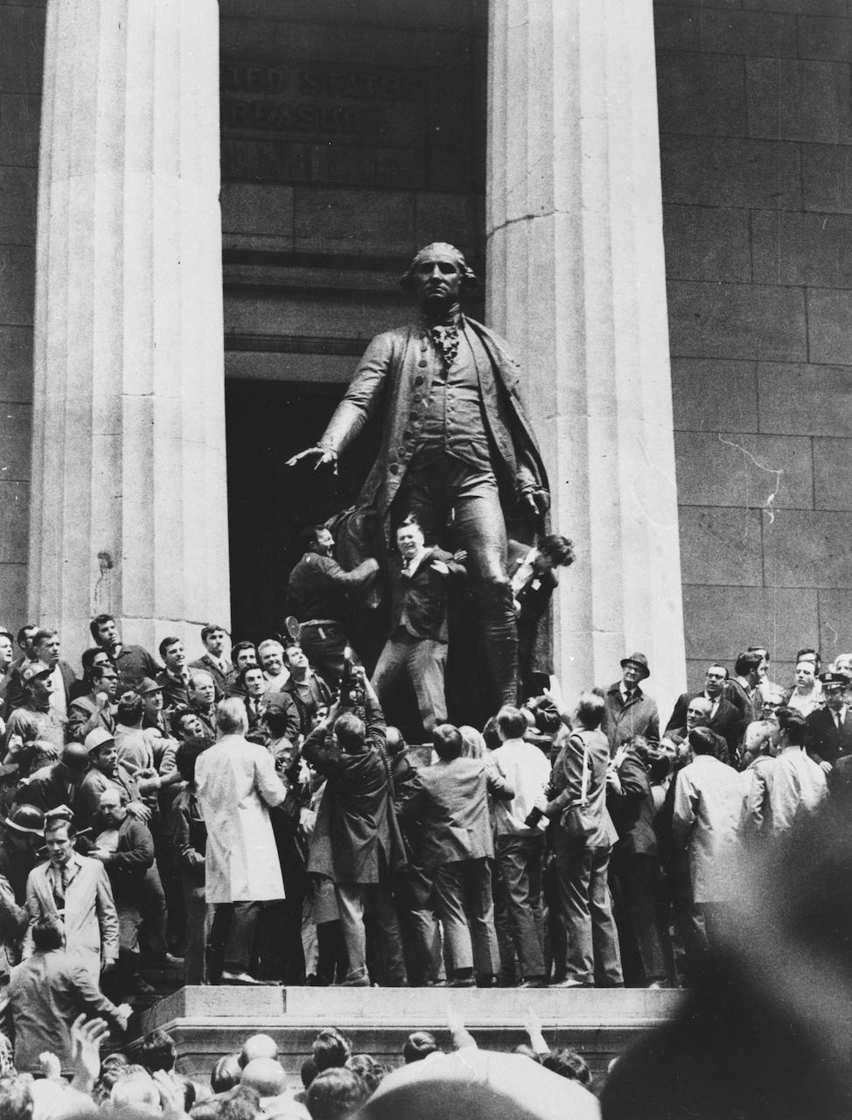
Credit: Abraham Zerykier

Hard Hat Riot tells the story of a struggling metropolis, a flailing president, a divided people, and a bloody juncture when the nation violently diverged ― culminating in a new political and cultural landscape that radically redefined American politics and foreshadowed the future. The film is based in part on the critically acclaimed book The Hardhat Riot by David Paul Kuhn, produced and written by Marc Levin and Daphne Pinkerson, produced by Mikaela Beardsley and Cary Woods, co-produced by David Paul Kuhn, and executive produced by Cameo George. Hard Hat Riot premieres Tuesday, September 30, 2025, 9:00-10:30 p.m. ET (check local listings) on American Experience on PBS, PBS.org and the PBS app.

In the early 1970s, New York City was on edge. Mayor John Lindsay’s “Fun City” had been brought to its knees by urban upheaval, from crippling transit and sanitation strikes to soaring crime. It was still a working-class city but was already suffering the effects of deindustrialization. The city’s “Second Skyscraper Age” offered a reprieve — the southern face of Manhattan was being remade, including the building of the World Trade Center. The city was also a center of the counterculture and anti-war student protesters, who rallied in Lower Manhattan at the heart of Wall Street, scarcely aware of the workers watching from the half-built skyscrapers above.

Hard Hat Riot focuses on a fateful week in May 1970, which began with President Nixon’s expansion of the war into Cambodia. Days of campus tumult and strikes followed, including the killing of four students at Ohio’s Kent State University by National Guardsmen. On May 7, thousands of mourners gathered in New York for the funeral of Jeffrey Miller, one of the Kent State Four who was from Long Island. Afterward, throngs of students headed down to Wall Street, leading to a small clash with workers. Few realized far worse would soon come.

By noon on May 8, hundreds of construction workers descended from their towers and surrounded a student demonstration on Wall Street. Student activists had the loudspeaker and, initially, the numbers. The hardhats unfurled a massive American flag and many Wall Street workers cheered. Then, a student activist waved a Vietcong flag. Suddenly, the construction workers surged forward, leading to a violent confrontation that revealed an emerging class fault line that became “a microcosm of the divides and the polarization that will come to define American life,” said Kuhn.

Hard Hat Riot is told through candid interviews with many of the workers and protestors who were there, as well as footage of the riot that has not been seen by the public until now. In addition, the film includes largely overlooked footage from that week filmed by and featuring an idealistic group of New York University film students and professors, including director Martin Scorsese, actor Harvey Keitel, and screenwriter Jay Cocks.

“What makes this film unique is how, by allowing both the students and the construction workers to explain their feelings and motivations, 55 years later and without judgment, we come to understand both sides,” said American Experience Executive Producer Cameo George. “And, as this incredibly powerful film shows, this was not just an early flashpoint in the culture wars that are so familiar to us now, but actually a tipping point in American politics, when the formerly solidly Democratic working class began to be wooed and won over by the Republican party.”

American Experience Hard Hat Riot will stream for free simultaneously with broadcast on all station-branded PBS platforms, including PBS.org and the PBS app, available on iOS, Android, Roku, Apple TV, Amazon Fire TV, Android TV, Samsung Smart TV, Chromecast and VIZIO. The film will also be available for streaming with closed captioning in English and Spanish on the American Experience website.

About the Major Participants

Billy Abbate (pronounced Abbot) was a steamfitter in NYC’s Local 638 who participated in the clashes of May 1970.

Michael Balzano was a garbage collector before earning a PhD at Georgetown University. He was selected by President Richard Nixon as a liaison to blue-collar, working-class communities.

Michael Belknap worked for the downtown law firm of Sullivan & Cromwell. On May 8, he took his lunch break to see what was causing the commotion and was beaten by a group of hardhats.

Harry Bolles was a student at NYU film school in 1970. He and his fellow students were filming a group of construction workers when some of them confronted them, and Bolles was beaten.

Stephen Bull was an aide to President Richard Nixon.

Sid Davidoff was an aide to New York City Mayor John Lindsay.

Ronnie Eldridge was an aide to New York City Mayor John Lindsay.

Joshua B. Freeman is Professor of History (Emeritus), Queens College and the Graduate Center, CUNY, and author of Working-Class New York: Life and Labor Since World War I.

David Friedman was a student who was beaten at the riot.

David Paul Kuhn is the author of The Hardhat Riot: Nixon, New York City, and the Dawn of the White Working-Class Revolution.

Gary LaBarbera is a New York labor leader and the President of the NYC Building and Construction Trades Council.

James Lapham was a 27-year-old electrician when he led a midtown workers’ rally during the outpouring of blue-collar activism in May 1970.

Ray Melville was a lather who served in the Vietnam War.

Dennis Milton was an ironworker at a building site near City Hall.

Dan Rossi was a sheet metal worker and Marine who served in Vietnam.

William W. Sales Jr. was a student activist at Columbia University in 1968 and one of the Black students who occupied Hamilton Hall.

Nancy Seifer was a liaison to working class communities for Mayor Lindsay.

David Sederholt was a freshman at Pace University when the riot broke out.

Jim Vermeulen was a police officer on an NYPD Special Events Squad, which was trained in crowd control. He was in the middle of the action when the construction workers attacked the students.

About the Filmmakers

American Experience Hard Hat Riot

Produced and Written by  Based in Part on the Book  The Hardhat Riot by  Co-Producer  Edited by  Produced by | MARC LEVIN  DAPHNE PINKERSON  DAVID PAUL KUHN  DAVID PAUL KUHN  HENRY MOSKOWITZ  MIKAELA BEARDSLEY  CARY WOODS

American Experience is a production of GBH Boston
Executive Producer | CAMEO GEORGE

Marc Levin (Producer/Writer) is an award-winning, independent filmmaker dedicated to telling powerful, real stories in a unique, authentic style. One of America’s most prolific director/producers, he has made over 50 films, including documentaries, TV series, dramatic feature films and episodic television. He has won four Emmys and four duPont-Columbia Awards, among other prominent accolades. Highlights include his dramatic hit SLAM, which won the Grand Jury Prize at Sundance and the Camera D'Or at Cannes; the groundbreaking docuseries Brick City, which won the Peabody Award and the NAACP Image Award; HBO’s Gang War: Bangin’ in Little Rock, winner of the national CableACE Award; the Emmy for Outstanding Non-Fiction Special for HBO's Thug Life in DC; and the DOC NYC Grand Jury Prize for HBO’s Class Divide. His most recent HBO film, An American Bombing, is streaming on Max and was recently nominated for an Emmy for Outstanding Historical Documentary.

Daphne Pinkerson (Producer/Writer) has produced a range of award-winning social and political documentaries for most of the major programmers, including 20 films for HBO. Recognition for her work includes an Emmy for Outstanding Non-Fiction Special for Thug Life in DC and a duPont-Columbia Award for Triangle: Remembering the Fire, which she directed. In 2001, NARAL presented its Courageous Advocate Award to her for Soldiers in the Army of God, a film she produced and co-directed. In addition to producing and directing, she shoots stylized film and video with small format cameras. She has captured some cinematic firsts, filming a gang drive-by shooting in Little Rock, Arkansas (HBO’s Gang War: Bangin’ in Little Rock) and inmates injecting drugs in prison (HBO’s Prisoners of the War on Drugs). She was also associate producer and additional shooter on the dramatic feature SLAM. In 1988, during the press restrictions in South Africa, she launched South Africa Now, a weekly half-hour news program that commissioned pieces from inside South Africa for broadcast on public television, CNN World Report and ITN. She has been a supervising producer on several documentary films as well, including three for HBO.

Mikaela Beardsley (Producer) is an Emmy Award-winning documentary producer who has worked with filmmakers Martin Scorsese, Marc Levin, Alex Gibney, Liz Garbus, Matthew Heineman, Karim Amer, Fisher Stevens, Heidi Ewing and Rachel Grady, and David Tedeschi, among others. Mikaela most recently produced Martin Scorsese’s Beatles ‘64, a Sikelia Productions / Apple Corps feature for Disney +. Other credits include Lincoln Project (Showtime), First Wave (National Geographic), A Once and Future Peace (CBC), The Fourth Estate (Showtime), The 50-Year Argument (HBO) and Reporter (HBO). Mikaela also created and executive produced Half the Sky Movement, a multi-year global media project aimed at improving opportunities for women and girls in the developing world. Centered around the PBS and internationally broadcast series based on Nicholas D. Kristof and Sheryl WuDunn's bestselling book, the project had over 2 billion media impressions and raised $5 million for direct programs.

Cary Woods (Producer) is one of the most prolific independent film producers of the last 25 years. Legendary for having been responsible for a library of films that define a golden era of indie filmmaking, he is best known for producing the worldwide blockbusters Scream and Godzilla, the beloved independent films Kids, Cop Land, and Gummo, as well as modern classics like Rudy and Swingers. Cary is also responsible for producing the breakthrough features of such notable directors as James Mangold, Doug Liman, M. Night Shyamalan, Alexander Payne, Harmony Korine, and Larry Clark, as well as the screenwriting debuts of Jon Favreau, Kevin Williamson, and Scott Rosenberg.

David Paul Kuhn (Author, Co-Producer) is a writer and political analyst living in New York City. He is the author of, most recently, The Hardhat Riot: Nixon, New York City, and the Dawn of the White Working-Class Revolution. Kuhn has served as the chief political writer for CBS News online, a senior political writer for Politico as well as chief political correspondent at RealClearPolitics. He has also written for The Atlantic, The New York Times, The Wall Street Journal, The Washington Post Magazine, The Los Angeles Times, National Review, New Republic, among other publications, and regularly appears on networks ranging from BBC to Fox News.

Cameo George (Executive Producer, American Experience) is an Emmy Award-winning producer, writer and journalist with more than 25 years of experience in documentary, broadcast television and digital content production. George has produced, developed and commissioned innovative programming at CNN, NBC News and ABC News. She was the senior producer of CNN’s groundbreaking series Black in America and Latino in America and executive producer of the eight-hour PBS documentary series 16 FOR '16: THE CONTENDERS, which was also broadcast on the BBC. George joined American Experience from ABC News, where she was head of development for long-form projects, responsible for creating a pipeline of docuseries and feature documentary films across Walt Disney Television platforms, including ABC News, Hulu, National Geographic and Disney+. She was recently named to The Root’s list of 2024’s 100 Most Influential Black Americans.

About American Experience
For nearly 40 years, American Experience has been television’s most-watched history series, bringing to life the incredible characters and epic stories that have shaped America’s past and present. American Experience documentaries have been honored with every major broadcast award, including 32 Emmy Awards, five duPont-Columbia Awards and 20 George Foster Peabody Awards. PBS’s signature history series also creates original digital content that innovates new forms of storytelling to connect our collective past with the present. Cameo George is the series executive producer. American Experience is produced for PBS by GBH Boston. Listen to the American Experience Presents podcast on Apple, Spotify, Amazon Music and more. Visit pbs.org/americanexperience and follow us on Facebook, Instagram, Threads and YouTube to learn more.

Major funding for American Experience provided by Liberty Mutual Insurance, Carlisle Companies and by the Alfred P. Sloan Foundation. Funding for Hard Hat Riot provided by The Arthur Vining Davis Foundations: Investing in Our Common Future. Additional funding for American Experience provided by the Robert David Lion Gardiner Foundation, The American Experience Trust, the Corporation for Public Broadcasting and public television viewers.

Hard Hat Riot is distributed internationally by PBS International.

* * *
Contacts: CaraMar Publicity
Mary Lugo 770-851-8190 lugo@negia.net
Cara White 843-881-1480 cara.white@mac.com
Abbe Harris 908-244-5516 abbe.harris@caramar.net

For further information and photos visit https://pressroom.pbs.org

