American Experience Kissinger
Premieres Monday and Tuesday, October 27-28, 2025
on PBS and Streaming on PBS.org

New Documentary Explores the Life and Continuing Influence of
Henry Kissinger, Who Singlehandedly Re-Shaped Global Geopolitics

(Boston, MA) — Kissinger, a new two-part, three-hour biography, offers an incisive portrait of Henry Kissinger, the enigmatic powerbroker who served in the topmost echelons of American diplomacy. Whether celebrated or reviled, Kissinger’s contradictions reflect those at the heart of America’s foreign policy during the second half of the 20th century, a period in which America became the unchallenged superpower in the world yet often pursued policy at odds with its own highest ideals. As historian and Kissinger biographer Niall Ferguson says in the film, “Nobody, before or since, has played such an important role in American foreign policy. We’ve had to recognize it’s Henry Kissinger’s world.”
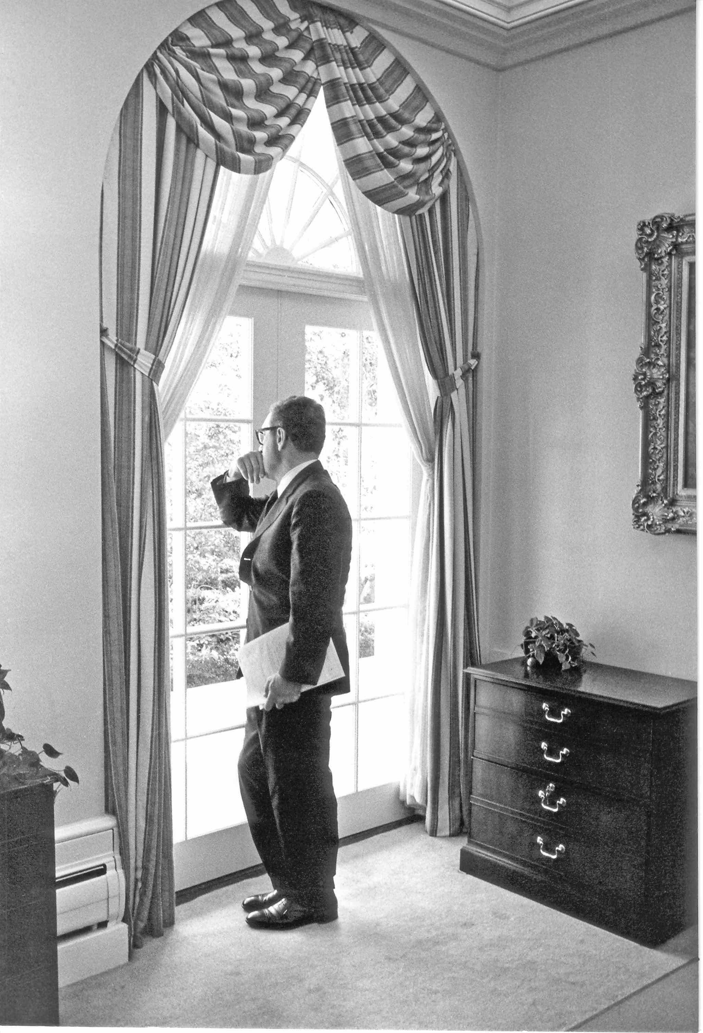
Henry Kissinger, September 21, 1970.
Credit: White House via CNP /Alamy

Credit:

Featuring interviews with dozens of Kissinger’s proteges and colleagues, including Roger Morris, John Negroponte, Winston Lord, and Morton Halperin, as well as historians and journalists including Hedrick Smith, Sally Quinn and Fareed Zakaria, Kissinger is written and produced by Barak Goodman, co-produced by Nora Neus and Michael Shorris, and executive produced by Cameo George. It premieres Monday and Tuesday, October 27-28, 2025, 9:00-10:30 p.m. ET (check local listings) on American Experience on PBS, PBS.org and the PBS app.

When Henry Kissinger died on November 29, 2023, newspapers devoted pages to his obituary and scores of world leaders praised his legacy. Yet the mere mention of his name can elicit seething contempt or reverent admiration. From his childhood in Hitler’s Germany to his years as a Nazi hunter in the United States Army, from his swift rise to the highest rungs of American foreign policy to his surprising reign as Washington’s most sought-after celebrity bachelor, Kissinger was a source of fascination. By examining his life up to and throughout his tortured relationship with President Richard Nixon, the film endeavors to understand precisely what drove Kissinger’s relentless drive for power. It is a story of deep contradictions — of Kissinger’s obsession with securing American supremacy, staving off nuclear war, and checking the power of our enemies, even while consorting with dictators and tolerating widespread violation of human rights.

Part One – “The Necessity of Power”

“I believe we have an obligation to prevent the totalitarians from taking over the world by force.”
– Henry Kissinger
Kissinger begins with the devastating childhood experiences that helped forge Henry Kissinger’s political philosophy. In August 1938, after Hitler’s government had embarked on a campaign to destroy Germany’s Jews, Kissinger’s family fled to the United States. Their escape came two months before Kristallnacht and the outbreak of violence that would culminate in the murder of six million Jews (and millions of others), including 13 members of Kissinger’s extended family, implanting in Kissinger the durable conviction that power was the prerequisite for liberty.

As a refugee in New York City, Kissinger worked his way up from a job at a shaving brush factory to a stint as an intelligence officer in the U.S. Army ferreting out Nazis in post-war Germany. He returned to earn an advanced degree and professorship at Harvard in government, marking the start of a dazzling career. He became an expert on nuclear weapons policy, eventually securing a position as National Security Advisor for President Richard Nixon at the height of the Cold War. He was an unlikely pick — an awkward academic with a thick accent who hired a staff of ideologically diverse young men, including film interviewees Anthony Lake, Winston Lord, Roger Morris, and Morton Halperin.

Bedeviled by how to end the increasingly unpopular war in Vietnam, the Nixon administration turned to increasingly audacious interventions to force Hanoi to the bargaining table, first secretly bombing, then invading neighboring Cambodia. Pundits debated whether these escalations were brilliant strokes of tactical genius or unconstitutional attacks on a neutral nation. Several Kissinger staffers resigned, and protests erupted across America. Public morale reached a bloody nadir on May 4, 1970, with the shooting of antiwar demonstrators at Kent State.

Part Two – “The Opportunist”

“Whatever you solve in foreign policy is not final and is simply an admissions ticket for some other crisis.” – Henry Kissinger

Nixon’s secret plan to end the Vietnam War had shown itself to be a mirage, and body counts kept rising. Only a brave, secret gambit to visit Mao Zedong’s China shifted the political conversation. In 1971, Kissinger secretly entered China via Pakistan, clandestinely organizing a summit for President Nixon and stunning the American public.

The opening to China remade the global chessboard, sidelining the Soviet Union and deep-freezing the Cold War in a new “triangular diplomacy.” But Kissinger’s policies were often concerned with global stability rather than with human rights. When a genocide erupted in East Pakistan, perpetuated by the same leader who helped Nixon reach China, Kissinger looked the other way. His eyes were on Moscow, where Nixon would soon meet Brezhnev for a series of consequential weapons negotiations.

Kissinger’s policies continued to have far-reaching human implications across the globe. When Chileans democratically elected the socialist Salvador Allende, Kissinger funded an effort to prevent him from reaching office, then directed the CIA to destabilize his government. Allende was deposed in a coup that led to his death; Kissinger embraced the subsequent dictator, Pinochet, reassuring Nixon that America’s “hand doesn’t show.”

Kissinger managed a final act before leaving the Nixon administration, seizing the opportunity of the Yom Kippur War to push the Soviet Union out of the Middle East and negotiating peace deals between Israel, Egypt, and Syria. On the cover of Newsweek, Kissinger was heralded as “Super-K,” the peacemaking celebrity in an administration collapsing beneath Watergate.

It was the zenith of Kissinger’s fame, and his 50 following years out of office were rife with debate. Today, his legacy is still being written.

American Experience Kissinger will stream for free simultaneously with broadcast on all station-branded PBS platforms, including PBS.org and the PBS app, available on iOS, Android, Roku, Apple TV, Amazon Fire TV, Android TV, Samsung Smart TV, Chromecast and VIZIO. The film will also be available for streaming with closed captioning in English and Spanish on the American Experience website.

About the Participants

Roham Alvandi is the author of Nixon, Kissinger, and the Shah: The United States and Iran in the Cold War.

Elizabeth Becker is a former journalist who covered Cambodia during the Vietnam War.

Robert Brigham is a professor of history at Vassar College specializing in U.S. foreign policy and the Vietnam War.

Kyle Burke is an assistant professor of history at the University of South Florida, specializing in U.S. foreign relations.

W. Scott Butcher is a retired senior foreign service officer.

Ariel Dorfman is an Argentine-Chilean-American novelist and playwright.

Sophal Ear is a Cambodian-American political scientist and associate professor in the Thunderbird School of Global Management at Arizona State University.

Carolyn Eisenberg is a professor of U.S. History and American Foreign Policy at Hofstra University.

John Farrell is author of Richard Nixon: The Life.

Niall Ferguson is a Senior Fellow at the Hoover Institution at Stanford University, and a senior faculty fellow of the Belfer Center for Science and International Affairs at Harvard. He is author of Kissinger: 1923-1958: The Idealist.

Greg Grandin is a professor of history at Yale University.

Richard Haass is a former American diplomat and President of the Council on Foreign Relations.

Morton Halperin served in the Johnson, Nixon, Clinton and Obama administrations in the Department of Defense and National Security Council.

Sam Hoskinson is a former State Department official.

Barbara Keys is a professor of history at Durham University, UK.

David Kissinger is Henry Kissinger’s son and a Hollywood film producer.

Peter Kornbluh is a senior analyst at the National Security Archive and the director of the Chile Documentation Project and the Cuba Documentation Project.

Anthony Lake is an American diplomat and political advisor who served under the assistant to the president for national security affairs in the Nixon administration. He later served as National Security Advisor to President Clinton.

Winston Lord served as Special Assistant to National Security Advisor Henry Kissinger from 1969-1973 and went on to serve as Ambassador to China and other high-level diplomatic posts.

Roger Morris served on the National Security Council during the Johnson and Nixon presidencies. He is author of Uncertain Greatness: Henry Kissinger and American Foreign Policy.

John Negroponte served in the U.S. Foreign Service from 1960 to 1997, as Ambassador to Honduras, Mexico and Iraq, and Director of National Intelligence from 2005-2007.

Lien-Hang Nguyen is Associate Professor in the History of the United States and East Asia at Columbia University.

William Quandt served as a member of the National Security Council under Presidents Nixon and Carter.

Sally Quinn is a former Washington Post journalist and chronicler and doyenne of the Washington social scene.

Raad Rahman is a journalist specializing in human rights.

Angus Reilly is a journalist writing a book about Kissinger during World War II.

Ben Rhodes served as a Deputy National Security Advisor under President Barack Obama.

Orville Schell is the Director of the Center on U.S.-China Relations at Asia Society in New York.

Thomas Schwartz is a historian and author of Henry Kissinger and America Power: A Political Biography.

Hedrick Smith is a Pulitzer Prize-winning former New York Times reporter.

Sarah Snyder is a historian and professor at American University.

Jeremi Suri is a historian at UT Austin and author of Henry Kissinger and the American Century.

Khatharya Um is Associate Dean of the Social Sciences Division, Associate Professor of Asian American and Asian Diaspora Studies in the Department of Ethnic Studies, and Chair of Peace and Conflict Studies at the University of California, Berkeley.

Juan Gabriel Valdes is a former Chilean Ambassador to the U.S.

Salim Yaqub is a professor of history at UC Santa Barbara and specialist on the Middle East.

Fareed Zakaria is a journalist, political commentator and author.

Jianying Zha is a Chinese-American journalist.

About the Filmmakers

American Experience
Kissinger

Part One

Written and Produced by | BARAK GOODMAN
Co-Produced by | NORA NEUS  MICHAEL SHORRIS
Edited by | CHRIS O’COIN

Part Two

Written and Produced by | BARAK GOODMAN
Co-Produced by  Edited by | MICHAEL SHORRIS  NORA NEUS  ILYA CHAIKEN
American Experience is a production of WGBH Boston
Executive Producer | CAMEO GEORGE

Barak Goodman (Writer/Producer) is the co-founder of Ark Media and a principal producer, director, and writer with the company. Over a career spanning more than two decades, his films have won multiple Peabody, Emmy, Writers Guild Awards, DuPont-Columbia Awards, and the RFK Journalism Prize, and been nominated for an Oscar. Goodman’s films, which have appeared on every major streamer and broadcast network, explore the moral complexity of American life, from politics and history to science and culture. Recent projects include the upcoming Netflix film Alienation (w.t.), an investigation of family court; American Experience Woodstock, marking the 50th anniversary of the iconic music festival; and Slay the Dragon, a deep dive into the threat of gerrymandering to American democracy. His other films for American Experience include Clinton, Oklahoma City, Ruby Ridge, My Lai, and more. He continues to lead major projects with Ark Media.

Nora Neus (Co-producer) is an Emmy-nominated producer, author, and freelance journalist with bylines in CNN, The Guardian, Teen Vogue, VICE News, POLITICO Magazine, The Washington Post, and more. She is also the author of four award-winning books. Neus holds a B.A. in History and Master of Public Policy degrees from the University of Virginia, and an M.A. in War Studies from King's College London.

Michael Shorris (Co-producer) is a writer and documentary filmmaker whose work has appeared in Harper’s, The Nation, The Brooklyn Rail, and other publications. Films he has co-produced have aired on HBO, PBS, Paramount+, and other platforms. His documentary projects have included political biographies (The Incomparable Mr. Buckley; Year One), legal thrillers (72 Seconds), and cultural studies on Italian fashion, sixties crooners, and seventies disco (Milano; Paul Anka; Mr. Saturday Night).

Cameo George (Executive Producer, American Experience) is an Emmy Award-winning producer, writer and journalist with more than 25 years of experience in documentary, broadcast television and digital content production. George has produced, developed and commissioned innovative programming at CNN, NBC News and ABC News. She was the senior producer of CNN’s groundbreaking series Black in America and Latino in America and executive producer of the eight-hour PBS documentary series 16 FOR '16: THE CONTENDERS, which was also broadcast on the BBC. George joined American Experience from ABC News, where she was head of development for long-form projects, responsible for creating a pipeline of docuseries and feature documentary films across Walt Disney Television platforms, including ABC News, Hulu, National Geographic and Disney+. She was recently named to The Root’s list of 2024’s 100 Most Influential Black Americans.

About American Experience
For nearly 40 years, American Experience has been television’s most-watched history series, bringing to life the incredible characters and epic stories that have shaped America’s past and present. American Experience documentaries have been honored with every major broadcast award, including 32 Emmy Awards, five duPont-Columbia Awards and 20 George Foster Peabody Awards. PBS’s signature history series also creates original digital content that innovates new forms of storytelling to connect our collective past with the present. Cameo George is the series executive producer. American Experience is produced for PBS by GBH Boston. Listen to the American Experience Presents podcast on Apple, Spotify, Amazon Music and more. Visit pbs.org/americanexperience and follow us on Facebook, Instagram, Threads and YouTube to learn more.

Major funding for American Experience provided by Liberty Mutual Insurance, Carlisle Companies and by the Alfred P. Sloan Foundation. Funding for Kissinger provided by The Arthur Vining Davis Foundations: Investing in Our Common Future. Additional funding for American Experience provided by the Robert David Lion Gardiner Foundation, The American Experience Trust, the Corporation for Public Broadcasting and public television viewers.

Kissinger is distributed internationally by PBS International.

* * *
Contacts: CaraMar Publicity
Mary Lugo 770-851-8190 lugo@negia.net
Cara White 843-881-1480 cara.white@mac.com
Abbe Harris 908-244-5516 abbe.harris@caramar.net

For further information and photos visit https://pressroom.pbs.org

