American Experience: LBJ

Encore Broadcast

Wednesday, August 10, 2016

8:00 p.m.-12:00 a.m. ET on PBS

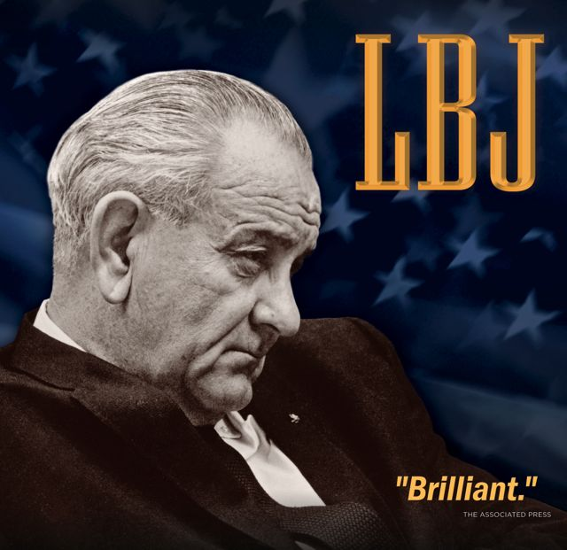
(BOSTON, MA) — Lyndon B. Johnson, a poor, rural Texan who became a vice president and president only to see his unprecedented social agenda undermined by a war he supported but never understood, is the subject of LBJ, a four-hour biography from the American Experience Peabody Award-winning collection The Presidents. Winner of an Alfred I. duPont-Columbia University Award, LBJ will have an encore broadcast Wednesday, August 10, 2016, 8:00 p.m.-12:00 a.m. ET (check local listings) on PBS.

Five years in the making, LBJ offers a look at disputed events of the past, including the Tonkin Gulf episode and the decision to “Americanize” the war in Vietnam in July 1965. It also examines the “stolen” senatorial election of 1948.

The visual record of Johnson’s political life has never been scrutinized more closely. The LBJ production team secured never-before-broadcast family movies, rare Navy Signal Corps footage, and voluminous still photos taken by U.S. Information Agency photographers who had unprecedented access to the president. In addition, LBJ features interviews with his wife Lady Bird, George Ball, Clark Clifford, John Connally, cousin Ava Cox, Daniel Ellsberg, Sen. J. William Fulbright, Doris Kearns Goodwin, Nicholas Katzenbach, George Reedy, Dean Rusk, Sargent Shriver, Roger Wilkins, Andrew Young, and many others.

The arc of Johnson’s life is a version of the American dream — the poor boy from the backwaters of the Texas hill country ascending to the very pinnacle of power. Driven by an all-consuming ambition, Johnson was big, brash, and intimidating — a man who dominated people and institutions.

He was a man of excesses and unwieldy contradictions. As a member of the House of Representatives, Johnson never voted for a civil rights bill — but as president, he signed the two most sweeping civil rights bills since Reconstruction. Few presidents before or after had such an effect on Congress yet, despite his political genius, his presidency ended in ruins.

In contrast to Johnson’s uncharismatic public persona, the film reveals a man of action, tense with anger or brimming over with charm and enthusiasm — a man most Americans rarely saw. He campaigned with the strength of ten men, one aide said: “It was as though he had an extra pair of glands.”

LBJ covers Johnson’s roots in the rural southwest, his early political campaigns, including the “stolen” election of 1948, his mastery of the Senate, his frustrating years as vice president, and his assumption of the presidency, which came about through one of the most dramatic moments in American history — the 1963 assassination of John F. Kennedy.

With the much-beloved president gone, the country looked with suspicion at the big Texan with a southern twang and an unsavory past, a political “wheeler-dealer” who, some said, stood for nothing beyond himself. Johnson had to earn the trust of the American people.

His first days in office were dark and difficult. Rumors of shadowy schemes and conspiracies were everywhere, but Johnson reassured a stunned and baffled nation, moving swiftly to continue the Kennedy agenda.

“The Johnson treatment,” developed in his Senate years, became a weapon in the arsenal of his presidency. Johnson surprised America with his forceful stand on civil rights and war on poverty. But he had also inherited the war in Vietnam, a war that would defy his political gifts and expose his human failings.

Following his overwhelming victory in the 1964 election, Johnson was one of the most popular presidents of the 20th century. He galvanized the nation with his appeal for racial justice and his vision of a Great Society and passed a tidal wave of legislation: funds for education, conservation, consumer protection, urban renewal and housing, Medicare, civil rights, public television, and the creation of the National Endowments for the Humanities and the Arts. But at the same time, he also ordered the bombing of North Vietnam and, without national debate or congressional approval, committed American troops to a full-scale land war in Asia.

Opposition grew as an increasing number of Americans began to question the Vietnam War, with riots in inner cities and anti-war protests spreading across the country. “I sometimes felt,” he said, “that I was living in a continuous nightmare.”

“‘Whom the gods would destroy, they first make mad,’” said former White House press secretary George Reedy. “This is a man who was so big, that reached so far and made it — and then let the whole thing crumble. I think it’s one of the great stories of history.”

LBJ is produced, written, and directed by David Grubin. Senior Producer: Chana Gazit. Editors: Geof Bartz and Tom Haneke. Associate Producers: Hillary Dann and Sam Sills. Cinematographer: William B. McCullough. Original Music: Michael Bacon. Executive Producers: Patricia Perini and David Grubin.

American Experience is a production of WGBH Boston. Senior Producer: Susan Bellows. Managing Director: James E. Dunford. Executive Producer: Mark Samels.

American Experience recently launched The Presidents, an all-new digital portal showcasing more than 750 assets from the Peabody Award-winning collection of films about our nation’s most important leaders. The portal allows viewers to screen full-length films, delve deeper with experts and living witnesses, and examine more than 200 primary source documents. Video galleries on The Presidents site explore how different presidents faced issues including the economy, war, dealing with a crisis, and abuses of power.

The National Endowment for the Humanities (NEH), an independent federal agency, has been a major funder of American Experience’s The Presidents for more than 20 years.

Films from The Presidents series are available on DVD at shopPBS.org or wherever DVDs are sold. Films are also available to download on iTunes.

Exclusive corporate funding for American Experience provided by Liberty Mutual Insurance. Major funding provided by the Alfred P. Sloan Foundation. Major funding for The Presidents provided by the National Endowment for the Humanities: Celebrating 50 Years of Excellence. Additional funding provided by the Corporation for Public Broadcasting and public television viewers. American Experience is produced for PBS by WGBH Boston.

About American Experience
For more than 28 years, American Experience has been the nation’s most-watched television history series. It has been hailed as “peerless” (The Wall Street Journal), “the most consistently enriching program on television” (Chicago Tribune), and “a beacon of intelligence and purpose” (Houston Chronicle). On air and online, the series brings to life the incredible characters and epic stories that have shaped America’s past and present. Acclaimed by viewers and critics alike, American Experience documentaries have been honored with every major industry award, including 30 Emmy Awards, four duPont-Columbia Awards, and 17 George Foster Peabody Awards; the series received an Academy Award® nomination for Best Documentary Feature in 2015 for Last Days in Vietnam.

Press Contacts:
CaraMar, Inc.
Mary Lugo 770-623-8190 lugo@negia.net
Cara White 843-881-1480 cara.white@mac.com
Abbe Harris 908-244-5516 abbe.harris@caramar.net

For further information and photos visit http://www.pbs.org/pressroom

Signature Image Credit: © WGBH Educational Foundation. Image of Lyndon Johnson courtesy of Lyndon Baines Johnson Presidential Library.

