American Experience Mr. Polaroid
Premieres Monday, May 19, 2025
on PBS and Streaming on PBS.org

New Documentary Profiles Edwin Land, a Pioneering Tech Disruptor and Inventor of the Midcentury Icon that Transformed Photography – the Polaroid Camera

(Boston, MA) — Long before the iPhone, another inventive device allowed everyone to instantly chronicle their lives — the Polaroid camera. The product, and the company’s unique culture, would launch not only instant photography mania but also become the model for today’s Silicon Valley tech culture. It all began with the Polaroid Model 95, first offered for sale in the fall of 1948. Its revolutionary power to allow the photographer to see the picture then and there would change the country, then the world. Mr. Polaroid tells the little-known story of the man behind the camera, a Harvard dropout named Edwin Land. Over a half century ago, before the smartphone, Land was dreaming up “a camera that you would use as often as your pencil or your eyeglasses.” He would also come to believe his company was “on its way to lead the world — perhaps even to save it.” Hubris, technology, brilliance, and a billion photographs a year are all part of the rollicking Polaroid story. Directed and written by Gene Tempest, produced by Amanda Pollak, edited by Josh Melrod, and executive produced by Cameo George, Mr. Polaroid premieres Monday, May 19, 2025, 9:00-10:00 p.m. ET (check local listings) on American Experience on PBS, PBS.org and the PBS app.
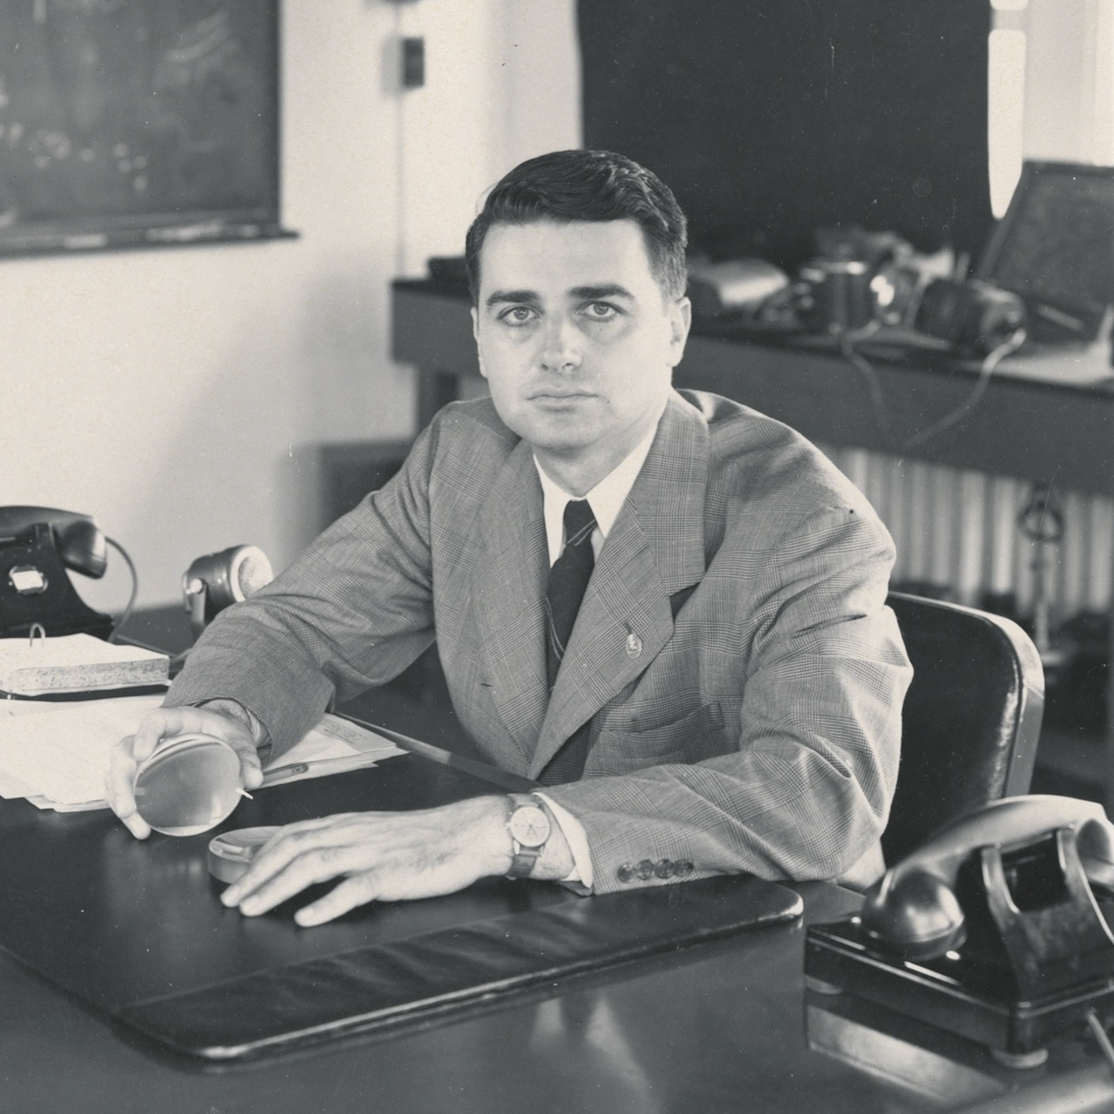
Edwin Land.
Credit: Harvard University, Baker Library

The invention Edwin Land believed would change the world was sparked by a near-accident on a dark Connecticut road. At the age of 14, he vowed to invent a solution for headlight glare, which killed thousands of motorists a year, and was convinced that the solution lay in a physics phenomenon known as polarization. By 1937, at age 28, he had already founded his own company, Polaroid. In the early years, Polaroid made sunglasses, camera lenses, glare-free windshields and headlights. But the tech he designed for carmakers never caught on. As his first great vision fizzled, Land found his way to a new field: photography. He had long believed that photography was perhaps humanity’s greatest invention. The problem, he thought, was that people were just too far removed from its magic.

At that time, photography was no simple act. It involved chemicals, darkrooms, specialists or special equipment, and above all, time: it usually took a week for a customer to see a photo after it was snapped. Land wanted to create a device that would collapse time and put the darkroom inside the camera. Helping Land make this dream a reality was an unusual group of pioneering female scientists and researchers, including Eudoxia Muller, who would make the first successful Polaroid instant photograph in 1943, and Meroë Morse, who for almost 30 years ran the Film Research Division. Land’s inclusive vision would break industry norms and expand opportunities for women in cutting-edge technological innovation.

After years of trials, in 1947, Land demonstrated a working scientific prototype of his Polaroid camera to the press; by the 1948 Christmas season, the first Polaroid went up for sale in Boston. It was an instant sensation, and Polaroid’s new kind of photography was on its way to profoundly changing how people documented their lives. Everyone loved the immediacy and the ability to take photographs that didn’t pass through the hands of middlemen afforded a new type of freedom. “You could take a Polaroid without the pressure of anyone external judging or controlling,” says photographer Rhiannon Adam. “It came with a sort of freedom to document your life as you were living it.”

Through the 1960s and 70s, Polaroid seemed to be riding ever higher, the Apple of its day. “Steve Jobs would tell you that Land was his idol in many, many ways because he created this technology company that made products people didn’t even know they wanted,” Land biographer Ron Fierstein says. With the Polaroid Swinger, introduced in 1965, the company captured the spirit and imagination of the era’s youth culture, and the camera — and its catchy jingle — became wildly popular.

But success masked risky financial gambles, a costly lawsuit against archrival Kodak, and an increasingly obsessive belief on Land’s part that technology could cure rifts in contemporary society. When workers discovered that the company was selling cameras to South Africa, where the apartheid government used them to photograph Black citizens for tracking purposes, they organized a protest, and the resulting publicity was devastating. As politics, social change, and the darker side of instant photography became enmeshed with innovation, Land would stumble.

The history of Land and Polaroid’s fall is as precipitous and revealing as that of his rise. Yet the magic of the Polaroid continues to hold sway. “It’s one of the most instantly recognizable brands ever,” Adam says. “And that sense of playfulness was really at the heart of the brand.”

American Experience Mr. Polaroid will stream for free simultaneously with broadcast on all station-branded PBS platforms, including PBS.org and the PBS App, available on iOS, Android, Roku, Apple TV, Amazon Fire TV, Android TV, Samsung Smart TV, Chromecast and VIZIO. The film will also be available for streaming with closed captioning in English and Spanish on the American Experience website.

About the Participants

Rhiannon Adam is a photographer and author of Polaroid: The Complete Guide to Experimental Instant Photography.

Christopher Bonanos is the author of Instant: The Story of Polaroid.

Ron Fierstein is the author of A Triumph of Genius: Edwin Land, Polaroid, and the Kodak Patent War.

Caroline Hunter was a chemist at Polaroid and co-founder of the Polaroid Revolutionary Workers Movement which petitioned the corporation to end its business in apartheid South Africa.

Holly French Perry joined the Polaroid Corporation in 1957 and worked closely with and as an assistant to Land for more than 30 years.

Ainissa Ramirez is the author of The Alchemy of Us, which examines how eight inventions, including photographic film, shaped the human experience.

Parker Sargent is a writer, director, producer and podcast host.

Drew Thompson is an associate professor at Bard College who teaches on the subject areas of African, African-American, and Black Diaspora visual and material culture and the history of photography.

About the Filmmakers

American Experience Mr. Polaroid

Written and Directed by  Produced by  Narrated by  Original Music by  Edited by | GENE TEMPEST  AMANDA POLLAK  GILLIAN JACOBS  EDUARDO ARAM  JOSH MELROD

American Experience is a production of GBH Boston
Executive Producer | CAMEO GEORGE

Gene Tempest (Writer, Director) is an award-winning American filmmaker and historian. Her screenwriting has been recognized with a Writers Guild Award, and her documentaries have been seen by millions of people across the country. From 2016 to 2017, she served as the first ever Historian in Residence for PBS’s flagship history series, American Experience, where she helped fund and develop new history programming for public television. Her writing has appeared in The Boston Globe, The New York Times, and elsewhere. Her most recent film, The Cancer Detectives, profiled the unlikely coalition of public health crusaders and scientists who helped bring the pap smear to the people. Past documentaries include The Sun Queen (writer/producer), Citizen Hearst (writer/producer), American Veteran (co-writer), and The Great War (co-producer) — all broadcast on PBS. She received her BA from the University of California at Berkeley, and her PhD from Yale University, where she won the Hans Gatzke Prize for pioneering work in military history.

Amanda Pollak (Producer) has been directing and producing highly acclaimed documentaries for over two decades, including over a dozen films for American Experience. She produced and co-directed The Great War, an epic six-hour series on America’s role in World War 1, which was seen by more than 10 million people nationwide. She produced Into the Grand Canyon, an environmental adventure story that premiered on National Geographic and is now streaming worldwide on Disney+, and executive produced Ailey, an immersive portrait of the renowned choreographer, which premiered at Sundance, was released theatrically by NEON and broadcast on PBS’s American Masters. Pollak was part of the founding team for Retro Report, an online series of investigative pieces featured on the front page of The New York Times digital edition. Her work has been recognized with three Emmy Awards, a Cine Golden Eagle Award and the George Foster Peabody Award.

Josh Melrod (Editor) is a filmmaker and editor whose projects have screened at Cannes, Sundance, SXSW, and Hot Docs, among many others, and been widely broadcast across networks and platforms including HBO, Netflix, Hulu, and PBS. His narrative feature film debut, Major Arcana, was released theatrically by Kino Lorber and acquired by Showtime. As an editor, his credits include Skunk, first prize Cinefondation winner at the Cannes Film Festival; The Cult of JT LeRoy; HBO's six-part true crime series Mind Over Murder; and the forthcoming documentary feature The Last Class with Robert Reich.

Cameo George (Executive Producer, American Experience) is an Emmy Award-winning producer, writer and journalist with more than 25 years of experience in documentary, broadcast television and digital content production. George has produced, developed and commissioned innovative programming at CNN, NBC News and ABC News. She was the senior producer of CNN’s groundbreaking series Black in America and Latino in America and executive producer of the eight-hour PBS documentary series 16 FOR '16: THE CONTENDERS, which was also broadcast on the BBC. George joined American Experience from ABC News, where she was head of development for long-form projects, responsible for creating a pipeline of docuseries and feature documentary films across Walt Disney Television platforms, including ABC News, Hulu, National Geographic and Disney+. She was recently named to The Root’s list of 2024’s 100 Most Influential Black Americans.

About American Experience
For over 37 years, American Experience has been television’s most-watched history series, bringing to life the incredible characters and epic stories that have shaped America’s past and present. American Experience documentaries have been honored with every major broadcast award, including 30 Emmy Awards, five duPont-Columbia Awards and 19 George Foster Peabody Awards. PBS’s signature history series also creates original digital content that innovates new forms of storytelling to connect our collective past with the present. Cameo George is the series executive producer. American Experience is produced for PBS by GBH Boston. Listen to the American Experience Presents podcast on Apple, Spotify, Amazon Music and more. Visit pbs.org/americanexperience and follow us on Facebook, Instagram, Threads and YouTube to learn more.

Major funding for American Experience provided by Liberty Mutual Insurance, Carlisle Companies and by the Alfred P. Sloan Foundation. Additional funding for American Experience provided by the Robert David Lion Gardiner Foundation, The American Experience Trust, the Corporation for Public Broadcasting and public television viewers.

Mr. Polaroid is distributed internationally by PBS International.

* * *
Contacts: CaraMar Publicity
Mary Lugo 770-851-8190 lugo@negia.net
Cara White 843-881-1480 cara.white@mac.com
Abbe Harris 908-244-5516 abbe.harris@caramar.net

For further information and photos visit http://www.pbs.org/pressroom

