American Experience Clearing the Air: The War on Smog
Premieres Tuesday, August 26, 2025
on PBS and Streaming on PBS.org

New Documentary Explores How Los Angeles’s Battle Against Smog Mobilized a Bipartisan Coalition to Create the EPA and the Clean Air Act
(Boston, MA) — In July 1943, dark, smoky clouds suddenly descended over Los Angeles, causing residents to complain of burning eyes, nausea, and difficulty breathing. People couldn’t see across the street and visibility was so bad that cars crashed. With World War II raging, many feared a chemical attack by the Japanese, but it soon became evident that no foreign enemy was to blame. The waves of pollution called “smog” — a combination of “smoke” and “fog” — continued and the cause remained a mystery. It was the beginning of an epic struggle for clean air involving years of scientific investigation and civic pressure, bringing together people across ideological divides in a remarkable example of bipartisanship. Their work would lead to the creation of the EPA and the Clean Air Act, which have had an enduring effect on the quality of air we breathe. Directed by Peter Yost, produced and written by Yost and Edna Alburquerque, and executive produced by Cameo George, Clearing the Air: The War on Smog premieres Tuesday, August 26, 2025, 9:00-10:00 p.m. ET (check local listings) on American Experience on PBS, PBS.org and the PBS app.
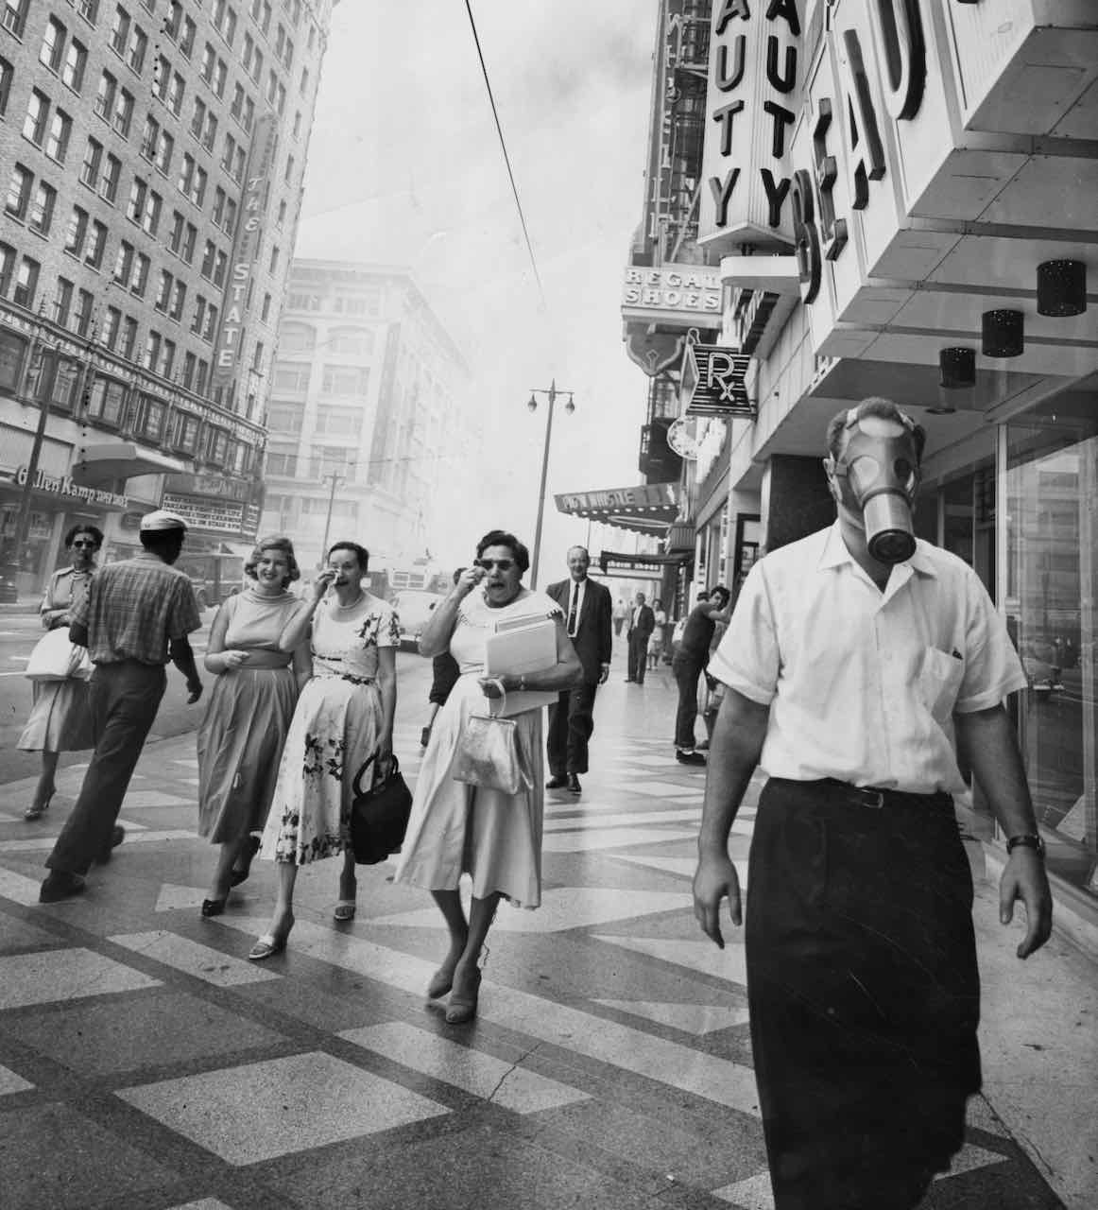
Los Angeles, 1958.
Credit: Los Angeles Public Library
Midcentury Los Angeles was a boomtown. People came for economic opportunities, Hollywood glamour, and the sunny, beautiful weather. But when thick, choking clouds threatened to tarnish its appeal, a commission was created to determine the source of the smog. Initially, the focus was on curbing emissions from a new chemical plant, but it became clear the problem was bigger than one factory. In 1947, Los Angeles County established the Air Pollution Control District (APCD), the first regulatory agency of its kind in the nation. Although inspectors ticketed factories and vehicles that emitted visible smoke, the problem continued.
L.A.’s unique geography was partly to blame. Mountains surround the city, trapping pollution, while hot air from nearby deserts pushes it downward. But understanding this was small consolation to Angelenos, especially when, in 1948, similar conditions trapped pollution in the industrial town of Donora, Pennsylvania, and killed at least 20 people. L.A. leaders felt a heightened urgency to solve the problem — and the solution came from a surprising place.
Arie Haagen-Smit, a plant chemist at Caltech, was working on distilling the essence of pineapple flavor for Dole when L.A. farmers noticed that their crops were dying at an unusual rate. Determined to find the cause, he used distilling techniques to reduce the smoggy L.A. air to a few drops of liquid and was surprised to discover large concentrations of ozone, a harmful form of oxygen. Haagen-Smit deduced that evaporated hydrocarbons in gasoline, activated by the city’s abundant sunlight, reacted with other chemicals in the air to create ozone. Having finally solved the mystery, he called his discovery “photochemical smog.”
Haagen-Smit faced immediate pushback from the petroleum and auto industries. For decades, he would fight alongside county officials and environmental groups like SOS (“Stamp Out Smog”), run by a group of Beverly Hills mothers who brought their children to meetings in gas masks. While the auto industry claimed they could do nothing, an early prototype of the catalytic converter showed promise in eliminating hydrocarbons before they could turn into ozone. Advocates didn’t back down, and in 1967, Governor Ronald Reagan created the California Air Resources Board, the first agency to require emissions standards on vehicles as a condition for sale. Los Angeles also spearheaded a lawsuit against the automakers, alleging a conspiracy to delay the development of emissions technology. Finally, carmakers agreed to stop suppressing emissions technology in a 1969 settlement with the Nixon administration.
California led the way, but political pressure to address environmental concerns was mounting nationwide, culminating in the first Earth Day in 1970. Soon after, President Nixon created the Environmental Protection Agency and passed the Clean Air Act of 1970, which set strict emissions targets for all new vehicles by 1975. Despite carmakers’ objections, they were forced to develop technology, including viable catalytic converters and unleaded gasoline, in order to comply with the regulations. These changes resulted in profound benefits on air quality and health to this day.
Today, Angelenos still live with occasional smog, but it is vastly reduced and car pollution is less than 1% of what it was when Haagen-Smit began his fight. A tale of tenacity, scientific ingenuity, and political skill, Clearing the Air: The War on Smog proves that solutions to environmental questions could transcend partisanship. The fight took decades, but Los Angeles changed the world.
American Experience Clearing the Air: The War on Smog will stream for free simultaneously with broadcast on all station-branded PBS platforms, including PBS.org and the PBS app, available on iOS, Android, Roku, Apple TV, Amazon Fire TV, Android TV, Samsung Smart TV, Chromecast and VIZIO. The film will also be available for streaming with closed captioning in English and Spanish on the American Experience website.

About the Participants
Mustafa Santiago Ali is a 24-year veteran of the EPA and founding member of the EPA Office of Environmental Justice. He currently serves as the Executive Vice President for the National Wildlife Federation.
Ann Carlson is Professor of Environmental Law and Founding Director of the Emmett Institute on Climate Change and the Environment at UCLA. Dr. Carlson is a leading scholar of climate change and air pollution law and policy and the co-editor of Lessons from the Clean Air Act: Building Durability and Flexibility into U.S. Climate and Energy Policy.
Merlin Chowkwanyun is Assistant Professor of Sociomedical Sciences at the Mailman School of Public Health, Columbia University, and author of All Health Politics is Local: Battles for Community Health in the Mid-Century United States.
Chip Jacobs is a Pasadena-based journalist and co-author, with William J. Kelly, of Smogtown: The Lung Burning History of Pollution in Los Angeles. His reporting and opinion pieces have been published and/or aired in the Los Angeles Times, Los Angeles Daily News, The New York Times, CNN, L.A. Weekly, and other outlets.
Mary Nichols is the former Chair of the California Air Resources Board, serving under Governors Brown (1975–82, 2010–18), Schwarzenegger (2007–10) and Newsom (2019–20). As an environmental lawyer for over 45 years, Nichols has played key roles in California and the nation’s progress toward healthy air and in crafting California’s internationally recognized climate action plan.
Christopher Wells is Professor of Environmental Studies and Chair of Environmental History at Macalester College. He is the author of Car Country: An Environmental History (2012) and editor of Environmental Justice in Postwar America: A Documentary Reader (2018).
About the Filmmakers

American Experience Clearing the Air: The War on Smog

Directed by  Written and Produced by  Edited by | PETER YOST  PETER YOST & EDNA ALBURQUERQUE  JON NEUBURGER

American Experience is a production of GBH Boston
Executive Producer | CAMEO GEORGE

Peter Yost (Director/Producer/Writer), the founder of Brooklyn-based Pangloss Films, has made numerous critically acclaimed documentaries. His previous film for American Experience, Nazi Town, USA, was nominated for both an Emmy and a 2025 duPont-Columbia Award. He recently co-directed (with Michael Rohatyn) the documentary Drop Dead City about the 1975 New York City fiscal crisis, which won the Library of Congress Lavine/Ken Burns Prize. Previously, Yost created seven films for the PBS science series NOVA on subjects ranging from the Hubble Space Telescope to the Dead Sea Scrolls, from drones to the microbiome. His most recent NOVA project was Crypto Decoded. Yost has also made over a dozen films for National Geographic’s Specials, traveling the world to cover topics ranging from hippos to the International Gold Trade. In 2021, he directed and produced the four-part PBS series Mysteries of Mental Illness. Among Yost’s other celebrated films are Inside North Korea, which was nominated for an Emmy for Best Long Form Documentary; The Color of Oil, an Emmy-nominated environmental film produced in conjunction with The New York Times; and Solitary Confinement, which helped lead to the reform of incarceration policies in Colorado and elsewhere. Other projects include profiles of Robert Redford and Marlon Brando. He has received support from the Sundance Institute and dozens of major foundations, been a frequent guest on radio and television and a speaker at leading universities. Yost is a graduate of Swarthmore College.
Edna Alburquerque (Writer/Producer) has worked on award-winning documentary films for 20 years, including over a decade with Pangloss Films. Specializing in bringing complex stories to life using in-depth research, her work has been nominated for an Emmy and a duPont-Columbia Award. Previously she produced American Experience’s Nazi Town, USA and Mysteries of Mental Illness, a four-part PBS series exploring the complex history of mental illness in science and society. Among numerous other films, she’s worked on projects for NOVA and National Geographic on a wide variety of topics, including cryptocurrency, the international gold trade, the use of solitary confinement in prisons, and the human microbiome. With cross-cultural roots in Mexico and the Middle East, she has long been interested in telling stories that examine the complexity and diversity of the human experience.
Cameo George (Executive Producer, American Experience) is an Emmy Award-winning producer, writer and journalist with more than 25 years of experience in documentary, broadcast television and digital content production. George has produced, developed and commissioned innovative programming at CNN, NBC News and ABC News. She was the senior producer of CNN’s groundbreaking series Black in America and Latino in America and executive producer of the eight-hour PBS documentary series 16 FOR '16: THE CONTENDERS, which was also broadcast on the BBC. George joined American Experience from ABC News, where she was head of development for long-form projects, responsible for creating a pipeline of docuseries and feature documentary films across Walt Disney Television platforms, including ABC News, Hulu, National Geographic and Disney+. She was recently named to The Root’s list of 2024’s 100 Most Influential Black Americans.

About American Experience
For nearly 40 years, American Experience has been television’s most-watched history series, bringing to life the incredible characters and epic stories that have shaped America’s past and present. American Experience documentaries have been honored with every major broadcast award, including 30 Emmy Awards, five duPont-Columbia Awards and 19 George Foster Peabody Awards. PBS’s signature history series also creates original digital content that innovates new forms of storytelling to connect our collective past with the present. Cameo George is the series executive producer. American Experience is produced for PBS by GBH Boston. Listen to the American Experience Presents podcast on Apple, Spotify, Amazon Music and more. Visit pbs.org/americanexperience and follow us on Facebook, Instagram, Threads and YouTube to learn more.

Major funding for American Experience provided by Liberty Mutual Insurance, Carlisle Companies and by the Alfred P. Sloan Foundation. Additional funding for American Experience provided by the Robert David Lion Gardiner Foundation, The American Experience Trust, the Corporation for Public Broadcasting and public television viewers.

Clearing the Air: The War on Smog is distributed internationally by PBS International.

* * *
Contacts: CaraMar Publicity
Mary Lugo 770-851-8190 lugo@negia.net
Cara White 843-881-1480 cara.white@mac.com
Abbe Harris 908-244-5516 abbe.harris@caramar.net

For further information and photos visit http://www.pbs.org/pressroom

