American Experience
Change, Not Charity: The Americans With Disabilities Act
Premieres Tuesday, March 25, 2025
on PBS and Streaming on PBS.org

Documentary Explores the Story of the Coalition of Activists and
Washington Insiders Who United to Pass One of the Most Consequential
Civil Rights Bills in the Nation’s History

(Boston, MA) — Change, Not Charity: The Americans with Disabilities Act, a new documentary directed by Jim LeBrecht (Crip Camp), written and produced by Chana Gazit, produced by Hilary Klotz Steinman and Sarah Keeling, and executive produced by Cameo George, tells the emotional and dramatic story of the decades-long push for equality and accessibility that culminated in the passage of the Americans with Disabilities Act (ADA) in 1990. While curb cuts, ramps at building entrances, and braille on elevator buttons seem commonplace today, they were once the subject of a pitched battle that landed on the steps of Congress. Told through the voices of key participants and witnesses, the film highlights the determined people who literally put their bodies on the line to achieve their goal and change the lives of all Americans. A story of courage and perseverance, the film brings to life one of the great civil rights movements in American history, where ordinary people made their voices heard and Congress responded. A testament to the power of coalition building and bipartisan compromise, the passage of the ADA is a shining example of democracy in action. Narrated by Peter Dinklage, Change, Not Charity: The Americans with Disabilities Act premieres Tuesday, March 25, 2025, 9:00-10:00 p.m. ET (check local listings) on American Experience on PBS, PBS.org and the PBS app.
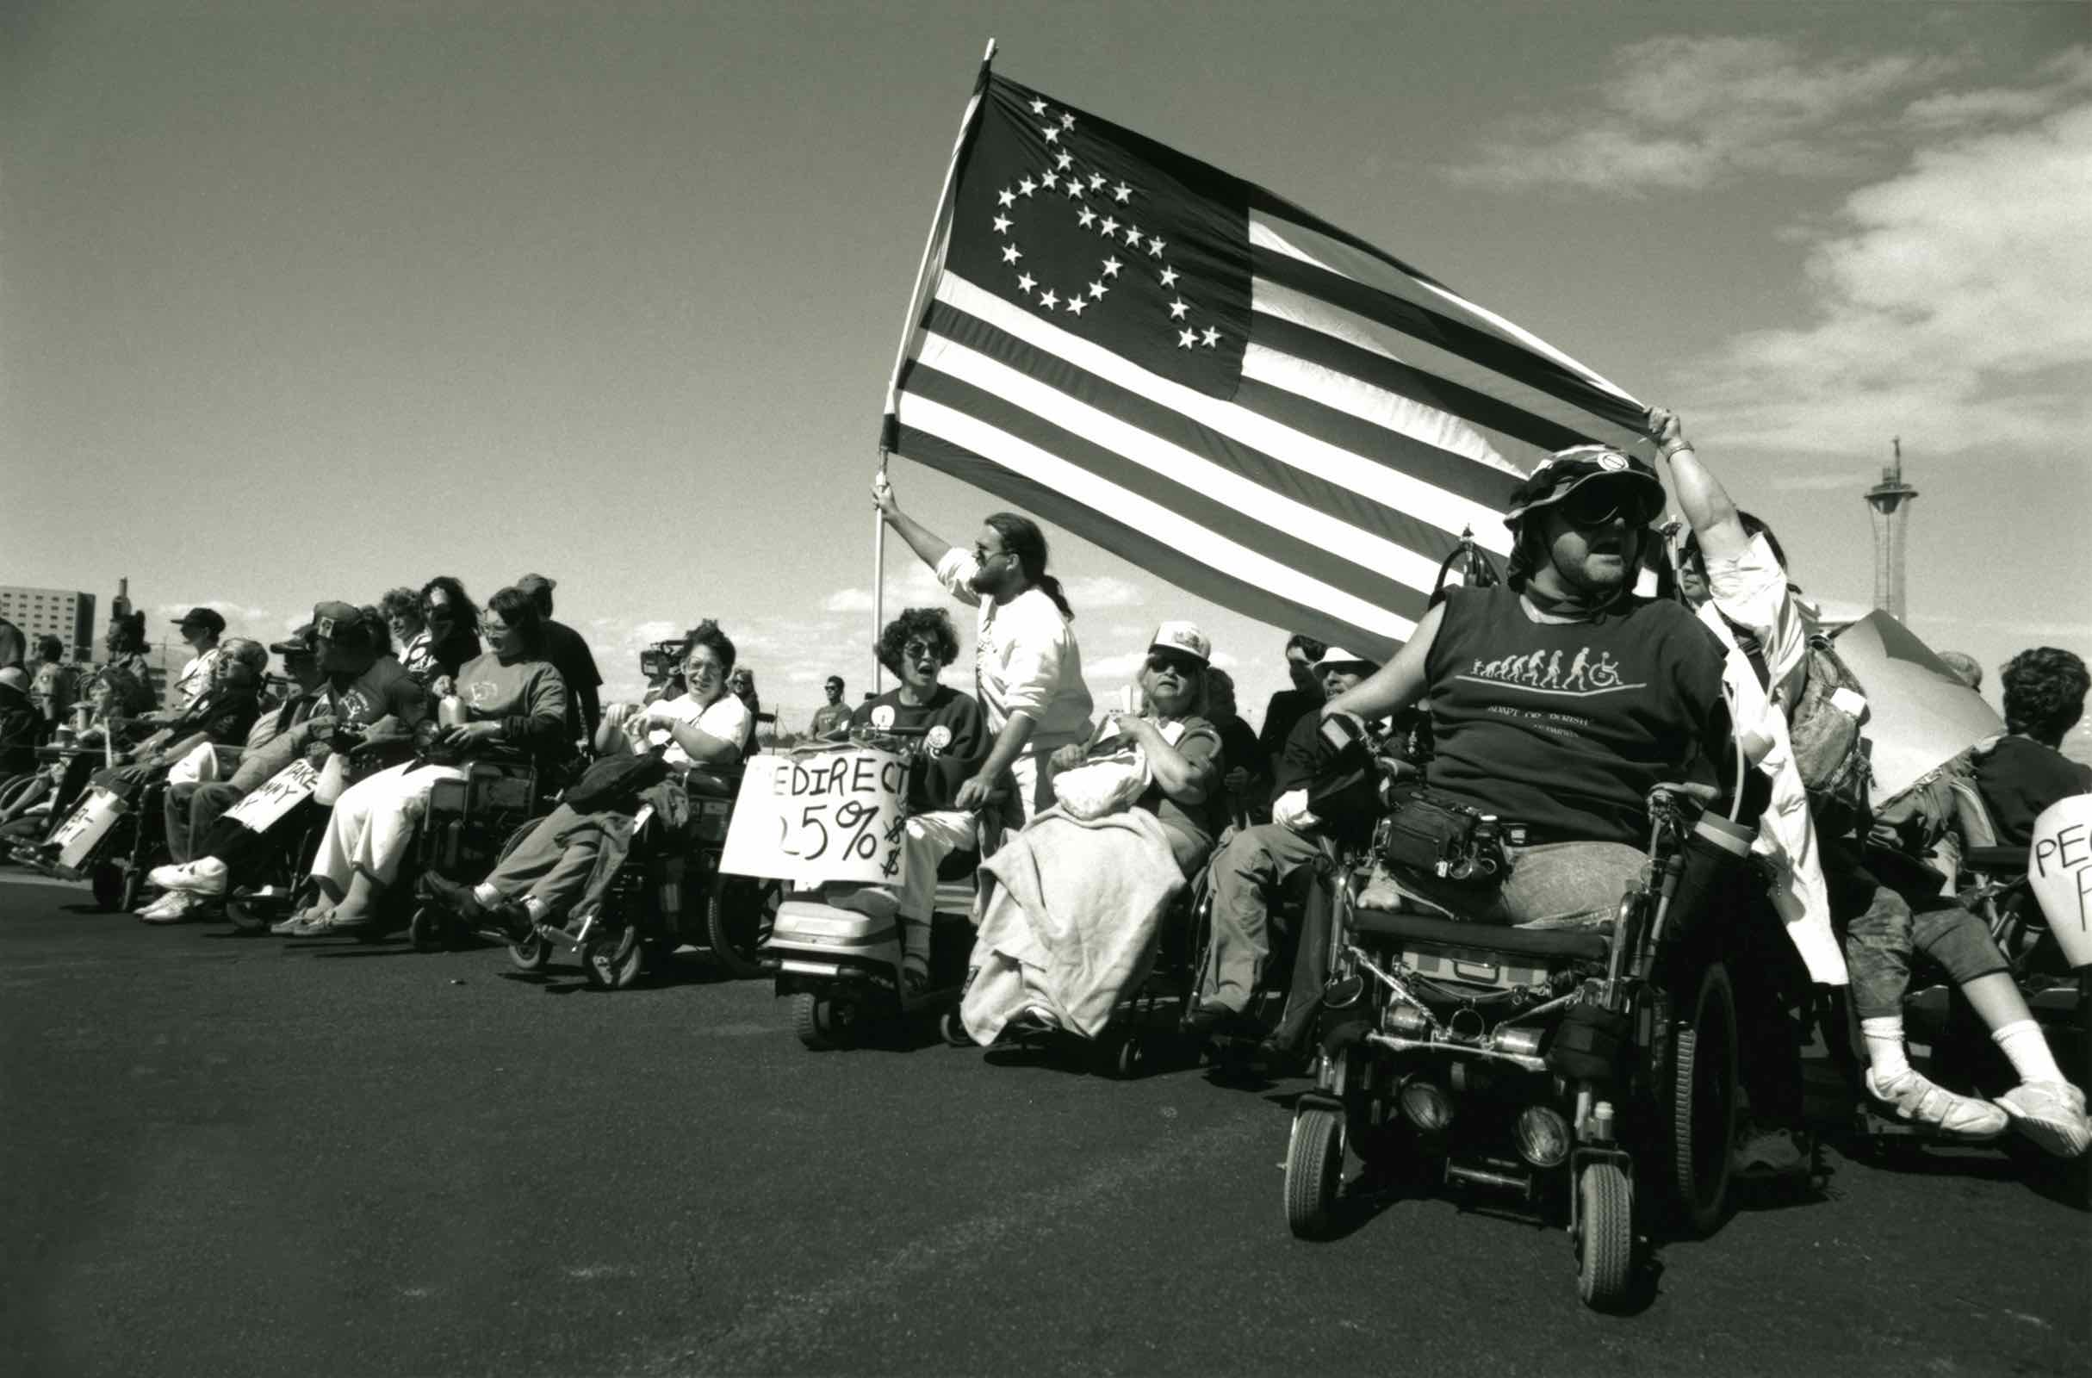
ADAPT (American Disabled for Accessible Public Transit) activists protest in Las Vegas.
Credit: Tom Olin

In the 1970s, a movement was ignited to lift disability out of the shadows, spurred by a shocking television expose of the horrific abuses at Willowbrook, a state institution for disabled children and adults in Staten Island. At the time, one in four Americans lived with a disability. A fraction held jobs and most lived in poverty. In California, a small group of disabled college students and community members formed the Center for Independent Living (CIL) in Berkeley. Rejecting the model of charity and pity, the Independent Living Movement charted a new course to empower people with disabilities to lead independent lives.

On April 5, 1977, demonstrations took place at federal offices across the country to fight for rights promised — but never implemented — in Section 504 of the 1973 Rehabilitation Act. The San Francisco protest lasted 28 days and ended victoriously with signed regulations prohibiting discrimination in federally funded institutions and programs. Empowered by the victory, a new organization grew out of CIL: the Disability Rights Education & Defense Fund (DREDF). Motivated to heighten their influence in shaping disability rights legislation and policy, DREDF opened an office in Washington, DC, in 1983. They took the battle to Washington to mobilize Congress and the White House to enact comprehensive legislation enshrining civil rights for people with disabilities in all public and private areas of American life.

While DREDF plotted the inside game of Washington politics, activists took to the streets to demand action. American Disabled for Accessible Public Transit (ADAPT) mobilized members to chain their wheelchairs to buses and form blockades at bus depots to draw attention to the lack of accessible transportation nationwide.

On March 6, 1988, students at Washington’s Gallaudet University, the premiere university for people who are deaf, launched a massive — and successful — protest to elect the first deaf president in its 124-year history.

In the wake of the protest, Congress finally proposed the Americans with Disabilities Act in April 1988. Derisively nicknamed “the bankruptcy bill” for the immense cost required to make the country accessible, the bipartisan effort to pass the bill failed. But in January 1989, newly elected president George H.W. Bush, whose favorite uncle was a polio survivor, signaled his support for disability rights, and the bill received a lifeline.

Still, scores of lobbyists tried to derail the bill and progress stalled. Frustrated, ADAPT summoned protesters to Washington, and on March 12, 1990, over 700 people marched from the White House to the Capitol. At the base of the Capitol, activists — most in wheelchairs — dropped to the ground and dragged themselves to the top of the 83 steps, forever remembered as “The Capitol Crawl.” The next day, protesters occupied the Capitol Rotunda, resulting in 104 arrests. The pressure from the protests and news coverage finally prompted Congress to pass the legislation, and on July 26, 1990, nearly 3000 people watched President Bush sign the ADA into law on the White House lawn.

Since its passing, the ADA has been responsible for transformational changes in the built environment — including curb cuts and ramps, wheelchair-accessible public transportation, braille signage in shared public spaces — and led to the widespread use of closed captioning, making video content available to those who are deaf and hard of hearing. Yet, there is still much to be achieved. Many Americans with disabilities remain unemployed and live in poverty. “I'm grateful for the ADA,” says activist Anita Cameron in the film. “I pushed for it. I fought for it. I went to jail for it. But the ADA is the floor — it's not the ceiling.”

American Experience Change, Not Charity: The Americans with Disabilities Act will stream for free simultaneously with broadcast on all station-branded PBS platforms, including PBS.org and the PBS app, available on iOS, Android, Roku, Apple TV, Amazon Fire TV, Android TV, Samsung Smart TV, Chromecast and VIZIO. The show will be broadcast with open captions and audio description.
Viewers who stream on the American Experience website, PBS.org and on the PBS app will have access to four versions of the film: a version with closed captions, a version interpreted with American Sign Language and open captions, a version with extended audio description, and a version with Spanish language closed captions.

About the Activists, Advocates and Allies

Representative Steve Bartlett, a first-term Republican from Texas, worked with Representative Steny Hoyer, a Democrat from Maryland, to helm the bipartisan effort to convince House members to vote for the ADA bill. He served in Congress from 1983 to 1991.

Dennis Billups is a blind disability rights and gentrification activist. In 1977, he participated in the 504 occupation of the San Francisco Federal Building.

Mary Lou Breslin has been a disability rights law and policy advocate and analyst for over 35 years. In 1979, she co-founded the Disability Rights Education and Defense Fund (DREDF), a leading national civil rights law and policy center. She currently serves as Senior Policy Advisor with DREDF, focusing on the organization’s healthcare research initiatives.

Anita Cameron is a disability justice activist who has been involved in social change activism and community organizing for over 40 years. Cameron participated in the Capitol Crawl and was one of 104 people arrested in the takeover of the Capitol Rotunda in 1990.

Lawrence Carter-Long is Director of Engagement for the ReelAbilities Film Festival. He formerly served as Co-Director of DisArt in Oakland and Director of Communications for the Disability Rights Education and Defense Fund (DREDF). In 2012, 2021, and 2024, Lawrence curated and cohosted “The Projected Image: A History of Disability in Film” on Turner Classic Movies.

Justin Dart (1930-2002) known as the “father” of the ADA, was a disability rights activist who became a wheelchair user after contracting polio at age 18. A successful business executive, Dart was appointed by President Reagan to be vice chair of the National Council on Disability. Dart and his wife traveled to all 50 states at their own expense to collect stories of hardships faced by people with disabilities. They delivered these stories to Washington, DC, and began working towards legislation that became known as the ADA.
Judith “Judy” Heumann (1947-2023) was an internationally recognized disability rights activist widely regarded as “the mother” of the Disability Rights Movement. She was a leader in the historic Section 504 Sit-In of 1977 and instrumental in developing and implementing other disability rights legislation.
Senator Tom Harkin, a young Democrat from Iowa, was tapped by Senator Ted Kennedy to craft legislation to protect the civil rights of Americans with physical and mental disabilities. The pair were the lead sponsors of the bill in the Senate, and the passage of the ADA in 1990 became Harkin’s signature legislative achievement. Harkin knew firsthand about the challenges facing people with disabilities from his late brother Frank, who was deaf from an early age. Harkin retired from the U.S. Senate in January 2015.

Representative Steny Hoyer was one of the principal sponsors of the ADA bill. A Democrat, Hoyer worked with Republican Steve Bartlett to helm the bipartisan effort to convince House members to vote for the bill. Hoyer continues to represent Maryland’s 5th Congressional District today.

Cyndi Jones was six years old when she became a March of Dimes Poster Child, a campaign that used her image to raise money for the organization. The experience changed her life, making her a lifelong activist for persons with disabilities.

I. King Jordan became the first deaf president of Gallaudet University, the world’s only university with all programs and services designed specifically for deaf and hard-of-hearing students. His appointment in 1988 followed widespread protests that successfully overturned the Board of Trustees’ appointment of a hearing person to the presidency.

Arlene Mayerson is Directing Attorney Emeritus, Disability Rights Education and Defense Fund (DREDF). Before her retirement in 2020, she served as Directing Attorney since 1981. One of the nation’s leading experts in disability rights law, she has been a key advisor to both Congress and the disability community for over three decades on major disability rights legislation.

Ralph Neas is a civil rights attorney and former Executive Director of the Leadership Conference on Civil and Human Rights. During his 15-year tenure at the Leadership Conference, he directed two dozen national campaigns that protected and strengthened the nation’s civil rights laws, including the 1982 Voting Rights Act Extension, the Fair Housing Act Amendments of 1988, and the 1990 Americans with Disabilities Act.

Carolyn Osolinik was chief counsel to Senator Ted Kennedy on the Senate Judiciary Committee and the Senator’s principal advisor on all major civil rights legislation considered by the Senate from 1985 to 1990.

John Wodatch is a disability rights attorney specializing in the Americans with Disabilities Act and the UN Convention on the Rights of Persons with Disabilities. He served for 42 years in the federal government, where he authored the government’s comprehensive disability rights regulations and created and led the Department of Justice’s office in charge of enforcing the ADA.

Patrisha “Pat” Wright is a disability rights activist and co-founder of the Disability Rights Education and Defense Fund (DREDF), where she served as its director of government affairs from 1980 to 2005. Her leadership during the passage of the Americans with Disabilities Act (ADA) earned her the nickname “The General,” and she became widely regarded as a formidable legislative and policy strategist at the forefront of the shift in U.S. disability policy from charity to civil rights.

About the Filmmakers

American Experience
Change, Not Charity: The Americans with Disabilities Act

Directed by  Written and Produced by  Produced by  Narrated by  Edited by | JIM LEBRECHT  CHANA GAZIT  HILARY KLOTZ STEINMAN  SARAH KEELING  PETER DINKLAGE  SANDRA CHRISTIE, ACE
American Experience is a production of GBH Boston
Executive Producer | CAMEO GEORGE

Jim LeBrecht (Director) has over 45 years of experience as a film and theater sound designer and mixer, filmmaker, podcast host, author, and disability rights activist. He co-directed and co-produced, with Nicole Newnham, the 2021 Oscar-nominated documentary, Crip Camp, which received the 2020 Sundance Film Festival Audience Award for feature-length documentary, the 2021 Independent Spirit Award for Best Feature Documentary and a 2021 Peabody Award. LeBrecht co-founded two organizations that support creatives with disabilities in the entertainment industry: FWD-Doc, an organization that supports documentary filmmakers, and The 1in4 Coalition, an intersectional coalition of disabled creatives working in Hollywood focused on long-term institutional shifts to increase employment and authentic representation of disabled people. LeBrecht is a member of the Disability Futures Fellowship, an initiative of the Ford Foundation, and The Andrew W. Mellon Foundation.

Chana Gazit (Writer, Producer) is an award-winning producer, director and writer whose work has been honored with three Emmy Awards and multiple Emmy nominations. Her work has been recognized by the Alfred I. duPont-Columbia Journalism Awards, the Peabody Awards, the Writers Guild Awards, and the Sundance Film Festival, among others. Career highlights include two acclaimed public television series: a four-part biography of Franklin Roosevelt and a four-part biography of Lyndon Johnson. She produced, directed, and wrote eight previous films for American Experience: Chicago ‘68, Surviving the Dust Bowl, Meltdown at Three Mile Island, Fatal Flood, The Pill, Test Tube Babies, The Forgotten Plague, and The Codebreaker. Other films featured include Healing and the Mind with Bill Moyers, Slavery & the Making of America, Destination America, and This Emotional Life. She also wrote two prominent television specials: All the President’s Men Revisited, a chronicle of the Watergate scandal, and Lincoln @ Gettysburg, an exploration of the most famous presidential speech ever written. More recently, she produced an in-depth investigation of the opioid epidemic for the series America Divided, followed by her work as a story producer on Soundtracks, a look at the social movements of the last half-century through the lens of music. In 2019, she completed an expose on the impact of captivity on the killer whales at SeaWorld. Next, she released an independent feature on an all-male ballet company, Ballerina Boys. And most recently, she executive produced a six-part series on Big Pharma, for which she also directed two episodes on the Sackler family and the opioid crisis.

Hilary Klotz Steinman (Producer) is an Emmy Award-winning independent documentary film producer and director and has been producing historical and vérité documentary films for over 25 years, with a focus on women’s history and the impact of technology on American lives. Her work has been featured on PBS, NBC, MSNBC, CNBC, at the New York Historical Society and in theaters. Hilary recently produced and directed the independent feature documentary, Loud Enough - Surviving Justice. In addition to producing the independent feature documentaries, Children of the Inquisition, Death By Design, and Going Blind, she has also collaborated with Chana Gazit to produce four documentaries for American Experience: Change, Not Charity: The Americans with Disabilities Act, The Codebreaker, Test Tube Babies (producer and director) and the Emmy Award-winning film The Pill. Steinman was honored with a Christopher Award and an Emmy nomination for her work on the PBS docuseries Slavery and the Making of America, and an Emmy nomination for her research on the Bill Moyers PBS docuseries Becoming American: The Chinese Experience. Hilary got her start working on American Experience documentaries as an Associate Producer on Eleanor Roosevelt and as the Footage Archivist for seven episodes of the award-winning American Experience docuseries New York: A Documentary Film.

Sarah Keeling (Producer) is a producer and documentary filmmaker whose work has been featured on HBO, ABC/Hulu, Showtime, and PBS and has screened at Metrograph and the Maysles Documentary Center. She has produced two episodes for the six-part Showtime documentary series, Big Pharma, co-directed by Chana Gazit and Robert Kenner. Keeling has worked as the archival producer and associate producer on the Emmy-nominated documentary GameStopped, Baby God, Ballerina Boys, and the Emmy-nominated weekly political documentary series, The Circus. Her credits include associate producing two American Experience films: The Codebreaker and The Busing Battleground. She co-directed the award-winning documentary short Into My Life (distributed by POV) and contributed research to PBS’s documentary series, Finding Your Roots with Henry Louis Gates Jr.

Cameo George (Executive Producer, American Experience) is an Emmy Award-winning producer, writer and journalist with more than 20 years of experience in documentary, broadcast television and digital content production. George has produced, developed and commissioned innovative programming at CNN, NBC News and ABC News. She was the senior producer of CNN’s groundbreaking series Black in America and Latino in America and executive producer of the eight-hour PBS documentary series 16 FOR '16: THE CONTENDERS, which was also broadcast on the BBC. George joined American Experience from ABC News, where she was head of development for long-form projects, responsible for creating a pipeline of docuseries and feature documentary films across Walt Disney Television platforms, including ABC News, Hulu, National Geographic and Disney+. She was recently named to The Root’s list of 2024’s 100 Most Influential Black Americans.

About American Experience

For over 37 years, American Experience has been television’s most-watched history series, bringing to life the incredible characters and epic stories that have shaped America’s past and present. American Experience documentaries have been honored with every major broadcast award, including 30 Emmy Awards, five duPont-Columbia Awards and 19 George Foster Peabody Awards. PBS’s signature history series also creates original digital content that innovates new forms of storytelling to connect our collective past with the present. Cameo George is the series executive producer. American Experience is produced for PBS by GBH Boston. Listen to the American Experience Presents podcast on Apple, Spotify, Amazon Music and more. Visit pbs.org/americanexperience and follow us on Facebook, Instagram, Threads and YouTube to learn more.

Major funding for American Experience provided by Liberty Mutual Insurance, Carlisle Companies and by the Alfred P. Sloan Foundation. Funding for Change, Not Charity: The Americans with Disabilities Act provided by the GBH Voices and Equity Fund. Additional funding for American Experience provided by the Robert David Lion Gardiner Foundation, The American Experience Trust, the Corporation for Public Broadcasting and public television viewers.

Change, Not Charity: The Americans with Disabilities Act is distributed internationally by PBS International.

* * *
Contacts: CaraMar Publicity
Mary Lugo 770-851-8190 lugo@negia.net
Cara White 843-881-1480 cara.white@mac.com
Abbe Harris 908-244-5516 abbe.harris@caramar.net

For further information and photos visit http://www.pbs.org/pressroom

