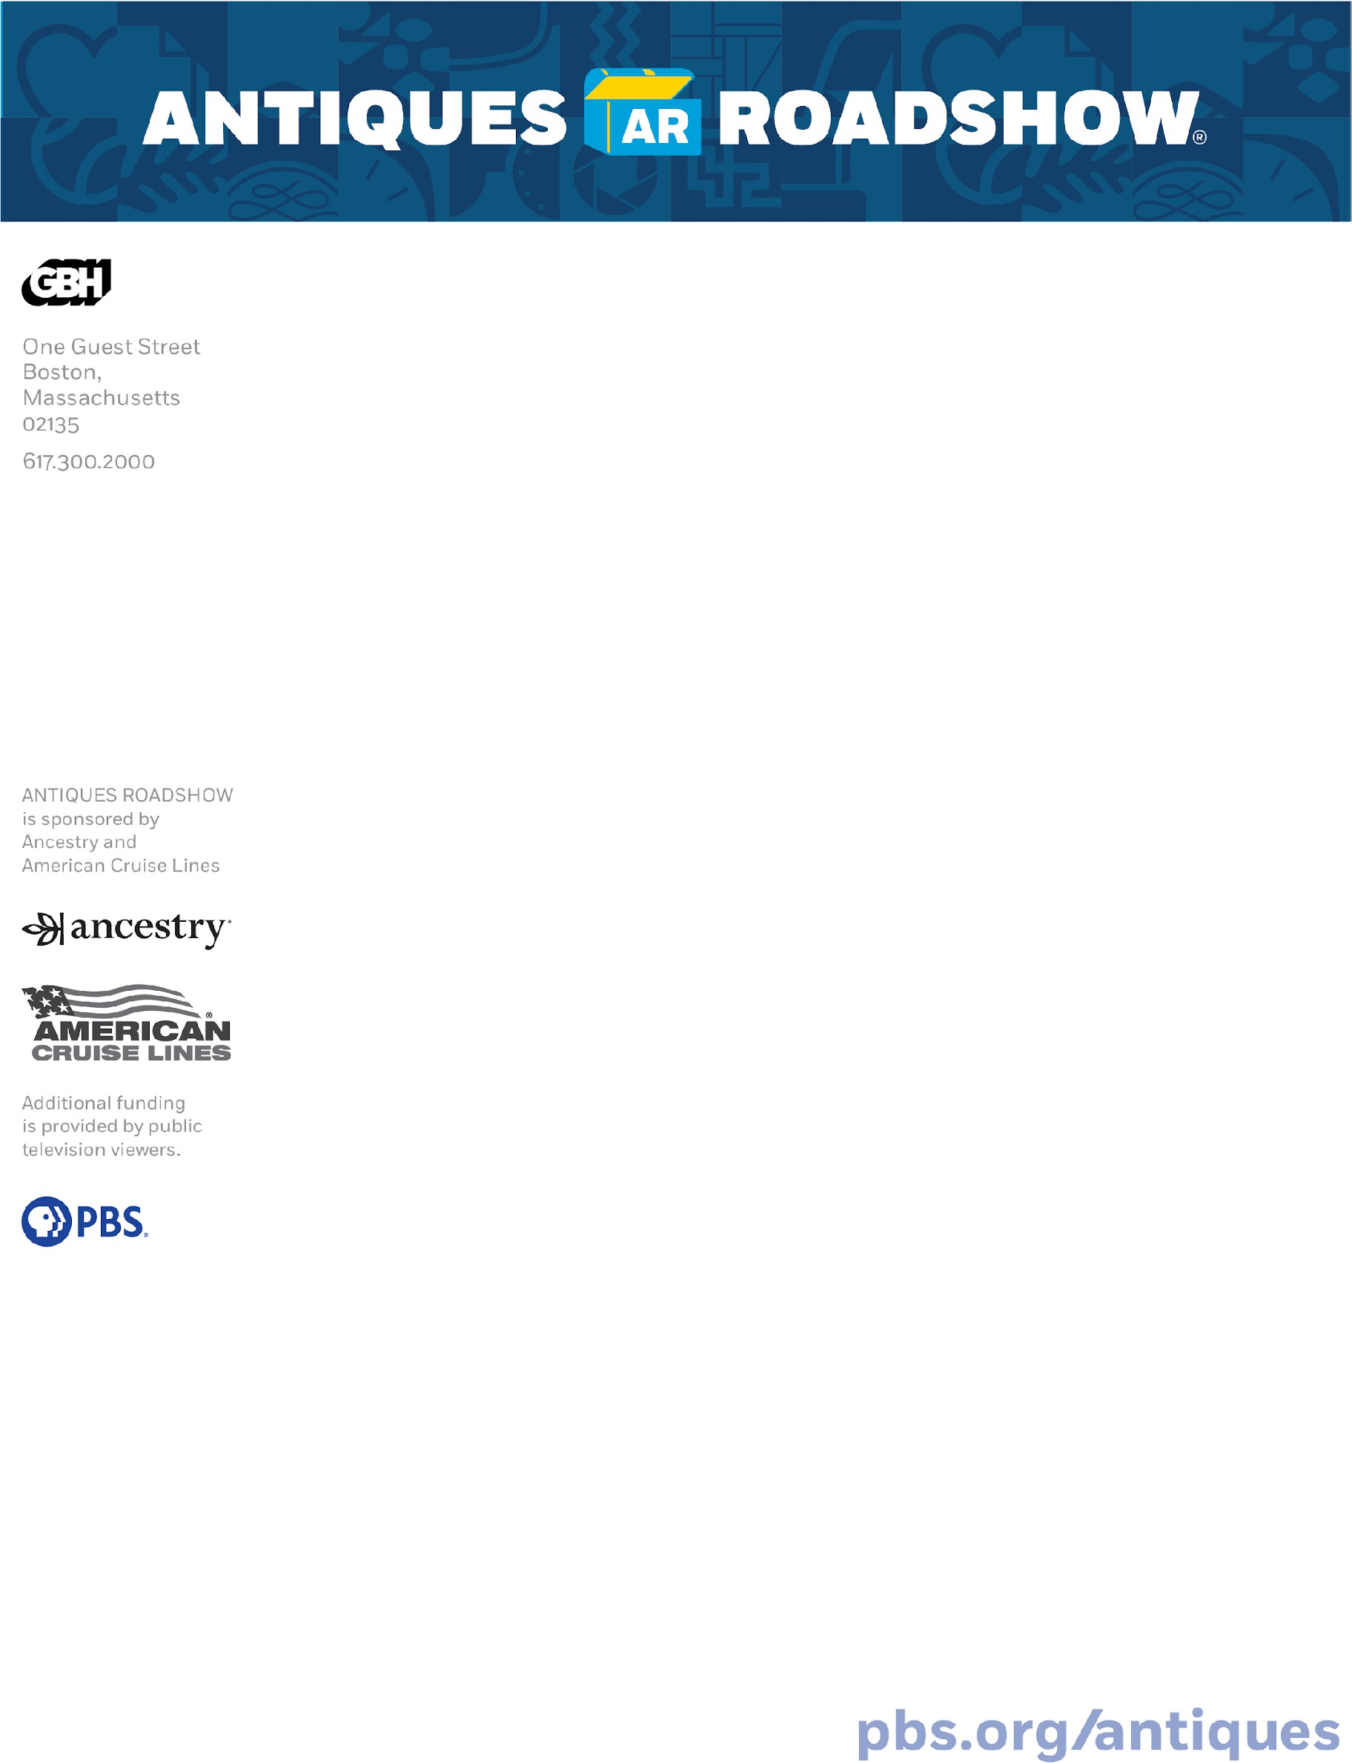

ANTIQUES ROADSHOW SETS OUT IN SEARCH OF HIDDEN TREASURES, UNDISCOVERED HISTORY, AND RIVETING STORIES FROM FAMILIES ACROSS AMERICA!

PBS’s Most-watched Ongoing Series Announces its 2026 Production Tour to Film All-new Season 31

Fans can enter to win tickets to visit ROADSHOW on tour and have their items appraised!

BOSTON, MA, January 12, 2026 — America’s favorite treasure hunt ANTIQUES ROADSHOW is going back on the road in 2026 to film for an all-new season of must-watch episodes — and people from across the country will be the stars of the show! Do you have this pop-culture phenomenon’s next big find?
“Nothing can stop America’s love of life-changing discoveries and authentic guest reactions,” said executive producer Marsha Bemko. “We’re excited to create a new season full of surprising items with jaw-dropping values, and are grateful for the support of our fans and sponsors who help ROADSHOW travel the country and bring TV magic to viewers!”
ANTIQUES ROADSHOW 2026 Production Tour Dates and Cities:
- Tuesday, May 19 — Tucson, AZ
- Monday, June 1 — Indianapolis, IN
- Wednesday, June 17 — Mumford, NY (Rochester area)
ROADSHOW will reveal the distinctive and historic venues for each event in the coming weeks.
At each appraisal event, guests will receive free verbal evaluations of their antiques, art, and collectibles by experts from the country’s leading auction houses and independent dealers. Each ticketed guest is invited to bring two items for appraisal.

Three one-hour episodes of ROADSHOW per city will be created from each 2026 event. The 23-time Emmy® Award-nominated production’s 31st broadcast season will air on PBS in 2027.

Admission to ANTIQUES ROADSHOW is free but tickets are required and must be obtained in advance. Fans can enter the 2026 ANTIQUES ROADSHOW Sweepstakes for a chance to win one pair of free tickets per



household. To enter and to see complete entry rules, go to pbs.org/roadshowtickets. The 2026 ANTIQUES ROADSHOW Sweepstakes entry period begins Monday, January 12 and ends on Monday, April 6, 2026, at 11:59PM PT. Information about ANTIQUES ROADSHOW and the 2026 Tour is available by calling toll-free 888-762-3749.

A small number of free tickets will also be available on social media to fans who enter on Instagram. Social media entries will be accepted beginning January 12, with an entry deadline of Thursday, February 12, 2026, at 11:59PM PT.

For both sweepstakes, no purchase is necessary, restrictions apply, you must be 18 or age of majority. Tickets have no cash value and may not be sold or transferred. Odds of winning depend on number of eligible entries received. For the ANTIQUES ROADSHOW Sweepstakes you must be a resident of U.S. or Canada (excluding Quebec). All Social Media Sweepstakes entrants must be US residents only. Void where prohibited. Sponsored by WGBH Educational Foundation, One Guest Street, Boston, MA 02135.
Complete rules can be found at the 2026 Tour Complete Rules page.
To see FAQs about ANTIQUES ROADSHOW events, go to: pbs.org/wgbh/roadshow/tour-faq/.
Produced by GBH, ANTIQUES ROADSHOW full episodes are seen by around
5.5 million weekly viewers on TV, streaming, online, and social media. ROADSHOW airs Mondays at 8/7c PM on PBS.

-###-

MORE INFORMATION
About ANTIQUES ROADSHOW
Part adventure, part history lesson, part treasure hunt, 23-time Emmy® Award nominated ANTIQUES ROADSHOW began its 30th broadcast season in 2026 and is the most-watched ongoing primetime PBS series. The series is produced by GBH for PBS under license from the BBC. The executive producer is Marsha Bemko. ANTIQUES ROADSHOW is sponsored by Ancestry and American Cruise Lines. Additional funding is provided by public television viewers. ANTIQUES ROADSHOW press materials, including streaming video and downloadable photos, are available at pbs.org/pressroom. For more

ANTIQUES ROADSHOW — including streaming episodes, searchable archive, web-exclusive video, in- depth articles, owner interviews and more — visit pbs.org/antiques. You can also find ROADSHOW on Facebook, YouTube, Instagram, Threads, X and TikTok.

About GBH
GBH is the leading multiplatform creator for public media in America. As the largest producer of content for PBS and partner to NPR and PRX, GBH delivers compelling experiences, stories and information to audiences wherever they are. GBH produces digital and broadcast programming that engages, illuminates and inspires, through drama and science, history, arts, culture and journalism. It is the creator of such signature programs as MASTERPIECE, ANTIQUES ROADSHOW, FRONTLINE, NOVA, AMERICAN
EXPERIENCE, Arthur and Molly of Denali and a catalog of streaming series, podcasts and on-demand video. GBH’s television channels include GBH 2, GBH 44, GBH Kids
and national services WORLD and Create. With studios and a newsroom headquartered in Boston, GBH reaches across New England with GBH 89.7, Boston’s Local NPR; CRB Classical 99.5; and CAI, the Cape and Islands NPR station. Dedicated to making media accessible to and inclusive of our diverse culture, GBH is a pioneer in delivering media to those who are deaf, hard of hearing, blind and visually impaired. GBH creates curriculum-based digital content for educators nationwide with PBS LearningMedia and has been recognized with hundreds of the nation’s premier broadcast, digital and journalism awards. Find more information at gbh.org.

About PBS
PBS, with more than 330 member stations, offers all Americans the opportunity to explore new ideas and new worlds through television and digital content. Each month, PBS reaches over 36 million adults on linear primetime television, more than 16 million users on PBS-owned streaming platforms, 53 million viewers on YouTube, and 60 million people view PBS content on social media, inviting them to experience the worlds of science, history, nature, and public affairs and to take front-row seats to world-class drama and performances. PBS’s broad array of programs has been consistently honored by the industry’s most coveted award competitions. Teachers of children from pre-K through 12th grade turn to PBS LearningMedia for digital content and services that help bring classroom lessons to life. As the number one educational media brand, PBS
KIDS helps children 2-8 build critical skills, enabling them to find success in school and life. Delivered through member stations, PBS KIDS offers high-quality content on TV — including a PBS KIDS channel — and streaming free on pbskids.org and the PBS KIDS Video app, games on the PBS KIDS Games app, and in communities across America. More information about PBS is available at PBS.org, one of the leading dot-org websites on the internet, Facebook, Instagram, or through ourapps for mobile and connected
devices. Specific program information and updates for press are available at pbs.org/pressroom or by following PBS Communications on X.

ANTIQUES ROADSHOW Press Contacts
Demee Gambulos, demee_gambulos@wgbh.org Abby Blackmore, abby_blackmore@wgbh.org

