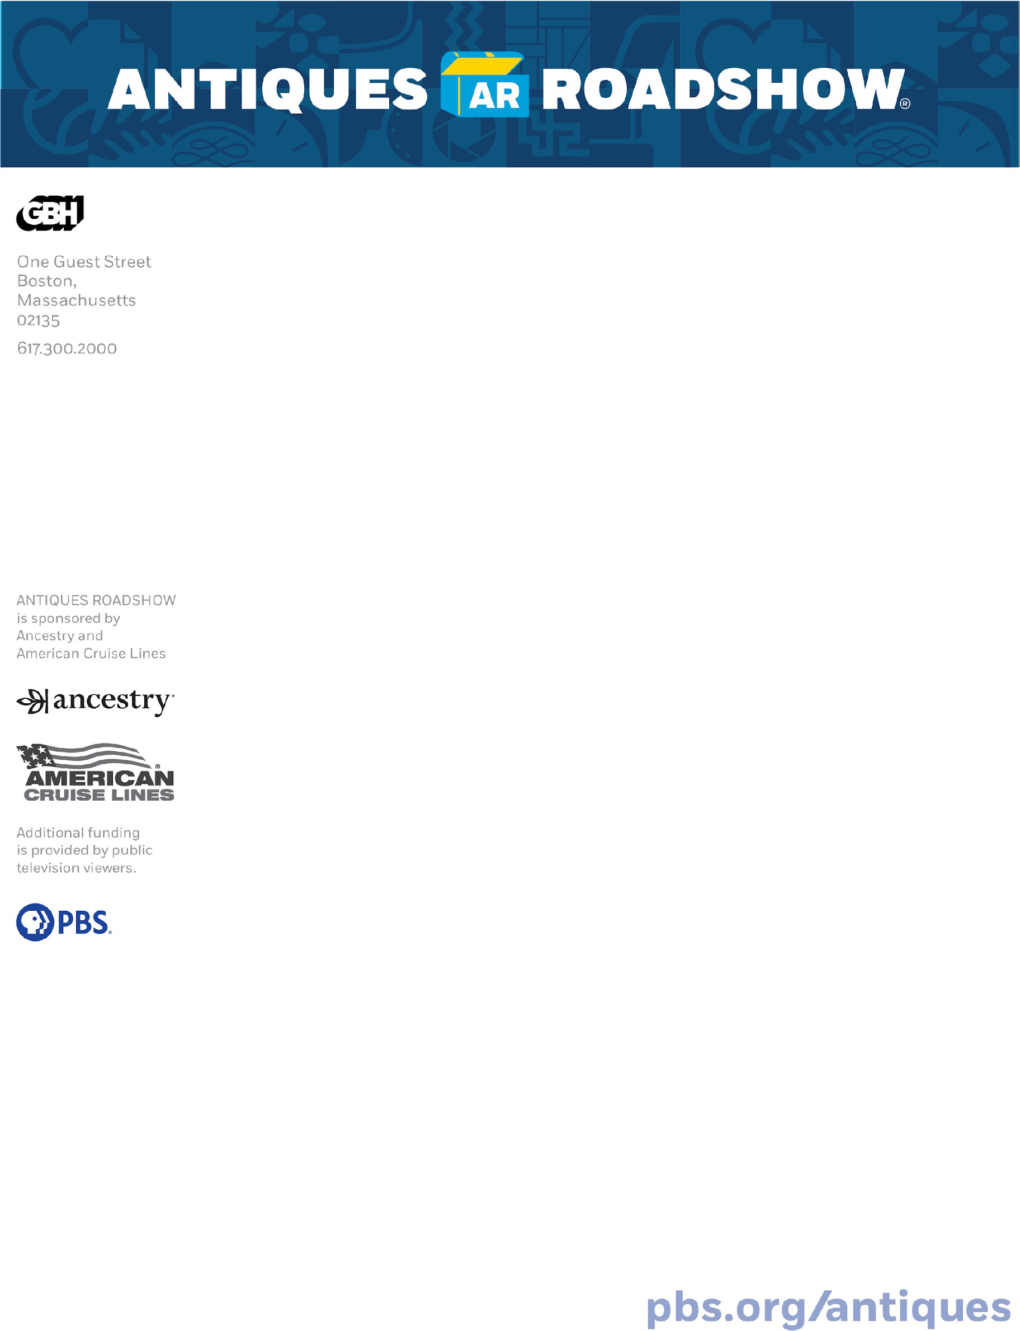

ANTIQUES ROADSHOW IS BACK, CELEBRATING 30 YEARS OF EYE-POPPING ITEMS, AUTHENTIC GUEST REACTIONS, AND LIFE-CHANGING VALUES WITH AN ALL-NEW SEASON
IN SEARCH OF AMERICA’S HIDDEN TREASURES!

The pop-culture phenomenon hit series reveals a season-topping treasure that reaches $500,000!

Season 30 premieres Monday, Jan. 5, at 8/7c PM on PBS

BOSTON, MA, December 11, 2025 — With newly discovered treasures from across the country to a look back at historic items with roots in the American Revolution, ANTIQUES ROADSHOW’s celebratory Season 30 is full of wow-worthy TV! All-new ROADSHOW premieres Monday, January 5, 2026, at 8/7c PM with a six-figure appraisal in Salt Lake City, UT.
This season, PBS’s most-watched ongoing series travels to five cities, stopping at distinctive venues including Red Butte Garden & Arboretum in Salt Lake City, UT; Georgia State Railroad Museum in Savannah, GA; Coastal Maine Botanical Gardens in Boothbay, ME; Castle Farms in Charlevoix, MI; and Grant’s Farm in St. Louis, MO.
“I’m often asked how a TV show stays on top over 30 years,” said ANTIQUES ROADSHOW executive producer Marsha Bemko. “The combination of personal stories, serendipitous finds, a little bit of history lesson, and those jaw-dropping values make up the secret sauce that keeps ROADSHOW irresistible to fans!”
A preview of standout Season 30 discoveries includes:

- In Salt Lake City, UT, a 1937 copy of The Hobbit was brought to ROADSHOW where a typo on the rear flap of the dust cover revealed it to be a true first printing of the UK first edition and yielded a whopping six-figure
value! (Episodes from Salt Lake City air Jan. 5, 12, and 19)

- In Savannah, GA, ROADSHOW discovered the year’s highest value find with a 1992 Olga de Amaral Lost Image VII tapestry. Inherited by the guest from his mother, a collector of works by women artists, this season-topping treasure is valued at up to $500,000! (Episodes from Savannah air Jan. 26, Feb. 2 and 9)

- In Boothbay, ME, a poignant piece of history was uncovered in a 1962 letter written by Dr. Martin Luther King, Jr. to the ROADSHOW guest’s father-in-law, a Unitarian minister who actively supported the Civil Rights efforts of the time.



The letter holds extraordinary value in both its rarity and message. (Episodes from Boothbay air Feb. 16, 23, and Mar. 23)

- In Charlevoix, MI, one ROADSHOW guest, originally in search of a grandfather clock, discovered a John Bailey dwarf clock, ca. 1800 in an online market and purchased it for $300. Even with some prior restoration the timepiece was revealed to be a rare treasure with a stunning value of $75,000! (Episodes from Charlevoix air Mar. 30, Apr. 6 and 13)
- In St. Louis, MO, a playful piece of Hollywood history made an appearance at ROADSHOW with a guest’s $10 estate-sale-purchased backgammon set, ca. 1970 associated with comedy legend Lucille Ball and purportedly donated by the star for a charity auction. (Episodes from St. Louis air Apr. 27, May 4 and 11).

The milestone 25-episode season includes a new slate of fan-favorite Vintage episodes where ROADSHOW looks back at memorable finds from 15 years ago to discover what they are worth today and how the market and their values have changed. Plus, an all-new special in honor of the country’s semiquincentennial in 2026. Celebrating 250 Years of Americana spotlights 30 years of ROADSHOW discoveries encompassing some of the best American art, artifacts, crafts, and collectibles spanning the country’s entire history.

Airing Mondays at 8/7c PM, 23-time Emmy® Award-nominated ANTIQUES ROADSHOW is produced by GBH for PBS and is seen by around 5.5 million viewers each week. New ROADSHOW episodes are available to stream on YouTube,
the ANTIQUES ROADSHOW website and the PBS app.

-###-

A press screener of “Red Butte Garden & Arboretum, Hour 1” is available to view on PBS Pressroom HERE.
A preview appraisal from the Season 30 Premiere is available to watch HERE.
Hi-res photos and interviews with ANTIQUES ROADSHOW producers and appraisers are available upon request.

MORE INFORMATION
About ANTIQUES ROADSHOW
Part adventure, part history lesson, part treasure hunt, 23-time Emmy® Award nominated ANTIQUES ROADSHOW begins its 30th broadcast season in 2026 and is the most-watched ongoing primetime PBS series. The series is produced by GBH for PBS under license from the BBC. The executive producer is Marsha Bemko. ANTIQUES ROADSHOW is sponsored by Ancestry and American Cruise Lines. Additional funding is provided by public television viewers. ANTIQUES ROADSHOW press materials, including

streaming video and downloadable photos, are available at pbs.org/pressroom. For more ANTIQUES ROADSHOW — including streaming episodes, searchable archive, web-exclusive video, in- depth articles, owner interviews and more — visit pbs.org/antiques. You can also find ROADSHOW on Facebook, YouTube, Instagram, Threads, X and TikTok.

About GBH
GBH is the leading multiplatform creator for public media in America. As the largest producer of content for PBS and partner to NPR and PRX, GBH delivers compelling experiences, stories and information to audiences wherever they are. GBH produces digital and broadcast programming that engages, illuminates and inspires, through drama and science, history, arts, culture and journalism. It is the creator of such signature programs as MASTERPIECE, ANTIQUES ROADSHOW, FRONTLINE, NOVA, AMERICAN
EXPERIENCE, Arthur and Molly of Denali, as well as WORLD Channel and a catalog of streaming series, podcasts and on-demand video. With studios and a newsroom headquartered in Boston, GBH reaches across New England with GBH 89.7, Boston’s Local NPR®; CRB Classical 99.5; and CAI, the Cape and Islands NPR® station. Dedicated to making media accessible to and inclusive of our diverse culture, GBH is a pioneer in delivering media to those who are deaf, hard of hearing, blind and visually impaired.
GBH creates curriculum-based digital content for educators nationwide with PBS LearningMedia and has been recognized with hundreds of the nation’s premier broadcast, digital and journalism awards. Find more information at wgbh.org.

About PBS
PBS, with more than 330 member stations, offers all Americans the opportunity to explore new ideas and new worlds through television and digital content. Each month, PBS reaches over 36 million adults on linear primetime television, more than 16 million users on PBS-owned streaming platforms, 53 million viewers on YouTube, and 60 million people view PBS content on social media, inviting them to experience the worlds of science, history, nature, and public affairs and to take front-row seats to world-class drama and performances. PBS’s broad array of programs has been consistently honored by the industry’s most coveted award competitions. Teachers of children from pre-K through 12th grade turn to PBS LearningMedia for digital content and services that help bring classroom lessons to life. As the number one educational media brand, PBS
KIDS helps children 2-8 build critical skills, enabling them to find success in school and life. Delivered through member stations, PBS KIDS offers high-quality content on TV — including a PBS KIDS channel — and streaming free on pbskids.org and the PBS KIDS Video app, games on the PBS KIDS Games app, and in communities across America. More information about PBS is available at PBS.org, one of the leading dot-org websites on the internet, Facebook, Instagram, or through ourapps for mobile and connected
devices. Specific program information and updates for press are available at pbs.org/pressroom or by following PBS Communications on X.

ANTIQUES ROADSHOW Press Contacts
Demee Gambulos, demee_gambulos@wgbh.org Abby Blackmore, abby_blackmore@wgbh.org

