

July 28, 2025
For Immediate Release

BECOMING THURGOOD: AMERICA’S SOCIAL ARCHITECT
premieres Tuesday, September 9 on PBS, PBS.org, and the PBS app

Executive produced by Stanley Nelson and Travis Mitchell and directed by Alexis Aggrey, new documentary
explores the life and legacy of Thurgood Marshall,
the nation’s first African American Supreme Court Justice

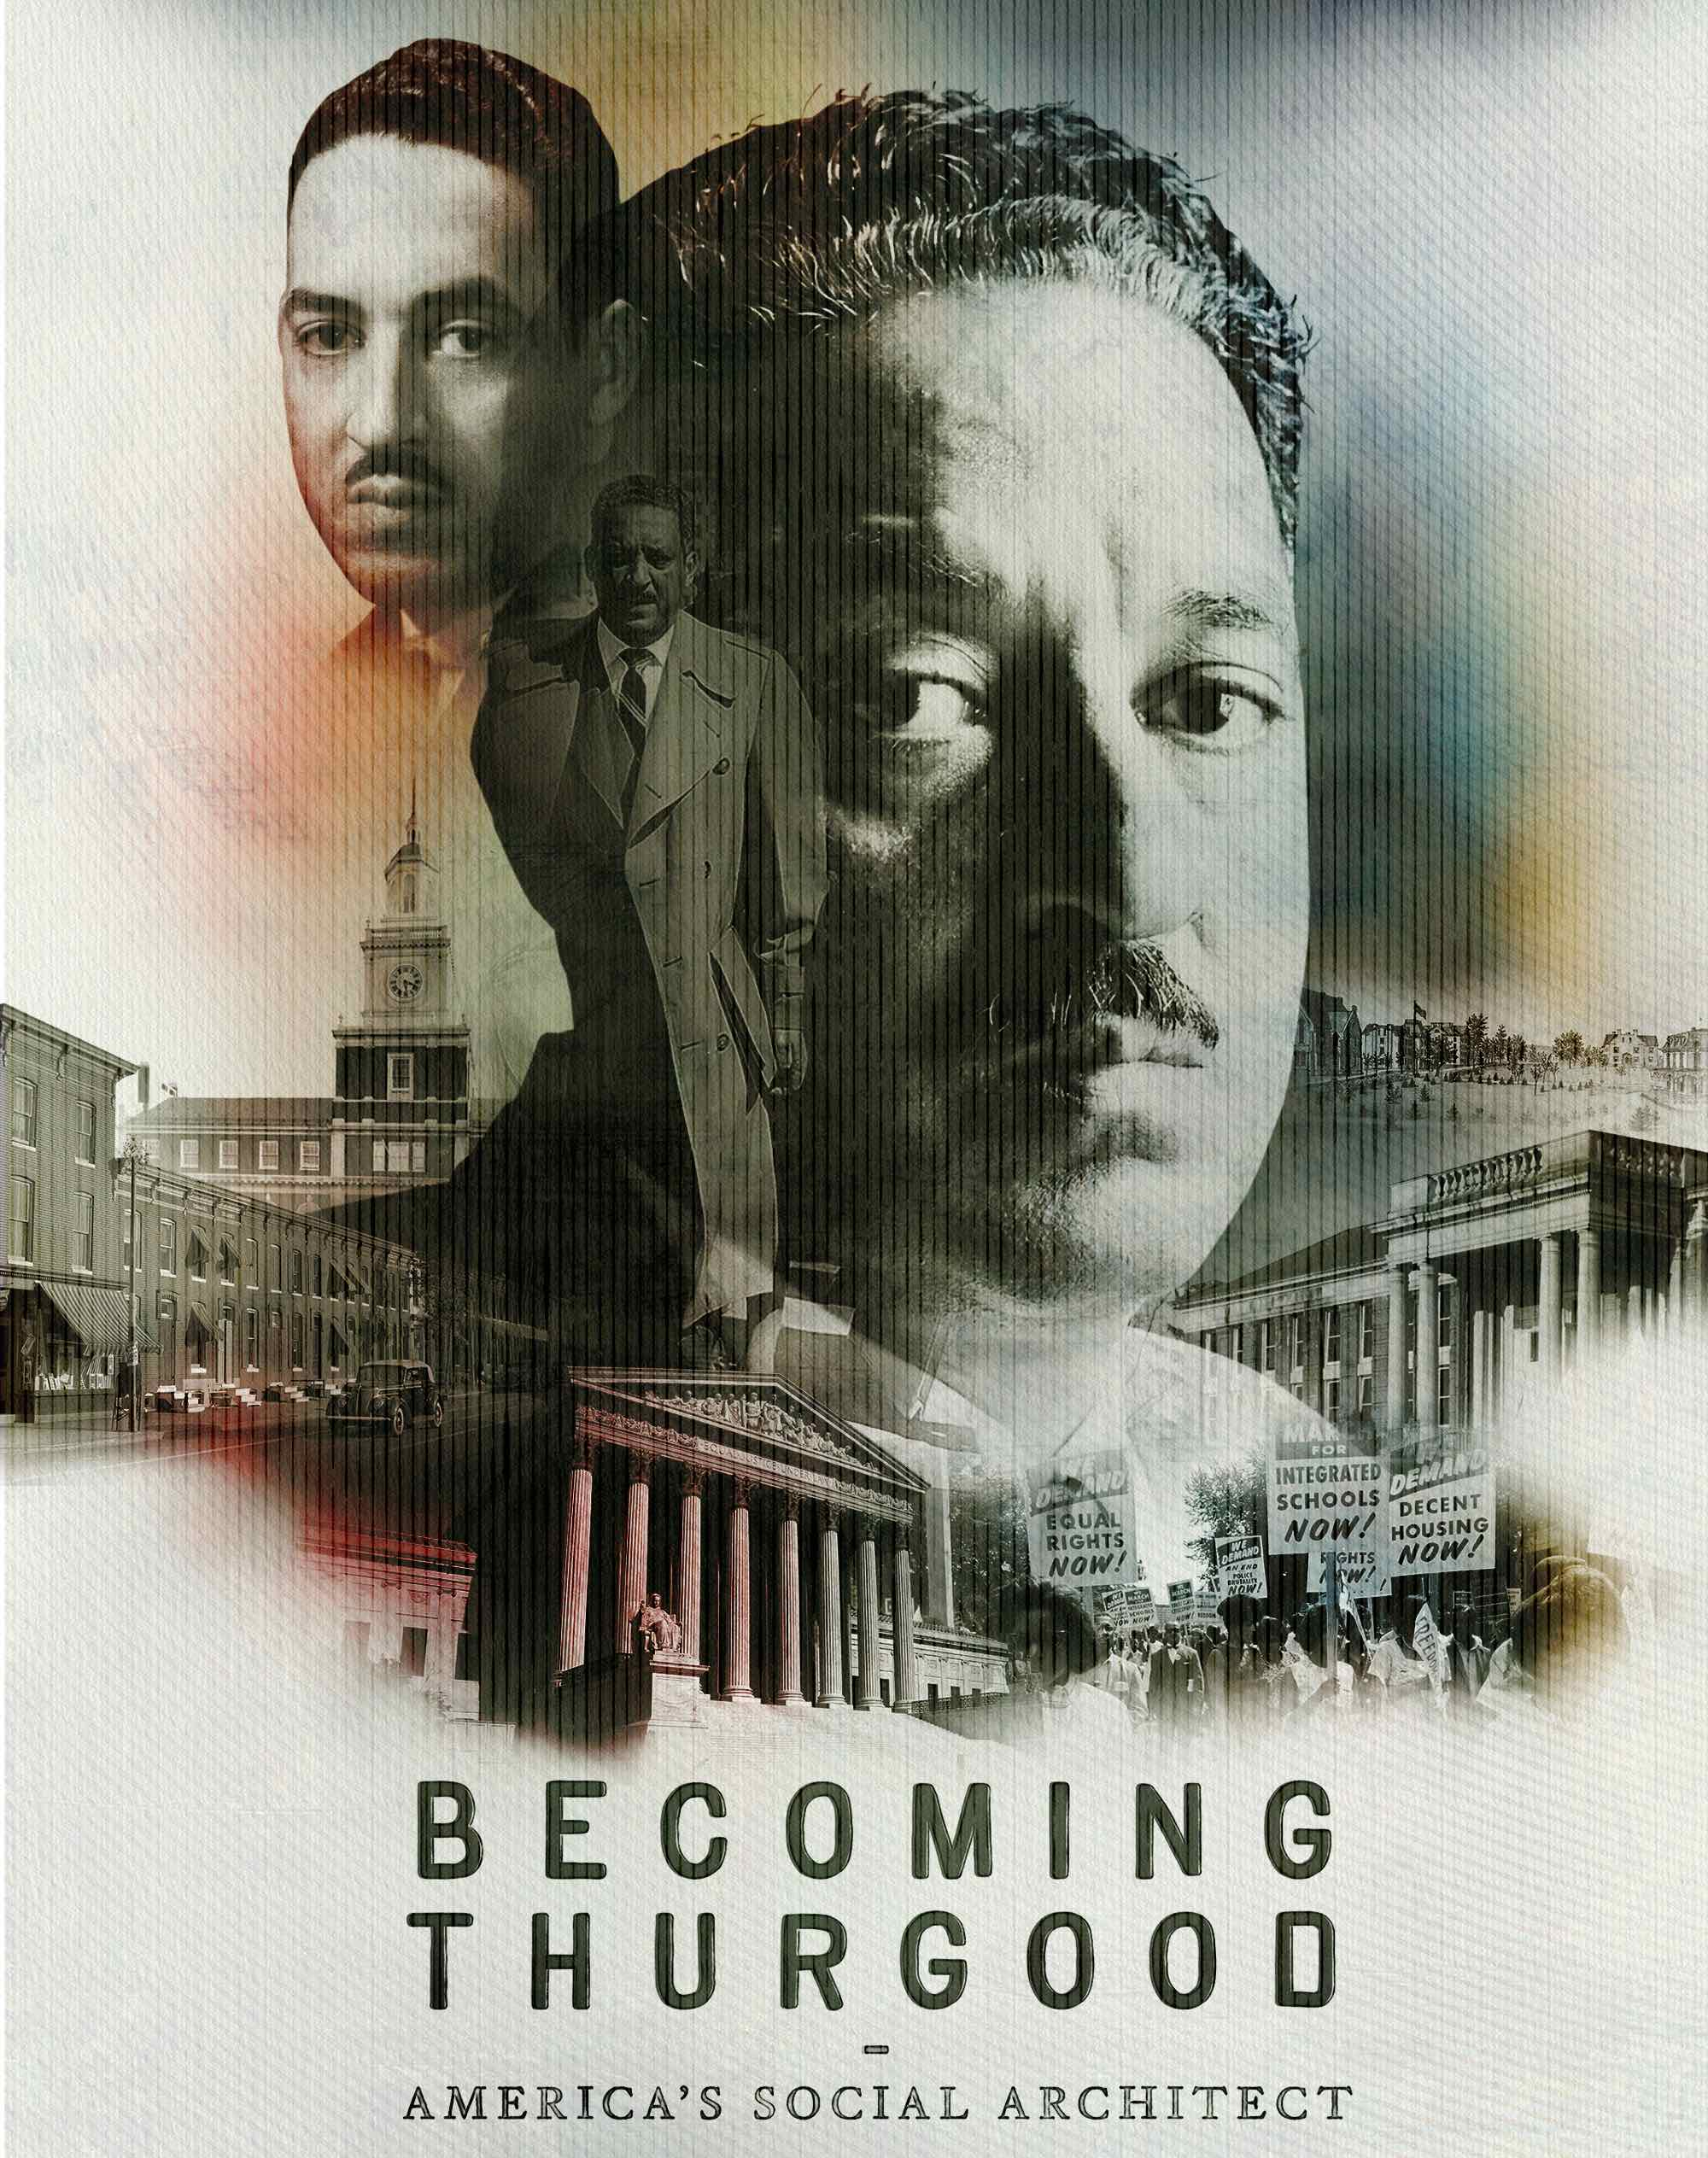
Owings Mills, MD — BECOMING THURGOOD: AMERICA’S SOCIAL ARCHITECT, a new one-hour documentary, explores the life and legacy of Thurgood Marshall, the visionary lawyer and civil rights leader who became the first Black justice on the United States Supreme Court. Drawing from rare archival recordings, personal photographs, and exclusive interviews, the film offers an intimate and timely portrait of a man who reshaped American democracy.

Executive produced by Emmy Award-winning and Oscar-nominated filmmaker Stanley Nelson and Maryland Public Television Senior Vice President and Chief Content Officer Travis Mitchell, the film is produced and directed by Alexis Aggrey, with music by two-time Grammy Award-winning composer Derrick Hodge.

A testament to Marshall’s extraordinary influence, BECOMING THURGOOD: AMERICA’S SOCIAL ARCHITECT premieres Tuesday, September 9, 10:00-11:00 p.m. ET (check local listings) on PBS, PBS.org, and the PBS app.

With a combination of oral history, animation, and evocative sound design, BECOMING THURGOOD brings Marshall’s story to life not as myth, but as a man of action — strategic, courageous, and deeply committed to justice. Through his work, Marshall held the nation accountable to its founding promises, redefined what was possible through the law, and helped move America closer to its highest ideals.

The film traces Marshall’s journey from his birth in Baltimore, Maryland, in 1908 to his formative years at Historically Black Colleges and Universities (HBCUs) Lincoln University and Howard University School of Law to his groundbreaking career as a lawyer championing civil rights and dismantling segregation.

Marshall won 29 of the 32 cases he argued before the U.S. Supreme Court, including the landmark Brown v. Board of Education in 1954, invalidating the “separate but equal doctrine” and ending racial segregation in public schools. But the decision was met with “massive resistance” across the South and continued to be fought in the courts for decades.

“When there are changes happening in your country, when there's unrest, when there's unfairness, people look to lawyers for the answer,” says Sherrilyn Ifill, Howard University School of Law. “So law and lawyers are very important tools in the toolbox of the very long, many hundred years quest of Black people to be free and full citizens in this country.”

In 1967, Marshall became the first African American appointed to serve on the U.S. Supreme Court. He served for 24 years and retired in 1991.

“To those of us who know the struggle is far from over, history has another lesson,” said Marshall. “It tells us how deeply rooted habits of prejudice are, dominating the minds of men and all our institutions for three centuries, and it cautions us to continue to move forward, lest we fall back.”

BECOMING THURGOOD: AMERICA’S SOCIAL ARCHITECT includes interviews with acclaimed authors, legal scholars, and family members, who offer fresh insights into the life and extraordinary influence of the man who became known as “Mr. Civil Rights.”

The film will serve as the centerpiece of HBCU Week NOW 2025, a public media partnership that offers content about the history, legacy, cultural heritage, and degree programs offered by America’s HBCUs. A collection of original long-form and short films, live events, and other HBCU-themed programming is available on the HBCU Week NOW YouTube Channel @HBCUWeekNOW and its companion Instagram page and website (hbcuweeknow.com).

BECOMING THURGOOD: AMERICA’S SOCIAL ARCHITECT is a production of Maryland Public Television, made possible with an appropriation from the State of Maryland for The Center for Maryland History Films. Funding for the film is also provided by Morgan State University, Theralogix, Sage Policy Group, and
Allan and Shelley Holt (through the Hillside Foundation).
BECOMING THURGOOD: AMERICA’S SOCIAL ARCHITECT is executive produced by Stanley Nelson and Travis Mitchell. The Supervising Producer is Troy Mosley. The film is produced and directed by Alexis Aggrey. The editor is Kimberly Brown. Cliff Charles is the Director of Photography.

BECOMING THURGOOD: AMERICA’S SOCIAL ARCHITECT will stream simultaneously with broadcast and be available on all station-branded PBS platforms, including PBS.org, and the PBS app, available on iOS, Android, Roku streaming devices, Apple TV, Android TV, Amazon Fire TV, Samsung Smart TV, Chromecast, and VIZIO.

About the Participants

Dr. Brenda A. Allen is President of Pennsylvania’s Lincoln University, from which Thurgood Marshall graduated in 1930.

Robert M. Bell served as Chief Judge, Maryland Court of Appeals (now known as the Supreme Court of Maryland), from 1996 to 2013. He was the first African American to hold the position.
Sheryll D. Cashin is an author and the Carmack Waterhouse Professor of Law, Civil Rights and Social Justice at Georgetown University. She is the author of White Space, Black ‘Hood: Opportunity Hoarding and Segregation in the Age of Inequality (2021), about the role of residential segregation in producing racial inequality. She also served as a law clerk to Justice Marshall in his last active year on the Supreme Court.
Wil Haygood is the author of Showdown: Thurgood Marshall and the Supreme Court Nomination That Changed America (2015). He serves as the Boadway Distinguished Scholar-in-Residence for the Department of Media, Journalism and Film at Miami University in Ohio.
Sherrilyn Ifill is the inaugural Vernon E. Jordan, Jr., Esq. Endowed Chair in Civil Rights at the Howard University School of Law. She is the former president and director-counsel for the NAACP Legal Defense and Educational Fund, Inc.(LDF). Thurgood Marshall was the first person to hold the director-counsel position from 1940 to 1961.
Dr. Irving Joyner is the Charles Hamilton Houston Endowed Chair and Professor of Law, North Carolina Central University in Durham.

Gilbert King is the author of Devil in the Grove: Thurgood Marshall, the Groveland Boys, and the Dawn of a New America, which won the 2013 Pulitzer Prize for general nonfiction.

John Marshall, a former Virginia state trooper and U.S. Marshal, is Thurgood Marshall’s son.

Cecilia Marshall is Thurgood Marshall’s granddaughter. She currently serves on the Board of Directors for the NAACP Legal Defense Fund and as Chief Advancement Officer at Ed Advancement, which supports social mobility by strengthening mission-focused colleges and universities that primarily serve low-income, first-generation, and under-resourced students and families.

About the Filmmakers

Alexis Aggrey (Director/Producer) is a director, producer and founder of The Aggrey Company, a boutique production house based in Washington, DC. With over 20 years of experience across public television, museums, and live events, she specializes in vérité documentaries and community-centered storytelling that elevate underrepresented voices. Her award-winning work includes the Emmy® Award- winning Water’s Edge: Black Watermen of the Chesapeake and the Peabody Award- winning 180 Days series, which premiered nationally on PBS. Aggrey has produced content for PBS, Paramount+, ESPN+, Amazon Originals and for many prominent museums, blending deep archival research with powerful, character-driven narratives. Through The Aggrey Company, she leads a collaborative team dedicated to crafting bold, thoughtful, and socially impactful media.

Travis Mitchell (Executive Producer) is the senior vice president and chief content officer for Maryland Public Television. He joined MPT in 2020 to oversee all content created, acquired, and aired on the statewide public television network's TV channels and digital properties.

Under Mitchell’s leadership, MPT has been nominated for 174 Emmy® Awards and has earned 56 Emmys from The National Capital Chesapeake Bay Chapter of The National Academy of Television Arts & Sciences. As an executive producer, he is a five-time Emmy recipient and nine-time Telly winner. He is the founder of HBCU Week NOW, a multiplatform distributor of content about historically Black colleges and universities.

Mitchell possesses more than two decades of media experience. Before his arrival at MPT, he served as chief content officer for University of North Carolina Television/UNC-TV (now PBS North Carolina). During his three years in this role with the public television station, he provided editorial vision and garnered support for UNC-TV's educational services and programming content on its four channels and online properties. Prior to being chief content officer, he was a UNC-TV Board of Trustees member for five years.

Mitchell was also executive vice president and chief operating officer for the Atlanta-based Black Family Channel, where he drove the channel's distribution growth from availability in two cities to more than 3,600 cities, 48 states, and 31 million homes while managing affiliate sales, advertising, programming, and launching sports and news divisions.

Mitchell serves on the Board of Trustees at Shaw University, where he received an honorary doctor of humane letters, recognizing his more than 25 years of service to the community as a media and non-profit executive. He also served on the foundation board of Morgan State University and is the chair of the Board of Visitors for Morgan State’s School of Global Journalism and Communications. In 2023, he was Morgan State’s Founder’s Day Convocation speaker and received the university’s Distinguished Achievement Award.

Stanley Nelson (Executive Producer) is today’s leading documentarian of the African American experience. His films combine compelling narratives with rich historical detail to shine new light on the under-explored American past. Awards received over the course of his career include a MacArthur “Genius” Fellowship, five Primetime Emmy® Awards, and lifetime achievement awards from the Emmys and IDA. In 2013, Nelson received the National Medal in the Humanities from President Obama. In 2019, Miles Davis: Birth of the Cool was nominated by the Grammys for Best Music Film and won two Emmy® Awards at the 42nd Annual News and Documentary Emmy Awards.

Nelson’s 2021 documentary Attica, for SHOWTIME Documentary Films, was nominated for Best Documentary Feature at the 94th Academy Awards® and earned him the DGA Award for Outstanding Directorial Achievement in Documentary. Also in 2021, Nelson directed the feature film Crack: Cocaine, Corruption & Conspiracy for Netflix, a 2022 duPont-Columbia Awards Finalist, and Tulsa Burning: The 1921 Race Massacre, with co-director Marco Williams, for the HISTORY Channel, which was nominated for three Primetime Emmy® Awards. Nelson also executive produced After Jackie for the HISTORY Channel in 2022 about the generation of Black baseball players who came after Jackie Robinson. In 2022 Nelson co-directed Sound of the Police with Valerie Scoon, which was produced with ABC News Studios and is now streaming on Hulu. Nelson’s latest film We Want the Funk! co-directed with Nicole London premiered on PBS’s Independent Lens in April 2025 and is now available to stream on PBS platforms.

In 2000, Nelson and his wife, Marcia Smith, co-founded Firelight Media, a non-profit organization that provides mentorship, funding, and artist development opportunities to emerging documentary filmmakers of color. In 2008, Nelson and Smith co-founded Firelight Films, a production company focused on making documentary films and developing strategies, partnerships, and materials to reach and engage diverse audiences.

About Maryland Public Television
Maryland Public Television (MPT) is a statewide, public-supported TV network and Public Broadcasting Service (PBS) member offering entertaining and educational content delivered by traditional broadcasting and streaming on TVs, computers, and mobile devices via its online video player and the free PBS app. A state agency operating under the auspices of the Maryland Public Broadcasting Commission, MPT also produces local, regional, and national programming and frequently earns regional Emmy® awards for its work. MPT’s commitment to educators, parents, caregivers, and learners of all ages is delivered through its Maryland Center for Media Literacy & Education and Thinkport.org. MPT’s year-round community engagement activities connect viewers with resources covering a wide range of topics. More information is available at mpt.org.

About the Aggrey Company
The Aggrey Company was established to connect award-winning talent to stories that matter from concept to delivery. Its principal, Alexis Aggrey, has worked in television production since 2004, and her work includes long-form vérité documentary, community engagement, museum display and live concert production. The Aggrey Company combines celebrated producers, cinematographers, editors and composers to execute content on time and on budget. The company has a proven track record of producing well-researched historical content that maintains high production standards and has extensive experience collecting primary research and conducting scholarly interviews through relationships with historical societies, including the Library of Congress, the National Archives, private collectors and stock vendors. These relationships were formed when working for the National Museum of African American History and Culture, National Geographic, and several PBS projects.
The Aggrey Company has a rich network of television contacts and has delivered award-winning content to local public media stations, PBS, Paramount+, ESPN+ and Smithsonian Channel.

CONTACTS:

MPT
Tom Williams, tomwilliams@mpt.org

Cara White / Mary Lugo, CaraMar, Inc.
cara@caramar.net; lugo@negia.net

MARC Global Communications
martine@marcglobalcommunications.com; sharon@marcglobalcommunications.com

For additional information, photos and a screener, visit PBS PressRoom BECOMING THURGOOD.

