SUMMER TCA BIG CATS 24/7 PANELIST BIOS
Diana El-Osta – PBS Senior Director of Multiplatform Programming and Development
Diana is responsible for developing and overseeing natural history and science programming for PBS. She previously served as the Head of Development for Still Life Projects, a digital production studio, and Condition One VR, a virtual reality production and technology company. At Condition One, she developed and produced VR content including the VR doc "Melting Ice," which premiered at the Sundance Film Festival in 2017 and "This is Climate Change" for Participant Media which premiered at the Tribeca Film Festival in 2018. She has extensive experience in both documentary film and factual television, having led the development for Al Jazeera America’s Documentary Unit and having served as Manager of Global Development and Production for National Geographic Channel and Nat Geo Wild.
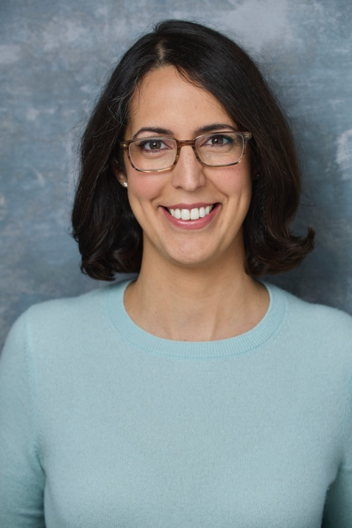

Rowan Crawford, Series Producer, BBC Studios
Inspired growing up surrounded by animals on a small island on the West Coast of Scotland, Series Producer Rowan Crawford has been making specialist factual series and live television that highlights the natural world for 15 years. Rowan has produced a range of programs from behavior-led natural history to observational documentary and children’s content, creating new formats and specializing in contemporary films that push the form. She was a senior producer on the BBC’s award-winning and long-running "Natural World" strand; and self-shooting director on the award-winning children’s mockumentary series "The Zoo" (CBBC). She is passionate about developing new talent and is actively involved in the drive to bring more on-screen diversity into the industry with series including "Big Cats 24/7" (BBC2), and "Planet Defenders" (CBBC).
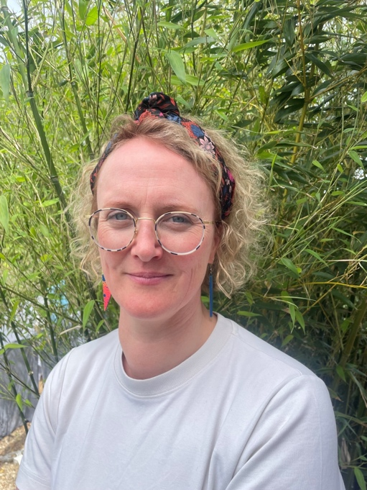

Gaokgonwe Seetsele “Sets” Nthomiwa – Wildlife Cinematographer
Sets grew up in Gabarone, the capital city of Botswana. He is a wildlife long-lens cinematographer and impact storyteller who highlights inspirational stories about the people and wildlife of his home country. He has worked on BBC Dynasties: Meerkats (BBC1), Whispers of the Delta and Surviving Paradise (Netflix).
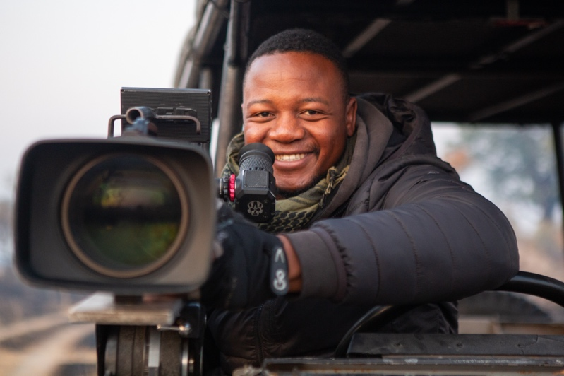
Brad Bestelink – Wildlife Cinematographer
Brad grew up in the Okavango Delta and has filmed there for more than 25 years. He is the co-founder and head of the Natural History Film Unit Botswana (NHFU), which operates out of a specialist film camp in the heart of the Okavango wilderness and trains local camera operators to capture the region’s wildlife. He has been following the individual big cats in this region for years and knows their stories better than anyone. With more than 30 films including Surviving Paradise (Netflix) and Savage Kingdom (National Geographic), Brad aims to teach people the importance of wild places and remaining connected with nature.

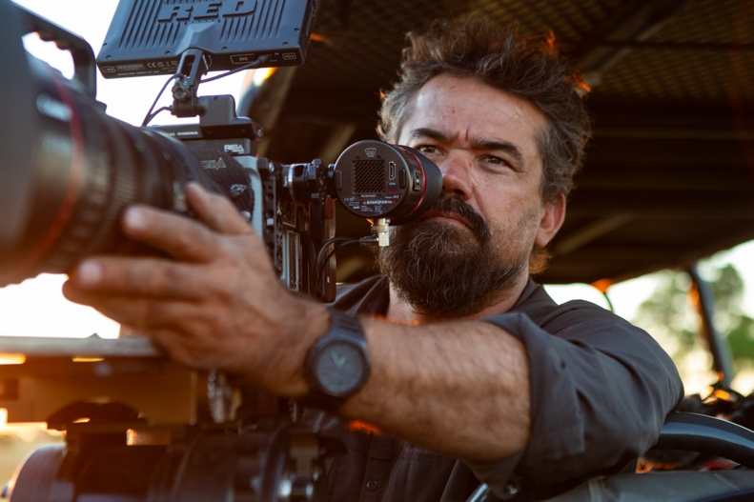

Anna Dimitriadis – Wildlife Cinematographer
Anna is a Greek-British wildlife cinematographer who has worked across the globe filming both above and below water in some of Earth’s last great wildernesses, from Antarctica to the jungles of the Central African Republic. Anna uses state-of-the-art filming technology to document and track wildlife for programs including Epic Adventures with Bertie Gregory (Disney+) and Animals Up Close with Bertie Gregory (Disney+). Her work has allowed her unprecedented views into the lives and behaviors of animals, and she is dedicated to protecting the natural world for future generations.

