New Murder Mystery Series, BOOKISH, Premieres
Sundays, January 11 – February 15, 2026, 10:00 p.m. ET on PBS, PBS.org, the PBS app and with PBS Masterpiece on Prime Video

Emmy Award-Winning Writer Mark Gatiss Stars in the Six-Part Crime Drama

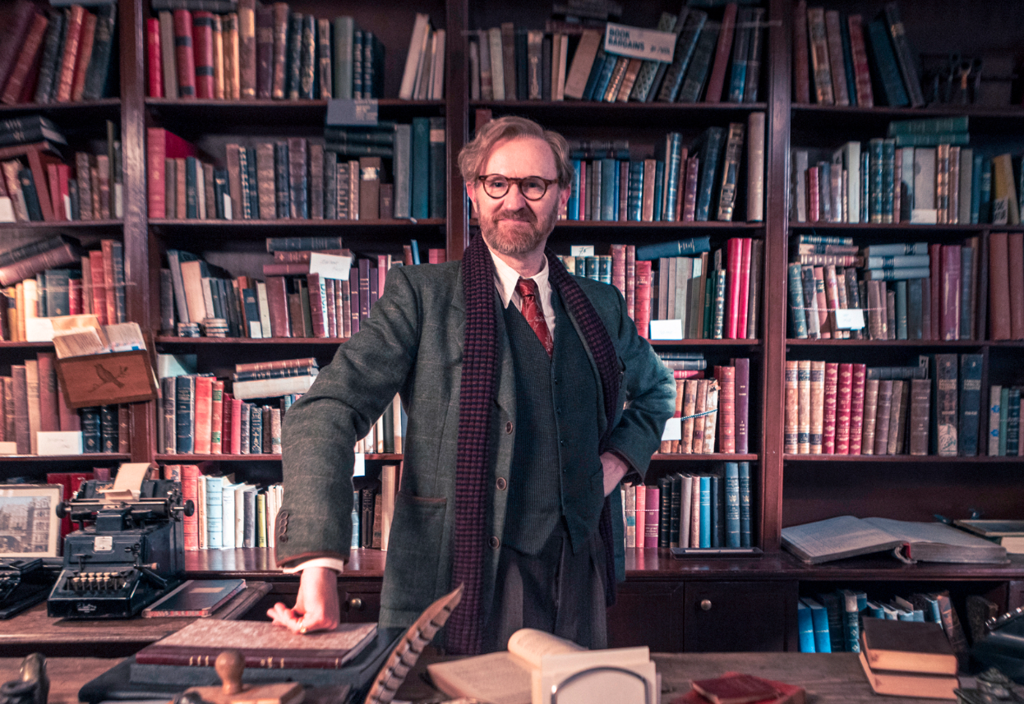
Caption: Mark Gatiss as Gabriel Book.
Credit: UKTV
ARLINGTON, VA; DECEMBER 19, 2025 – PBS announced today the U.S. premiere of BOOKISH, a new six-part murder mystery series created, starring and written by Emmy Award-winning writer Mark Gatiss (Sherlock, The League of Gentlemen). Premiering Sundays, January 11 – February 15, 2026, 10:00 – 11:00 p.m. ET on PBS (check local listings), the series follows antiquarian bookshop owner Gabriel Book (Gatiss) as he helps police solve a variety of mysterious crimes.

The shared creative vision of writer, creator and star Mark Gatiss, and director Carolina Giammetta, is what truly sets BOOKISH apart. BOOKISH takes audiences into the chaotic and dangerous shadows of post-war 1946 London, where Gabriel Book’s encyclopedic knowledge of literature and history makes him an invaluable — if unconventional — consultant to the local police. With razor-sharp wit and an entourage of charming social misfits, Book helps unravel London’s most puzzling mysteries by turning to the thousands of books lining his shelves.

BOOKISH takes the cozy crime genre and injects it with danger, pathos, darkness, and most importantly, truth, creating a fresh and original show. BOOKISH features three cases across six episodes, with an intimate mystery simmering beneath the surface: the unconventional marriage between Gabriel and his wife and childhood best friend Trottie, who runs the wallpaper shop next door.

Polly Walker (Bridgerton, Line of Duty) stars as Trottie Book; Connor Finch (Everything I Know About Love) as Jack; Elliot Levey (We Were the Lucky Ones, Quiz) as Inspector Bliss; Blake Harrison (World on Fire, Still Up) as Sergeant Morris; and Buket Kömür (Our House) as Nora.

Episode descriptions for BOOKISH are provided below.

Season Premiere - Sunday, January 11, 2026, 10:00 pm ET
Episode 1: “Slightly Foxed, Part 1”
It’s Jack’s first day as Book’s assistant, but excavation of a nearby bomb site means the business of bookselling takes an instant back seat, because the site is full of skeletons. And when local chemist Harkup is found poisoned in his shop, Jack realizes that his new employer has an unexpected sideline: solving murders.

Sunday, January 18, 2026, 10:00 pm ET
Episode 2: “Slightly Foxed, Part 2”
The investigation into Harkup’s death continues and Book discovers something surprising about the bomb site skeletons. With multiple suspects in the frame, a missing jade figurine, and an unexpected beneficiary in Harkup’s will, Book will need all his ingenuity to solve the case. The Law must take its course, but over whom does the shadow of the gallows lie?

Sunday, January 25, 2026, 10:00 pm ET
Episode 3: “Deadly Nitrate, Part 1”
The nation’s favorite screen couple, Sandra Dare and Stewart Howard, descend on Archangel Lane to film their latest picture, but is all as rosy as it seems? A journalist hovers around in search of juicy gossip, and then an extra drops dead after eating poisoned chocolates destined for one of the cast. Who was the intended victim? And will the killer strike again?

Sunday, February 1, 2026, 10:00 pm ET
Episode 4: “Deadly Nitrate, Part 2”
On the film set, poisoned chocolates have given way to broken necks. Book finds himself in a race against time to uncover the truth before anyone else is left on the cutting room floor — permanently. But might the written word hold the key to the murderer’s identity? Meanwhile, Jack gets an unexpected answer when he confronts Trottie and Book about their past.

Sunday, February 8, 2026, 10:00 pm ET
Episode 5: “Such Devoted Sisters, Part 1”
The Walsingham Hotel has seen it all and come through the war battered but unbowed, but can the grand old place cope with murder? When Captain Victor Orr is poisoned by a cocktail in the hotel bar, there is no end of potential suspects — including Trottie! But was Captain Orr the intended victim? The two exiled Princesses of Scutari — living in constant fear of assassination — think not.

Season Finale - Sunday, February 15, 2026, 10:00 pm ET
Episode 6: “Such Devoted Sisters, Part 2”
A gunshot, an unexpected bottle of champagne, and an unfortunate misunderstanding lead to chambermaid Eadie enjoying the hospitality of the Royal House of Scutari. Meanwhile, Book discovers something curious in Captain Victor Orr’s little black book and the source of the Princesses’ threatening letters becomes clear. Secrets from the past will be revealed — and not just about the case at hand.

BOOKISH will begin streaming January 11, 2026 and be available on all station-branded PBS platforms, including PBS.org and the PBS app, available on iOS, Android, Roku, Apple TV, Amazon Fire TV, Android TV, Samsung Smart TV, Chromecast and VIZIO. All episodes of BOOKISH will be available to binge the night of premiere via PBS Passport and will also stream with PBS Masterpiece on Prime Video. For more information about PBS Passport, contact your local PBS station or visit the PBS Passport FAQ website.

BOOKISH is a production of Eagle Eye Drama (an ITV Studios Company) and Happy Duck Films produced in association with UKTV and Beta Film for PBS. Directed by Carolina Giammetta, and written by Mark Gatiss and Matthew Sweet.
About PBS
PBS, with more than 330 member stations, offers all Americans the opportunity to explore new ideas and new worlds through television and digital content. Each month, PBS reaches over 36 million adults on linear primetime television, 16 million users on PBS-owned streaming platforms, 56 million viewers on YouTube, and 10 million followers on social media, inviting them to experience the worlds of science, history, nature, and public affairs and to take front-row seats to world-class drama and performances. PBS’s broad array of programs has been consistently honored by the industry’s most coveted award competitions. As the number one educational media brand, PBS KIDS helps children 2-8 build critical skills, enabling them to find success in school and life. Delivered through member stations, PBS KIDS offers high-quality content on TV — including a PBS KIDS channel — and streaming free on pbskids.org and the PBS KIDS Video app, games on the PBS KIDS Games app, and in communities across America. Teachers of children from pre-K through 12th grade turn to PBS LearningMedia for digital content and services that help bring classroom lessons to life. More information about PBS is available at PBS.org, one of the leading dot-org websites on the internet, Facebook, Instagram, or through our apps for mobile and connected devices. Specific program information and updates for press are available at pbs.org/pressroom or by following PBS Communications on X.

– PBS –

CONTACTS:
Stephanie Kennard, PBS, skkennard@pbs.org

Cara White / Mary Lugo, CaraMar, Inc.
cara.white@mac.com; lugo@negia.net

For images and additional up-to-date information on this and other PBS programs, visit PBS PressRoom at pbs.org/pressroom.

