PBS Announces New Documentary, COMING HOME: FROM SHADOWLAND TO SPIRITWORLD

Premieres Monday, November 2, 2026, at 10 p.m. ET on PBS and the PBS App

View Trailer

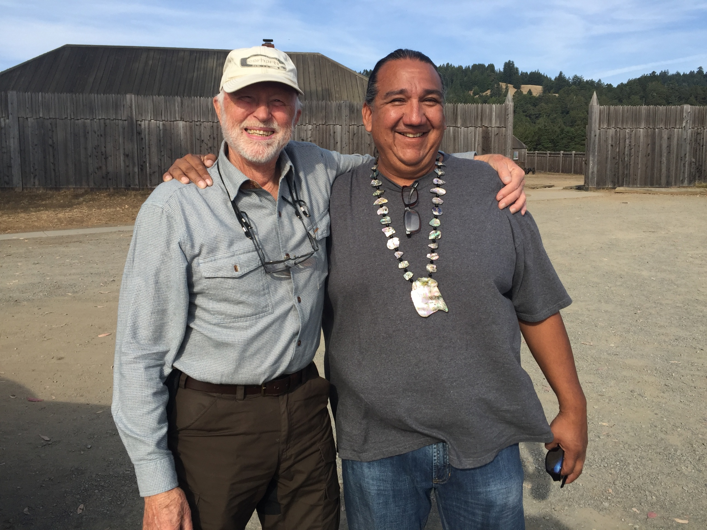
Arlington, VA; (October 30, 2026) – PBS today announced that COMING HOME: FROM SHADOWLAND TO SPIRITWORLD, the documentary that follows the story of a California Native Tribe’s successful recovery of sacred land, will premiere on Monday, November 2, 2026, at 10 p.m. ET on PBS (check local listings).

The 90-minute-long film follows the Kashia Band of Pomo Indians’ journey to reclaim their ancestral lands on the Sonoma Coast after 170 years of displacement. Shot over a period of 14 years in a cinéma vérité style, the film allows the Kashia to tell their own story without a third-party narrator as they confront the legacy of historical trauma, the return to their sacred places like Metini and reveal how restoring land can help renew identity, resilience and community.
Co-Directors Bob Elfstrom & Daniel Golding (Quechan) at Fort Ross, California
Photo Credit: J. Mitchell Johnson

COMING HOME: FROM SHADOWLAND TO SPIRITWORLD tells two stories in parallel timelines. The first is the contemporary story of the Kashia’s successful efforts to repatriate lands taken from them in the 19th century and ongoing attempts to connect with family members descended from the women who were taken to Russia at the end of the Russian colonial enterprise. The second is the historical story of the Kashia and the tribe’s relationships with European colonists and settlers that led to their long exile from their coastal homeland. COMING HOME: FROM SHADOWLAND TO SPIRITWORLD weaves these threads through a combination of photography, interviews, archival materials, animation and evocative recreations.

COMING HOME: FROM SHADOWLAND TO SPIRITWORLD comes from the film-making team of J. Mitchell Johnson and Daniel Golding and cinematographer Bob Elfstrom.

COMING HOME: FROM SHADOWLAND TO SPIRITWORLD premieres nationally on PBS on November 2, 2026 and will stream simultaneously with broadcast on all station-branded PBS platforms, including PBS.org and the PBS app, available on iOS, Apple TV, Android mobile and tablets, Android/GoogleTV, Roku, Amazon Fire TV and tablets, Comcast Xfinity, Chromecast, Samsung Smart TV, VIZIO and LG Smart TVs. PBS station members can view many series, documentaries, and specials via PBS Passport. For more information about PBS Passport, visit the PBS Passport FAQ website or contact your local station.
“PBS is committed to sharing stories that broaden our understanding of American history and bring important perspectives to light,” said Geoff Daniels, Vice President, Programming & Development, PBS. COMING HOME: FROM SHADOWLAND TO SPIRITWORLD tells the powerful story of the Kashia people’s journey to reclaim their ancestral land and highlights the lasting connection between land, history and cultural identity.”
"I have known of Dan Golding's talent for twenty years when I was at National Geographic," says Francene Blythe-Lewis, CEO and President of Vision Maker Media, which co-produced the film. "Like all his films, COMING HOME is a powerful story about memory - the land, the people, the natural elements do not forget and eventually find each other again to become whole. Dan Golding is a masterful storyteller in glorious filmmaking."

Funding for COMING HOME: FROM SHADOWLAND TO SPIRITWORLD was provided by National Endowment for the Humanities California Humanities Council, Indian Land Tenure Foundation, Diane and Henry J. Louis and Teutsch Partners. The Indian Land Tenure Foundation provided funding for this program and also provides funding for Native American land recovery. Indian Land Tenure Foundation had no editorial involvement in the creation of COMING HOME: FROM SHADOWLAND TO SPIRITWORLD.

COMING HOME: FROM SHADOWLAND TO SPIRITWORLD is a co-production of J. Mitchell Productions, Inc. dba Natural Democracies and Vision Maker Media.

About Vision Maker Media
Vision Maker Media (VMM) is the premier source of media by and about Native Americans since 1976. Vision Maker Media’s mission is empowering and engaging Native people to share stories, envisioning a world changed and healed by understanding Native stories and the public conversations they generate. VMM works with its funded producers to develop, produce and distribute programs for all media. VMM supports training to increase the number of Native Americans and Alaska Natives producing programs across a variety of platforms.
About PBS
PBS, with more than 330 member stations, offers all Americans the opportunity to explore new ideas and new worlds through television and digital content. Each month, PBS reaches over 36 million adults on linear primetime television, 16 million users on PBS-owned streaming platforms, 56 million viewers on YouTube, and 10 million followers on social media, inviting them to experience the worlds of science, history, nature, and public affairs and to take front-row seats to world-class drama and performances. PBS’s broad array of programs has been consistently honored by the industry’s most coveted award competitions. As the number one educational media brand, PBS KIDS helps children 2-8 build critical skills, enabling them to find success in school and life. Delivered through member stations, PBS KIDS offers high-quality content on TV — including a PBS KIDS channel — and streaming free on pbskids.org and the PBS KIDS Video app, games on the PBS KIDS Games app, and in communities across America. Teachers of children from pre-K through 12th grade turn to PBS LearningMedia for digital content and services that help bring classroom lessons to life. More information about PBS is available at PBS.org, one of the leading dot-org websites on the internet, Facebook, Instagram, or through our apps for mobile and connected devices. Specific program information and updates for press are available at pbs.org/pressroom or by following PBS Communications on X.

– PBS –

CONTACTS:

PBS
Meredith Tiger, mjtiger@pbs.org
Anna Merrill, admerrill@pbs.org

Bullseye Communications
Lisa Dyer, lisa.dyer@bullseyecomm.com
Heather Marohn, heather.marohn@bullseyecomm.com

For images and additional up-to-date information on this and other PBS programs, visit PBS PressRoom at pbs.org/pressroom.

