St. Louis Home Cook Adjo Honsou Wins Season 3 of
THE GREAT AMERICAN RECIPE

PBS Renews Series For Season 4 Premiering Summer 2025

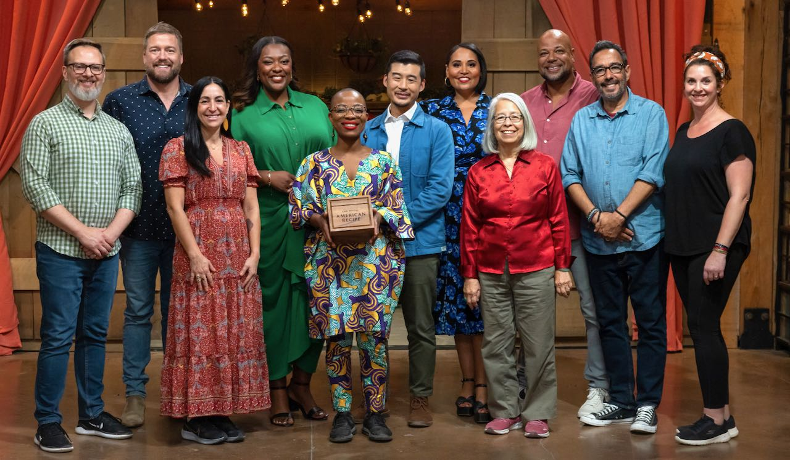
Winner Adjo Honsou (center) with the cast of Season 3 of
THE GREAT AMERICAN RECIPE.
Credit: PBS

ARLINGTON, VA; August 13, 2024 – Adjo Honsou, a home cook from St. Louis, Missouri, was chosen as the winner of Season 3 of THE GREAT AMERICAN RECIPE on last night’s season finale, which premiered Monday, August 12, on PBS. Originally from Togo, West Africa, Honsou was selected by judges Tiffany Derry, Tim Hollingsworth and Francis Lam. Host Alejandra Ramos and the judges praised Honsou for her ability to tell her story through food and for showing tremendous spirit through her recipes during the series. For the finale, Honsou chose to remake her signature dish, Oxtail in Palm Nut Stew, a recipe she prepared in the first episode but which did not win the challenge. Her second attempt wowed all the judges, with Tiffany Derry calling it “perfect.” All episodes of Season 3 of THE GREAT AMERICAN RECIPE are currently streaming on PBS.org and the PBS app.

PBS also announced today that the series has been renewed for a fourth season, with host Ramos and judges Derry, Hollingsworth and Lam set to return. Production will begin in Fall 2024. Season 4 is scheduled to premiere in Summer 2025 with a new crop of home cooks from across the country ready to showcase their beloved family recipes.

“After another season of heartwarming stories, mouthwatering dishes, new faces and talented contestants, we are thrilled that THE GREAT AMERICAN RECIPE will return for a fourth helping of friendly competition next year,” said Zara Frankel, Senior Director of Programming and Development, General Audience Programming. “Congratulations to Adjo Honsou for winning big with her Oxtail in Palm Nut Stew, a recipe re-do from the first episode. Her victory is a testament to the heart of the show, which is her personal growth as a cook throughout the competition. We can’t wait for Season 4!”

“Season 3 continued to show how much America embraces this joyful authentic series,” said VPM Chief Content Officer and Executive Producer Steve Humble. “VPM is thrilled to be back for a fourth season to watch another group of inspiring home cooks share their stories, heritage and recipes with us all."

Jilly Pearce, Objective Media Group America President added, “We’re so proud to be back with PBS and VPM for another feel-good season of The Great American Recipe. After Adjo’s impressive Season 3 win, we can’t wait to introduce our Season 4 cast of talented home cooks and watch them surprise and delight the judges with their delicious family recipes and uplifting personal histories.

THE GREAT AMERICAN RECIPE is an uplifting cooking competition that blends food, family and fun, highlighting the amazing variety of tastes and traditions found across the U.S., while capturing the roots of America’s diverse cuisine. Season 3 is currently streaming and is available on all station-branded PBS platforms, including PBS.org and the PBS app, available on iOS, Android, Roku, Apple TV, Amazon Fire TV, Android TV, Samsung Smart TV, Chromecast and VIZIO.

THE GREAT AMERICAN RECIPE is co-produced for PBS by VPM and Objective Media Group America. Steve Humble is the Executive in Charge for VPM. Zara Frankel is the Executive in Charge for PBS. At Objective Media Group America, an All3Media company, Alyssa Hastrich is Showrunner, Layla Smith and Jilly Pearce are Executive Producers and Erin Flynn is Senior Vice President of Current Series.

About VPM
As Virginia’s home for public media, VPM connects nearly 2 million people across Central Virginia and the Shenandoah Valley to insightful programming in news, education, arts and culture across its television, radio and digital channels. The VPM News team delivers award-winning coverage of Virginia’s General Assembly; statewide politics; educational, economic and legal issues; as well as the news of the day. VPM produces acclaimed series and documentaries, plus a range of music shows with local hosts curating selections in classical, jazz, hop-hop and alternative music. VPM also creates content through its Science Matters initiative and provides early childhood educational resources to families, caregivers and educators. Since 2021, VPM has operated Style Weekly, a magazine centered on deeper arts and culture coverage and local storytelling. Learn more at VPM.org and on Facebook, Bluesky, TikTok,
Instagram and several channels on YouTube.

About OBJECTIVE MEDIA GROUP AMERICA
Objective Media Group America is the U.S. arm of Objective Media Group. An LA-based All3Media America company, OMG America is led by President Jilly Pearce in creating and producing original entertainment and reality formats, including “Lingo” (CBS), “The Cube” (TBS), “12 Dates of Christmas” (HBO Max), “Worst Cooks in America” (The Food Network), “Elf on the Shelf: Sweet Showdown (The Food Network) and more. Objective Media Group, an All3Media company, is headquartered in London and headed up by CEO Layla Smith.

About PBS
PBS, with more than 330 member stations, offers all Americans the opportunity to explore new ideas and new worlds through television and digital content. Each month, PBS reaches over 36 million adults on linear primetime television, more than 16 million users on PBS-owned streaming platforms, 53 million viewers on YouTube, and 60 million people view PBS content on social media, inviting them to experience the worlds of science, history, nature, and public affairs and to take front-row seats to world-class drama and performances. PBS’s broad array of programs has been consistently honored by the industry’s most coveted award competitions. Teachers of children from pre-K through 12th grade turn to PBS LearningMedia for digital content and services that help bring classroom lessons to life. As the number one educational media brand, PBS KIDS helps children 2-8 build critical skills, enabling them to find success in school and life. Delivered through member stations, PBS KIDS offers high-quality content on TV — including a PBS KIDS channel — and streaming free on pbskids.org and the PBS KIDS Video app, games on the PBS KIDS Games app, and in communities across America. More information about PBS is available at PBS.org, one of the leading dot-org websites on the internet, Facebook, Instagram, or through our apps for mobile and connected devices. Specific program information and updates for press are available at pbs.org/pressroom or by following PBS Communications on X.

– PBS –
CONTACTS:

Atiya Frederick / Meredith Wohl, PBS
PR@pbs.org

Cara White / Mary Lugo, CaraMar, Inc.
cara.white@mac.com; lugo@negia.net

For screeners, images and additional information visit PBS PressRoom at pbs.org/pressroom.

