Popular Cookbook Author and Food Influencer Jake Cohen Joins THE GREAT AMERICAN RECIPE Season 4 Finale as a Special Guest Judge

Top Three Contestants Will Compete in the Final Episode on Friday, August 15 on PBS and PBS.org

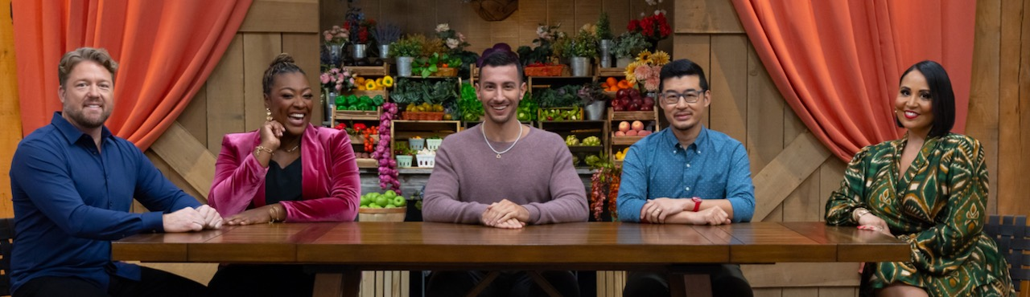
Left to right: Judges Tim Hollingsworth and Tiffany Derry, special guest judge Jake Cohen, judge Francis Lam and host Alejandra Ramos. Credit: PBS

ARLINGTON, VA; August 11, 2025 – PBS today announced that Jake Cohen will be a special guest judge on THE GREAT AMERICAN RECIPE Season 4 finale, premiering Friday, August 15, 2025, 9:00-10:00 p.m. ET (check local listings) on PBS, PBS.org and the PBS app. Cohen joins judges Tiffany Derry, Tim Hollingsworth and Francis Lam and series host Alejandra Ramos as they decide which of the three finalists will be named the winner of this year’s competition.

Jake Cohen is The New York Times bestselling author of Jew-ish and I Could Nosh, star of A&E’s Jake Makes It Easy, and an enormously popular food influencer, with more than a million followers on Instagram. Jake and his recipes have been featured on Rachael Ray, The Drew Barrymore Show, Live with Kelly and Mark, Good Morning America, and the Food Network, and in The New York Times, Food & Wine, The Wall Street Journal, Bon Appetit, and Forbes, among others. When he’s not posting on social media (@jakecohen), he’s eating and gallivanting around New York City.

“I was blown away by the talent and inventiveness of the contestants,” said Jake Cohen. “It was a true pleasure getting to see what they cooked up under pressure!”

Season 4 of THE GREAT AMERICAN RECIPE is available to stream on all station-branded PBS platforms, including PBS.org and the PBS app, available on iOS, Android, Roku, Apple TV, Amazon Fire TV, Android TV, Samsung Smart TV, Chromecast and VIZIO.

Season 4 of THE GREAT AMERICAN RECIPE was filmed at Green Door Gourmet, a 350-acre farm, on-farm market, and agritourism destination in Nashville, Tennessee. THE GREAT AMERICAN RECIPE is co-produced for PBS by VPM and Objective Media Group. Steve Humble is the Executive in Charge for VPM. Zara Frankel is the Executive in Charge for PBS. At Objective Media Group, an All3Media company, Alyssa Hastrich is Showrunner, Layla Smith and Jilly Pearce are Executive Producers and Erin Flinn is Senior Vice President, Current Programming.

About VPM
As Virginia’s home for public media, VPM connects nearly 2 million people across Central Virginia and the Shenandoah Valley to insightful programming in news, education, arts and culture across its television, radio and digital channels. The VPM News team delivers award-winning coverage of Virginia’s General Assembly; statewide politics; educational, economic and legal issues; as well as the news of the day. VPM produces acclaimed series and documentaries, plus a range of music shows with local hosts curating selections in classical, jazz, hop-hop and alternative music. VPM also creates content through its Science Matters initiative and provides early childhood educational resources to families, caregivers and educators. Since 2021, VPM has operated Style Weekly, a magazine centered on deeper arts and culture coverage and local storytelling. Learn more at VPM.org and on Facebook, Bluesky, TikTok, Instagram and several channels on YouTube.

About OBJECTIVE MEDIA GROUP
Objective Media Group, an All3Media company, produces across the US and UK. Original entertainment, reality and scripted programming includes “Lingo” (CBS), “The Cube” (TBS), “Worst Cooks in America” (The Food Network), “Elf on the Shelf: Sweet Showdown (The Food Network) and forthcoming limited series “Wayward” (Netflix).

About PBS
PBS, with more than 330 member stations, offers all Americans the opportunity to explore new ideas and new worlds through television and digital content. Each month, PBS reaches over 36 million adults on linear primetime television, more than 16 million users on PBS-owned streaming platforms, 53 million viewers on YouTube, and 60 million people view PBS content on social media, inviting them to experience the worlds of science, history, nature, and public affairs and to take front-row seats to world-class drama and performances. PBS’s broad array of programs has been consistently honored by the industry’s most coveted award competitions. Teachers of children from pre-K through 12th grade turn to PBS LearningMedia for digital content and services that help bring classroom lessons to life. As the number one educational media brand, PBS KIDS helps children 2-8 build critical skills, enabling them to find success in school and life. Delivered through member stations, PBS KIDS offers high-quality content on TV — including a PBS KIDS channel — and streaming free on pbskids.org and the PBS KIDS Video app, games on the PBS KIDS Games app, and in communities across America. More information about PBS is available at PBS.org, one of the leading dot-org websites on the internet, Facebook, Instagram, or through our apps for mobile and connected devices. Specific program information and updates for press are available at pbs.org/pressroom or by following PBS Communications on X.

– PBS –

CONTACTS:

Atiya Frederick, PBS, anfrederick@pbs.org

Cara White / Mary Lugo, CaraMar, Inc.
cara.white@mac.com; lugo@negia.net

For images and additional up-to-date information on this and other PBS programs, visit PBS PressRoom at pbs.org/pressroom.

