Meet the Newest Batch of Home Cooks Competing in
Season 4 of THE GREAT AMERICAN RECIPE

Series Premieres Fridays, July 11 – August 15 on PBS and Streaming on PBS.org and the PBS app

Join Host Alejandra Ramos and Judges Tiffany Derry, Tim Hollingsworth and Francis Lam with Special Guest Judge TODAY Co-Host Al Roker in Season Opener

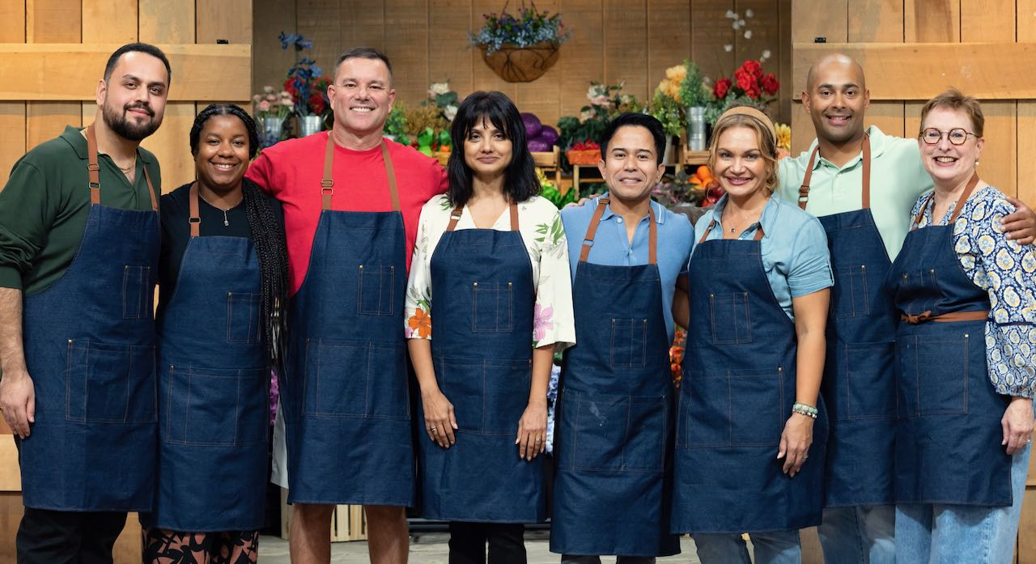

The home cooks featured in Season 4.

ARLINGTON, VA; date – PBS today announced the eight home cooks from across America who will put their culinary skills to the test in Season 4 of THE GREAT AMERICAN RECIPE. Mixing camaraderie with competition, the uplifting cooking competition celebrates the incredible variety of tastes and traditions from around the country, revealing the rich personal stories behind the home cooks’ signature dishes and favorite recipes. With a range of cooking styles infused by their backgrounds — from Bangladeshi to Belizean, Puerto Rican to Southern, Cajun to Afghan, Filipino to Thai — the eight home cooks reflect the wealth of diversity that makes American food so vibrant and delicious.

Host Alejandra Ramos is joined by award-winning chefs and restaurateurs Tiffany Derry and Timothy Hollingsworth and Splendid Table host Francis Lam, who serve as judges
to guide and encourage the home cooks along the way. Each week, after two challenges, the judges determine who has the winning dish, and in the final episode, the top three cooks compete to win the national search for “The Great American Recipe.” Joining the fun in the opening episode is special guest judge Al Roker, beloved TV personality, bestselling cookbook author, and creator of the upcoming PBS KIDS series WEATHER HUNTERS. Season 4 of THE GREAT AMERICAN RECIPE premieres Fridays, July 11 through August 15, 2025, 9:00-10:00 p.m. ET (check local listings) on PBS, PBS.org and the PBS app.

Meet the Home Cooks in Season 4

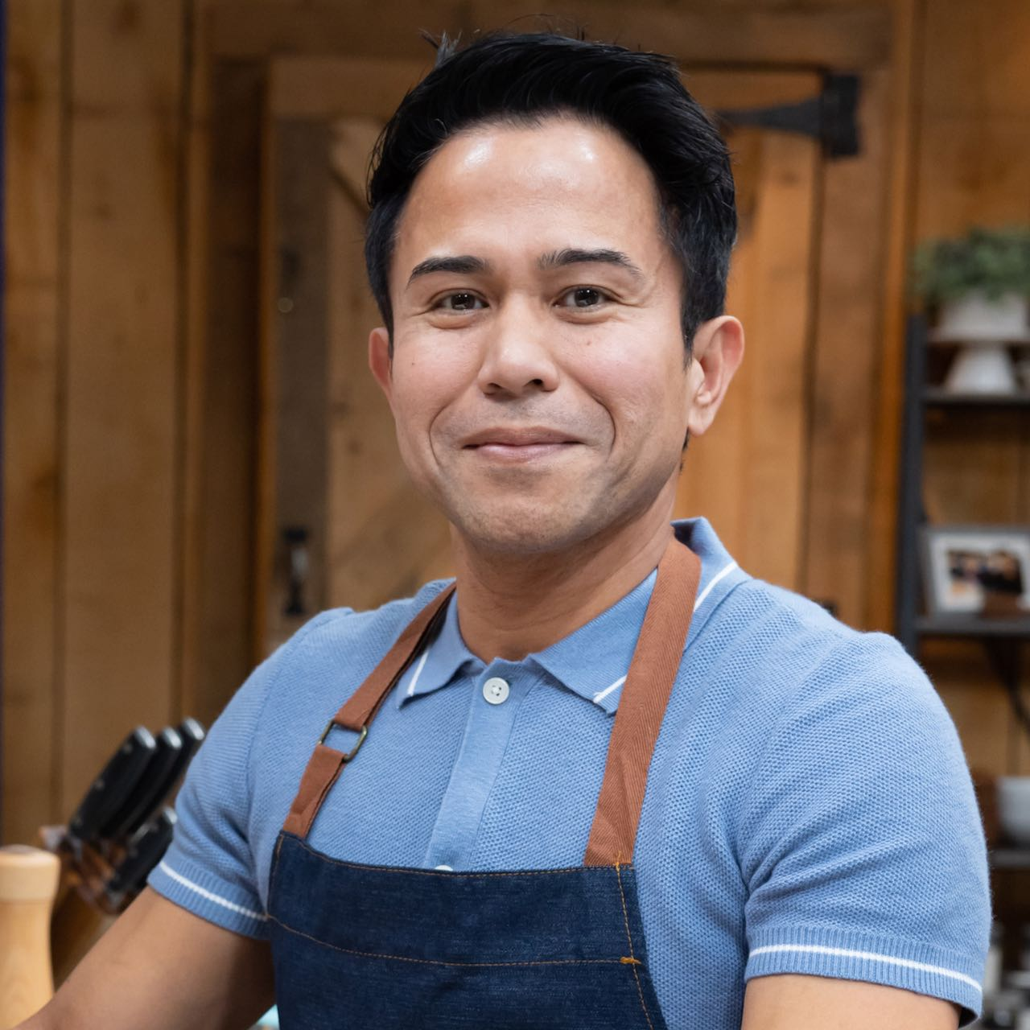
Rex Alba (Columbus, Ohio) is a physical therapist and devoted husband with a deep passion for Filipino cuisine. Born and raised in Tagbilaran City, Bohol, Philippines, Rex learned to cook from his mother, his first culinary mentor. With his father working overseas to support the family, young Rex helped prepare meals for his three siblings, fostering a close bond with his mother and a lifelong love of cooking. In 2005, Rex and his wife moved to the United States seeking a better life. Rex adapts traditional Filipino dishes with local produce while preserving authentic flavors. As President of the Philippine American Society of Central Ohio, he proudly represents his community. His signature dish is Dinuguan (Pork Blood Stew), a flavorful nod to his heritage.

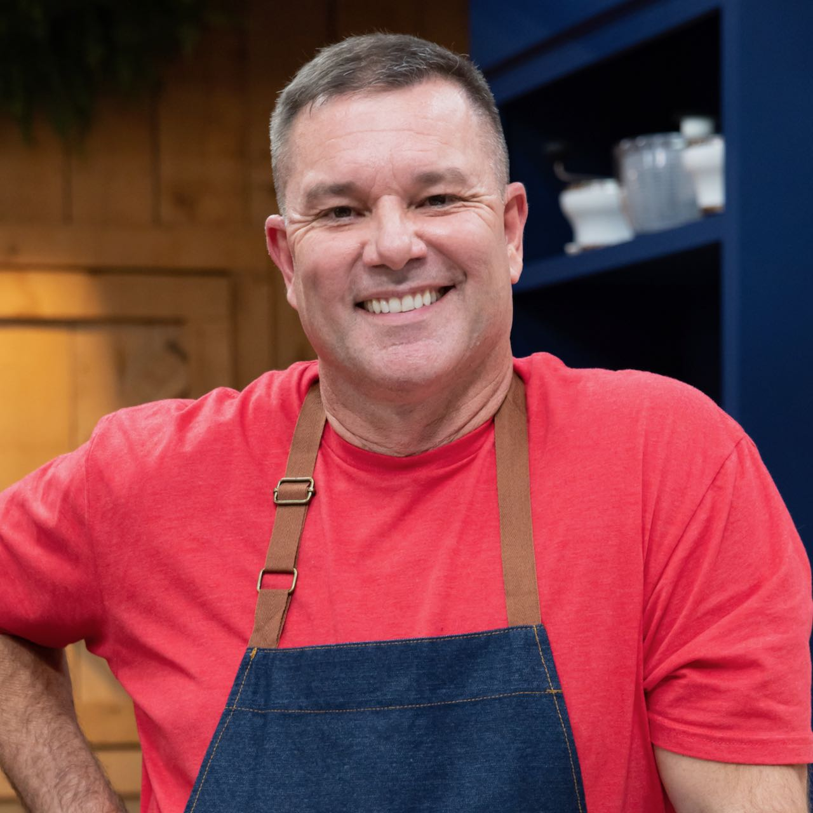
Coby Bailey (Lafayette, Louisiana) is a firefighter, husband, and proud father of two. Growing up, he was immersed in culinary traditions passed down through generations, with his earliest inspirations coming from his mother and grandmother, both exceptional Cajun cooks. After serving in the U.S. Navy, including during Desert Storm, Coby joined the Lafayette Fire Department, where he has worked for 27 years, serving as captain for the past decade. Cajun cuisine, deeply rooted in African, European, and Native American influences — most notably French — reflects a rich history of bold flavors, rustic techniques, and communal dining. For Coby, cooking is more than nourishment; it’s a way of life and a connection to his heritage. Today, he proudly carries on that legacy, mastering traditional dishes that define Cajun culture. His signature dish, Stuffed Chicken with Andouille Sauce, embodies the hearty, soulful spirit of his roots.

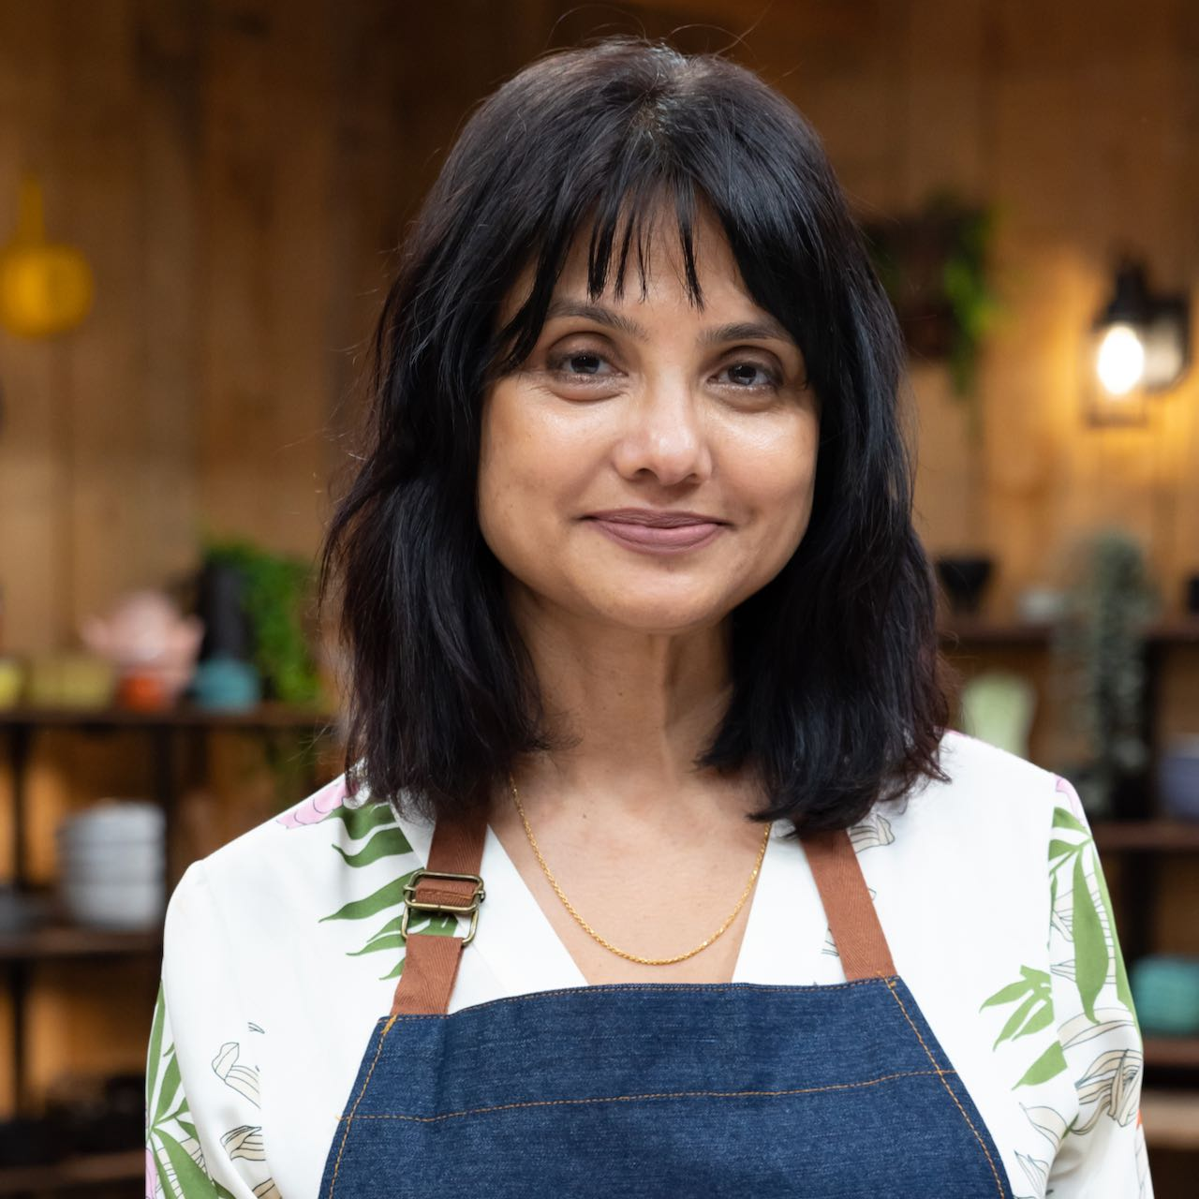
Anika Chowdhury (New York, New York), a director of project management, was born and raised in Dhaka, Bangladesh, in a home where food was an expression of love, care, and celebration. Her parents hosted dinners centered on fresh, seasonal dishes, sparking her passion for cooking and her belief that food can bring people together. Now living in Manhattan with her husband, Anika balances her career with an active life exploring global cuisines, cooking, hosting, and sharing recipes on her blog Kitchen Gatherings. She regularly cooks for siblings and friends and enjoys gardening, including growing Bangladeshi vegetables in a community garden. Her cooking reflects her Bengali heritage, shaped by her parents and grandmothers: the citrusy, aromatic dishes of her paternal grandmother from Sylhet in northern Bangladesh and the coconut- and yogurt-based curries of her maternal side, rich with flavors from the South Asian region. Her signature Chingri Malai Kari (Prawns in Coconut Milk) blends her family’s culinary influences into a comforting dish made for both celebrations and everyday enjoyment.

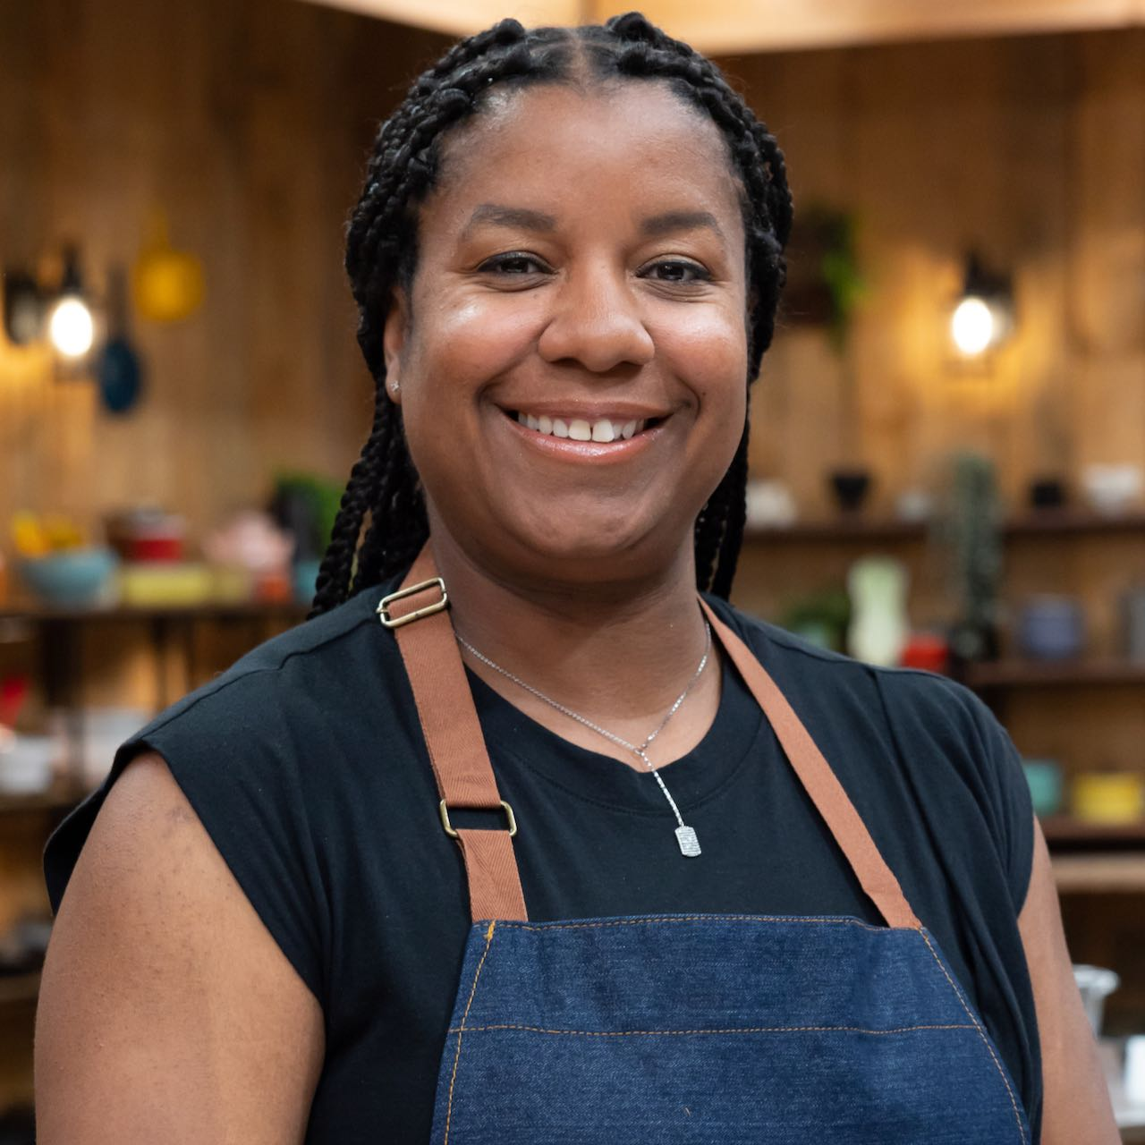
Brie Jamieson (Great Falls, Montana) is a teacher aide, Special Olympics Montana and elementary school track and field coach, military wife, and mother of two. Born and raised in the suburbs of Chicago, she grew up in a traditional Caribbean-American household. Her grandmother and mother, passionate about preserving their heritage, made it a priority to pass down family recipes as a way for Brie to continue their legacy of cooking, culture, and togetherness. For the past 17 years, Brie’s husband has served in the military, leading them to move frequently. This made it even more important for her to keep her kids connected to their Caribbean roots. Brie masterfully blends the vibrant spices and flavors of the Caribbean, drawing inspiration from her Belizean and Jamaican heritage. Her cooking is a celebration of culture, family, and tradition. Her signature dish, Oxtail with Rice and Peas, embodies those values with every bite.

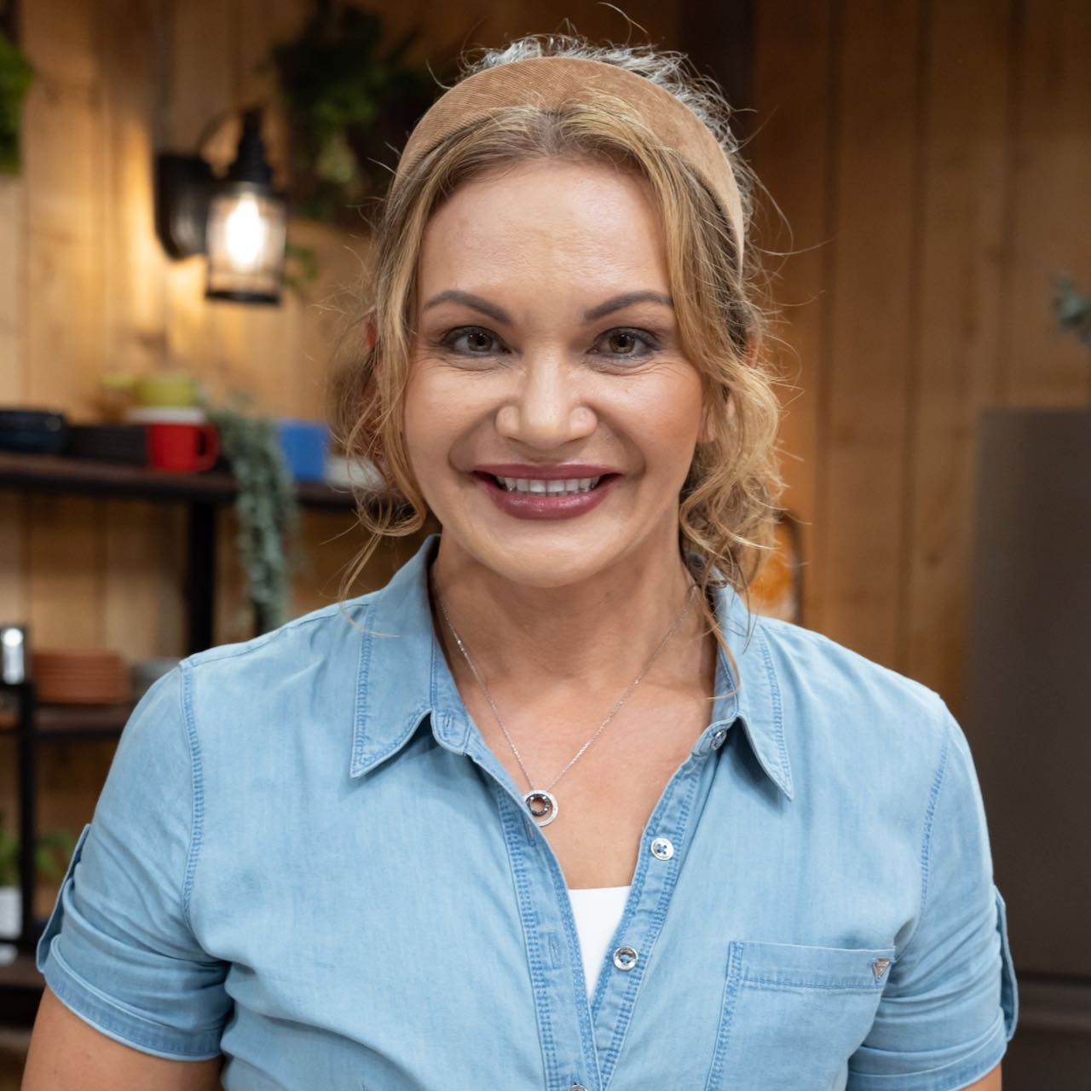
Suwanee Lennon (Spokane, Washington) is a Thai food blogger, photographer, and storyteller who shares the vibrant flavors of her heritage. Born in Bangkok and raised in a small leprosy village in Surin, a northeastern province of Thailand, her early years were shaped by the bold, earthy flavors of Isaan cuisine. When she was 13, an American woman working in a refugee camp visited her village and chose to sponsor her journey to the US, starting a new life in Eau Claire, Wisconsin. Suwanee is a wife to a retired Air Force pilot, a busy mom of two, and a passionate cook. Through her blog, Simply Suwanee, she captures the beauty of Thai food and culture. Two years ago, Suwanee started the Feed the Village Project to give back to elderly leprosy patients, many of whom helped her when she left for America. With support from Feast World Kitchen, a Spokane nonprofit that empowers immigrant and refugee chefs, she fundraised to enable the village women to cook for the elderly, preserving traditions and honoring the community that first supported her dreams. Her signature dishes, like Khanom Jeen Nam Ya (Thai Fish Curry) and spicy, herb-packed larb, celebrate the food and culture of her Isaan upbringing.

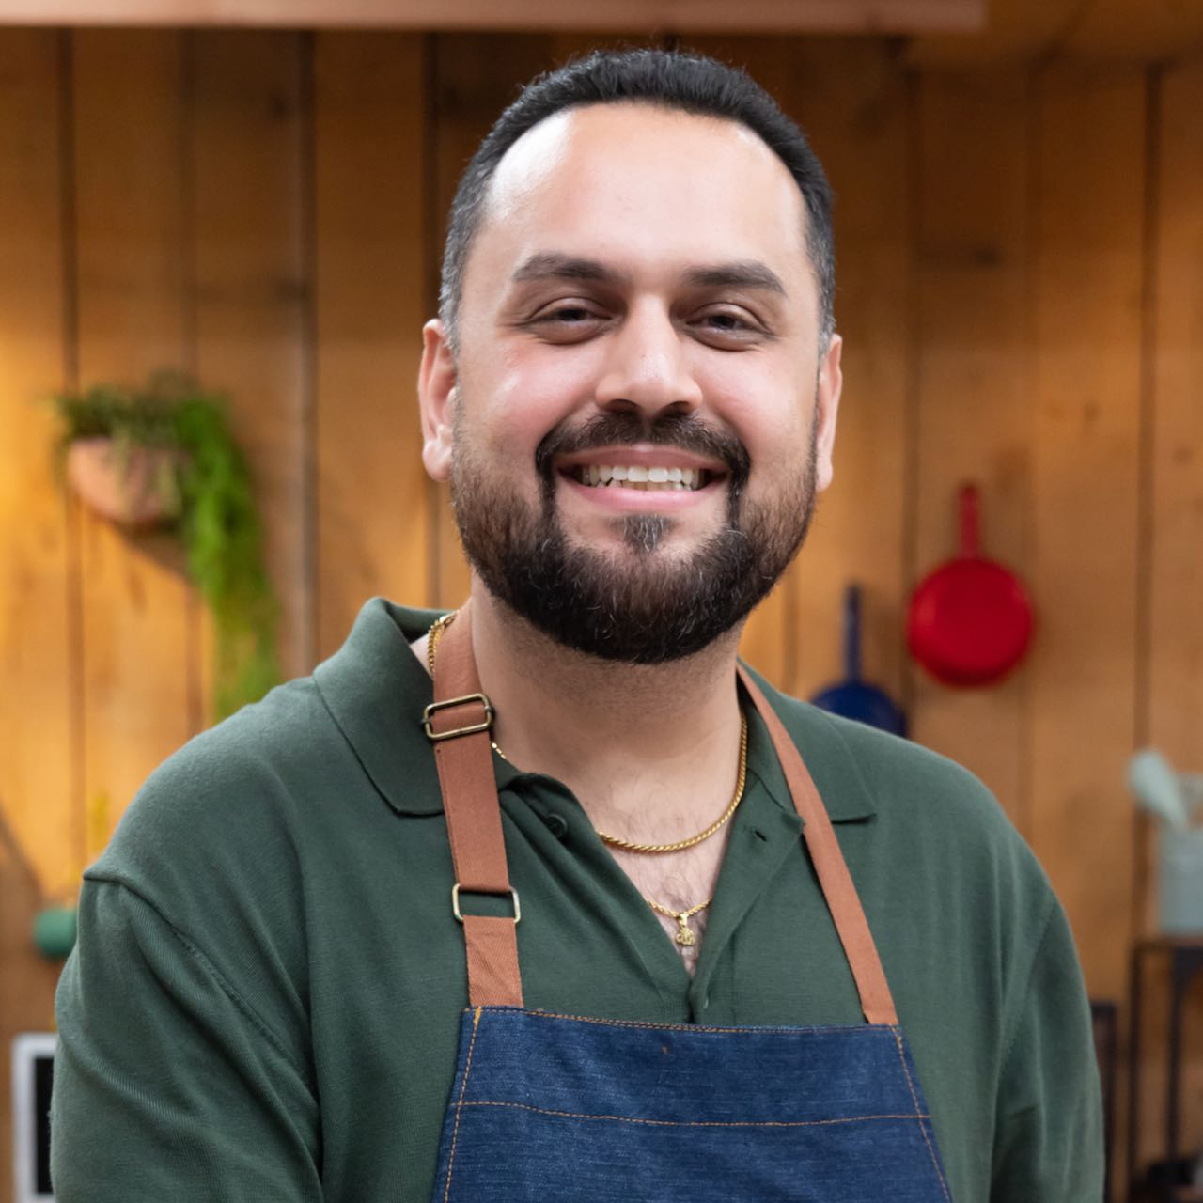
Waigal Safi (San Diego, California) is a foster care specialist who cooks authentic Afghan dishes inspired by recipes passed down through generations from his mother’s side of the family. Waigal’s curiosity about different flavors led him to quietly observe and learn from his mother’s cooking. At 14, when his mother traveled to Afghanistan, he began cooking for his father and quickly discovered his culinary talent. Waigal’s passion for Afghan cuisine goes beyond flavor — he focuses on the artful cultivation and balance of traditional spices, challenging the common misconception that Afghan food is overly spicy. His cooking reflects a deep respect for his family’s heritage. With parents who fled Afghanistan as refugees, preserving family recipes has become a vital link to their homeland and culture. Today, Waigal finds joy in cooking for his family, especially his seven nieces and nephews. His signature dish, Lawand ba Zereshk Palow (chicken in a yogurt-based stew with rice), embodies his dedication to tradition, flavor, and community.

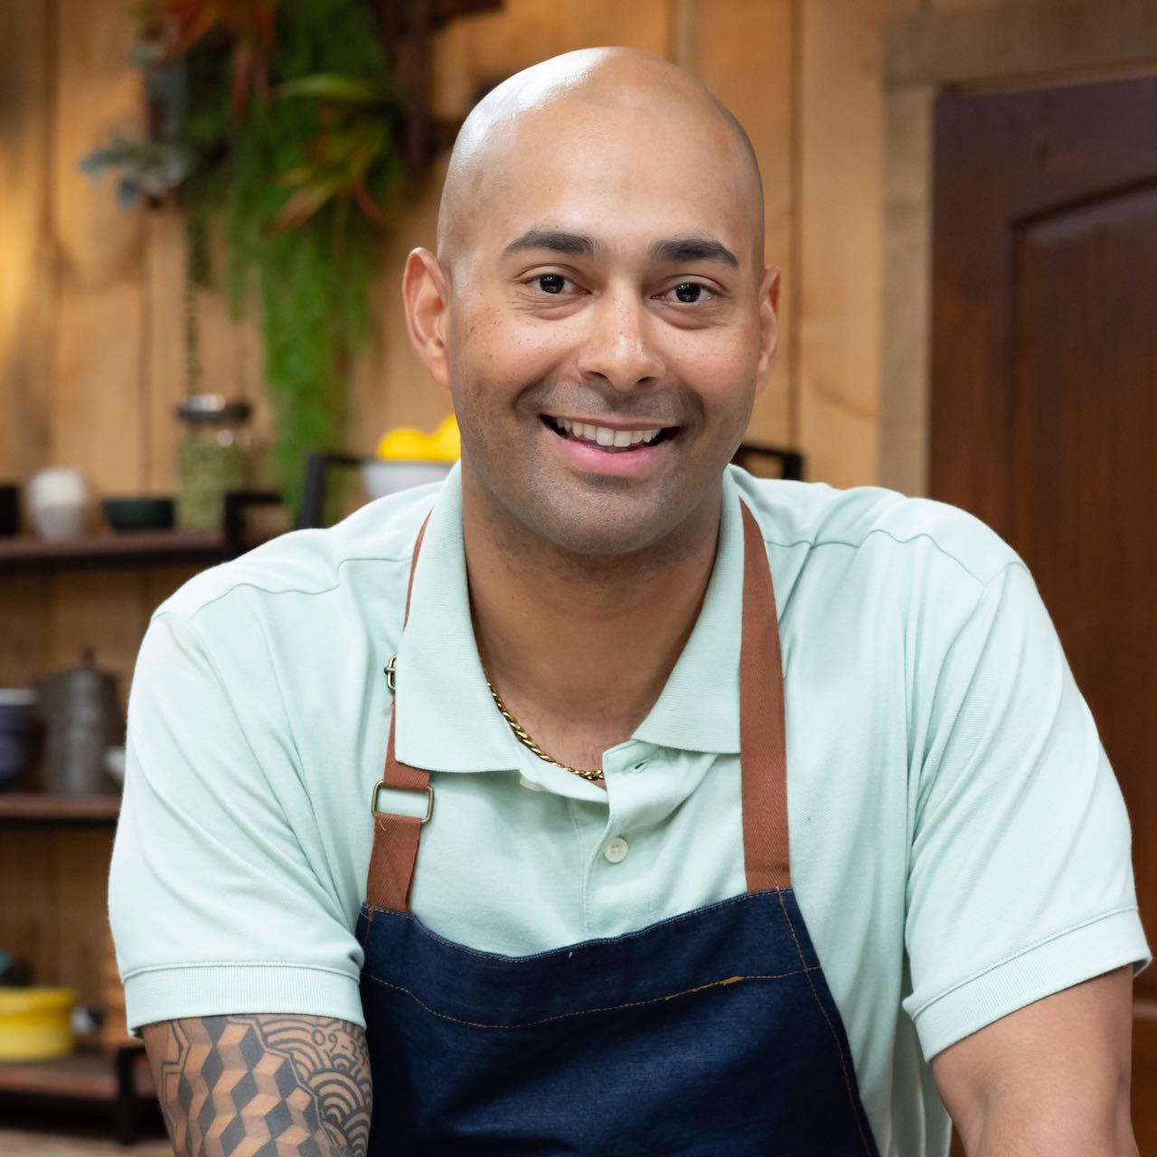
Carlos Tiburcio (formerly Aurora, Colorado, now San Antonio, Texas) is a human resources sergeant in the U.S. Army and a husband and father of two who proudly preserves his Puerto Rican heritage through cooking. Born and raised in Cupey, P.R., he learned traditional recipes at a young age. With his mother working long hours as a nurse, Carlos often prepared meals after school, sparking his lifelong passion for cooking. Carlos elevates his dishes with fresh local produce and premium meats from Colorado while staying true to his Puerto Rican roots. As a father, he’s more committed than ever to keeping those culinary traditions alive, ensuring that his children stay connected to their culture. Carlos leads with heart, compassion, and a spirit of service. His kitchen is a place where love, heritage, and delicious food come together to create lasting memories. His signature dish is Fricasé de Pollo con Arroz Blanco (Chicken Stew with White Rice).

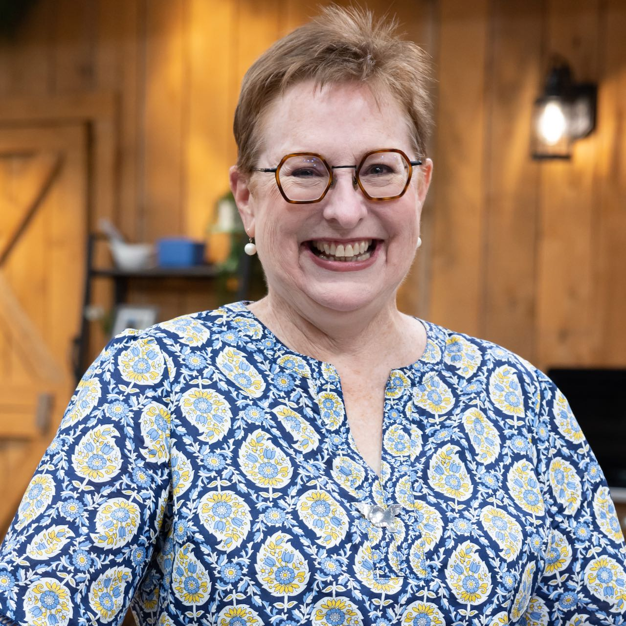
Fran Wescott (Durham, North Carolina), a strategic content consultant, is a wife and mother of two young adults. Her earliest culinary memories are around meals at the dinner table at her childhood home in Durham, her grandparents’ home in Moore County, NC, and in far-flung places where she and her family traveled. While Southern dishes formed the foundation of her cooking, traveling and attending college in the Northeast broadened her palate, inspiring her to elevate those familiar flavors. Fran experienced the profound loss of both parents, and during their final months, lovingly prepared their favorite dishes. THE GREAT AMERICAN RECIPE was an unexpected opportunity to honor their memory and revisit those recipes that now hold additional significance. Fran combines her family’s Southern recipes with locally sourced meats, fresh produce, and global influences. Her signature dish, Shrimp and Grits featuring blue corn grits, beautifully reflects her culinary journey and heritage.

THE GREAT AMERICAN RECIPE will stream simultaneously with broadcast and be available on all station-branded PBS platforms, including PBS.org and the PBS app, available on iOS, Android, Roku, Apple TV, Amazon Fire TV, Android TV, Samsung Smart TV, Chromecast and VIZIO.

Season 4 of THE GREAT AMERICAN RECIPE was filmed at Green Door Gourmet, a 350-acre farm, on-farm market, and agritourism destination in Nashville, Tennessee. THE GREAT AMERICAN RECIPE is co-produced for PBS by VPM and Objective Media Group. Steve Humble is the Executive in Charge for VPM. Zara Frankel is the Executive in Charge for PBS. At Objective Media Group, an All3Media company, Alyssa Hastrich is Showrunner, Layla Smith and Jilly Pearce are Executive Producers and Erin Flinn is Senior Vice President, Current Programming.

About VPM
As Virginia’s home for public media, VPM connects nearly 2 million people across Central Virginia and the Shenandoah Valley to insightful programming in news, education, arts and culture across its television, radio and digital channels. The VPM News team delivers award-winning coverage of Virginia’s General Assembly; statewide politics; educational, economic and legal issues; as well as the news of the day. VPM produces acclaimed series and documentaries, plus a range of music shows with local hosts curating selections in classical, jazz, hop-hop and alternative music. VPM also creates content through its Science Matters initiative and provides early childhood educational resources to families, caregivers and educators. Since 2021, VPM has operated Style Weekly, a magazine centered on deeper arts and culture coverage and local storytelling. Learn more at VPM.org and on Facebook, Bluesky, TikTok, Instagram and several channels on YouTube.

About OBJECTIVE MEDIA GROUP
Objective Media Group, an All3Media company, produces across the US and UK. Original entertainment, reality and scripted programming includes “Lingo” (CBS), “The Cube” (TBS), “Worst Cooks in America” (The Food Network), “Elf on the Shelf: Sweet Showdown (The Food Network) and forthcoming limited series “Wayward” (Netflix).

About PBS
PBS, with more than 330 member stations, offers all Americans the opportunity to explore new ideas and new worlds through television and digital content. Each month, PBS reaches over 36 million adults on linear primetime television, more than 16 million users on PBS-owned streaming platforms, 53 million viewers on YouTube, and 60 million people view PBS content on social media, inviting them to experience the worlds of science, history, nature, and public affairs and to take front-row seats to world-class drama and performances. PBS’s broad array of programs has been consistently honored by the industry’s most coveted award competitions. Teachers of children from pre-K through 12th grade turn to PBS LearningMedia for digital content and services that help bring classroom lessons to life. As the number one educational media brand, PBS KIDS helps children 2-8 build critical skills, enabling them to find success in school and life. Delivered through member stations, PBS KIDS offers high-quality content on TV — including a PBS KIDS channel — and streaming free on pbskids.org and the PBS KIDS Video app, games on the PBS KIDS Games app, and in communities across America. More information about PBS is available at PBS.org, one of the leading dot-org websites on the internet, Facebook, Instagram, or through our apps for mobile and connected devices. Specific program information and updates for press are available at pbs.org/pressroom or by following PBS Communications on X.

– PBS –

CONTACTS:

Atiya Frederick, PBS, anfrederick@pbs.org

Cara White / Mary Lugo, CaraMar, Inc.
cara.white@mac.com; lugo@negia.net

For images and additional up-to-date information on this and other PBS programs, visit PBS PressRoom at pbs.org/pressroom.

