GREAT MUSICIANS OF OUR TIME
Offers Intimate Portraits of Six Extraordinary
Classical Music Artists

Six-Part Series Premieres with “Itzhak Perlman: Virtuoso Violinist”
on Friday, October 9 on PBS, PBS.org and the PBS app

ARLINGTON, VA; September 24, 2026 – GREAT MUSICIANS OF OUR TIME is a six-part series that offers intimate portraits of six of the most influential and celebrated classical music artists: violinists Itzhak Perlman and Pinchas Zukerman, guitarist Andrés Segovia, and pianists Vladimir Ashkenazy, Evgeny Kissin and Daniil Trifonov. Rich in archival footage and filled with candid moments, each episode is a historically important record of a great artist — mostly in their own words — as they reflect on their careers and dazzle with unforgettable performances from around the world. GREAT MUSICIANS OF OUR TIME opens with “Itzhak Perlman: Virtuoso Violinist” on Friday, October 9, 10:00 p.m. ET (check local listings), followed by Episode 2, “Pinchas Zukerman: Here to Make Music,” on Friday, October 16, 10:00 p.m. ET (check local listings) on PBS and streaming on PBS.org and the PBS app.
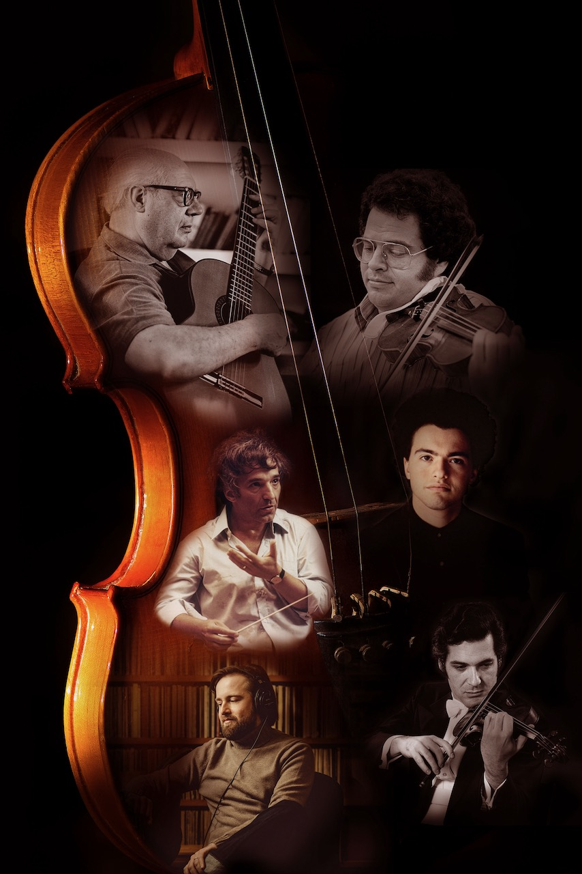
Credit:

GREAT MUSICIANS OF OUR TIME is a tribute to the work of filmmaker Christopher Nupen, who emerged in the 1960s as a pioneer of a new genre of classical music film. Using the first lightweight, silent 16mm film camera, he recorded musicians in close quarters — both backstage and in concert — for the first time. The effects were dramatic, providing new and intimate insights into the workings of great artists and their music-making. Along with the exploding popularity of public television, his films brought music to many people for the first time in their lives.

Episode 1: “Itzhak Perlman: Virtuoso Violinist”
Friday, October 9, 10:00 p.m. ET
Shot over three years (1975-77), this remastered feature-length documentary shows Perlman at home in New York with his family; on tour in Europe with Pinchas Zukerman; playing Sarasate’s “Zigeunerweisen” with the Philharmonia Orchestra of London, conducted by Lawrence Foster; in the studio with Vladimir Ashkenazy, recording Beethoven sonatas; playing Scott Joplin in Wuppertal with Bruno Canino; solo Bach at a BBC Lunchtime Concert in St. John’s, Smith Square, London and rehearsing, performing and teaching at the Aspen Music School in Colorado.
Episode 2: “Pinchas Zukerman: Here to Make Music”
Friday, October 16, 10:00 p.m. ET
Remastered from 16mm film to create a definitive feature-length documentary, this episode showcases the early development and charisma of the Israeli-American violinist, violist and conductor, whose celebrated career has endured over five decades. Shot over a period of seven years (1967-1974) on location in Italy, Israel, Denmark, Germany, London and New York, the film documents the development of his talent, from its beginnings to early maturity. It includes sound recordings of Zukerman’s playing from the age of nine and filmed performances from the age of 19. It also traces the development of Zukerman’s relationship with the English Chamber Orchestra, which led him to conduct for the first time in 1970.

Additional episodes of the series premiere in 2027 as follows:

Episode 3: “Vladimir Ashkenazy: The Vital Juices are Russian”
Sunday, January 10
A remastered documentary of the celebrated Russian pianist, Vladimir Ashkenazy, using archival footage shot between 1966 and 1987. Ashkenazy, who left the Soviet Union in 1963 for a new life in the West, is captured in riveting rehearsal and concert performances across Europe. The film also includes insightful interviews with the pianist reflecting on his life and career.

Episode 4: “Evgeny Kissin: The Gift of Music”
Sunday, January 17
With dazzling virtuosity and unmistakable star appeal, Russian pianist Evgeny Kissin had a meteoric rise to the top of the international concert circuit. Filmed when Kissin was 26 years old, Episode 4 culminates in his now-legendary Promenade concert at the Royal Albert Hall in 1997, the first Prom in the event’s 103-year history to be given by a solo recitalist. The audience’s enthusiasm resulted in Kissin playing the longest succession of encores in the entire history of the Proms.

Episode 5: “Andrés Segovia: The Song of the Guitar”
Sunday, January 24
Andalusian maestro Andrés Segovia taught himself how to play the guitar, revolutionized the technique, and won acceptance for the instrument on concert platforms all over the world. During a career that lasted 78 years, he performed over 5,000 concerts and championed dozens of new compositions on a tireless quest to expand the guitar’s repertoire — a unique achievement in the history of Western music.

Episode 6: “Daniil Trifonov: The Magics of Music”
Sunday, January 31
Established as perhaps the finest pianist of his generation, Russian virtuoso Daniil Trifonov has musical gifts that must be seen and heard to be believed. Born in 1991, Trifonov is a superbly talented musician for whom composing, improvising, and performing flow seamlessly together. The film includes complete live performances of several Chopin preludes, extracts of works by Ravel, Scriabin, Strauss and the rarely heard Rachmaninov’s Variations on a Theme of Chopin, Opus 22.

GREAT MUSICIANS OF OUR TIME will stream simultaneously with broadcast and be available on all station-branded PBS platforms, including PBS.org and the PBS app, which is available on iOS, Apple TV, Android mobile and tablets, Android/Google TV, Roku, Amazon Fire TV and tablets, Comcast, Samsung Smart TV, VIZIO and LG Smart TVs.

GREAT MUSICIANS OF OUR TIME is a production of Allegro Films for PBS. Christopher Nupen is director, writer and narrator. Caroline Nupen is executive producer and Matthew Percival is series producer.

About PBS
PBS, with more than 330 member stations, offers all Americans the opportunity to explore new ideas and new worlds through television and digital content. Each month, PBS reaches over 36 million adults on linear primetime television, 16 million users on PBS-owned streaming platforms, 56 million viewers on YouTube, and 10 million followers on social media, inviting them to experience the worlds of science, history, nature, and public affairs and to take front-row seats to world-class drama and performances. PBS’s broad array of programs has been consistently honored by the industry’s most coveted award competitions. As the number one educational media brand, PBS KIDS helps children 2-8 build critical skills, enabling them to find success in school and life. Delivered through member stations, PBS KIDS offers high-quality content on TV — including a PBS KIDS channel — and streaming free on pbskids.org and the PBS KIDS Video app, games on the PBS KIDS Games app, and in communities across America. Teachers of children from pre-K through 12th grade turn to PBS LearningMedia for digital content and services that help bring classroom lessons to life. More information about PBS is available at PBS.org, one of the leading dot-org websites on the internet, Facebook, Instagram, or through our apps for mobile and connected devices. Specific program information and updates for press are available at pbs.org/pressroom or by following PBS Communications on X.

– PBS –
CONTACTS:

Meredith Tiger, PBS, mjtiger@pbs.org

Cara White / Mary Lugo, CaraMar, Inc.
cara.white@mac.com; lugo@negia.net

For images and additional up-to-date information on this and other PBS programs, visit PBS PressRoom at pbs.org/pressroom.

