THE 39th HISPANIC HERITAGE AWARDS PREMIERES
FRIDAY, OCTOBER 2 ON PBS

The ceremony will also stream on PBS.org and the PBS app,
in celebration of Hispanic Heritage Month

2026 Honorees: The People of Minnesota (Humanitarian Award),
Oscar D’León (Legend Award), Mon Laferte (Social Justice Award),
Eladio Carrión (Inspira Award), and Ximena Sariñana (Music Award)

Special Headline Music Performance By Previous Legend Honorees
Los Tigres Del Norte

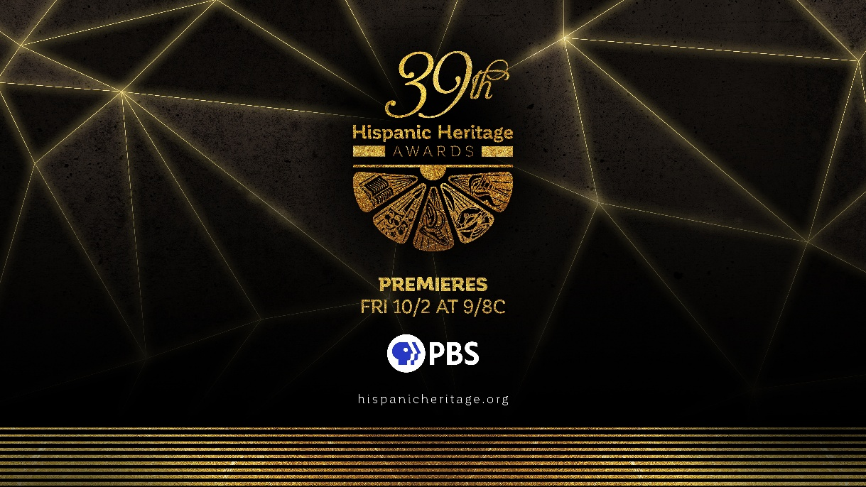

WASHINGTON, D.C. 9/24/2026 - The Hispanic Heritage Foundation (HHF) and PBS announced today that the 39th Annual Hispanic Heritage Awards premieres Friday, October 2 at 9:00 p.m. ET on PBS (check local listings). The awards, taped for broadcast on Thursday, September 10, at Orchestra Hall in Minneapolis, Minnesota, will also stream on PBS.org and the PBS app in celebration of Hispanic Heritage Month.

This year’s Hispanic Heritage Awards honors The People of Minnesota with the Humanitarian Award in recognition of their collective strength, resilience, compassion, and courageous action in times of crisis, and their commitment to fostering unity among all communities. Additional honorees include singer/musician Oscar D’León (Legend Award), along with singer-songwriter Mon Laferte (Social Justice Award), rapper Eladio Carrión (Inspira Award), and singer-songwriter-actress Ximena Sariñana (Music Award), with all three artists performing on the broadcast. The ceremony is hosted by celebrated stand-up comedian and entertainer Anjelah Johnson-Reyes, and also features a very special return from seven-time GRAMMY winners and previous HHA Legend Award honorees Los Tigres Del Norte as the headline performers.

“We are privileged and grateful to once again partner with PBS and all of our sponsors to celebrate and share our community’s accomplishments, cultural pride, and great promise to America and the world,” said Antonio Tijerino, President and CEO of the Hispanic Heritage Foundation. “The PBS broadcast and streaming will ensure our inspiring stories will be seen broadly to foment a greater understanding and appreciation of the Latino community.”

“Every year, the Hispanic Heritage Awards reminds us how much strength lives in community,” said Zara Frankel, Senior Director, Programming & Development. “PBS is honored to partner with the Hispanic Heritage Foundation to celebrate honorees who remind us what's possible when communities show up for each other.”

The Hispanic Heritage Awards were established by the White House in 1988 to commemorate the creation of Hispanic Heritage Month in America and are recognized as “America’s Hispanic Heritage Month Celebration” and supported by more than 40 national, Latino-serving institutions.

Past Awardees have included: Rita Moreno, Justice Sonia Sotomayor, Gloria Estefan, Bad Bunny, Celia Cruz, Martin Sheen, Tito Puente, Ricky Martin, Anthony Quinn, Fania All-Stars, Junot Diaz, José Feliciano, Isabel Allende, Carolina Herrera, Jose Andres, Juanes, Antonio Banderas, Juan Luis Guerra, Carlos Vives, Alejandro Sanz, J Balvin, Zoe Saldaña, Los Tigres Del Norte, Oscar de la Hoya, America Ferrera, Pedro Martinez, Daddy Yankee, Astronaut Dr. Ellen Ochoa, Gael Garcia Bernal, Carlos Santana, Salma Hayek, Linda Ronstadt, Karol G, Richard “Crazy Legs” Colon, and more inspiring figures ranging from essential farmworkers to pioneering NASA engineers. Find all past HHA Honorees HERE.

About the Hispanic Heritage Awards
The Hispanic Heritage Awards serve as a launch of HHF’s year-round mission, focused on economic mobility, stronger communities, positive narratives and cultural pride through education, workforce development, service, societal impact, entrepreneurship, and leadership. Visit https://hhflink.org/WeAreHere for a video highlighting HHF’s award-winning programs, and visit the website at www.HispanicHeritage.org. Follow HHF on Instagram, Facebook, X, and TikTok. Listen to the HHF podcast Fritanga on your favorite streaming service and HHF YouTube channel.

About PBS
PBS, with more than 330 member stations, offers all Americans the opportunity to explore new ideas and new worlds through television and digital content. Each month, PBS reaches over 36 million adults on linear primetime television, 16 million users on PBS-owned streaming platforms, 56 million viewers on YouTube, and 10 million followers on social media, inviting them to experience the worlds of science, history, nature, and public affairs and to take front-row seats to world-class drama and performances. PBS’s broad array of programs has been consistently honored by the industry’s most coveted award competitions. As the number one educational media brand, PBS KIDS helps children 2-8 build critical skills, enabling them to find success in school and life. Delivered through member stations, PBS KIDS offers high-quality content on TV — including a PBS KIDS channel — and streaming free on pbskids.org and the PBS KIDS Video app, games on the PBS KIDS Games app, and in communities across America. Teachers of children from pre-K through 12th grade turn to PBS LearningMedia for digital content and services that help bring classroom lessons to life. More information about PBS is available at PBS.org, one of the leading dot-org websites on the internet, Facebook, Instagram, or through our apps for mobile and connected devices. Specific program information and updates for press are available at pbs.org/pressroom or by following PBS Communications on X.
###
For more information on the 39th Hispanic Heritage Awards, please contact John Reilly, jreilly@jrprmusic.com or Nicolás Peña, Nicolas@HispanicHeritage.org
For PBS:
Anna Merrill, admerrill@pbs.org

Cara White / Mary Lugo, CaraMar, Inc.
cara.white@mac.com; lugo@negia.net

