Bios
One Person, One Vote? on Independent Lens
Mon, Sept 30 on PBS and PBS app
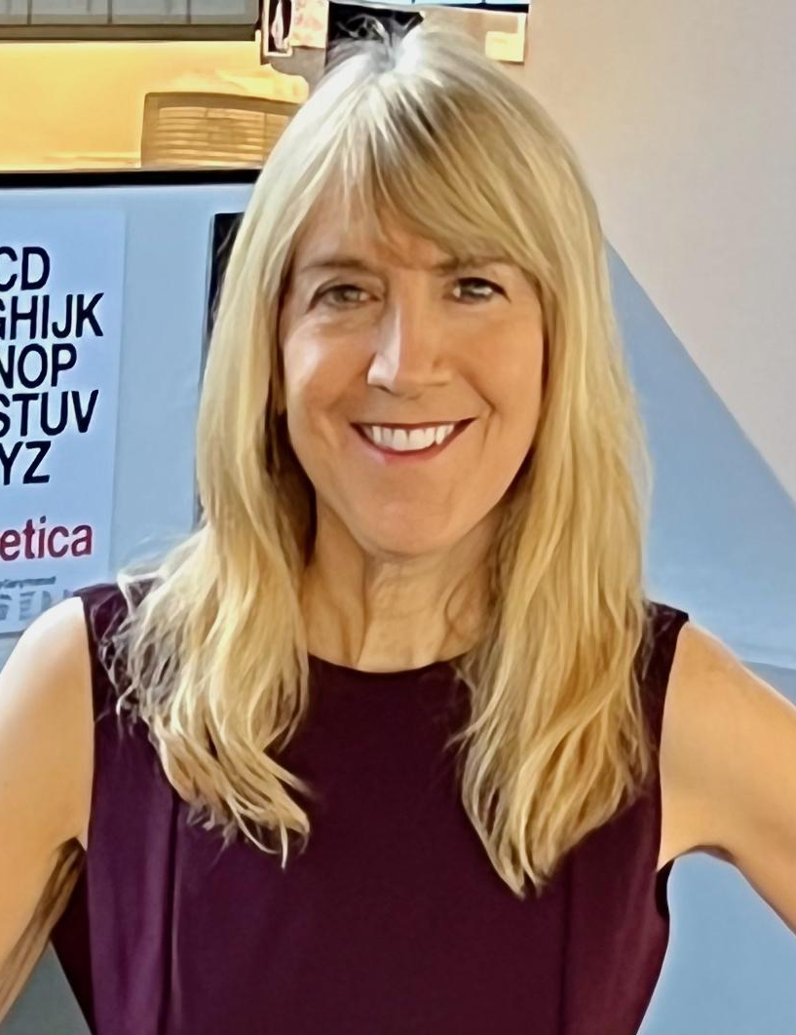
Lois Vossen (Moderator, Independent Lens EP)

LOIS VOSSEN is the founding executive producer of Independent Lens on PBS since 2002. She leads the programming, made by independent filmmakers, of a diverse slate of 25-30 original documentaries each season about an array of social, political and cultural issues, and Independent Lens evolution into a multiplatform series. Under her leadership, Independent Lens has become synonymous with high-quality, award-winning documentaries on timely topics including Philly DA, Belly of the Beast, I Am Not Your Negro, Tower, and The Invisible War. Awarded Best Series by the International Documentary Association (IDA) five times, Independent Lens is recognized with the industry's most prestigious honors, including more than 75 Peabody, Emmy and duPont-Columbia Awards and Academy Award nominations.

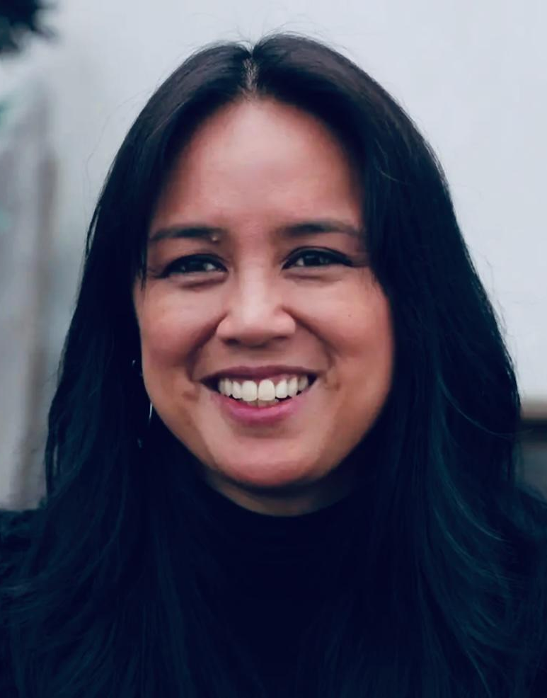
Maximina Juson (Director, Producer, Cinematographer)

Maximina Juson is an award-winning filmmaker and founder of HUMovies, a film production company in Los Angeles. Her debut feature film, One Person, One Vote? is a National Endowment for the Humanities grant recipient that world premiered at the Pan African Film Festival, taking home the Programmers’ Award for Best Documentary Feature.

@1person1votedoc

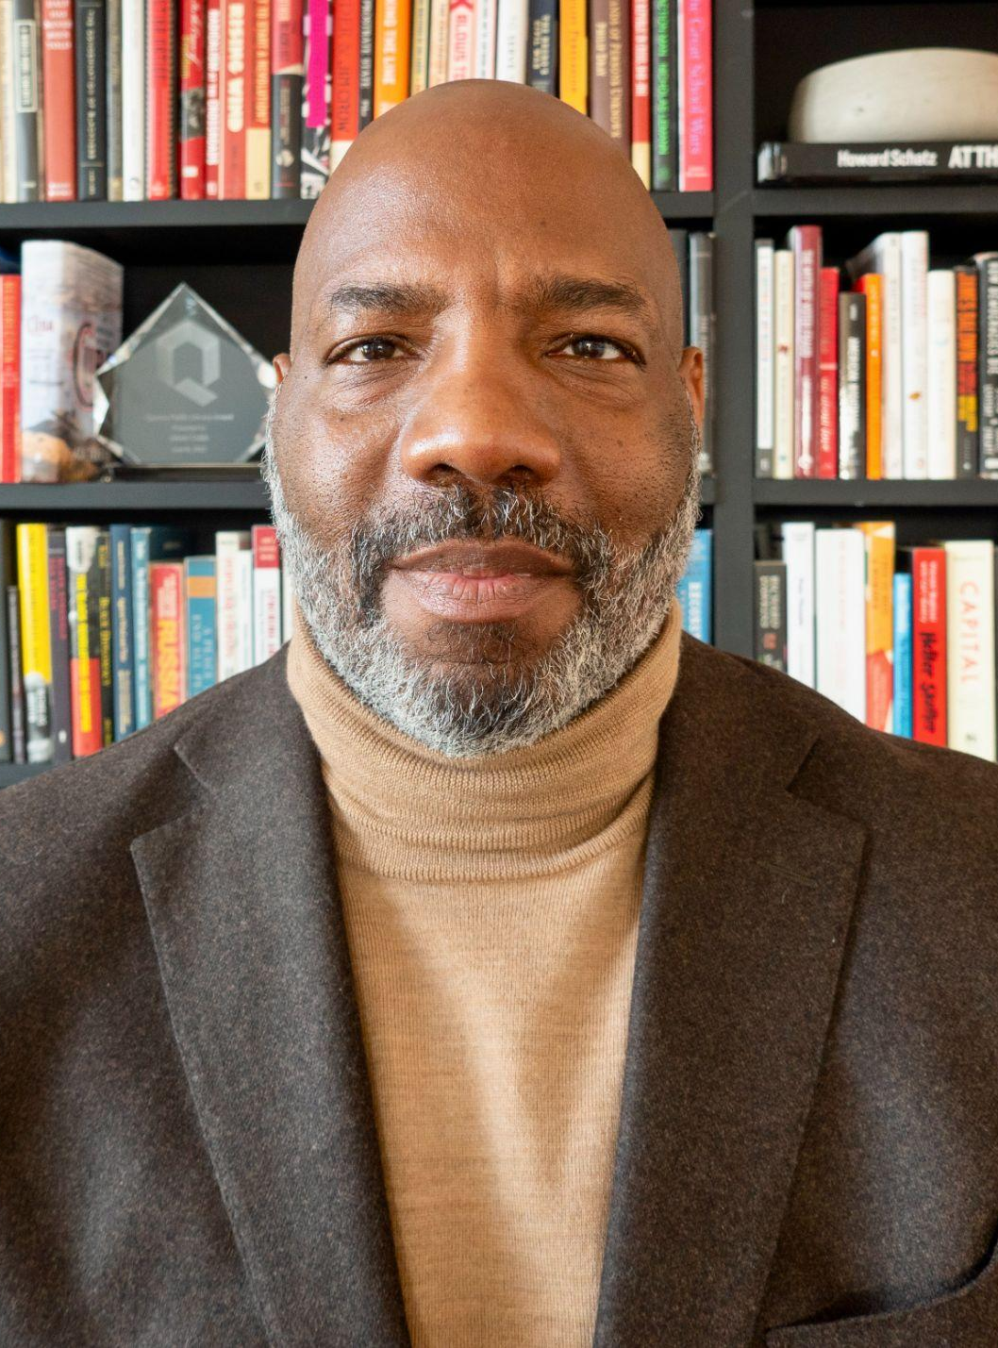
Jelani Cobb (Dean and Professor, Columbia Journalism School and staff writer at The New Yorker)

Jelani Cobb joined the Columbia Journalism School faculty in 2016 and became Dean in 2022. He has been a staff writer at The New Yorker since 2015. He received a Peabody Award for his 2020 PBS Frontline film Whose Vote Counts? and was a finalist for the Pulitzer Prize in Commentary in 2018. He has also been a political analyst for MSNBC since 2019.
He is the author of The Substance of Hope: Barack Obama and the Paradox of Progress and To the Break of Dawn: A Freestyle on the Hip Hop Aesthetic. He is the editor or co-editor of several volumes including The Matter of Black Lives, a collection of The New Yorker’s writings on race and The Essential Kerner Commission Report. He is producer or co-producer on a number of documentaries including Lincoln’s Dilemma, Obama: A More Perfect Union and Policing the Police.
Dr. Cobb was educated at Jamaica High School in Queens, NY, Howard University, where he earned a B.A. in English, and Rutgers University, where he completed his MA and doctorate in American History in 2003. He is also a recipient of fellowships from the Ford Foundation, the Fulbright Foundation and the Shorenstein Center at Harvard University’s Kennedy School of Government.
He currently serves on the Board of Directors of the American Journalism Project, and was elected to the American Academy of Arts & Sciences in 2023.
@jelani1906

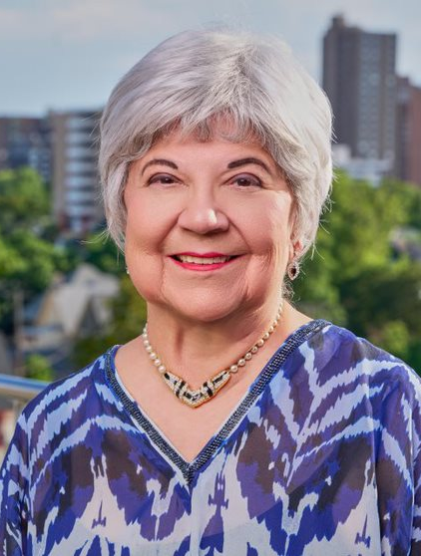
Polly Baca (Democratic Elector and former Chair of the Democratic Caucus of the Colorado State Senate)

Senator Polly Baca served in both the Colorado House of Representatives (1975-1978) and the Colorado Senate (1979-1986). She was the first woman elected to chair the Democratic Caucus of the Colorado House (1977), the first woman of color and first Hispanic woman elected to the Colorado State Senate (1978-1986), the first Hispanic woman in the U.S. to be nominated by a major political party for the U.S. Congress (1980 Democratic Party Congressional nominee), and
the first Hispanic woman to co-chair two National Democratic Conventions (1980 and 1984). Sen. Baca was also the first person of color to be elected to the
Colorado State Legislature from Adams County (1974). She served as Vice Chair of the National Democratic Party for eight years, from 1981 to 1989.

Sen. Baca has worked for three Presidents of the United States. She was a Public Information Officer for a White House Agency during the Lyndon B. Johnson Administration, was the Rocky Mountain States Coordinator for President Jimmy Carter’s 1980 Presidential campaign, and was Special Assistant to President Bill Clinton for Consumer Affairs and Director of the United States Office of Consumer Affairs. Sen. Baca served as a National Co-Chair of Catholics for Obama in 2012 and National Co-Chair of Catholics for Biden/Harris in 2020. At the 2016 National Democratic Convention, Sen. Baca served as the Colorado Whip Captain for the Hillary Clinton for President campaign.

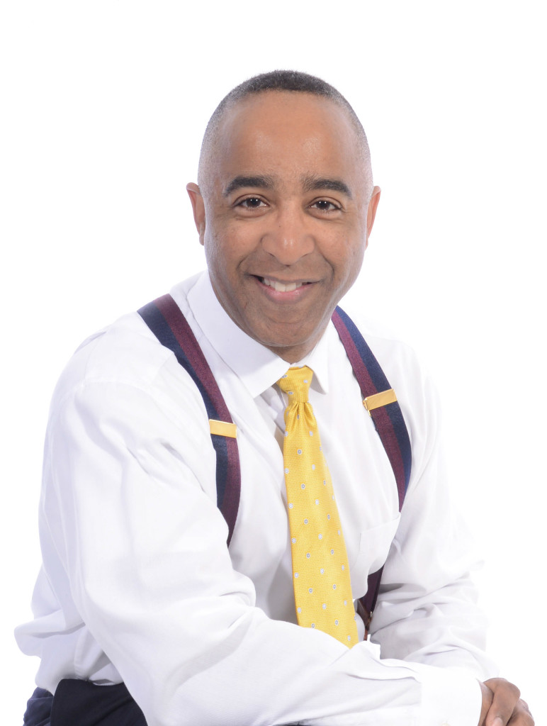
Derrick Wilburn (Republican Elector and Founder and Executive Director of the Rocky Mountain Black Conservatives)

Married 29 years and father of three amazing children, Derrick is the founder and Executive Director of the Rocky Mountain Black Conservatives and the driving force behind the POC Capitol Interns. His organization’s and personal mission are to bridge the gap that exists between conservative political causes, parties, candidates and officer-holders and ethnic-minorities in the USA.

He holds a Bachelor’s of Science degree in marketing and economics, as well as a Master’s of Business Administration from the University of San Francisco, has served as a faculty adjunct in the undergraduate school of business at the University of Phoenix’s San Jose California campus and currently teaches at Charis Bible College in Woodland Park, Colorado. He's been published nationally by multiple internet news sites including American Thinker, Daily Caller, Townhall, CNS News, speaks at conferences, conventions, rallies, universities, and political gatherings and has been featured on national news networks.

