KING OF THEM ALL: THE STORY OF KING RECORDS PREMIERES FRIDAY, OCTOBER 10 on PBS

KING OF THEM ALL: THE STORY OF KING RECORDS Unveils The Incredible Untold Story of the Groundbreaking Record Label

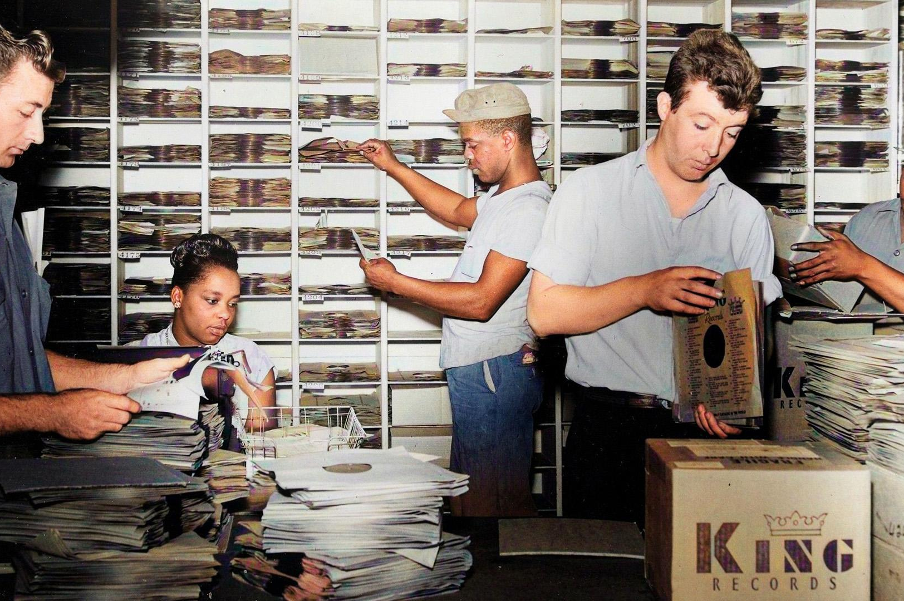
Caption: Signature image.
Credit: Afrochine
CINCINNATTI, OH; SEPTEMBER 18, 2025 -- KING OF THEM ALL: THE STORY OF KING RECORDS, a new feature-length documentary directed and produced by Cincinnati filmmaker Yemi Oyediran, will premiere nationwide on Friday, October 10, 2025, 9:00-10:00 p.m. ET (check local listings) on PBS, pbs.org and the PBS app, bringing to light the untold story of one of America’s most groundbreaking record labels.

Founded in 1943 by Syd Nathan, King Records reshaped the American musical landscape by recording country, rhythm & blues, and rock ’n’ roll under one roof—at a time when the music industry, and the nation itself, was divided by race and genre. The label launched the careers of legendary artists, including James Brown, Wynonie Harris, Hank Ballard, Little Willie John, The Stanley Brothers, and countless others whose influence can still be heard today.

Blending rare archival footage, newly colorized film reels, hand-drawn 1950s-style animation, and exclusive interviews with musicians, historians, and industry veterans, KING OF THEM ALL: THE STORY OF KING RECORDS is both a love letter to Cincinnati and a testament to King Records’ outsized role in shaping global popular music.

As part of PBS’s unwavering commitment to independent filmmakers, we’re thrilled to support Yemi Oyediran through our Open Call for Emerging Filmmakers program,” said Wendy Llinás, Senior Director, Programming & Development at PBS. “KING OF THEM ALL: THE STORY OF KING RECORDS illuminates the unsung heroes who have shaped the soundtrack of American life and demonstrates the essential storytelling PBS uniquely platforms for national audiences.”

Director and Producer Yemi Oyediran adds that “King Records was far more than a record label—it was a revolution in sound and spirit. At a time when the country and the industry were divided by race and genre, King proved that great music has no boundaries. From James Brown to the Stanley Brothers, its artists helped shape the soundtrack of the 20th century. This film is about giving long-overdue recognition to the visionaries who changed American culture from right here in Cincinnati, and it has been an honor to bring their voices and legacies to the screen through the PBS platform.”

The film underscores the Midwest’s central role in American music history and features commentary from Vince Gill, Christian McBride, Seymour Stein, Tammy Kernodle, Alan Leeds, Clyde Brown, Daru Jones, John Curley, and others, alongside newly unearthed perspectives from the families of King Records’ artists and staff. View the film’s teaser trailer HERE.

KING OF THEM ALL: THE STORY OF KING RECORDS will stream October 10, 2025 and be available on all station-branded PBS platforms, including PBS.org and the PBS app, available on iOS, Android, Roku, Apple TV, Amazon Fire TV, Android TV, Samsung Smart TV, Chromecast and VIZIO.

Major Funding for KING OF THEM ALL: THE STORY OF KING RECORDS was provided by Greater Cincinnati Foundation, Bailey Lamson Family Foundation, Carol Ann and Ralph V. Haile, Jr. Foundation, Warrington Foundation, and Louise Semple Taft Foundation. Additional funding provided by Ohio Humanities, The Stephen H. Wilder Foundation, FC Cincinnati Foundation, The Erma A. Bantz Foundation, Cincinnati Institute of Fine Arts, Scott and Julie Jolson, and by viewers like you.

KING OF THEM ALL: THE STORY OF KING RECORDS is produced by Afrochine in partnership with PBS’s Open Call for Emerging Filmmakers. Directed by Yemi Oyediran and produced by Oyediran and JP Leong, it marks the feature-length directorial debut of Oyediran. Executive in charge for PBS is Wendy Llinás.

About Afrochine
Afrochine is a Cincinnati-based media collective dedicated to producing films, music, and cultural projects that highlight overlooked histories and amplify communal narratives. Founded by filmmaker and musician Yemi Oyediran and creative partner JP Leong, Afrochine blends storytelling, scholarship, and innovation to create work that bridges past and present. From documentary filmmaking to music production and education, Afrochine projects are rooted in uncovering untold stories and fostering deeper cultural understanding.

Afrochine’s debut feature, King of Them All: The Story of King Records, will premiere nationally on PBS in 2025. The collective continues to develop films and creative initiatives that connect local histories to global conversations in music, race, and culture.
About PBS
PBS, with more than 330 member stations, offers all Americans the opportunity to explore new ideas and new worlds through television and digital content. Each month, PBS reaches over 36 million adults on linear primetime television, more than 16 million users on PBS-owned streaming platforms, 53 million viewers on YouTube, and 10 million people follow PBS content on social media, inviting them to experience the worlds of science, history, nature, and public affairs and to take front-row seats to world-class drama and performances. PBS’s broad array of programs has been consistently honored by the industry’s most coveted award competitions. Teachers of children from pre-K through 12th grade turn to PBS LearningMedia for digital content and services that help bring classroom lessons to life. As the number one educational media brand, PBS KIDS helps children 2-8 build critical skills, enabling them to find success in school and life. Delivered through member stations, PBS KIDS offers high-quality content on TV — including a PBS KIDS channel — and streaming free on pbskids.org and the PBS KIDS Video app, games on the PBS KIDS Games app, and in communities across America. More information about PBS is available at PBS.org, one of the leading dot-org websites on the internet, Facebook, Instagram, or through our apps for mobile and connected devices. Specific program information and updates for press are available at pbs.org/pressroom or by following PBS Communications on X.

– PBS –

CONTACTS:
Stephanie Kennard, PBS, skkennard@pbs.org

42West, KingOfThemAll@42west.com

For images and additional up-to-date information on this and other PBS programs, visit PBS PressRoom at pbs.org/pressroom.

