New Four-Part Series
LUCY WORSLEY’S KEYS TO THE CASTLE
Premieres Sundays, December 6-27 on PBS, PBS.org
and the PBS app

Join the Popular Historian for a Rare, Behind-the-Scenes Look at Four of Europe’s Most Iconic Castles

ARLINGTON, VA; date – After more than two decades as Chief Curator of Britain’s Historic Palaces, historian Lucy Worsley knows her way around a castle. Now, armed with the keys to four iconic palaces — the Doge’s Palace in Venice, the Palace of Versailles in France, Britain’s Blenheim Palace and Neuschwanstein Castle in Germany — Worsley leads viewers behind the velvet ropes into hidden rooms, sealed archives and private spaces, uncovering stories of obsession, heroic escapades, stolen treasure and the secret life of a notorious queen. “This is my dream project,” says Worsley. “I’ve had years of being behind the scenes at various castles and palaces and know how much fun it can be, and I can’t wait to share that with viewers.” LUCY WORSLEY’S KEYS TO THE CASTLE premieres Sundays, December 6-27, 2026, at 8:00 p.m. ET (check local listings) on PBS, PBS.org and the PBS app.
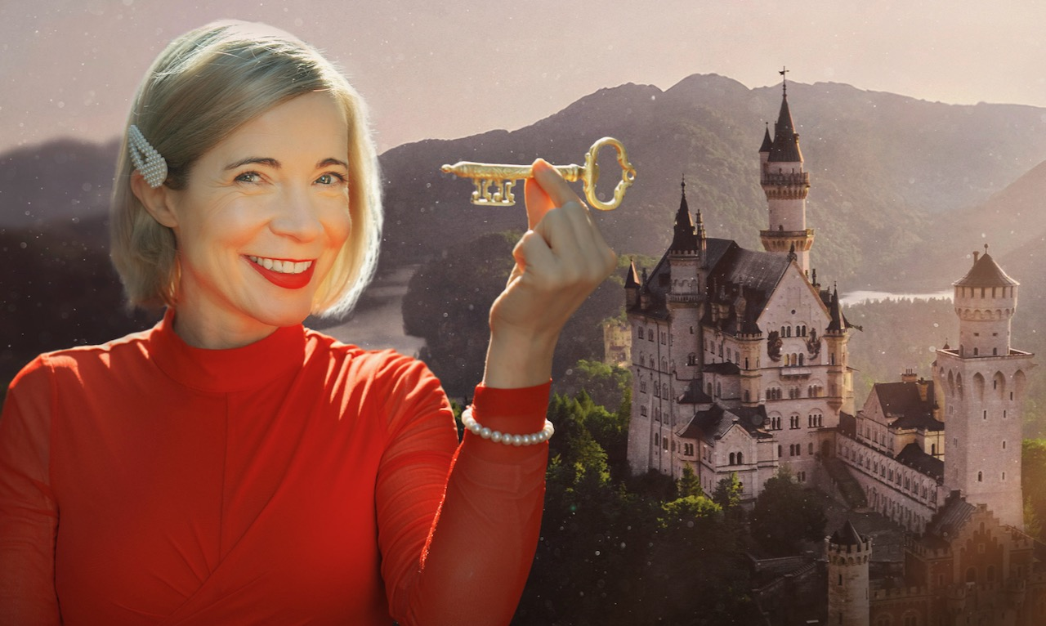
Credit: BBC Studios

Over four episodes, Worsley guides viewers through the architecture, design, art, personal treasures and artifacts found in spaces the public rarely gets to see, using the castles to offer a fascinating take on some of history’s most important events and the people who lived them. From Marie Antoinette to Winston Churchill, the doges of Venice to “Mad” King Ludwig, the residents of these palaces not only shaped these castles but were shaped by them.

Episode 1 – “Versailles” (December 6)
Lucy Worsley visits the spectacular Palace of Versailles and goes beyond the ostentatious state rooms into the private quarters of its most notorious resident, Marie Antoinette. Only 14 when she married and 18 when she became Queen, her life was ruled by rigid etiquette and constant surveillance. Yet, within the magnificence of Versailles, the young woman carved out private spaces where she could relax with friends and her children. Venturing behind hidden doors into these little-seen refuges, Lucy discovers details that paint an intimate picture of the Queen’s daily life. It’s a dramatic tale of money, sex, power — and snowy white goats.

Episode 2 – “Doge’s Palace” (December 13)
At the Doge’s Palace in Venice, Lucy uncovers the dark secrets hiding in one of the city’s most ornate buildings — the nerve center of one of the world’s most glorious empires. Stretching from northern Italy to the Black Sea, Venice’s empire lasted a thousand years, with the Doge’s Palace as its opulent seat of power. Wowed by a 24-carat gold staircase and magnificent art, Lucy explores one of Europe’s grandest rooms, but darker corners hint at the brutality meted out to enemies of the state. Behind the gilding, Lucy uncovers long-lost messages from the past and has a close shave in a Venetian torture chamber.

Episode 3 – “Blenheim Palace” (December 20)
In the Cotswolds market town of Woodstock, Lucy Worsley visits Blenheim Palace to uncover how a twist of fate, the invention of the corridor and a stolen head helped wartime leader Winston Churchill fulfill his destiny. Gifted to the first Duke of Marlborough by Queen Anne in 1704, Blenheim was not only the site of the birth of the Duke’s six-times great-grandson Winston, but it would serve as a roadmap for Winston’s life as a great military leader. In this episode, Lucy explores places ordinary tour guides aren’t allowed, including an abandoned attic, a ballroom hidden inside a bridge, and the highest point of the palace for a rooftop rendezvous with a king.

Episode 4 - “Neuschwanstein Castle” (December 27)
Historian Lucy Worsley explores how the fairytale rooms of Neuschwanstein Castle — the inspiration for the iconic Disney castle — reveal the tragic story of the handsome young king who built it. High in the Bavarian Alps, the castle was the fantastical creation of Bavarian King Ludwig II. Imaginative, creative and secretive, Ludwig was obsessed with romantic art and Wagnerian opera, and his castle became a stage set for his obsessive fantasies. With the castle all to herself, Lucy discovers a golden throne room with no throne, a royal diary full of scandalous secrets, and a hidden stash of priceless art.

LUCY WORSLEY’S KEYS TO THE CASTLE will stream simultaneously with broadcast and be available on all station-branded PBS platforms, including PBS.org and the PBS app, which is available on iOS, Apple TV, Android mobile and tablets, Android/Google TV, Roku, Amazon Fire TV and tablets, Comcast, Samsung Smart TV, VIZIO and LG Smart TVs.

LUCY WORSLEY’S KEYS TO THE CASTLE, a 4x60’ for BBC Two and BBC iPlayer, is made by BBC Studios Specialist Factual Productions. It was commissioned by Alistair Pegg, Commissioning Editor BBC Arts, and Suzy Klein, Head of Arts and Classical Music TV for the BBC. Zara Frankel is the Executive in Charge for PBS. The Executive Producer is Amanda Lyon, and the Series Producer is Victoria Bell. BBC Studios is handling global sales.
About Lucy Worsley
For over two decades, Lucy Worsley, OBE, served as the Chief Curator at Historic Royal Palaces in the U.K. She is the author of popular books about Jane Austen and Queen Victoria and the Sunday Times No. 1 bestselling biography of Agatha Christie. Her most recent book is Queens and Kings: An Unusually Personal History. She is the host of dozens of PBS specials and series including Lucy Worsley Investigates, Lucy Worsley’s Holmes Vs. Doyle, Agatha Christie: Lucy Worsley On The Mystery Queen, Lucy Worsley’s Royal Myths And Secrets, A Very British Romance With Lucy Worsley, 12 Days Of Tudor Christmas, Victoria & Albert: The Wedding, Tales From The Royal Bedchamber, and more. She also hosts the hit BBC Radio 4 podcasts “Lady Killers” and “Lady Swindlers With Lucy Worsley,” which investigate the crimes of Victorian women from a contemporary, feminist perspective, and runs her popular Substack, My Life In The Past.

About PBS
PBS, with more than 330 member stations, offers all Americans the opportunity to explore new ideas and new worlds through television and digital content. Each month, PBS reaches over 36 million adults on linear primetime television, 16 million users on PBS-owned streaming platforms, 56 million viewers on YouTube, and 10 million followers on social media, inviting them to experience the worlds of science, history, nature, and public affairs and to take front-row seats to world-class drama and performances. PBS’s broad array of programs has been consistently honored by the industry’s most coveted award competitions. As the number one educational media brand, PBS KIDS helps children 2-8 build critical skills, enabling them to find success in school and life. Delivered through member stations, PBS KIDS offers high-quality content on TV — including a PBS KIDS channel — and streaming free on pbskids.org and the PBS KIDS Video app, games on the PBS KIDS Games app, and in communities across America. Teachers of children from pre-K through 12th grade turn to PBS LearningMedia for digital content and services that help bring classroom lessons to life. More information about PBS is available at PBS.org, one of the leading dot-org websites on the internet, Facebook, Instagram, or through our apps for mobile and connected devices. Specific program information and updates for press are available at pbs.org/pressroom or by following PBS Communications on X.

– PBS –
CONTACTS:

Atiya Frederick, PBS, anfrederick@pbs.org

Cara White / Mary Lugo, CaraMar, Inc.
cara.white@mac.com; lugo@negia.net

For images and additional up-to-date information on this and other PBS programs, visit PBS PressRoom at pbs.org/pressroom.

