PBS Announces MEDICINE BALL, New Documentary Exploring Basketball's Complex Legacy in Native American Communities

Premieres Monday, November 9, 2026, at 10 p.m. ET on PBS & PBS App

View Trailer

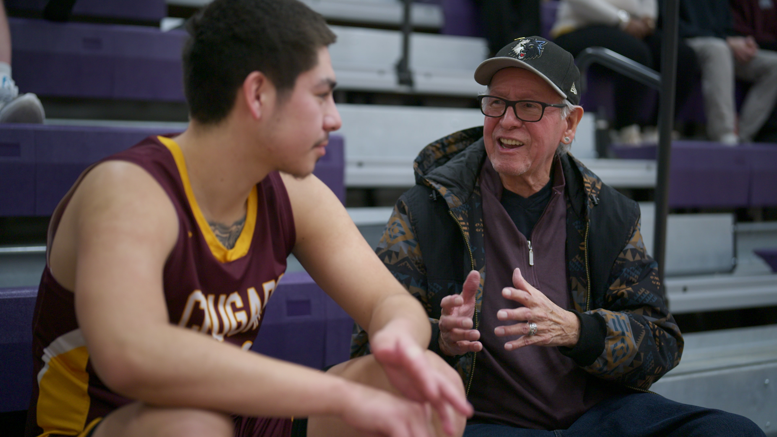
Arlington, VA; (November 2, 2026) – PBS will present MEDICINE BALL, a new hour-long documentary following Native American college student-athletes as they examine the complex history of basketball in Indigenous boarding schools and its evolution into a symbol of cultural resilience, premiering Monday, November 9, 2026, at 10 p.m. ET on PBS (check local listings), PBS.org and the PBS app.
LeRoy Staples-Fairbanks IV and Syd Beane at UMN Morris vs. NW University, Northwestern College Campus. Photo Credit: Rachel Mueller

The film follows Native college athletes Lexus Redthunder and Leroy Staples-Fairbanks IV as they navigate basketball and college life at the University of Minnesota Morris, located on the site of former Native boarding school.

Guiding their path is Dakota historian Syd Beane, whose own family connection to basketball provides a living bridge between past and present. The players’ personal journeys unfold alongside the layered history of how basketball became a powerful symbol of resilience, hope, and pride – a way to carry forward culture, build community, and create joy amidst adversity.

MEDICINE BALL is directed by Leya Hale (Sisseton Wahpeton Dakota/Diné), whose work explores the resilience, strength and survival of Native people.

“MEDICINE BALL is a powerful example of how storytelling can deepen our understanding of Native American history while celebrating the strength and resilience of Indigenous communities,” said Maria Bruno Ruiz, Vice President, Program Content Strategy & Scheduling, PBS. “As we curated programming for Native American Heritage Month and throughout the year, we’re proud to share stories that offer meaningful perspectives on Indigenous experiences, histories, and cultures, and that connect audiences to the people and traditions shaping communities today.”

“Basketball was introduced to Native youth in boarding schools as a tool of assimilation and control. Yet, like so many imposed systems, our people transformed it into something uniquely ours,” said Hale. “For Native families, the game is more than sport; it is a lifeline, a way to carry forward culture, to build community, and to create joy amidst adversity. My hope is that audiences walk away with a deeper understanding of the boarding school era’s enduring impact, but also the hope, ceremony, and empowerment embodied in the game of basketball for Native communities today.”

MEDICINE BALL premieres nationally on PBS on November 9, 2026, at 10 p.m. ET and will stream simultaneously with broadcast on all station-branded PBS platforms, including PBS.org and the PBS app, available on iOS, Apple TV, Android mobile and tablets, Android/GoogleTV, Roku, Amazon Fire TV and tablets, Comcast Xfinity, Chromecast, Samsung Smart TV, VIZIO and LG Smart TVs. PBS station members can view many series, documentaries, and specials via PBS Passport. For more information about PBS Passport, visit the PBS Passport FAQ website or contact your local station.

Funding for MEDICINE BALL was provided by Minnesota State Legislature Arts and Cultural Heritage Fund and Lorraine R. Hart.

MEDICINE BALL was produced by Twin Cities Public Television and Vision Maker Media.

About Vision Maker Media
Vision Maker Media (VMM) is the premier source of media by and about Native Americans since 1976. Vision Maker Media’s mission is empowering and engaging Native people to share stories, envisioning a world changed and healed by understanding Native stories and the public conversations they generate. VMM works with its funded producers to develop, produce and distribute programs for all media. VMM supports training to increase the number of Native Americans and Alaska Natives producing programs across a variety of platforms.
About PBS
PBS, with more than 330 member stations, offers all Americans the opportunity to explore new ideas and new worlds through television and digital content. Each month, PBS reaches over 36 million adults on linear primetime television, 16 million users on PBS-owned streaming platforms, 56 million viewers on YouTube, and 10 million followers on social media, inviting them to experience the worlds of science, history, nature, and public affairs and to take front-row seats to world-class drama and performances. PBS’s broad array of programs has been consistently honored by the industry’s most coveted award competitions. As the number one educational media brand, PBS KIDS helps children 2-8 build critical skills, enabling them to find success in school and life. Delivered through member stations, PBS KIDS offers high-quality content on TV — including a PBS KIDS channel — and streaming free on pbskids.org and the PBS KIDS Video app, games on the PBS KIDS Games app, and in communities across America. Teachers of children from pre-K through 12th grade turn to PBS LearningMedia for digital content and services that help bring classroom lessons to life. More information about PBS is available at PBS.org, one of the leading dot-org websites on the internet, Facebook, Instagram, or through our apps for mobile and connected devices. Specific program information and updates for press are available at pbs.org/pressroom or by following PBS Communications on X.

– PBS –

CONTACTS:

PBS
Meredith Tiger, mjtiger@pbs.org
Anna Merrill, admerrill@pbs.org

Bullseye Communications
Lisa Dyer, lisa.dyer@bullseyecomm.com
Heather Marohn, heather.marohn@bullseyecomm.com

For images and additional up-to-date information on this and other PBS programs, visit PBS PressRoom at pbs.org/pressroom.

