Press Contacts: Chelsey Saatkamp, The WNET Group, 513-266-1748 saatkampc@wnet.org,
Gabrielle Torello, Grand Communications, 917-312-2832, gab@grandcommunications.com
Press Materials: pbs.org/pressroom or thirteen.org/pressroom

Websites:
pbs.org/nature, facebook.com/PBSNature, @PBSNature, instagram.com/pbsnature, youtube.com/naturepbs, tiktok.com/@pbsnature, #NaturePBS

Nature: American Horses
Talent Biographies


Fred Kaufman
Executive Producer, Nature
@kaufman_fred

For 40 years, Fred Kaufman has been a leader in the natural history genre. As the executive producer of the acclaimed PBS series Nature, Kaufman has won eight Emmys and two Peabody Awards. He has worked on Nature since its beginning in 1982 and has overseen it since 1991. During his tenure, Nature has been honored with hundreds of industry awards. In 2012, Kaufman was named the recipient of the International Wildlife Film Festival’s Lifetime Achievement Award for Media. In 2010, Nature earned the Outstanding Achievement Award from the prestigious Wildscreen Festival in Bristol, England. It was the first time in the 20-year history of the festival that the award was presented to an American wildlife series. Kaufman is a member of the Writers Guild of America and a board member of the Jackson Hole Wildlife Film Festival and the Bronx Children’s Museum. He appears regularly on public television fundraising drives as a spokesman for quality natural history television.

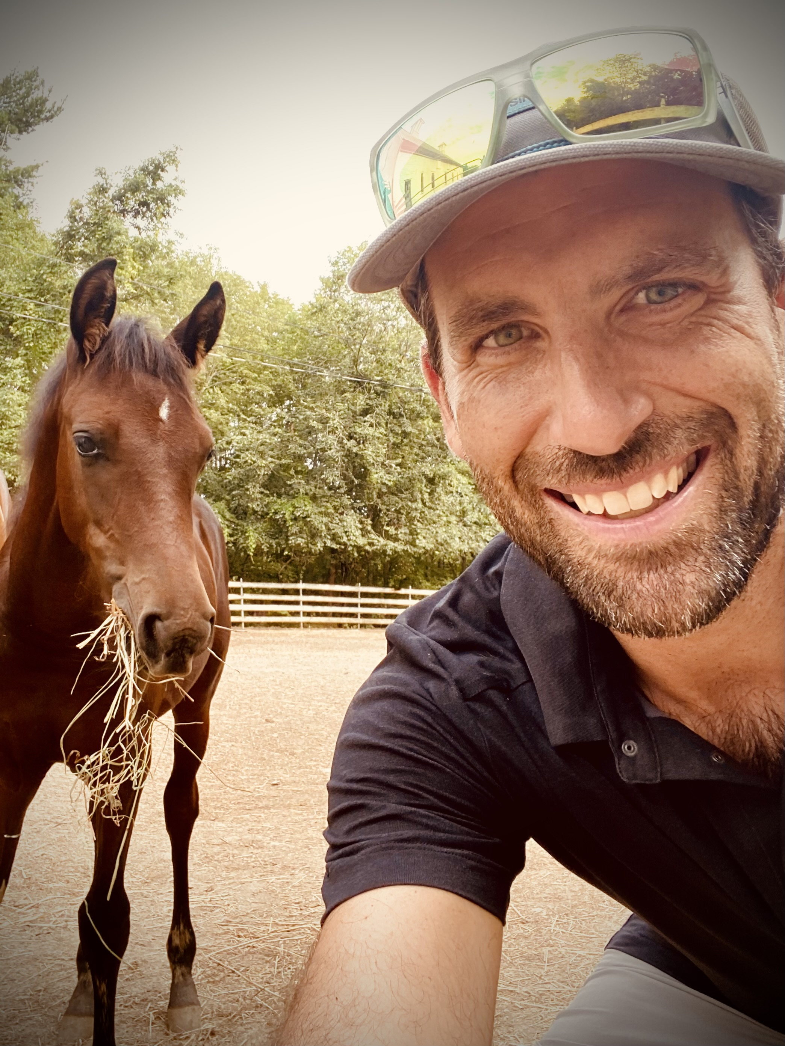
Eric Bendick
Producer, Nature: American Horses
https://www.instagram.com/grizzlycreekfilms/?hl=en
Eric Bendick is a director, producer and writer whose work explores connectivity, conflict and wonder at the intersection of the human and natural world. Bendick has led filming expeditions in many of the last wild places such as the Florida Everglades, the Grand Canyon, the Great Bear Rainforest and the most remote spot in Yellowstone National Park. His work has aired on PBS, National Geographic, Smithsonian and History Channel, as well as streamed online for numerous platforms. Bendick is a current grantee of the Redford Center. His productions have garnered an Emmy, Webby and numerous other awards and accolades from major film festivals around the world.

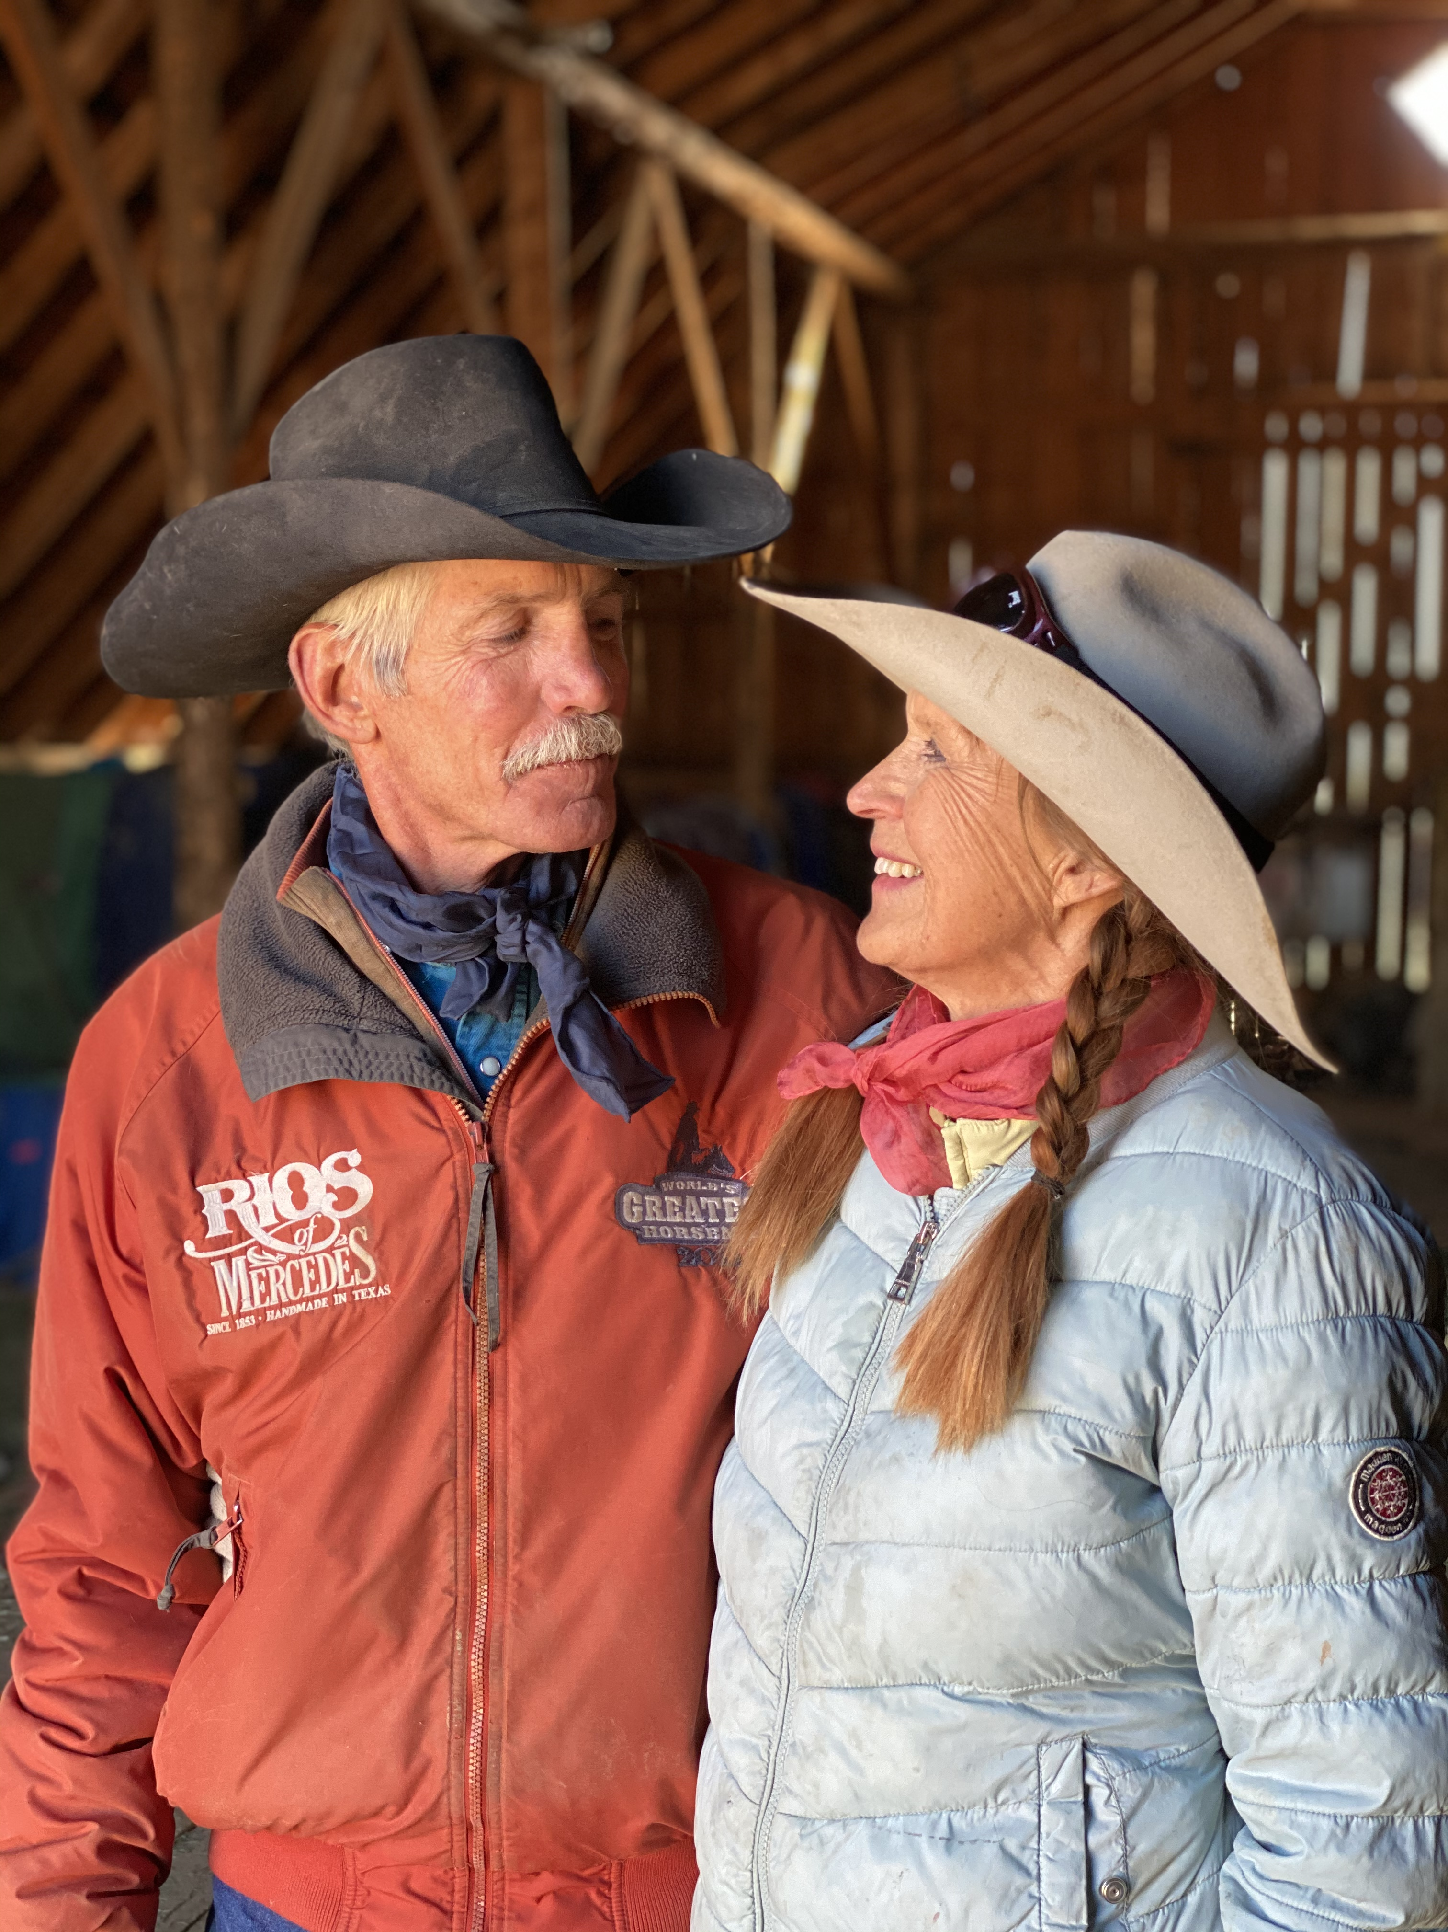
Mike and Tara Miller
Wyoming ranchers and breeders of Quarter Horses; interviewees, Nature: American Horses

Mike and Tara Miller are cattle ranchers and have been highly involved in all phases and many disciplines of horsemanship since they were young children. Mike Miller is a fourth-generation rancher working on the land his family homesteaded in 1885. Mike has been training horses since he was nine years old and rode saddle broncs professionally. He has been very successful competing in cutting, reining, reined cow horse, roping, chariot racing and ranch rodeo. Tara Miller has competed in numerous major events as well as barrel racing. Miller Land and Livestock is comprised of nearly 20,000 acres. The Millers breed, raise and train champion Quarter Horses. In 2021, the Millers received the honor of Remuda of the Year from the American Quarter Horse Association (AQHA), one of its most coveted awards.
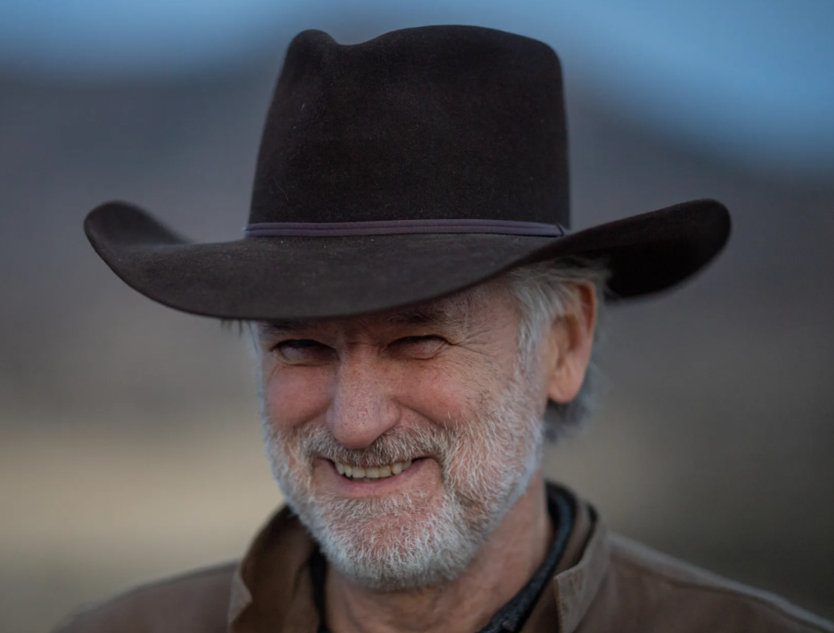
Bill Pullman
Narrator, Nature: American Horses

William James Pullman was born in Hornell, New York. After high school, Pullman went into a building construction program at State University of New York (SUNY) Delhi. He transferred to SUNY Oneonta where he received his B.A. in Theater. He received both his M.F.A. in Theater/Directing and an honorary Ph.D. from University of Massachusetts at Amherst. While teaching directing at Montana State University in Bozeman, Montana, one of Pullman's students was the soon-to-be film director John Dahl, who later cast Pullman in The Last Seduction. Moving to New York City, he worked with Kathy Bates in the acclaimed stage production of Curse of the Starving Class. However, it was his first work in three strikingly diverse films that brought him to the attention of his audience: Ruthless People with Danny DeVito and Bette Milder, the Mel Brooks hit Spaceballs and the Oscar-nominated The Accidental Tourist.

Still attracted to the art and study of building construction, Pullman has designed and/or restored three barns. In Montana, he converted a 1933 barn at his ranch into his family home. In Los Angeles, he built a Truss barn in the style of LA’s 1910 fruit storage barns. In western New York state, he restored a 3-bay barn that sometimes serves as a community center near his hometown of Hornell. Focused more on neighborhoods, Pullman has defined himself by his work with his local communities. He works to bridge communities of Los Angeles through his board work with Cornerstone Theater. Pullman continues to work with his neighbors who formed Concerned Citizens Montana to secure a place at the table regarding the national need for a smart grid for energy transmission. He also works with the local university (Alfred University, New York) as well as supports local health services (The Pullman Women’s Health and Birthing Center at St. James Hospital, Hornell, New York).
Pullman is also an MS Society Ambassador.

Based in Los Angeles, New York City and Western Montana, Pullman is married to dancer Tamara Hurwitz Pullman and they have three children.

