New PBS Series, OUR NEW WORLD, Asks What World Will We Live In Tomorrow?

The two-part series premieres Wednesday, April 1, at 10 p.m. ET on PBS
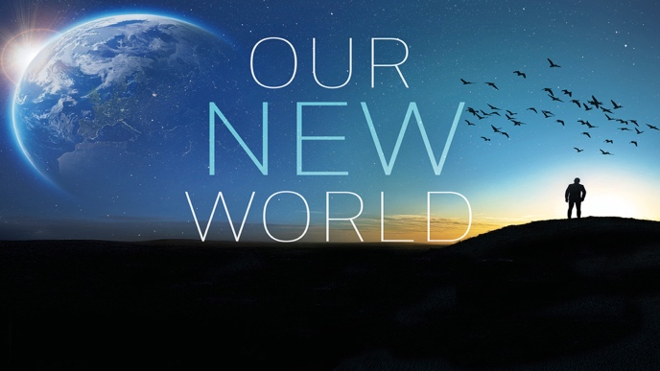
Arlington, VA; (March 5, 2026) – PBS announced today a new two-part series, OUR NEW WORLD, premiering Wednesdays, April 1 and 8, 2026 at 10 p.m. ET on PBS, PBS.org and the PBS app (check local listings). Facing global warming, our planet is undergoing rapid and profound changes, with ecosystems transforming worldwide. As a result, animals and plants are moving in search of more suitable conditions, and their behaviors are evolving to adapt to a changing climate. This two-part series explores these global transformations and highlights nature’s remarkable capacity to adapt in the face of a changing climate.

Using cutting-edge visual effects, OUR NEW WORLD reveals the metamorphosis of landscapes: the migration of forests, the journey of corals, the greening of mountains after the retreat of glaciers, and the many transformations that are gradually shaping the face of our new world.

The series features experts from across the globe, including shepherds, fishers and conservationists who are confronted with the rapid transformation of their natural environments. In their daily lives, they must adapt, find solutions and reduce conflicts between humans and wildlife as resources and territories become scarcer. This series follows their efforts to keep pace with nature’s movements and to support ecosystems as they adjust to new climatic conditions. Through these human stories, it shows us how individuals can become a supporting force for nature.

“The resilience of nature is on full display in this beautiful and inspiring series, and I’m thrilled to bring it to PBS audiences during Earth Month, said Diana El Osta, Sr. Director, Multiplatform Programming & Development at PBS. “It also serves as a powerful reminder that humans can be a force for good in the natural world.”

Episode Descriptions
Episode 1: “The Pulse of Change” (Wednesday, April 1, 2026, 10 p.m. ET)
Four experts on four continents confront the transformation of their environment in the wake of climate change. They witness profound changes in the behavior of animals and plants around them and actively search for solutions to adapt and prevent conflict between humans and wildlife as territory and resources become increasingly scarce.

Episode 2: “A Wild Revival” (Wednesday, April 8, 2026, 10 p.m. ET)
Five ecosystems are entirely transformed by climate change. Ice fields and underwater forests disappear, giving birth to totally new ecosystems. Humans and animals must adapt as nature reshapes itself at an unprecedented pace.
Each episode of OUR NEW WORLD will stream Wednesday, April 1, 2026 and be available on all station-branded PBS platforms, including PBS.org and the PBS app, available on iOS, Android, Roku streaming devices, Apple TV, Android TV, Amazon Fire TV, Samsung Smart TV, Chromecast and VIZIO. PBS station members can view many series, documentaries, and specials via PBS Passport. For more information about PBS Passport, visit the PBS Passport FAQ website or contact your local station.

OUR NEW WORLD is a co-production of Boréales, Terra Mater Factual Studios GmbH,
Lonfish Films, France Télévisions, Ushuaia TV, Radio Télévision Suisse (RTS), and Federation Studios. Series producers are Fred Fougea, Gilles Dufraisse, Sabine Holzer and Birgit Peters. Executive in Charge for PBS is Diana El-Osta.

OUR NEW WORLD was made possible, in part, by a grant from Anne Ray Foundation. Other funders include Centre National du Cinéma et de l'image animée and Société Producteurs Cinéma et Télévision.

About Boréales
Boréales has been producing films about wildlife and human adventure for major international broadcasters since 1990. With more than one hundred awards, including two Emmy Awards, the company has captivated a very broad audience around the world.
About PBS
PBS, with more than 330 member stations, offers all Americans the opportunity to explore new ideas and new worlds through television and digital content. Each month, PBS reaches over 36 million adults on linear primetime television, 16 million users on PBS-owned streaming platforms, 56 million viewers on YouTube, and 10 million followers on social media, inviting them to experience the worlds of science, history, nature, and public affairs and to take front-row seats to world-class drama and performances. PBS’s broad array of programs has been consistently honored by the industry’s most coveted award competitions. As the number one educational media brand, PBS KIDS helps children 2-8 build critical skills, enabling them to find success in school and life. Delivered through member stations, PBS KIDS offers high-quality content on TV — including a PBS KIDS channel — and streaming free on pbskids.org and the PBS KIDS Video app, games on the PBS KIDS Games app, and in communities across America. Teachers of children from pre-K through 12th grade turn to PBS LearningMedia for digital content and services that help bring classroom lessons to life. More information about PBS is available at PBS.org, one of the leading dot-org websites on the internet, Facebook, Instagram, or through our apps for mobile and connected devices. Specific program information and updates for press are available at pbs.org/pressroom or by following PBS Communications on X.

– PBS –

CONTACTS:

PBS
Chelsie Pope, cepope@pbs.org

Bullseye Communications
Lisa Dyer, lisa.dyer@bullseyecomm.com
Heather Marohn, heather.marohn@bullseyecomm.com

For images and additional up-to-date information on this and other PBS programs, visit PBS PressRoom at pbs.org/pressroom.

