PBS Announces New Series
Pati Jinich Explores Panamericana

The Award-Winning Chef, Bestselling Author and Television Host Embarks on a Pan-American Journey from Alaska to Alberta in New Three-Part Docuseries Premiering Tuesday, April 29 at 9:00 pm ET

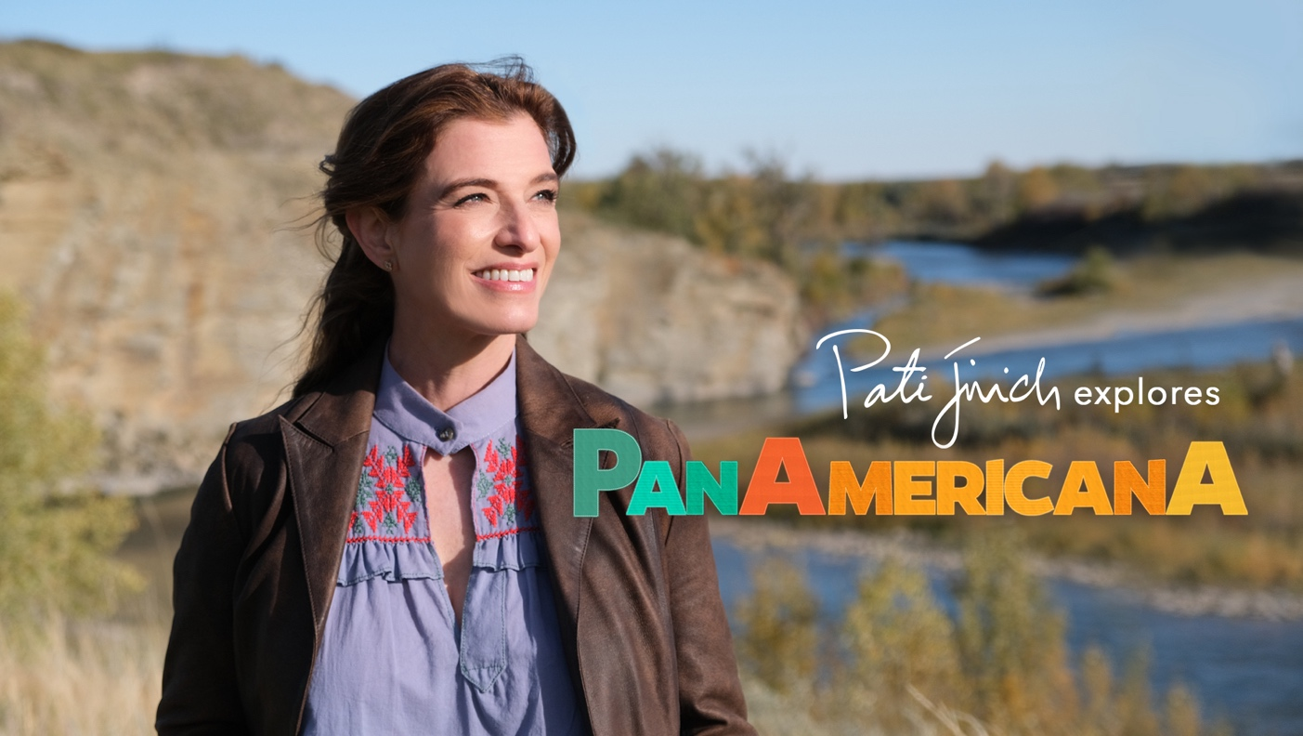

ARLINGTON, VA; (February 19, 2025) - As part of its Spring 2025 programming slate, PBS announces a new primetime docuseries PATI JINICH EXPLORES PANAMERICANA. Hosted and Executive Produced by the James Beard Award-winning author and Emmy-nominated host, the three-part series will premiere Tuesdays, April 29 - May 13, 2025 at 9:00 p.m. ET (check local listings) on PBS, PBS.org and the PBS app.

Known for her captivating exploration into understanding cultural identity through shared meals, Pati’s lifelong work has been focused on building bridges between her two beloved countries, her homeland of Mexico and her current home in the United States. PATI JINICH EXPLORES PANAMERICANA expands this remarkable endeavor on a journey inspired by the Pan-American Highway, a symbol of connection and collaboration between countries from Alaska to Argentina.

In Season 1, Pati travels from the top of Alaska to southern Alberta, beginning an epic adventure along the length of the Western Hemisphere and delving into our migratory evolution, history and identity as citizens of the Americas. Throughout her voyage she engages in heartfelt conversations that celebrate diversity and cherished traditions, ultimately exploring the myriad ways people form the basis of their identities.

Filled with stunning visual landscapes, rich history and fascinating stories, the series also promises adventure; from dog sledding and groundbreaking science in the Arctic, to salmon fishing in Halibut Cove, Alaskan Native modern art and Filipino food in Juneau, glass blowing in Whitehorse, and experiencing the cowboy life in the Alberta heartlands while exploring its connections to Montana and Texas.
An engaging and timely exploration of humanity, PATI JINICH EXPLORES PANAMERICANA reveals lessons learned to be shared, diversity to celebrate and the traditions we cherish, all while underscoring a profound truth: much like the roads that weave through our landscapes to connect us, we share more similarities than differences. At the core, we are all longing for home and craving to belong.

“My life’s work has focused on forging bonds between my home country of Mexico and my new home of the US by sharing delicious, culturally revealing meals with people from all walks of life,” says Pati. “In PANAMERICANA my adventures take me further, traveling an extraordinary path paved by the past, the present, and future possibilities for collaboration between people and countries. I’m honored to share the incredible stories gathered on this journey. It is through our stories that we can better understand one another to overcome the internal borders dividing our communities, change existing narratives, infuse hope into our discussions, and redefine what it means to be American.”

“PBS is thrilled to work with chef Pati Jinich to bring another appetizing adventure to our audiences,” said Zara Frankel, Senior Director, Programming & Development at PBS. “PATI JINCH EXPLORES PANAMERICANA is a program that treks through Alaska and western Canada, highlighting the unique people, flavors and cultures within the region. As a host, Pati’s warm energy, delicious curiosity and heartfelt conversations bring to life some of the region’s most interesting stories.”

EPISODE DESCRIPTIONS:

- Episode 1: “Alaska – Wild Harvest”
Premieres April 29, 9:00 p.m. ET
Pati Jinich travels from the northernmost city in the United States to the remote island community of Halibut Cove in southern Alaska - discovering that subsistence living transcends all differences. At the top of the Americas, in Utqiagvik, Pati meets Geoff and Marie Carroll who have fought for the Inupiat people to maintain their traditional ways of hunting, goes for a ride with sled dogs, visits scientists monitoring climate change, and discovers the town’s obsession with a familiar sport – basketball. Then in Anchorage, she forages for berries with an Indigenous community leader Anna Sattler, gets the lay of the city’s food scene with food writer Julia O’Malley, crashes the recording session of local band Sazón, and gets a taste of Americana at the Alaska State Fair. As she continues south, she stops in the Russian village of Nikolaevsk, before landing in one of the most stunning and unique places in the U.S., Halibut Cove, with Martha Cotten and her family. She learns that living in this frontier region instills Alaskans of all backgrounds with a deep connection to the ebbs and flows of their natural environment.

- Episode 2: “Juneau & Whitehorse – Sister Cities”
Premieres May 6, 9:00 p.m. ET
Pati Jinich explores the sister cities of Alaska’s capital, Juneau, and the capital of Canada’s Yukon Territory, Whitehorse. Pati greets Juneau over the airwaves where she’s invited to take over a radio show and interview members of the city’s thriving Filipino community who are documenting their history. Afterwards, they take her to try traditional foods at a Filipino community center. Then Pati visits artist Crystal Worl, who is bringing Indigenous art to the modern world, and meets her brother, athlete Kyle Worl, who found his Identity through Arctic Sports and dreams of getting them in the Olympics. She shares a meal and an emotional conversation about Native adoptions with activist Jennifer Quinto. Before heading west to Yukon, Pati visits the historic Taku Lodge, once owned by outdoorswoman Mary Joyce, who completed a legendary dogsledding feat nearly 100 years ago. In Whitehorse, Pati gets her bearings at the local market with food writer Miche Genest before foraging in the Mt. Logan foothills. Then she connects with artist and fellow Mexico City native, Anick Fernandez, who finds inspiration in family roots and connection to nature. Pati meets a former police officer who found an alternative way to promote safety in indigenous communities, and she ends in the hottest place in Whitehorse – the studio of glassblower Luann Baker-Johnson, who uses her art to give back. In these remote cities, she finds a pioneering culture of artistry and entrepreneurship and small, tight-knit communities produce big characters forging unique lives adjacent to the unforgiving wilderness.

- Episode 3: “Alberta – Canada’s Changing Heartland”
Premieres May 13, 9:00 p.m. ET
Pati Jinich finishes the first leg of her Pan-American journey in Alberta, traveling through Canada’s heartland to Edmonton and Calgary and south to the Montana border. As the peaks of the Canadian Rockies give way to wide-open prairies, cowboy and immigrant communities work together in the constant creation of a new Canadian identity. Pati dives into cowboy culture at John Scott’s ranch, the backdrop for many westerns, and learns about Canada’s connection to Hollywood. Then she visits the town of Wildwood, founded by Canada’s first black settlers who migrated north from the US. In Edmonton, she eats butter chicken with food writer Ramneek Singh and, in Calgary, meets Nigerian chef Kunbi Olalere who is introducing locals to her culture’s cuisine through a Nigerian-Canadian fusion menu at her restaurant Ahinke’s Kitchen. Many Albertans have Ukrainian heritage and are welcoming refugees from the war in Ukraine. Pati shares a meal with a family who recently immigrated from Ukraine and the people who helped them resettle and visits Don’ya, a kitchen that provides jobs and community to newly arrived Ukrainian women. Continuing southward towards Montana, Pati learns why Alberta is known as the “Texas of Canada” at the Bonjean family flower winery, then visits a family who recently started a new life outside the city on a farm. Pati wraps her journey on a medicine walk with ancestors of the first people to ever call this land home, the indigenous mother-daughter duo Matricia and Mackenzie Brown, known as the “Warrior Women.”

PATI JINICH EXPLORES PANAMERICANA begins streaming on Tuesday, April 29, 2025 and will be available on all station-branded PBS platforms, including PBS.org and the PBS app, available on iOS, Android, Roku streaming devices, Apple TV, Android TV, Amazon Fire TV, Samsung Smart TV, Chromecast and VIZIO. PBS station members can view many series, documentaries, and specials via PBS Passport. For more information about PBS Passport, visit the PBS Passport FAQ website or contact your local station.

PATI JINICH EXPLORES PANAMERICANA is produced by Mexican Table and Early Light Media in association with PBS. Pati Jinich serves as executive producer with Darren Durlach as director. The executive in charge for PBS is Zara Frankel.

ABOUT HOST AND EXECUTIVE PRODUCER PATI JINICH
Pati Jinich is the James Beard Award-winning Mexican chef, New York Times bestselling author, and Emmy-nominated television host who has dedicated her career to building a shared understanding between her two neighboring home countries: Mexico, where she was born, and the United States, where she lives currently and is raising her family. She’s the executive producer and host of the Emmy-nominated PBS series Pati’s Mexican Table, which has brought Mexican flavors, colors and textures into American homes and kitchens for more than 10 years, as Pati takes viewers through the diverse geographic regions of the country. Pati is also the executive producer and host of La Frontera, her PBS Primetime docuseries, which uses food as a vehicle to showcase the vibrant people and culture along the largely misunderstood and misrepresented US-Mexico border. Pati’s works has been featured in The New York Times, The Washington Post, CNN, Univision, Los Angeles Times, Good Morning America, and many others. She was recently selected for The Washington Post’s “Post Next 50” profiling people expected to have a notable impact in 2025. Pati was also named one of the National Immigration Forum’s “Keepers of the American Dream,” which honors individuals who embody the spirit of immigrant achievement and contribute to the well-being of immigrants in the US. Visit PatiJinich.com.

ABOUT PBS
PBS, with more than 330 member stations, offers all Americans the opportunity to explore new ideas and new worlds through television and digital content. Each month, PBS reaches over 120 million people through television and 26 million people online, inviting them to experience the worlds of science, history, nature and public affairs; to hear diverse viewpoints; and to take front row seats to world-class drama and performances. PBS’s broad array of programs has been consistently honored by the industry’s most coveted award competitions. Teachers of children from pre-K through 12th grade turn to PBS for digital content and services that help bring classroom lessons to life. Decades of research confirms that PBS’s premier children’s media service, PBS KIDS, helps children build critical literacy, math and social-emotional skills, enabling them to find success in school and life. Delivered through member stations, PBS KIDS offers high-quality educational content on TV — including a 24/7 channel — online at pbskids.org, via an array of mobile apps and in communities across America. More information about PBS is available at pbs.org, one of the leading dot-org websites on the internet, or by following PBS on Twitter, Facebook or through our apps for mobile and connected devices. Specific program information and updates for press are available at pbs.org/pressroom or by following PBS Communications on Twitter.

MEDIA CONTACT:
Stephanie Kennard, PBS; skkennard@pbs.org
Ashley Sandberg, Triple 7 PR; ashley@triple7pr.com

For images and additional up-to-date information on this and other PBS programs, visit PBS PressRoom at pbs.org/pressroom.

