PBS Sets Hit Crime Drama PATIENCE Season 2
Early Streaming Premiere for May 31 Ahead of
Broadcast Debut in June

Season 1 of the series was one of the most-streamed series on
PBS’s digital platforms in 2025

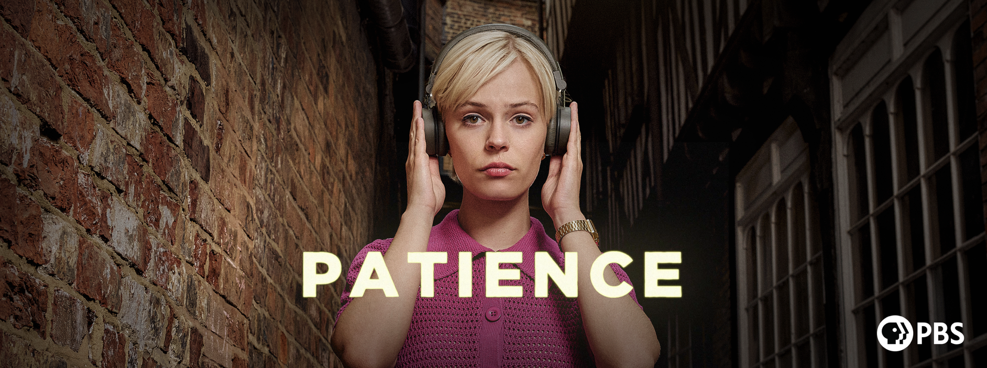
Caption: Patience Season 2 Key Art
Credit: Eagle Eye Drama Limited / Amy Brammall

LOS ANGELES, CA / ARLINGTON, VA, April 27, 2026 – PBS announced the Season 2 early streaming premiere of PATIENCE, an adaptation of the popular French series “Astrid.” All eight episodes will be available to stream beginning Sunday, May 31 with PBS Passport and PBS Masterpiece on Prime Video. The series will broadcast Sundays, June 14 - Aug. 2 at 8 p.m. ET on PBS (check local listings). PATIENCE presents an authentic neurodivergent perspective, bringing an expanded lens to the crime drama genre.

In the U.S., PATIENCE was one of the most-streamed series on PBS’s digital platforms, PBS Passport, and on demand in 2025. PATIENCE Season 2 will stream on all station-branded PBS platforms, including PBS.org, and the PBS app, which is available on iOS, Apple TV, Android mobile and tablets, Android/Google TV, Roku, Amazon Fire TV and tablets, Comcast, Samsung Smart TV, VIZIO and LG Smart TVs. PATIENCE Season 2 will also be available to stream with PBS Passport and PBS Masterpiece on Prime Video.

PATIENCE follows Patience Evans (Ella Maisy Purvis, “A Kind of Spark”), an autistic woman who works in the Criminal Records Office in the city of York. In Season 2, Patience is back tackling puzzling crimes when new detective Frankie Monroe (Jessica Hynes, “Miss Austen”) bursts onto the scene. Their differences spark tension, but they must learn to work as a team as they investigate cases of murder and mystery across the city. Meanwhile, Patience searches for her mother and navigates the ups and downs of new love.

The ensemble cast also features Nathan Welsh (“The Ledge”), Mark Benton (“Anna and the Apocalypse”), Adrian Rawlins (The Harry Potter Franchise), Tom Lewis (“Redeeming Love”), Ali Ariaie (“The Great”), Liza Sadovy (“A Real Pain”), and others.

“Audiences connected with PATIENCE in its first season, and we’re excited to bring the mystery back for another chapter,” said Maria Bruno Ruiz, VP, Program Content Strategy & Scheduling at PBS. “With new cases, new characters, and deeper emotional stakes, Season 2 builds on what viewers loved while expanding the world of the show.”

Episode 1 - “Vampire”
After a photographer is found dead with a stake through his heart, Patience pursues a rational explanation for what appears to be a vampire killing. DI Frankie Monroe ruffles feathers but comes to see Patience’s value, while Patience continues her romance with Elliot.

Episode 2 - “Music In The Minster”
When a music student is found dead, and then her professor dies suddenly, Patience races to unlock the mystery. A showdown in the spectacular setting of York Minster exposes the unlikely killer. Patience looks forward to her first date with Elliot.

Episode 3 - “The Magpie”
A businessman is shot in a packed boardroom. A dead magpie points the investigation into the world of magic, where Patience’s neurodivergent mind sees what others miss. Patience traces her mother’s address and hears some shocking news.

Episode 4 - “The Timetable”
A young autistic girl witnesses her father’s murder at the railway museum but is unable to tell anyone what happened. Patience connects with her and coaxes some information from her, leading to a breakthrough in the case.

Episode 5 - “The Runes”
A Viking expert dies before a big, controversial speech, and Patience finds a coded message in his work that suggests there’s more to his death than meets the eye. As another scholar is targeted, she and Frankie race to uncover the truth. Meanwhile, Patience’s relationship with Elliot hits a rough patch.

Episode 6 - “Paco’s Revenge”
A woman is found dead in the botanical gardens – was she murdered or did she die of natural causes? Patience suspects foul play and falls out with Frankie, who needs convincing. Meanwhile, Patience tries to deny her feelings for Elliot.

Episode 7 - “A Monk's Tale”
A monk is found dead, kneeling in prayer. Patience and Frankie investigate, and secrets surface at the monastery. When Patience finds herself on stage as the face of the City of York police, she starts rethinking her decision about Elliot.

Episode 8 - “Hostage”
Patience and Frankie are held hostage by an escaped prisoner seeking justice. As armed police prepare to storm the building, Frankie’s past resurfaces. Meanwhile, Patience realizes she’s ready to be honest about her feelings for Elliot.

PATIENCE was adapted by lead writers Amy Shindler and Beth Chalmers, alongside Jacqui Honess-Martin and Rachel Smith, and directed by Maarten Moerkerke alongside Raf Reyntjens. The series is an Eagle Eye Drama title produced in association with Channel 4 for PBS, which is currently averaging 4.2 million viewers per episode in the U.K. and their top drama of the last four years. The series is also produced in association with Happy Duck Films and Gallop Tax Shelter with the support of Tax Shelter of the Belgian Federal Government. PATIENCE is produced by Jacqueline Clyne and executive produced by Walter Iuzzolino, Jo McGrath, and Alison Kee. Beta Film handles international distribution for PATIENCE while PBS Distribution handles North American distribution.

About EAGLE EYE DRAMA (an ITV Studios company)
Eagle Eye Drama is one of the UK’s fastest growing drama producers. It was launched in 2018 by Walter Iuzzolino, Jo McGrath and Jason Thorp, the same three founders and creative team behind the global drama brand Walter Presents. The company produces dramas based both on adaptations and original ideas. In 2022, Eagle Eye launched new Belgian based company Happy Duck Films. In October 2024 ITV Studios acquired a majority stake in the company.
Follow Eagle Eye Drama on Facebook, X and Instagram.

About PBS Masterpiece on Prime Video
PBS Masterpiece on Prime Video consists of binge-worthy British and international drama series and movies from MASTERPIECE, Walter Presents and other critically acclaimed producers. The subscription rate for PBS Masterpiece on Prime Video is $5.99/month in the US and CAN$6.99/month in Canada with an Amazon Prime or Prime Video subscription. Every purchase helps support public television for all. The content available on the service varies between the U.S. and Canada as rights permit. Follow PBS Masterpiece on Prime Video on Facebook.

About PBS Passport
PBS Passport is one of many member benefits from participating PBS stations that gives eligible donors and supporters extended access to an on-demand library of quality public television programming online or within the PBS app. For more information about PBS Passport, visit the PBS Passport FAQ website.

About PBS
PBS, with more than 330 member stations, offers all Americans the opportunity to explore new ideas and new worlds through television and digital content. Each month, PBS reaches over 36 million adults on linear primetime television, 16 million users on PBS-owned streaming platforms, 56 million viewers on YouTube, and 10 million followers on social media, inviting them to experience the worlds of science, history, nature, and public affairs and to take front-row seats to world-class drama and performances. PBS’s broad array of programs has been consistently honored by the industry’s most coveted award competitions. As the number one educational media brand, PBS KIDS helps children 2-8 build critical skills, enabling them to find success in school and life. Delivered through member stations, PBS KIDS offers high-quality content on TV — including a PBS KIDS channel — and streaming free on pbskids.org and the PBS KIDS Video app, games on the PBS KIDS Games app, and in communities across America. Teachers of children from pre-K through 12th grade turn to PBS LearningMedia for digital content and services that help bring classroom lessons to life. More information about PBS is available at PBS.org, one of the leading dot-org websites on the internet, Facebook, Instagram, or through our apps for mobile and connected devices. Specific program information and updates for press are available at pbs.org/pressroom or by following PBS Communications on X.

About PBS DISTRIBUTION
PBS Distribution is a leading distributor of public media content around the world, entertaining audiences across platforms and formats. The company, a joint venture of PBS and GBH Boston, provides premium content through multiple digital channels and video services. PBS Distribution operates seven subscription streaming channels — PBS Masterpiece (US and CA), PBS KIDS, PBS Living, PBS Documentaries (US and CA) and PBS America (U.K.) as well as numerous Free Advertising-Supported Streaming TV (FAST) Channels in the U.S. and U.K. In addition, the company reaches viewers through Transactional Video On Demand (TVOD), Subscription Video On Demand (SVOD) licensing, Advertising-Supported Video on Demand (AVOD), DVD and Blu-ray, theatrical releasing, educational platforms, non-theatrical and inflight sales, and serves broadcasters and producers providing program sales and co-production financing.

PBS Distribution offers consumers and educators the highest quality factual, scripted, and children’s programming including films from Ken Burns, hit series from MASTERPIECE and foreign language dramas from Walter Presents, entertaining and educational PBS KIDS series, and award-winning documentaries from NOVA, FRONTLINE, AbloMERICAN MASTERS, NATURE, AMERICAN EXPERIENCE, and many independent producers. For over 15 years, the company has extended the reach of programming beyond broadcast while generating revenue for the public media system, stations, and producers. Follow PBS Distribution on Facebook.

###

Media Contacts:
BECK Media & Marketing
pbsd@beckmedia.com

Chelsie Pope, PBS
cepope@pbs.org

