PBS Sets New Crime Drama PATIENCE Season 1 Premiere Date for Sunday, June 15

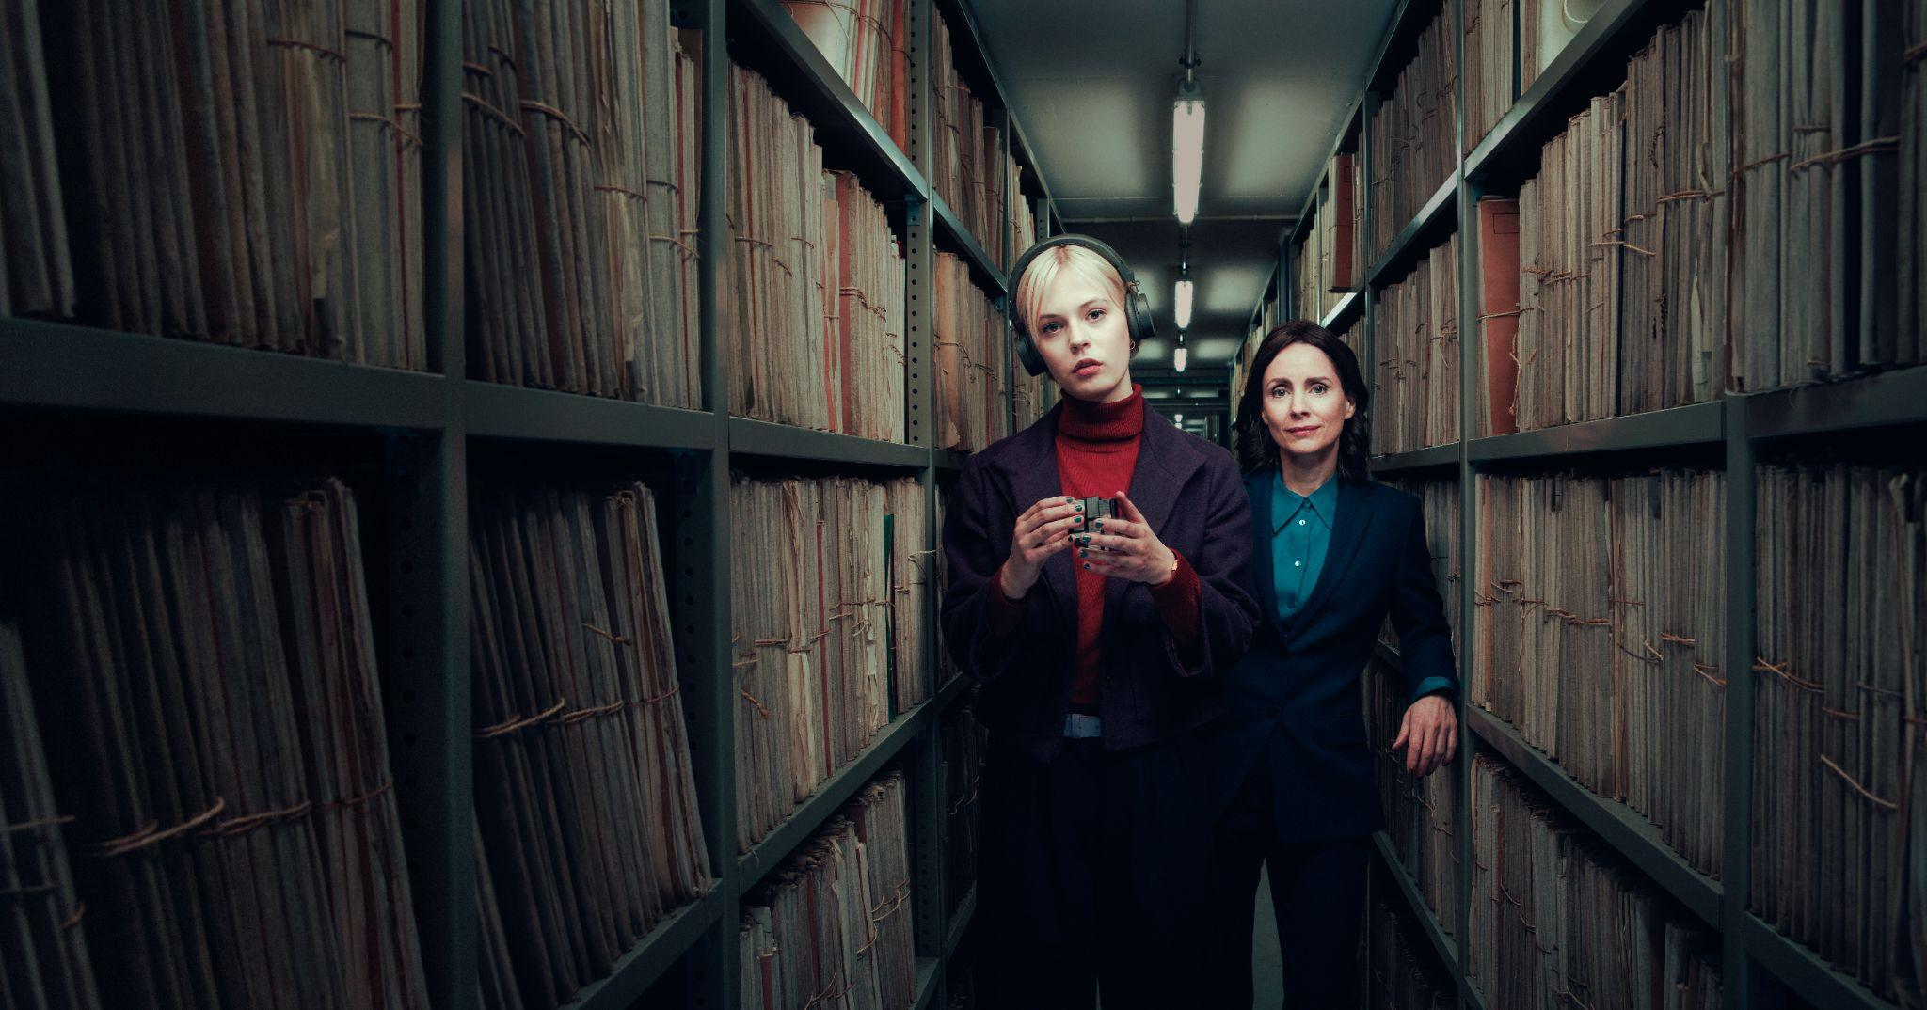
Caption: Patience Season 1 Key Art
Credit: Eagle Eye Drama / Charlie Clift

SERIES PROMO

LOS ANGELES, CA / ARLINGTON, VA, May xx, 2025 – PBS announces the premiere of PATIENCE, an adaptation of the popular French series “Astrid,” debuting on Sunday, June 15th at 8 p.m. ET on PBS (check local listings). Produced by Eagle Eye Drama in association with Channel 4, the series brings a unique and authentic perspective to the crime drama genre.

PATIENCE will stream on all station-branded PBS platforms, including PBS.org, and the PBS App, available on iOS, Android, Roku streaming devices, Apple TV, Android TV, Amazon Fire TV, Samsung Smart TV, Chromecast, and VIZIO. Patience will also be available to stream on PBS Passport and with PBS Masterpiece on Prime Video.

PATIENCE follows Patience Evans, played by Ella Maisy Purvis (A Kind of Spark), a neurodivergent woman who works in the Criminal Records Office in the city of York. Patience is autistic and views the world in a unique way. When Detective Inspector Bea Metcalf, played by Laura Fraser (Breaking Bad), recognizes her talents, she takes Patience under her wing to assist with complex criminal investigations. Together, they tackle a series of challenging cases, with Patience offering extraordinary insight that transforms the way crimes are solved.

The ensemble cast includes Nathan Welsh (The Ledge), Mark Benton (Anna and the Apocalypse), Ali Ariaie (“The Great”), Adrian Rawlins (The Harry Potter Franchise) and others.

“PATIENCE brings a fresh perspective to PBS audiences and our viewers will be captivated by this journey,” says Maria Bruno Ruiz, Vice President of Program Content Strategy and Scheduling at PBS. “Patience, an autistic character played by a neurodiverse actress, shows us new ways of seeing the world and making connections.”

Episode One “Paper Mountain Girl Part 1” - Sunday, June 15th at 8 p.m. ET
Detective Bea Metcalf is intrigued when Patience connects a suicide to other cases.

Episode Two “Paper Mountain Girl Part 2” - Sunday, June 22nd at 8 p.m. ET
Bea learns more about Patience’s difficult past, and together they uncover a trail.

Episode Three “The Missing Link” - Sunday, June 29th at 8 p.m. ET
A body in a museum exhibit leads the team into the shadowy world of fossil smuggling.

Episode Four “The Locked Room” - Sunday, July 6th at 8 p.m. ET
A bestselling crime writer is found dead behind locked doors, and all is not as it seems.

Episode Five “My Brother’s Keeper” - Sunday, July 13th at 8 p.m. ET
A body disappears from the morgue. Patience has a connection to the case.

Episode Six “Pandora’s Box”- Sunday, July 20th at 8pm ET
A man dies on a bus, and Bea is warned off the case, but she refuses to stop investigating.

PATIENCE was adapted and written by Matt Baker (“Hotel Portofino”), Stephen Brady (“Red Election”), and Daniella Devinter (“Before We Die”) and directed by Maarten Moerkerke (“Thieves of the Wood”). The series is an Eagle Eye Drama title produced in association with Channel 4 for PBS, which is currently averaging 4.2 million viewers per episode in the U.K. and their top drama of the last four years. The film is also produced in association with Happy Duck Films and Gallop Tax Shelter with the support of Tax Shelter of the Belgian Federal Government. PATIENCE is produced by Alison Kee and executive produced by Walter Iuzzolino, Jo McGrath, and Dries Vos. Beta Film handles international distribution for PATIENCE and secured the agreement with PBS Distribution for the series.

About EAGLE EYE DRAMA
Eagle Eye Drama was formed by Walter Iuzzolino, Jo McGrath, and Jason Thorp, the same three founders and creative team behind the global drama company Walter Presents. The company produces dramas and animations, based on adaptations and original ideas. In 2022, they launched two new companies under the Eagle Eye umbrella, Belgian-based Happy Duck

Films and animation-focused Eaglet Films.
Follow Eagle Eye Drama on Facebook, Twitter, and Instagram.

About PBS MASTERPIECE on Prime Video
MASTERPIECE has been setting the standard for exceptional British drama in the U.S. for 50 years. PBS MASTERPIECE on Prime Video continues this legacy and has expanded to include award-winning TV series from around the world. Streamers can subscribe to PBS MASTERPIECE on Prime Video for $5.99 a month, in addition to an Amazon Prime or Prime Video subscription. Follow PBS Masterpiece on Prime Video on Facebook.

About PBS Passport
PBS Passport is a member benefit from participating PBS stations that gives eligible donors and supporters extended access to an on-demand library of quality public television programming online or within the PBS Video app. For more information about PBS Passport, visit the PBS Passport FAQ website.

About PBS
PBS, with more than 330 member stations, offers all Americans the opportunity to explore new ideas and new worlds through television and digital content. Each month, PBS reaches over 36 million adults on linear primetime television, more than 16 million users on PBS-owned streaming platforms, 53 million viewers on YouTube, and 60 million people view PBS content on social media, inviting them to experience the worlds of science, history, nature, and public affairs and to take front-row seats to world-class drama and performances. PBS’s broad array of programs has been consistently honored by the industry’s most coveted award competitions. Teachers of children from pre-K through 12th grade turn to PBS LearningMedia for digital content and services that help bring classroom lessons to life. As the number one educational media brand, PBS KIDS helps children 2-8 build critical skills, enabling them to find success in school and life. Delivered through member stations, PBS KIDS offers high-quality content on TV — including a PBS KIDS channel — and streaming free on pbskids.org and the PBS KIDS Video app, games on the PBS KIDS Games app, and in communities across America. More information about PBS is available at PBS.org, one of the leading dot-org websites on the internet, Facebook, Instagram, or through our apps for mobile and connected devices. Specific program information and updates for press are available at pbs.org/pressroom or by following PBS Communications on X.

About PBS DISTRIBUTION
PBS Distribution is a leading distributor of public media content around the world, entertaining audiences across platforms and formats. The company, a joint venture of PBS and GBH Boston, provides premium content through multiple digital channels and video services. PBS Distribution operates seven subscription streaming channels — PBS Masterpiece (US and CA), PBS KIDS, PBS Living, PBS Documentaries (US and CA) and PBS America (U.K.) as well as numerous Free Ad-supported Streaming TV (FAST) Channels in the U.S and U.K. In addition, the company reaches viewers through Transactional Video-on-Demand (TVOD), Subscription Video-on-Demand (SVOD) licensing, Advertising-based Video on Demand (AVOD), DVD and Blu-ray, theatrical releasing, educational platforms, non-theatrical and inflight sales, and serves broadcasters and producers providing program sales and co-production financing.

PBS Distribution offers consumers and educators the highest quality factual, scripted, and children’s programming including films from Ken Burns, hit series from MASTERPIECE and foreign language dramas from Walter Presents, entertaining and educational PBS KIDS series, and award-winning documentaries from NOVA, FRONTLINE, AMERICAN MASTERS, NATURE, AMERICAN EXPERIENCE, and many independent producers. For over 15 years, the company has extended the reach of programming beyond broadcast while generating revenue for the public media system, stations, and producers.

Follow PBS Distribution on Facebook.

###

Media Contacts:
Ali Smith, MPRM Communications
asmith@mprm.com

Chelsie Pope, PBS
cepope@pbs.org

