
Zachariah OHora
Creator and Executive Producer, “Carl the Collector”

New York Times best-selling illustrator and author Zachariah OHora is creator and executive producer of “Carl the Collector,” which is produced by his Fuzzytown Productions along with Spiffy Pictures.

The series, PBS KIDS’ first to center on a neurodiverse character, follows the everyday adventures of Carl, a warm-hearted autistic raccoon who loves collecting things. The series celebrates the diverse ways kids think and express themselves while helping them develop a strong sense of self and community.

OHora’s award-winning books include My Cousin Momo!, Niblet & Ralph, The Not So Quiet Library and Fuzzy (Inside & Out).

OHora also created the Rivian Gear Guard avatar featured in all the cutting-edge electric vehicle company’s security systems.

OHora resides in Narberth, Pennsylvania with his wife and two kids.


Lisa Whittick
Director, “Carl the Collector”

Lisa Whittick is director of “Carl the Collector,” PBS KIDS’ first show centering on a neurodiverse character. The series follows the everyday adventures of Carl, a warm-hearted autistic raccoon who loves collecting things. Carl’s friends include both neurotypical and neurodiverse characters, each with different traits, behaviors, learning preferences, and challenges. As the mom of a neurodiverse son, the series is an especially meaningful project for Whittick who brings her authenticity, empathy and personal experience to the series.

Whittick also served as director of seasons four and five of Spiffy Pictures’ and PBS KIDS’ Emmy Award-nominated and Environmental Media Award-winning hit series “Nature Cat.” Before directing, she served as a storyboard artist on the series’ first three seasons.

A Canadian-born director with a life-long passion for art and visual storytelling, Whittick is a graduate of the world-renowned Classical Animation Program at Sheridan College where she received the Best Classically Animated Film Award, sponsored by Nelvana, as well as the Teletoon Scholarship Award for her graduate film “Burger, fries and a Pop.” She spent her early career working for studios across Canada as a storyboard artist and in various assistant director roles before landing at Yowza! Animation. Whittick’s credits include “Thomas and Friends, All Engines Go!,” “Magic School Bus Rides Again,” “Cyberchase,” “Almost Naked Animals,” “Arthur,” and “Martha Speaks!”

Whittick resides in Oshawa, Ontario with her husband, three kids and two Boston terriers.


Ava Xiao-Lin Rigelhaupt
Writer, “Carl the Collector”

Ava Xiao-Lin Rigelhaupt (she/her) is a writer on “Carl the Collector,” PBS KIDS’ first show centering on a neurodiverse character.

Rigelhaupt works as a writer, actress, consultant, and advocate for diversity, autism, and disability representation in entertainment. As a Chinese, Jewish, autistic, transracial adoptee, she shares her intersectional lived experiences through writing and consulting work.

Rigelhaupt received a Drama Desk Special Award for Authentic Autistic Representation for her work as the Autistic Creative Consultant on the critically acclaimed neurodiverse coming-of-age Broadway musical, “How to Dance in Ohio,” which follows seven autistic young adults (authentically cast) at a social skills center in Ohio, as they form connections and prepare for a dance. It's going to the UK in 2025!

Rigelhaupt’s additional consulting projects include Disney’s The Ghost and Molly McGee, the Apple TV+ film Cha Cha Real Smooth, Cartoon Network’s Lu & the Bally Bunch, and PBS KIDS’ Xavier Riddle and the Secret Museum. She also works with various theaters and arts organizations and has spoken at industry events including SXSW and Sundance Film Festival.

Rigelhaupt’s additional writing credits include Nickelodeon’s “Blue’s Clues & You” and “Daniel Tiger’s Neighborhood.”

A native of Columbus, Ohio, Rigelhaupt is a graduate of Sarah Lawrence College and currently resides in Rhode Island.

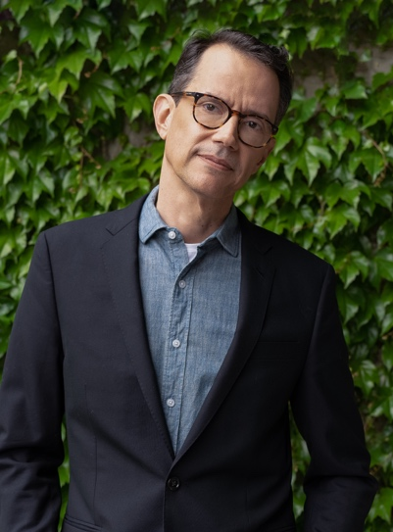
Adriano Schmid
Vice President of PBS KIDS Content
PBS

As Vice President of PBS KIDS Content, Adriano Schmid leads the PBS KIDS Content team and the network’s full content library. He is responsible for PBS KIDS’ robust multi-platform content strategy, meeting the evolving needs of the PBS KIDS audience by identifying new industry talent, fostering relationships with current producers and partners, and supporting development of new approaches to content production on emerging platforms.

Prior to joining PBS, Schmid, a media veteran with more than 20 years' experience, most recently focused on multi-lingual programming in both Latin American and U.S. Hispanic markets at Warner Bros. Discovery, Inc. There, he developed and produced curriculum-based projects for preschool-age audiences in the non-fiction, live-action & animation long-form genres. He also supervised the creation of short and digital kids' content, such as e-books, games and webisodes.

Schmid has also worked on factual and lifestyle programming, overseeing on-air promotion and working in production for HBO Brazil. He received an MFA in Screenwriting from the University of Miami and a bachelor's degree in Business from Fundação Getúlio Vargas.

