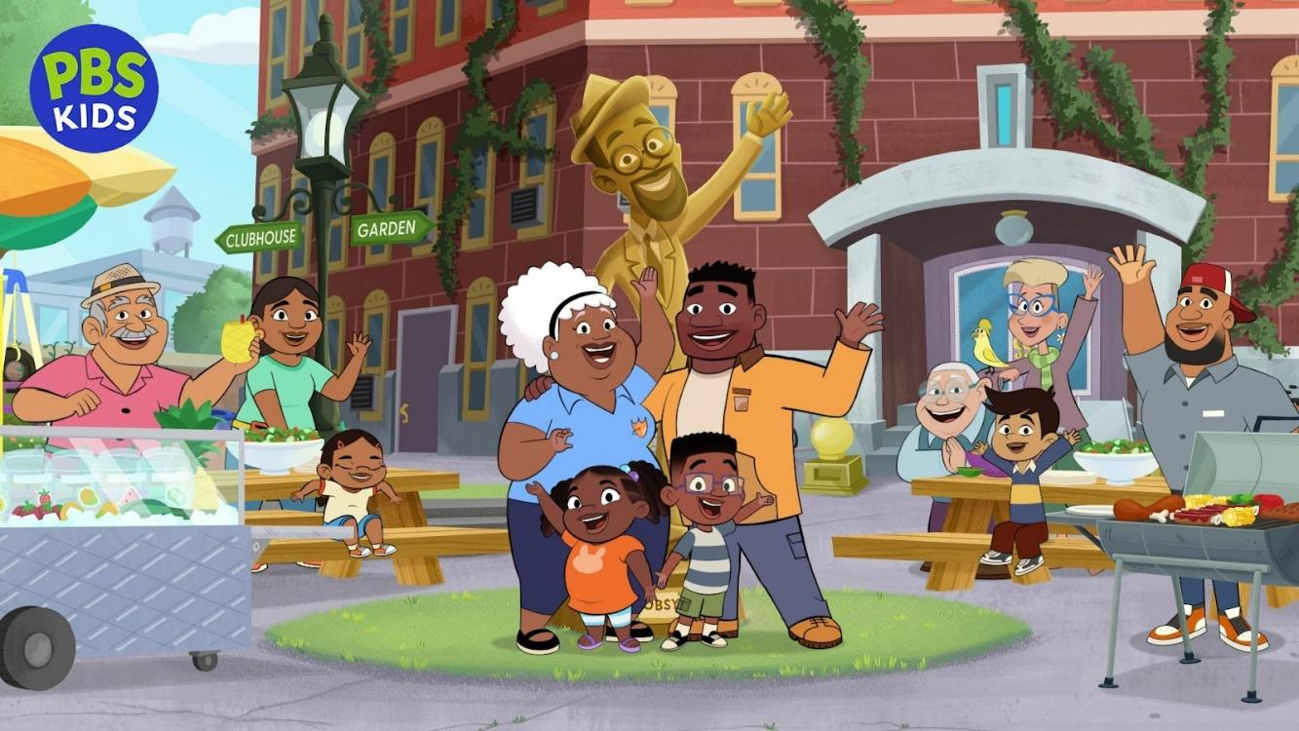
PHOEBE & JAY Premieres February 2, 2026 on PBS KIDS
New Animated Series Helps Boost Everyday Literacy Skills and Empowers Preschoolers to Navigate the World Around Them
Arlington, VA, September 30, 2025 – Today, PBS KIDS announced the premiere date for PHOEBE & JAY, a fun, literacy-focused animated series for children ages 3-5 from Phoebe & Jay Productions and Mainframe Studios (SUPER KITTIES, COCOMELON, OCTONAUTS). The new show, which follows the adventures of the curiously charismatic 6-year-old fraternal twins, Phoebe and Jay Yarber, highlights a variety of texts that preschoolers encounter in their daily lives–from labels and signs to posters and more–to foster their early literacy skills and help them navigate the world around them. Created by Genie Deez and Thy Than, PHOEBE & JAY debuts on PBS KIDS February 2, 2026.
“Every year, 40% of children enter kindergarten with literacy skills one to three years behind their grade level, creating a difficult gap for them to overcome*,” said Sara DeWitt, Senior Vice President and General Manager, PBS KIDS. “We hope that PHOEBE & JAY’s relatable characters, fun, family-centered stories, and foundational curriculum will help equip young viewers nationwide with the everyday literacy skills they need to find success in school and in life.”
PHOEBE & JAY’s literacy curriculum is designed to closely support preschoolers as they learn how to create and use the many types of functional texts that they encounter each day. As the twins uncover adventures in their new home, they use a flyer to help a neighbor find a lost pet and read clothing labels to find the right size shirt. Phoebe and Jay showcase for young viewers how they, too, can utilize these skills to explore their surroundings, pursue their interests, and accomplish tasks big and small in their own lives.
The titular twins live with their dad, Pete, an eternal optimist, with the support of their loving, no-nonsense Grandma Annie. The series captures some of the experiences and learning opportunities found in the fantastical Tobsy Towers, the unique setting for many of the close-knit Yarber family’s adventures, which was inspired by the grand old hotels in Los Angeles that have been repurposed into affordable apartments. In one story, after Phoebe and Jay accidentally get paint on the mail, they need to decode the addresses so each of their Tobsy Towers neighbors receive the correct packages. And in another, the twins discover reel-to-reel recordings left behind by Tobsy, the architect of Tobsy Towers, and create labels to sort the recordings.
“We are grateful for the opportunity to create a show that features so many different neighbors and thinkers who laugh together, help each other, and go on fun adventures. We hope viewers recognize themselves in one of our characters and that the show inspires them to notice all the signs, symbols and texts that surround us in our daily lives,” said co-creator Thy Than. “We’re very excited for families to watch and play with Phoebe and Jay together.”
"Growing up, my brother and I were fortunate to have a strong role model in our Grandma Annie who helped raise us, and who also showed us how to think in terms of respect and resilience. Similarly, our show models executive function skills like impulse control, which encourages children to stop and think when frustrated solving a problem, and flexible thinking when switching between tasks. These strategies are crucial to teaching pre-literacy," said co-creator Genie Deez.
In addition to new episodes, Phoebe and Jay’s Dance Party game will debut on pbskids.org and the PBS KIDS Games app in tandem with the series launch. Players will help the twins get ready for themed dance parties by finding inspiration at the Pass-It-On table, making posters, sorting party outfits by size, dressing up, and learning special dance moves. Additional games will continue to roll out and will be available in both English and Spanish. Resources for parents and teachers will be available on PBS KIDS for Parents and PBS LearningMedia.
PHOEBE & JAY is created and Executive Produced by Genie Deez and Thy Than and is produced by Phoebe & Jay Productions and Mainframe Studios. Tanya Green is Supervising Producer. Thy Than is Supervising Director. Mike Alcock and Mark Sinclair are series co-directors. Aydrea Walden is Head Writer. Executive Producers for Mainframe are Michael Hefferon and Kim Dent Wilder. Additional Executive Producers are Wendy Moss Klein and Nancy Steingard.
Advisors for the series include Lead Curriculum Advisor, Kelly Cartwright, PhD, Spangler Distinguished Professor of Early Child Literacy at the University of North Carolina at Charlotte; Geraldine Oades-Sese, Ph.D, licensed psychologist, children’s book author, and former Adjunct Associate Professor of Pediatrics at Rutgers Robert Wood Johnson Medical School; Wendy Sapp, Ph.D., Chief Research Officer for Bridge Multimedia, Accessibility/Education Consultant; Tim Ojetunde, MEd, educator from South LA, Culture Specialist; and Cathy Tran, PhD, Writer’s Room Curriculum Consultant.
Funding for PHOEBE & JAY was provided by a grant from the U.S. Department of Education as part of the Ready To Learn Initiative and a grant from the Corporation for Public Broadcasting.
About PBS KIDS
PBS KIDS believes the world is full of possibilities, and so is every child. With PBS KIDS, the number one educational media brand for kids, children ages 2-8 learn lessons that last a lifetime. Across media and community-based programs, PBS KIDS sparks children’s curiosity, helping them succeed in school and life. Families can stream PBS KIDS for free anytime on the PBS KIDS Video app, connected TV devices, pbskids.org and more (no subscription required). Kids can play hundreds of educational games on the PBS KIDS Games app and pbskids.org. PBS KIDS and local stations across the country support children’s learning anytime, anywhere – empowering parents, caregivers, and teachers. For more information, visit pbs.org/pressroom, or follow PBS KIDS on Facebook and Instagram.
About Phoebe & Jay Productions
Phoebe & Jay Productions is a Los Angeles based media company that specializes in authentic, educational, and story-driven media. Formed in 2021, the founders Genie Deez and Thy Than bring a breadth of experience from various fields including music production, live-action, animation, television, feature film, interactive and education. Their mission is to create authentic characters and stories that celebrate the lived experiences of all peoples in our communities.
About Mainframe Studios
Since 1993, Vancouver based Mainframe Studios has been a leader in animation, producing creative, ground-breaking animated content. Mainframe has produced 1,000+ television episodes and 70+ long form projects, including two original theatrical feature films. The studio harnesses the creative power of its global talent base along with the latest innovative technology in CG, 2D and Unreal, to create top-tier animated productions for broadcasters, clients, and partners.
*Source: Children’s Reading Foundation
# # #
Press contacts:
PBS; 703-739-8463; pbskidspr@pbs.org
Alison Grand, Grand Communications; 212-584-1133; alison@grandcommunications.com
Gabrielle Torello, Grand Communications; 917-312-2832; gab@grandcommunications.com
The contents of PHOEBE & JAY were developed under a grant from the Department of Education. However, those contents do not necessarily represent the policy of the Department of Education, and you should not assume endorsement by the Federal Government. The project is funded by a Ready To Learn grant [PR/Award No. S295A200004, CFDA No. 84.295A] provided by the Department of Education to the Corporation for Public Broadcasting.

