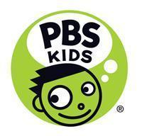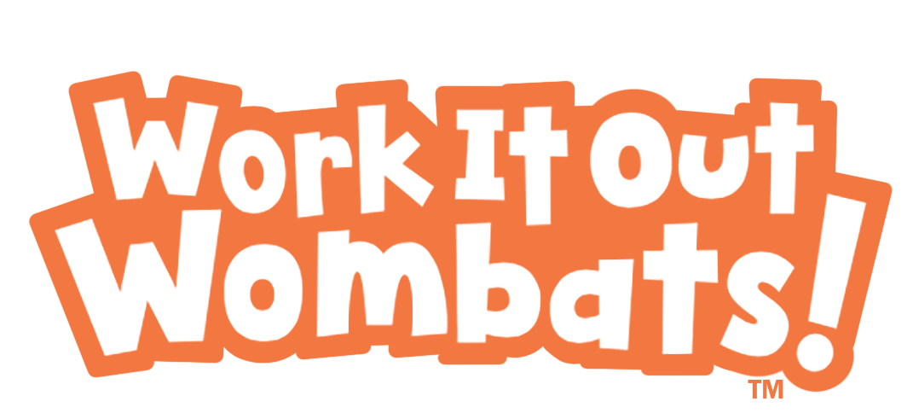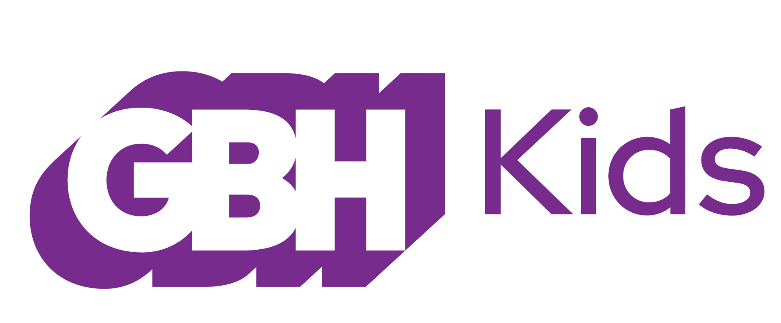
PBS KIDS Announces New Series, WORK IT OUT WOMBATS!
Debuting Winter 2023

New Animated Series from GBH Kids and Pipeline Studios Helps Children Learn Creative and Systematic Ways to Solve Problems

Arlington, VA, January 18, 2022 – Today at the Television Critics Association Press Tour, PBS KIDS announced WORK IT OUT WOMBATS!, a new animated series for kids ages 3-6 from GBH Kids and Pipeline Studios. WORK IT OUT WOMBATS! stars Malik, Zadie, and Zeke—three energetic and creative marsupial siblings who live with their grandmother in her treehouse apartment complex. The playful trio will demonstrate computational thinking (CT) for preschoolers, a way of thinking that enables them to solve problems, express themselves, and accomplish tasks using the practices, processes and ideas at the core of computer science. WORK IT OUT WOMBATS! is set to premiere on PBS KIDS in early 2023.

“Like most preschoolers, Malik, Zadie, and Zeke are curious and naturally inclined to explore the world around them,” said Sara DeWitt, Senior Vice President and General Manager, PBS KIDS. “We’re excited to bring the Wombats and all their fun adventures to kids across the country, inspiring them to work with others to solve problems and tackle challenges.”

Produced by GBH Kids and Pipeline Studios, WORK IT OUT WOMBATS! takes place in the Treeborhood, the biggest treehouse in existence—with secret passageways, gondolas, and rope swings. The residents of the Treeborhood—wombats, snakes, moose, kangaroos, iguanas, fish, tarsiers, and eagles—bring varied skills and abilities, assorted ways of thinking, and different family structures and traditions to this diverse and vibrant community of neighbors, a place where even the adults join in the play.

In each story, the Wombats demonstrate computational thinking for preschoolers, learning as they go. Their aspirations will sometimes exceed their proficiency. But, eventually they’ll stop, take a breath, put their heads together and figure out a fix—using the design process, sequencing, debugging, and other key elements of computational thinking.

“Preschoolers are passionate about achieving their goals, but they don’t always know the best way to go about meeting them,” said Marcy Gunther and Marisa Wolsky, Executive Producers, GBH Kids. “By using computational thinking, they have a powerful toolkit for self-expression, for building projects, and for getting out of messes.”

“Our goal with WORK IT OUT WOMBATS! is to empower our creative talent and artists to seamlessly blend education and entertainment as they bring the adventures, surprises, mysteries, and hilarious mess-ups of the Wombats and their friends and neighbors to life,” said Luis Lopez, Executive Producer, Pipeline Studios.

Full of boundless energy, Malik, Zadie, and Zeke run, bounce, roll, and romp, always on the lookout for interesting Treeborhood problems to solve. Malik is thoughtful, considerate, and sometimes set in his ways (which can be a good thing when you’re problem-solving). His speedy, adventurous younger sister, Zadie, is a brainstormer extraordinaire, with ideas that range from silly to very smart. Zeke is the youngest—a funny, curious cuddle-bug who loves to play and explore. Super, their grandmother, is the Superintendent and unofficial “Mayor” of the Treeborhood—the de facto heart and soul of the place.

With WORK IT OUT WOMBATS! fantastical animal world, the GBH and Pipeline Studios teams have been deliberate in taking an inclusive and authentic approach to telling stories. Leading this effort are Darlene Mortel Edouard, Ph.D. and Kareem Edouard, Ph.D, who serve as the Creative Producers of the series and have expertise in cultural and visual studies, intersectionality, and STEM engagement from communities underrepresented in STEM fields.

“WORK IT OUT WOMBATS introduces problem-solving, critical thinking, and collaboration to young learners in a fun and age-appropriate way, helping children get excited about learning and laying important groundwork for success in school and life,” said Debra Tica Sanchez, senior vice president, Educational Media and Learning Experiences, Corporation for Public Broadcasting (CPB).

The series is being developed as part of the Corporation for Public Broadcasting (CPB) and PBS Ready To Learn Initiative with funding from the U.S. Department of Education. The Ready To Learn Initiative is a federal program that supports the development of innovative educational television and digital media targeted to preschool and early elementary school children and their families.

WORK IT OUT WOMBATS! games will launch in tandem with the series on pbskids.org and the free PBS KIDS Games App. To extend the learning at home, parent and caregiver resources, including tips and hands-on activities, will be available on PBS KIDS for Parents. For educators, PBS LearningMedia will offer classroom-ready materials, including videos, games, teaching tips and printable activities.

About PBS KIDS
PBS KIDS believes the world is full of possibilities, and so is every child. As the number one educational media brand for kids, PBS KIDS helps children ages 2-8 learn lessons that last a lifetime. Through media and community-based programs, PBS KIDS wants children to see themselves uniquely reflected and celebrated in lovable, diverse characters who serve as positive role models, and to explore their feelings and discover new adventures along the way. Families can stream PBS KIDS for free anytime, no subscription required. A large collection of mobile apps and pbskids.org provide accessible content that spark kids’ curiosity. PBS KIDS and local stations across the country support the entire ecosystem in which children learn and grow – including their teachers and caregivers, parents, and community – providing resources accessible anytime and anywhere. For more information, visit pbs.org/pressroom, or follow PBS KIDS on Twitter, Facebook and Instagram.

About GBH Kids
GBH Kids is one of the top producers for public media, creating educational content for kids, parents, caregivers and teachers, including iconic PBS Kids programs such as the award-winning Arthur and Molly of Denali, digital series such as Scribbles and Ink, games, apps and podcasts. GBH Kids, based in Boston, also works closely with PBS LearningMedia, providing digital curricula for more than 2 million teachers across all 50 states. GBH Kids is committed to equity and access to educational media and the healthy development of all children. As the inventor of closed captioning and audio description, GBH is dedicated to making media accessible and inclusive. Find more information at gbh.org/kids

About Pipeline Studios
Pipeline Studios is a leading global entertainment company that focuses on developing, producing, and distributing award-winning animated content for audiences worldwide. Pipeline continues to expand with top international talent and robust animation technology across its offices worldwide. As an industry leader in animated content, Pipeline Studios’ extensive credit list includes Alma’s Way and Elinor Wonders Why (PBS KIDS), Sunny Day and Bubble Guppies (Nickelodeon), Star vs. the Forces of Evil (Disney Channel) and more. Active production partners include PBS Kids, Netflix, Nick Jr., NBC Universal, Disney Junior, Discovery, CBC Kids, and more. Find more information at pipelinestudios.com, and follow Pipeline Studios on Twitter, Facebook, Instagram and LinkedIn.
About CPB
The Corporation for Public Broadcasting (CPB), a private, nonprofit corporation created by Congress in 1967, is the steward of the federal government's investment in public broadcasting. It helps support the operations of more than 1,500 locally managed and operated public television and radio stations nationwide, and is the largest single source of funding for research, technology, and program development for public radio, television and related online services. For more information, visit cpb.org, follow us on Twitter @CPBmedia, Facebook and LinkedIn and subscribe for other updates.
About The Ready To Learn Initiative
The Ready To Learn Initiative is a cooperative agreement funded and managed by the U.S. Department of Education’s Office of Elementary and Secondary Education (OESE). It supports the development of innovative educational television and digital media targeted to preschool and early elementary school children and their families. Its general goal is to promote early learning and school readiness, with a particular interest in reaching children living in low-income households. In addition to creating television and other media products, the program supports activities intended to promote national distribution of the programming, effective educational uses of the programming, community-based outreach, and research on educational effectiveness.

# # #

Contacts:
PBS | Lubna Abuulbah | labuulbah@pbs.org
Grand Communications | Alison Grand | alison@grandcommunications.com

The contents of this release were developed under a grant from the U.S. Department of Education. However, those contents do not necessarily represent the policy of the Department of Education, and you should not assume endorsement by the Federal Government. The project is funded by a Ready To Learn grant (PR/Award No. S295A200004, CFDA No. 84.295A) provided by the Department of Education to the Corporation for Public Broadcasting.

