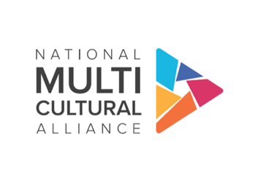
PBS SoCal Contact:
JP Shields
JPShields@pbssocal.org
747-201-5886

New PBS Stand-up Comedy Documentary Series
ROOTS OF COMEDY WITH JESUS TREJO
Reveals How Humor Mirrors Society’s Complex Social Issues

Streaming May 24 and Broadcasting June 21, New Series Showcases Six Comedians

Located in Diverse Regions Across the U.S. Telling the ‘Stories Behind the Laughs’

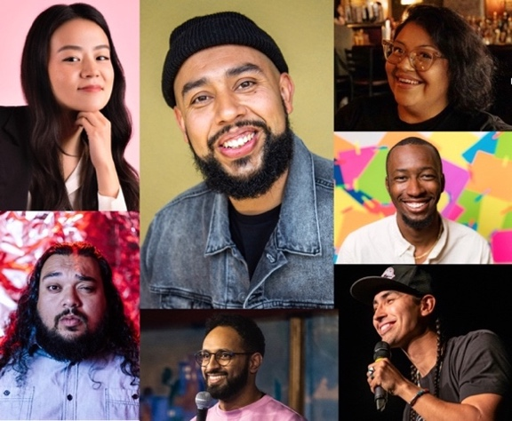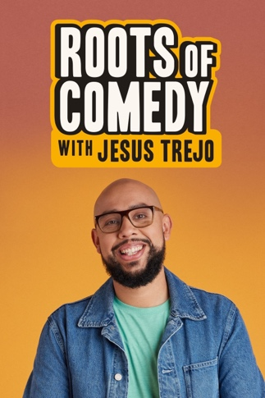

(Left) Featured Comedians in ROOTS OF COMEDY WITH JESUS TREJO include (Clockwise From Upper Left):
Sierra Katow, Host Jesus Trejo, Vanessa Gonzalez, Eeland Stribling, Tatanka Means, Ali Sultan and Adam Pasi.
(Right) ROOTS OF COMEDY WITH JESUS TREJO Key Art.
(Images courtesy of PBS SoCal)

https://pressroom.pbs.org/programs/r/roots-of-comedy

Series will also be available to stream on PBS.org and the PBS app.

Los Angeles, Calif. – April 16, 2024 – PBS SoCal, Southern California’s flagship PBS station, announced today a new comedy-documentary series ROOTS OF COMEDY WITH JESUS TREJO. Part comedy, part social commentary, part travelogue, the series follows the host, Mexican-American comedian Jesus Trejo, as he embarks on an emotional odyssey and telling the “stories behind the laughs,” revealing how the most memorable comedy traces back to the roots of a community with themes that are central to the series. Along his journey, Trejo visits six U.S. regions (Denver, Portland, Minneapolis, Austin, Los Angeles and Chinle, Arizona) where he meets with six rising comedians who explore the mosaic of our nation through the lens of stand-up comedy. The six episode series with 30-minute episodes is executive produced by Jesus Trejo, Juan Devis and Danny Lee, and co-produced for PBS by PBS SoCal and BIPOC-production studio CALICO in association with the National Multicultural Alliance. A special early release of all six episodes of ROOTS OF COMEDY WITH JESUS TREJO will stream for free on the PBS app and PBS.org starting Fri., May 24. The series will also be available to stream on the PBS YouTube channel, following the television broadcast premiere on PBS stations across the country on Fri., June 21 at 10 p.m. ET/ 9 p.m. CT.

Host and Executive Producer Jesus Trejo is a Los Angeles-based comedian, actor and writer. Born and raised in Long Beach, Trejo’s first hour stand-up special “Stay at Home Son” recently premiered on Showtime. He is currently a Staff Writer on Hulu’s “This Fool” and also the host of “Tacos Con Todo,” a web series in which he navigates the LA taco scene with celebrity guests. Also an author of two upcoming children’s books, Trejo was named in “Variety’s Top 10 Comics to Watch” in 2017 and is a paid regular at the Comedy Store in Los Angeles.

“No matter where you live or what your beliefs are, our love of laughter is something we all have in common,” commented Jesus Trejo. “Laughter opens our ears and our hearts--and once people are listening, who knows what they might be inspired to do?”

“Our hope is that ROOTS OF COMEDY WITH JESUS TREJO will spark conversation and inspire viewers,” explained PBS SoCal Chief Content Officer Tamara Gould. “With the series’ unique ability to blend levity, reality and education on multiple platforms, our goal is that viewers will find some of the nation’s toughest challenges a little more accessible, allowing audiences to connect more deeply with their own communities.”

ROOTS OF COMEDY WITH JESUS TREJO episodes are slated to air as follows (subject to change):

“Ali Sultan” Premieres on Fri., June 21 at 10 p.m. ET/ 9 p.m. CT
In Minneapolis, Jesus Trejo meets Yemeni comedian Ali Sultan. Ali opens up about his mental health struggles, weaving humor and vulnerability into a narrative of resilience and self-discovery, highlighting how comedy has helped his well-being.

“Vanessa Gonzalez” Premieres on Fri., June 21 at 10:30 p.m. ET/ 9:30 p.m. CT
Jesus Trejo follows Austin-based rising comedian Vanessa Gonzalez on a Texan adventure back to her hometown of Laredo. Vanessa shares the humor of her childhood as the daughter of first-generation, Mexican American border patrol agents.

“Eeland Stribling” Premieres on Fri., June 28 at 10 p.m. ET/ 9 p.m. CT
Jesus Trejo travels to Denver to meet a comic whose life on the river is as important as his life on stage. Eeland Stribling strives to find true life balance in the outdoors of Colorado where he often calls on his experience as a wildlife biologist.

“Tatanka Means” Premieres on Fri., June 28 at 10:30 p.m. ET/ 9:30 p.m. CT
Exploring Chinle, Arizona, Jesus Trejo connects with Native American comic and actor Tatanka Means. Tatanka delves into his upbringing on the reservation, using humor to illuminate the enduring challenges faced by Indigenous communities nationwide.

“Adam Pasi” Premieres on Fri., July 5 at 10 p.m. ET/ 9 p.m. CT
In Portland, Jesus Trejo meets Samoan comedian Adam Pasi. The only ever two-time winner of Portland's Funniest Person competition, Adam takes Jesus behind the scenes, showcasing the grind it takes to become a successful comic while performing for his parents for the first time.

“Sierra Katow” Premieres on Fri., July 5 at 10:30 p.m. ET/ 9:30 p.m. CT
In Los Angeles, Jesus Trejo embraces the hometown vibe, teaming up with actor/comedian Sierra Katow. A fourth-generation Chinese and Japanese American, Sierra and Jesus together weave culture, history and humor against the vibrant tapestry of L.A.

The comedians to be included in the series are as follows (in alphabetical order by last name):

- Vanessa Gonzalez – Austin, TX – In 2022, Vanessa Gonzalez was named one of “Variety’s Top 10 Comics to Watch“ and she was just voted this year's "Best Stand-Up Comic in Austin” by The Austin Chronicle for the second year in a row. She's been featured on TruTV’s “Laff Mobb’s Laff Tracks,” HBO’s “Entre Nos” and Comedy Central’s “Stand-Up Presents” as well as “A Little Late with Lilly Singh.” You can currently catch her on “Comedy Chingonas” on Max, “This Joka” on the Roku Channel and performing live opening for Chelsea Handler on the 2023 “Little Big Bitch Tour.” Gonzalez recently did a guest star role on “Lopez Vs. Lopez” for NBC. Prior to that she had guested on “The Garcias” for MAX.” Recent work includes her comedy album “My Birthday's Tomorrow” and her podcast with Micheal Foulk “I'm Not Busy.”

- Sierra Katow – Los Angeles, CA – A standup comic, writer, and actor, Katow recently released her debut comedy special, “Funt,” with Comedy Dynamics on April 2nd. She can be seen playing Evangeline on both seasons of Mindy Kaling’s “The Sex Lives of College Girls” on Max. Previously, she starred in “The G Word with Adam Conover” on Netflix and voiced characters in Disney’s “Raya and the Last Dragon.” She has been featured on “Last Comic Standing” (NBC), “Last Call with Carson Daly” (NBC) and “Just For Laughs’ Straight Up Stand Up.” Most recently, she was a writer/co-producer for an unannounced Comedy Central series. In the past, she has developed projects for FXX and SK Global and written for “Exploding Kittens” (Netflix), “Close Enough” (Max), “Earth to Ned” (Disney+), “Eureka!” (Disney+), and more.

- Tatanka Means – Chinle, AZ – Tatanka Means is an award-winning actor and stand-up comedian. He represents the Navajo, Omaha, Ihanktonwan Nations and is an enrolled member of the Oglala Lakota Sioux Tribe in Pine Ridge, South Dakota. His most recent work includes FX’s critically acclaimed series “Reservation Dogs” and Martin Scorsese’s “Killers of the Flower Moon.” Means stars in the upcoming highly anticipated Kevin Costner Western epic “Horizon” and “Wind River: Rising” directed by Kari Skogland, the sequel to Taylor Sheridan’s acclaimed 2017 film, “Wind River,” as well as the much anticipated A24 horror film, “Opus”, alongside Ayo Edebiri and John Malkovich. Aside from acting, Means performs stand-up comedy throughout Indian Country spreading laughter and speaking to Native youth about healthy living and sobriety wellness.

- Adam Pasi – Portland, OR – A Northwest comedy mainstay and the only ever two-time winner of Helium's annual “Portland's Funniest Person” contest, Pasi is of Samoan descent and is memorably BIG in all the right ways. His big and passionately hilarious stances in his comedy, undeniable charm and personality, intense stage presence and large, loveable stature make him a memorable performer. He has been featured at national comedy festivals such as Laughing Skull, Bridgetown, Limestone and the Big Sky Comedy Festival. Pasi can be recognized from his roles in “Portlandia.” Recently he toured the country with Skweezy Jibbs on the CAPS LOCK LIVE Tour as well as headlining his own shows.

- Eeland Stribling – Denver, CO – Eeland Stribling is a wildlife biologist and an outdoor educator. He’s a regular at Comedy Works, the Improv and clubs around the country. Besides telling jokes and teaching about wildlife, he also is a fly-fishing legend. Stribling is the creator and owner of “Comedians On the Fly.” He also recently won New Faces at Comedy Works and was the recipient of the AAWMAD (African-Americans Who Make A Difference) award in Denver.

- Ali Sultan – Minneapolis, MN – Ali Sultan is a Yemeni-Ethiopian comedian seen on Comedy Central’s “The Late Show with Stephen Colbert.” He filmed his half-hour comedy special in Dubai for Comedy Central Arabia and won the “Best in The Midwest” competition at Gilda’s LaughFest. Sultan’s Dry Bar Comedy special has over a million views on YouTube.

ROOTS OF COMEDY WITH JESUS TREJO is funded by grants from the Corporation for Public Broadcasting, the Wyncote Foundation and the Frieda Berlinski Foundation.

The series is co-produced for PBS by PBS SoCal, CALICO and the National Multicultural Alliance. Jesus Trejo and Juan Devis executive produce along with CALICO’s Danny Lee and Justin Yungfleisch
as well as PBS SoCal’s Tamara Gould. The series is directed by Donny Jackson. Wendy Llinás is the executive in charge for PBS.
For images and additional up-to-date information on this and other PBS programs, visit PBS PressRoom at https://pressroom.pbs.org/programs/r/roots-of-comedy.

Join the conversation on social media using #RootsOfComedyPBS and tagging @pbs.

Follow us on social at @pbssocal.

About PBS SoCal
PBS SoCal uses the power of public media for good, strengthening the civic fabric of Southern California and providing our community with an essential connection to a wider world. As a local, donor/member-supported non-profit organization, PBS SoCal manages 7 channels — including 2 primary broadcast channels, PBS SoCal and PBS SoCal Plus as well as 5 digital subchannels. With a commitment to make content available anytime and anywhere for free, PBS SoCal is reaches nearly 19M viewers in the region with programming that reflects the diversity of Southern California and showcases the full schedule of beloved and trusted PBS content spanning Education, News, Environment and Arts & Culture. PBS SoCal programming is available to viewers over-the-air, on all key streaming platforms via the free PBS App and PBS KIDS App. PBS SoCal also sparks the sharing of ideas at in-person cultural events and community conversations as well as prepares children for kindergarten and beyond by bringing bilingual, hands-on learning experiences to the community for free.

About CALICO
The brainchild of filmmaker Danny Lee, CALICO is a 100% BIPOC-owned, award-winning production company dedicated to culturally authentic + impactful storytelling through inventive filmmaking. In TV + film, CALICO has produced projects for HBO, Amazon, Hulu, Netflix, Showtime, ESPN, PBS, Uninterrupted, Starz, Spotify, Complex, and more. CALICO is also an MBE (Minority Business Enterprise) certified company.

About National Multicultural Alliance
The National Multicultural Alliance (NMCA) comprises five distinct and separate organizations — Black Public Media (BPM), Center for Asian American Media (CAAM), Latino Public Broadcasting (LPB), Pacific Islanders in Communications (PIC), and Vision Maker Media (VMM). With primary funding from the Corporation for Public Broadcasting, the NMCA is a leader in the diverse independent film and digital media field. Having developed and provided production support for a wealth of broadcast and digital media content for more than four decades, the NMCA has contributed to the nation’s appreciation of diverse cultures and storytelling. The programs it supports enjoy multi-platform distribution on PBS, and to schools and libraries. Its member organizations provide production training, professional development, and mentorship for the advancement of filmmakers of color. The NMCA also collaborates on national series and specials for public media, and it works with public television stations to launch community engagement initiatives. For more information, visit https://nmcalliance.org/.

