SACRED PLANET WITH GULNAZ KHAN
Premieres Wednesdays, September 10-October 1
on PBS and Streaming on PBS.org and the PBS app

New Series Travels the World to Explore How Indigenous Leaders and Faith Communities Are Working to Find Solutions
to the Climate Crisis

Click here for Preview

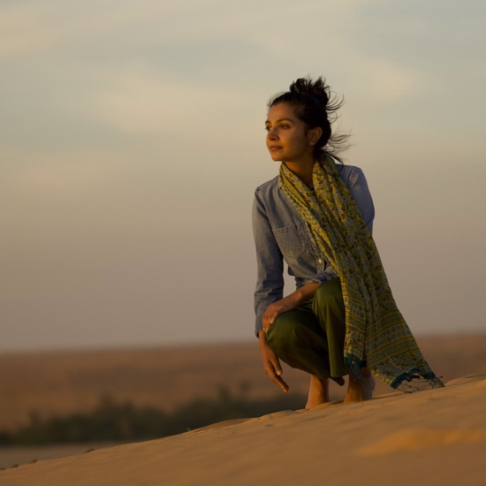
ARLINGTON, VA; August 20, 2025 – SACRED PLANET WITH GULNAZ KHAN is a new four-part, four-hour documentary series exploring Earth’s most hallowed places in search of hope and resilience on a changing planet. Part cinematic odyssey, part spiritual meditation, environmental journalist Gulnaz Khan travels to natural and cultural sanctuaries in Japan, Colombia, Peru, and the African Sahel. Each episode offers more than a portrait of threatened ecological beauty; it unfolds a deeply human story of reverence and renewal. In these sacred sites rarely accessed by outsiders, Khan meets with Indigenous elders, spiritual leaders, and community stewards confronting the climate crisis with centuries-old ecological wisdom. SACRED PLANET WITH GULNAZ KHAN premieres Wednesdays, September 10-October 1, 2025, 10:00–11:00 p.m. ET (check local listings) on PBS, PBS.org and the PBS app.
Gulnaz Khan.
Credit: Andre Dahlman, © 1904 Media

“In a warming world, we’re witnessing the slow erasure of the planet’s most sacred places — not just landscapes, but lifeways, languages, and traditions. Faith-based communities everywhere are rising to meet this crisis with timeless wisdom and radical hope. Their stories remind us that to honor the earth is to honor ourselves,” Khan said.

Episode 1: “The Heart of the World” – Wednesday, September 10
In Colombia’s Sierra Nevada de Santa Marta — the world’s highest coastal mountain range — the Indigenous Arhuaco people have maintained an unbroken connection to their ancestral lands for over a millennium. Gulnaz receives a rare invitation to enter their sacred territory, home to one of the few Indigenous communities in the Americas to preserve their cultural traditions through centuries of colonization. The Arhuaco consider themselves the spiritual “elder brothers of humanity,” tasked with keeping the world in balance. Now, as climate change threatens the delicate ecosystems they’ve long protected, they believe their “younger brothers” must learn what they know before it’s too late.

Episode 2: “Stopping the Desert” – Wednesday, September 17
The Sahara is advancing southward at an unprecedented pace, swallowing cities across Africa’s Sahel region along with centuries of culture and tradition. But amid this ecological upheaval, Gulnaz meets priests, imams, and scientists turning ancestral knowledge into tools of resistance. In Chinguetti, Mauritania, she meets scholars racing to preserve some of the world’s oldest Islamic manuscripts as sand dunes threaten libraries that have stood for eight centuries. In Senegal, Muslim and Christian communities have joined forces, reviving ancestral agricultural techniques that are not only restoring degraded land, but revitalizing the regional economy. Finally, at the Sahel’s eastern reaches of Ethiopia, Gulnaz encounters a remarkable phenomenon: church forests that serve as living seed banks, preserving the biodiversity needed to reforest entire landscapes.

Episode 3: “Saving the World’s Forests” – Wednesday, September 24
Gulnaz travels to Japan’s Lake Suwa, where Shinto priests have maintained meticulous climate records for over 600 years. Most notably, they chronicle the omiwatari — striking ice formations believed to trace the path of the gods across the winter lake. But as global temperatures rise, the lake rarely freezes, and the divine crossing has become a memory. Its disappearance reflects a broader reality: Japan's natural disasters are intensifying. As the nation deploys massive engineering projects like Tokyo’s underground flood-control systems, Gulnaz discovers a different kind of climate solution rooted in spiritual stewardship. In the 1970s, botanist Akira Miyawaki studied the vegetation surrounding Shinto shrines, where centuries of protection preserved Japan’s last native forests. From these sacred spaces, he developed the “Miyawaki method” — a technique for creating rapidly growing, biodiverse forests that could shield the island nation from future disasters.

Episode 4: “Reclaiming Peru’s Glaciers” – Wednesday, October 1
Gulnaz travels to Paucartambo, Peru, to witness one of the Andes’ most sacred and enduring traditions: the annual Qoyllur Rit’i pilgrimage — a vibrant fusion of Catholic and Andean beliefs. She meets Catholic priest Padre Mijail and José Luis Mamani, leader of the Quechua brotherhood known as the Pablitos to learn how rising temperatures are changing age-old customs. For generations, pilgrims climbed to the glaciers to retrieve blocks of sacred ice. But as the glaciers retreat, these rituals are disappearing — and with them, a way of life. Across the Andes, entire communities face worsening drought and flooding. Yet, Gulnaz discovers resilience in unexpected forms: from a farmer and mountain guide pursuing a landmark climate case in court, to remote villages reviving ancestral water knowledge and combining it with modern engineering to secure their water supply.

SACRED PLANET will stream simultaneously with broadcast and be available on all station-branded PBS platforms, including PBS.org and the PBS app, available on iOS, Android, Roku, Apple TV, Amazon Fire TV, Android TV, Samsung Smart TV, Chromecast and VIZIO.

Produced by 1904 Media in association with PBS, SACRED PLANET WITH GULNAZ KHAN is created and hosted by Gulnaz Khan. The Executive Producers are Alex Jouve, Gulnaz Khan and Jason Williams. The Director and Director of Photography for Episode 1 is Jeremy Seifert. The Director and Director of Photography for Episodes 2, 3 and 4 is Hossam Aboul-Magd. Executive in Charge for PBS is Diana El-Osta. Original production funding provided by Anne Ray Foundation and the Rosalind P. Walter Foundation.

About Gulnaz Khan
Gulnaz Khan is the climate editor at TED and a former editor at National Geographic. She’s the host and executive producer of Sacred Planet with Gulnaz Khan, a new documentary series exploring how climate change is reshaping sacred spaces and traditions around the world. Both an elegy for what’s vanishing and a call to protect what remains, it’s rooted in the belief that our connection to the earth is intrinsic to who we are — and to how we survive. The series builds on her research as a 2022–23 Ted Scripps Fellow in Environmental Journalism at the University of Colorado Boulder, where she studied how faith-based communities are responding to unprecedented ecological breakdown. She holds a Master of Science from the Johns Hopkins Bloomberg School of Public Health and a Certificate in Climate Change and Health from Yale University.

About PBS
PBS, with more than 330 member stations, offers all Americans the opportunity to explore new ideas and new worlds through television and digital content. Each month, PBS reaches over 36 million adults on linear primetime television, more than 16 million users on PBS-owned streaming platforms, 53 million viewers on YouTube, and 60 million people view PBS content on social media, inviting them to experience the worlds of science, history, nature, and public affairs and to take front-row seats to world-class drama and performances. PBS’s broad array of programs has been consistently honored by the industry’s most coveted award competitions. Teachers of children from pre-K through 12th grade turn to PBS LearningMedia for digital content and services that help bring classroom lessons to life. As the number one educational media brand, PBS KIDS helps children 2-8 build critical skills, enabling them to find success in school and life. Delivered through member stations, PBS KIDS offers high-quality content on TV — including a PBS KIDS channel — and streaming free on pbskids.org and the PBS KIDS Video app, games on the PBS KIDS Games app, and in communities across America. More information about PBS is available at PBS.org, one of the leading dot-org websites on the internet, Facebook, Instagram, or through our apps for mobile and connected devices. Specific program information and updates for press are available at pbs.org/pressroom or by following PBS Communications on X.

– PBS –

CONTACTS:

Meredith Tiger, PBS, mjtiger@pbs.org

Becky Scullin, PBS, brscullin@pbs.org

Cara White / Mary Lugo, CaraMar, Inc.
cara.white@mac.com; lugo@negia.net

For images and additional up-to-date information on this and other PBS programs, visit PBS PressRoom at pbs.org/pressroom.

