PBS Celebrates Those Who Serve With
SALUTE TO SERVICE 2025: A VETERANS DAY CELEBRATION
Hosted by Country Music Icon Trace Adkins

Premieres Monday, November 10, 2025
on PBS and Streaming on PBS.org and the PBS app

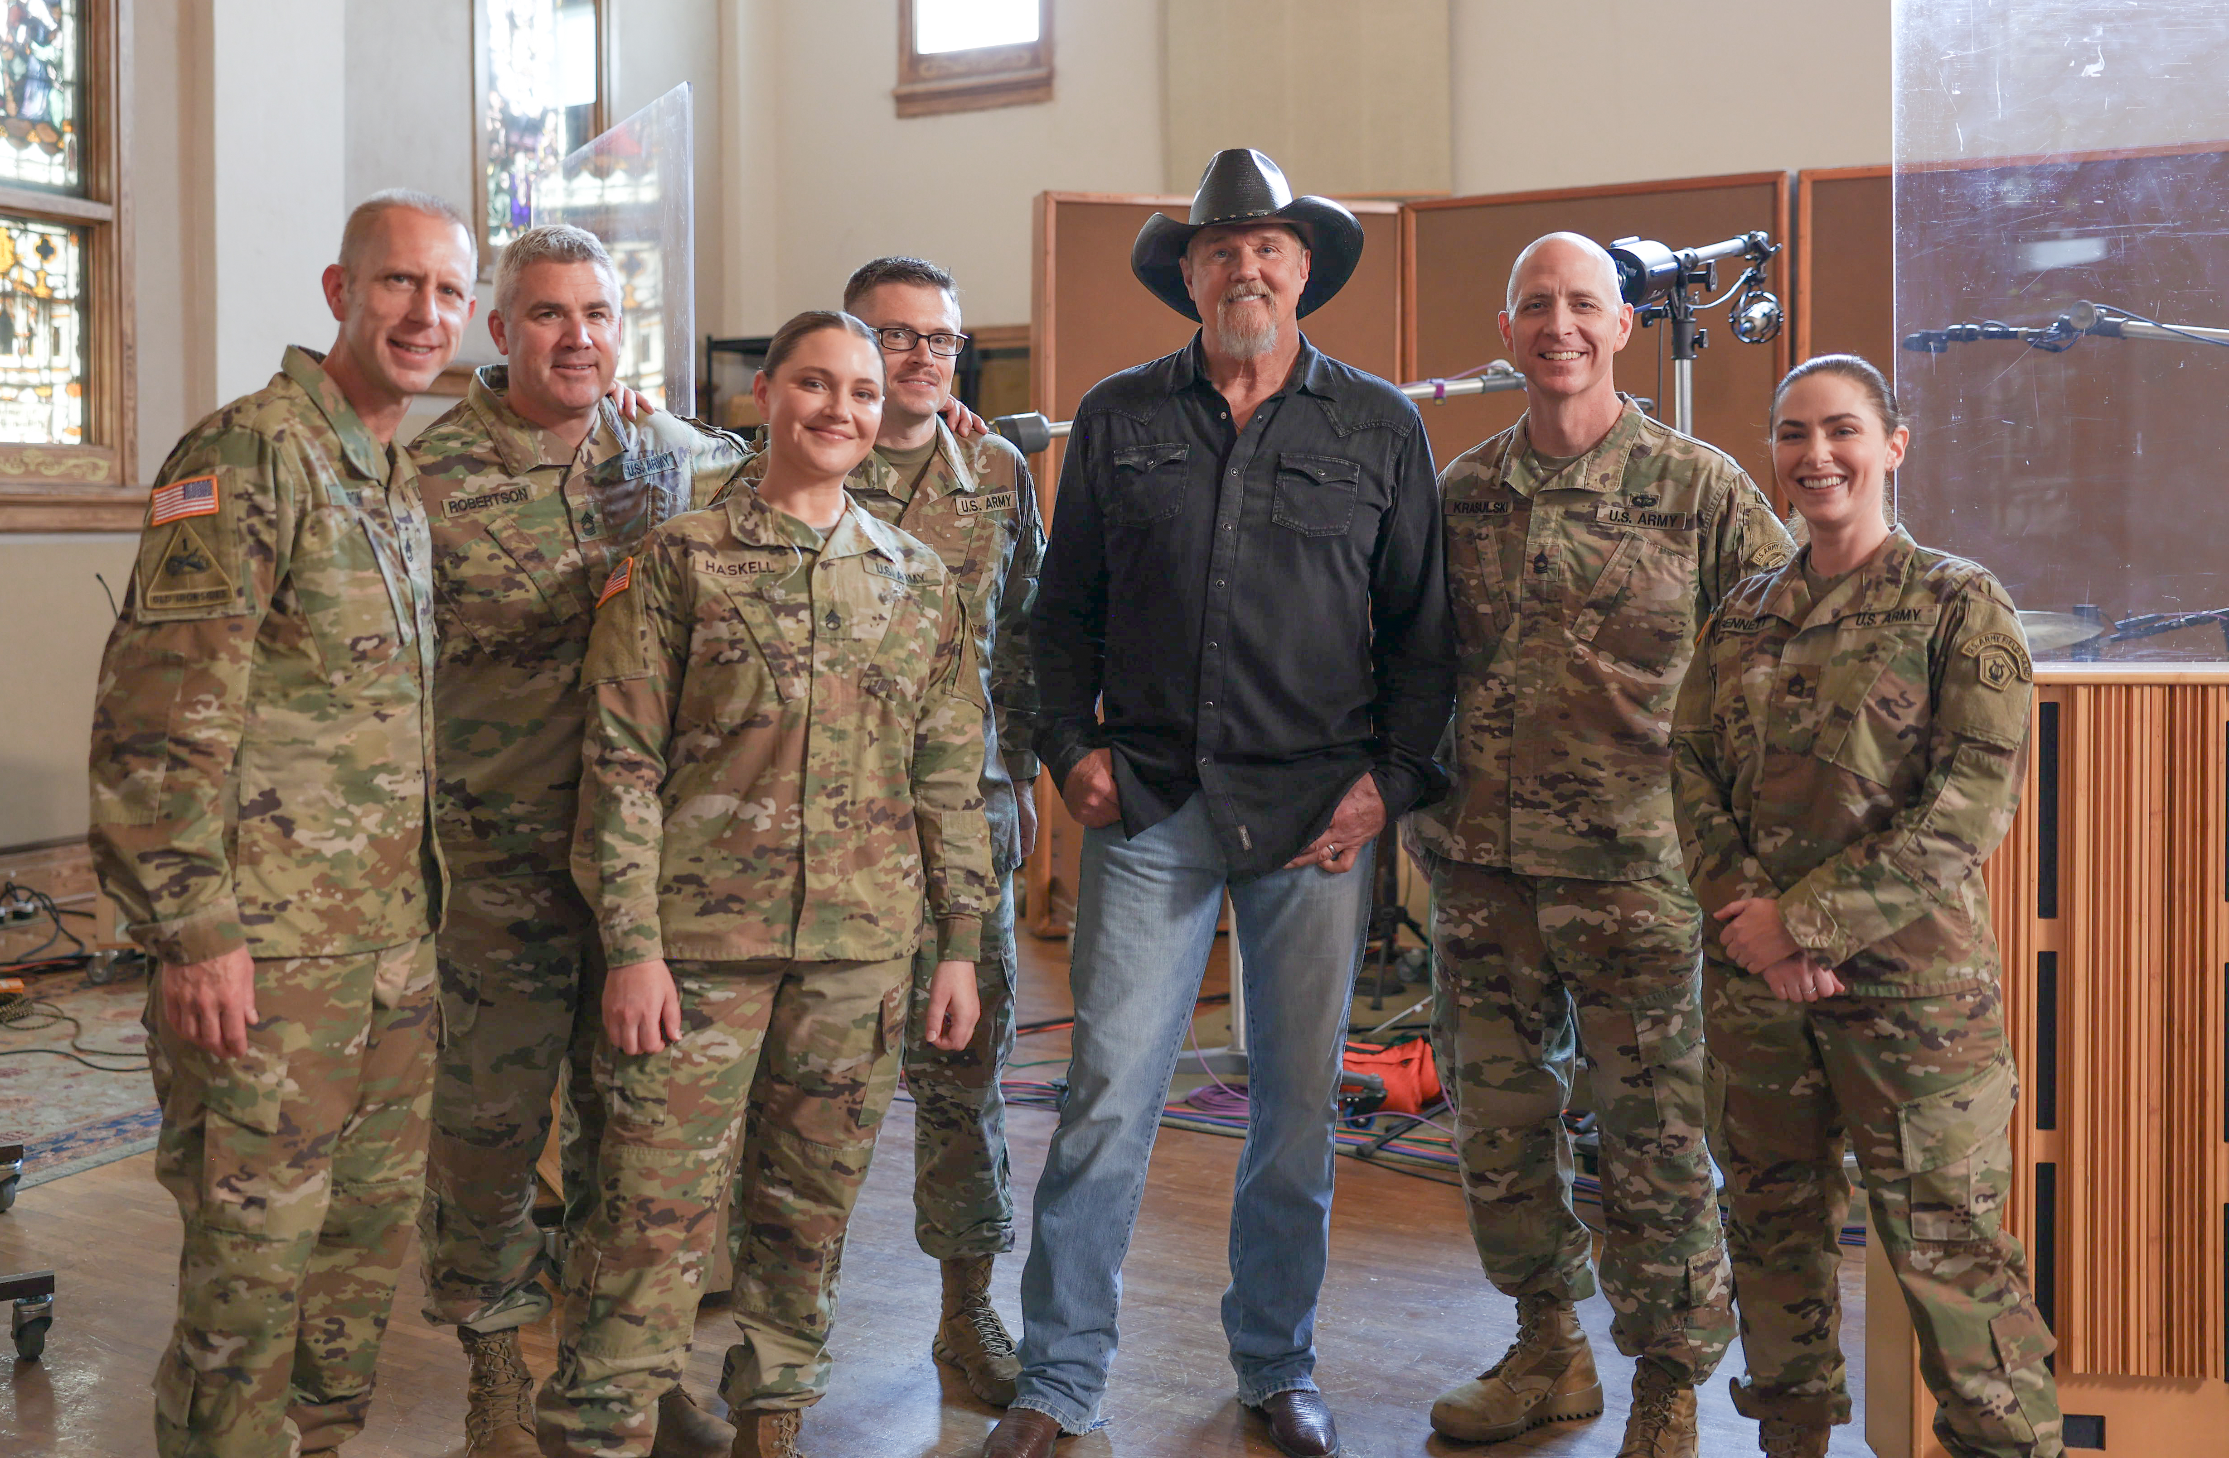
Trace Adkins with the Six String Soldiers at the historic Ocean Way Nashville Studio.
Credit: PBS
ARLINGTON, VA; Oct. 14, 2025 – This November, PBS will premiere SALUTE TO SERVICE 2025: A VETERANS DAY CELEBRATION, featuring multi-platinum entertainer and TV/film actor Trace Adkins alongside the US Army Field Band. In addition to Adkins, this latest installment of the annual celebration features inspiring performances by opera superstar Angel Blue, Grammy-winning jazz vocalist Kurt Elling, as well as fascinating profiles of veterans from across the nation and across the generations. SALUTE TO SERVICE 2025: A VETERANS DAY CELEBRATION premieres Monday, November 10, 2025, 9:00-10:00 p.m. ET (check local listings) on PBS, PBS.org and the PBS app.

Through powerful music and heartfelt storytelling, the program honors the courage and sacrifice of our nation’s veterans. SALUTE TO SERVICE features remarkable stories of service members, including:

- World War II veteran John Gleeson, who served in the Army Air Corps and still flies planes today at age 101;
- The Corley brothers, triplets who followed their father’s lead into the Army along with their mother, who enlisted a year after they joined the service;
- Tracey Hunter of Beyond the Call, an organization dedicated to preserving the stories of WWII vets and taking them to reunions on some of the battlefields where they served;
- In Colorado, Special Forces veterans at the Warrior Mission Ranch help veterans combat both physical and mental injuries, and members of the famed Blue Angels, who perform air shows around the country, highlight the importance of naval aviation while honoring its historical significance; and
- A visit to the Library of Congress highlights the Veterans History Project, which collects and preserves the firsthand recollections of US military veterans for future generations.

Musical highlights include rousing renditions of “God Bless America” and “The Battle Hymn of the Republic” with Angel Blue and the US Army Field Band. Kurt Elling joins the US Army Jazz Ambassadors for standards “I Like the Sunrise” and “Long as You’re Living,” and country superstar and longtime advocate for the nation’s veterans, award-winning, Country music icon Trace Adkins, performs his hits “Still a Soldier” and “Somewhere In America” alongside the Six String Soldiers.

“It was such a high honor to be asked to be involved with SALUTE TO SERVICE,” says Adkins. “Getting to speak in-depth with these heroes who have served our country for generations and selflessly fought for our freedom is an experience that I’ll never forget. Also getting to sing my songs ‘Still a Soldier’ and ‘Somewhere In America’ with the U.S. Army Field Band brought even greater meaning and valor to the lyrics. I’m so proud to be part of this and love to support our troops as much as I can.”

SALUTE TO SERVICE 2025: A VETERANS DAY CELEBRATION will stream simultaneously with broadcast and be available on all station-branded PBS platforms, including PBS.org and the PBS app, which is available on iOS, Android, Roku, Apple TV, Amazon Fire TV, Android TV, Samsung Smart TV, Chromecast and VIZIO.

SALUTE TO SERVICE 2025: A VETERANS DAY CELEBRATION is produced by Snap Snap Productions and directed by Habib Azar. It is written by Master Sgt. Pamela Daniels, Master Sgt. Lauren Urquhart and Sgt. 1st Class Courtney Martin.

About Trace Adkins
In his storied career in Country music, Trace Adkins has sold over 11 million albums, charted 40 singles on Billboard’s Country Airplay Chart, earned numerous awards, multiple GRAMMY nominations, and garnered over 3.5 billion streams. A Grand Ole Opry member for two decades, the Louisiana native is known for his dynamic baritone, fiery live performance, and notable roles as an actor in film and TV. Since his 1996 breakout debut DREAMIN’ OUT LOUD delivered smashes “Every Light In The House,” which hit Top 5 on Billboard’s Hot Country Songs chart and #1 “This Ain’t (No Thinkin’ Thing),” Adkins has pioneered a mix of classic Country minded traditionalism and adventurous, good-natured showmanship, breaking open new avenues in modern Country through fun-filled hits like “Honky Tonk Badonkadonk” and “Hillbilly Bone” with Blake Shelton. Returning with 2021’s THE WAY I WANNA GO (Verge Records) — a 25-song album applauded by media and fans alike with Billboard praising as “a creative tour de force that serves up the lyrical and stylistic diversity that would make his hero [Ronnie] Milsap proud” — he has since followed with “Somewhere in America,” “What Color’s Your Wild,” “That Someday,” and more.

Not only a multi-platinum entertainer, Adkins is also a well-known philanthropist – especially in the military community. He has been recognized with a slew of awards for his support, including National Defense Industrial Association's Dwight D. Eisenhower Award (2016), the Army's Outstanding Civilian Service Award (2016), the Bob Hope Award for Excellence in Entertainment from the Medal of Honor Convention (2010), the DAR Medal of Honor (2010), and the USO Merit Award (2007). He is also one of Wounded Warrior Project’s earliest and most dedicated celebrity sponsors. He’s been committed to its mission since 2010, winning the Talkhouse Award this same year, and has helped raise millions of dollars to support injured post-9/11 veterans. He’s shown his support in a variety of ways to help honor and highlight the continuing needs of our nation’s veterans, performing at benefits and galas, appearing in commercials, and offering rights to use his music. In addition to military support, Adkins is heavily involved in ACM Lifting Lives, GRAMMY Foundation, Monroe Carell Jr. Children's Hospital at Vanderbilt, MusiCares, Shriners Hospitals for Children, and many more. Meanwhile, he continues to tour nationwide. After wrapping his featured spot on Blake Shelton’s Friends & Heroes Tour, he’s currently on his headline What Color's Your Wild Tour through the end of the year.

About Snap Snap Productions
Snap Snap Productions is led by eight-time Emmy Award-winning director Habib Azar. One of the world's leading multi-camera directors and a specialist in filming music for TV, Habib Azar's work spans popular and classical music styles. Snap Snap Productions regularly films the world's leading artists at Carnegie Hall and David Geffen Hall. Habib directs the annual July 4th Boston Pops Fireworks Spectacular, which has featured artists including Jon Batiste, Mavis Staples, Chaka Khan, and En Vogue. For PBS, he has directed for series including The Met: Live in HD, LIVE FROM LINCOLN CENTER, The All-Star Orchestra, and GREAT PERFORMANCES. His feature film Armless was an official selection of the Sundance Film Festival.

About PBS
PBS, with more than 330 member stations, offers all Americans the opportunity to explore new ideas and new worlds through television and digital content. Each month, PBS reaches over 36 million adults on linear primetime television, 16 million users on PBS-owned streaming platforms, 56 million viewers on YouTube, and 10 million followers on social media, inviting them to experience the worlds of science, history, nature, and public affairs and to take front-row seats to world-class drama and performances. PBS’s broad array of programs has been consistently honored by the industry’s most coveted award competitions. As the number one educational media brand, PBS KIDS helps children 2-8 build critical skills, enabling them to find success in school and life. Delivered through member stations, PBS KIDS offers high-quality content on TV — including a PBS KIDS channel — and streaming free on pbskids.org and the PBS KIDS Video app, games on the PBS KIDS Games app, and in communities across America. Teachers of children from pre-K through 12th grade turn to PBS LearningMedia for digital content and services that help bring classroom lessons to life. More information about PBS is available at PBS.org, one of the leading dot-org websites on the internet, Facebook, Instagram, or through our apps for mobile and connected devices. Specific program information and updates for press are available at pbs.org/pressroom or by following PBS Communications on X.

For images and additional up-to-date information on this and other PBS programs, visit PBS PressRoom at pbs.org/pressroom.

