Join Host Jason Kelce for
SALUTE TO SERVICE 2026: A VETERANS DAY CELEBRATION,
Premiering Friday, November 6 on PBS and
Streaming on PBS.org and the PBS app

Tribute to America’s Veterans Features Alejandro Villanueva and
Musical Guest Jon Batiste with Performances by the U.S. Army Field Band

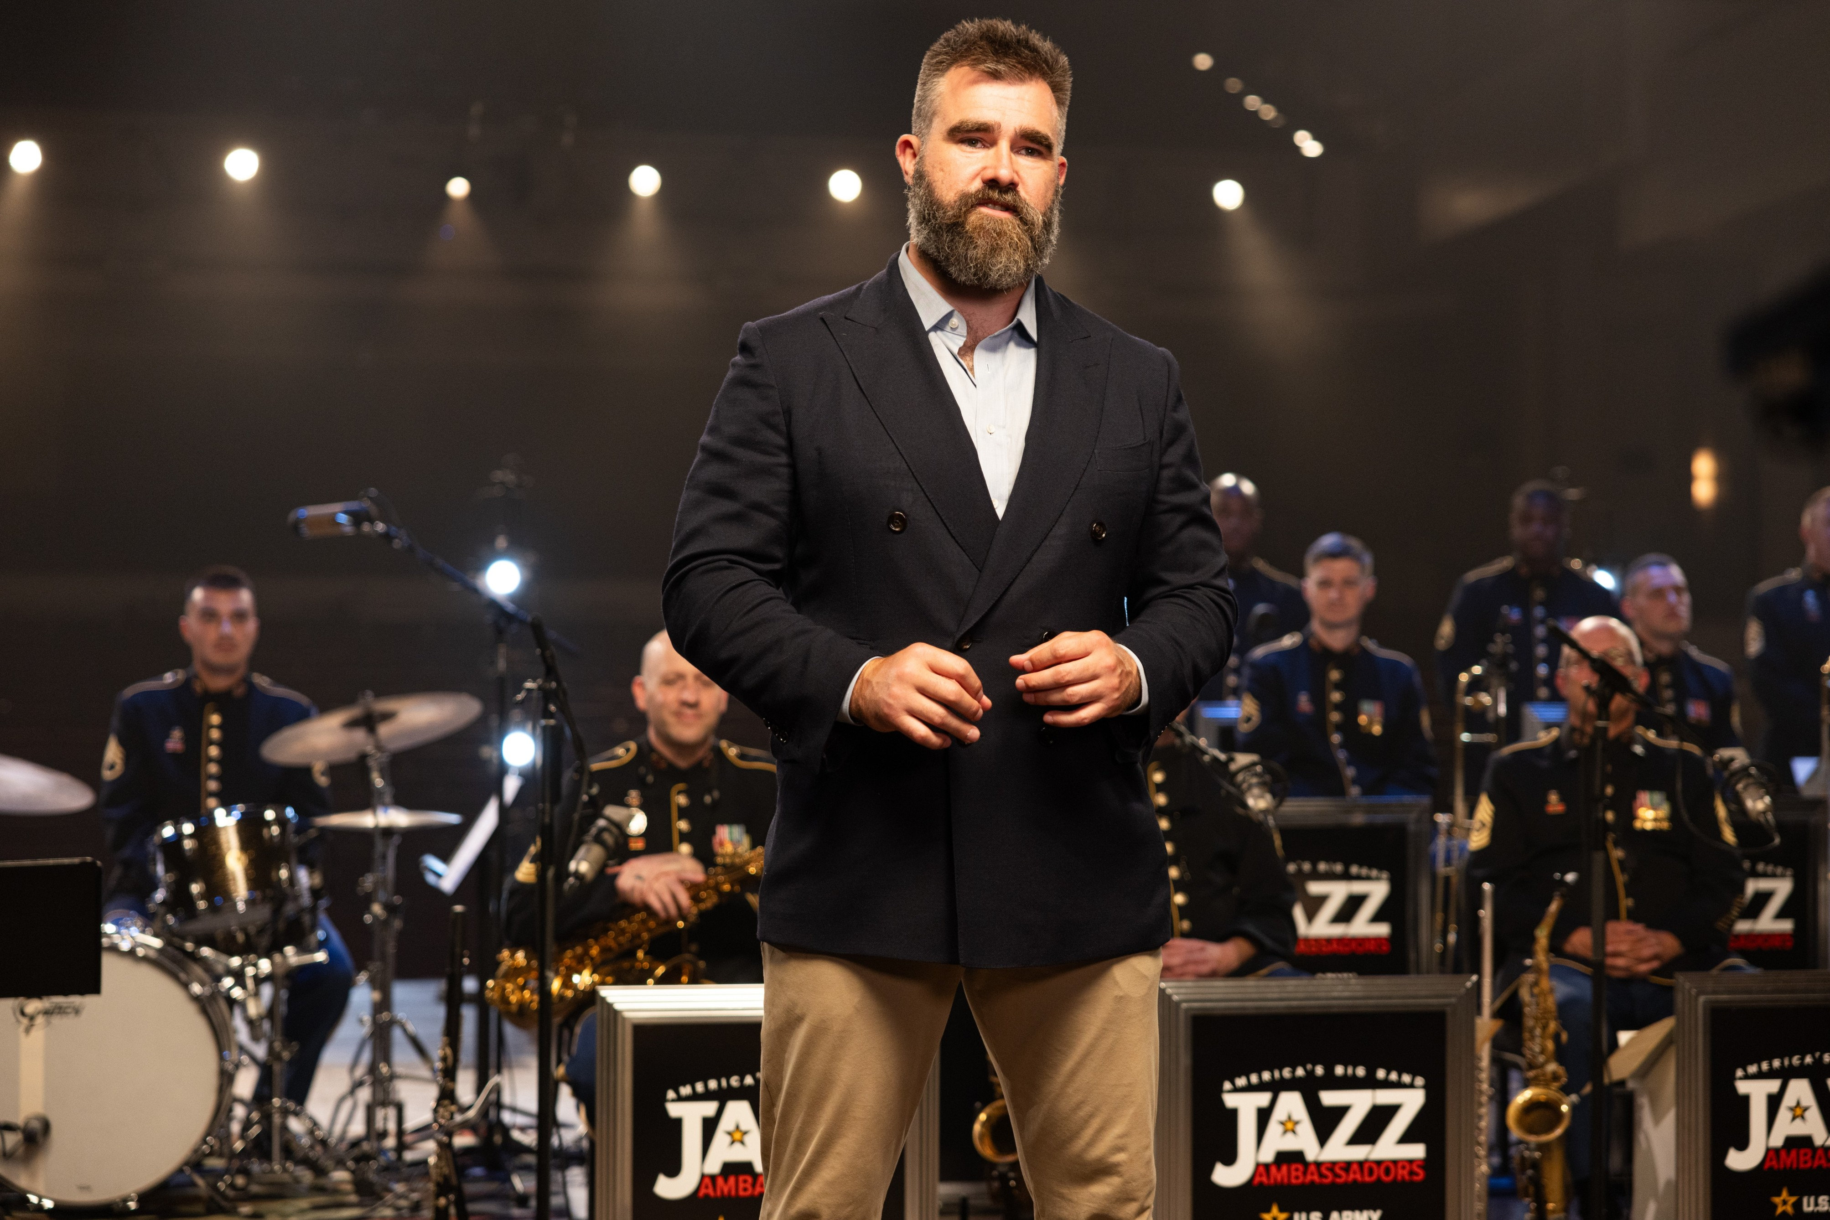
ARLINGTON, VA; Oct. 12, 2026 – SALUTE TO SERVICE returns to PBS this November to honor our nation’s veterans as well as those currently serving. Hosted by Jason Kelce, this year’s installment features Army veteran and former NFL player Alejandro Villanueva and eight-time Grammy, Academy, and Emmy Award–winning singer, songwriter, composer, and pianist Jon Batiste. Performances by the U.S. Army Field Band and its musical ensembles — Six-String Soldiers, Jazz Ambassadors, Concert Band, and Soldiers’ Chorus — showcase a wide range of musical styles. SALUTE TO SERVICE 2026: A VETERANS DAY CELEBRATION premieres Friday, November 6, 2026, 9:00-10:00 p.m. ET (check local listings) on PBS, PBS.org and the PBS app.
Photo by: Staff Sgt. Raymond Maldonado

As host for SALUTE TO SERVICE, Kelce is all-in on the mission to bring “great music, great energy, and some incredible guests” together to celebrate America’s men and women in the military. Special guest Alejandro Villanueva, Army veteran, former NFL player and graduate of the U.S. Military Academy at West Point, takes Kelce on a behind-the-scenes tour of his alma mater, including a helicopter ride, an “ambush” by cadets in the field, and navigating the Water Obstacle Course, including a 25-foot drop. Villanueva shares memories of his time as a cadet, his reasons for wanting to serve, and why — despite his NFL success — his time in the military is the highlight of his life.

Musical guest Jon Batiste sings, plays guitar, piano, and melodica with the Six-String Soldiers on “Big Money,” his one-of-a-kind blues arrangement of “Für Elise-Batiste / Alla Turc Movement,” his interpolation of Thelonious Monk’s “Blue Monk,” and his uplifting anthem “Freedom.” Batiste also reflects on his grandfather’s service in the Korean War and the influence of other family members. "Freedom is hard-earned and requires great sacrifice, often unrewarded and performed by unsung heroes that most of us never meet. Since the earliest days of this country my family has inspired me by their examples of service and resilience. They taught me the lessons of how important it is for us to cherish freedoms that we have and to continue to believe in freedom for all people,” said Batiste.

Celebrating its 80th anniversary in 2026, the U.S. Army Field Band has spent decades connecting the Army with American people through music. Leading off the show with a stirring rendition of “Gonna Fly Now,” the band is joined by Kelce on the saxophone. Other performances include “The Climb,” sung by Staff Sgt. Aaron McAleavey at the Library of Congress and “The Long Road Home”. The Six-String Soldiers perform the bluegrass classic “I’ve Endured” and Eric Clapton’s “Change the World,” with standout vocals on both from Staff Sgt. Megan Haskell. And Kelce gets a chance to wail on the baritone sax on “Moanin’” with the Jazz Ambassadors. The Soldiers’ Chorus features Staff Sgt. Alexus Monroe on “None So Beautiful,” a moving tribute honoring fallen soldiers, sacrifice and bravery filmed at Arlington National Cemetery.

Kelce participates in athletic drills with members of the 3d U.S. Infantry Regiment “The Old Guard,” the Army’s ceremonial unit, and learns about their duties. He gets a lesson on how to carry the flag from the Continental Color Guard, walks through the U.S. Army Drill Team’s gauntlet of moving bayonets, and gets outfitted as a Drum Major by The Old Guard Fife and Drum Corps. And at the Tomb of the Unknown Soldier, Kelce learns about the meticulous training of the elite, handpicked sentinels who guard the tomb round the clock, and whose precision marching honors the unknowns who made the ultimate sacrifice.

SALUTE TO SERVICE 2026: A VETERANS DAY CELEBRATION will stream simultaneously with broadcast and be available on all station-branded PBS platforms, including PBS.org and the PBS app, which is available on iOS, Apple TV, Android mobile and tablets, Android/Google TV, Roku, Amazon Fire TV and tablets, Comcast, Samsung Smart TV, VIZIO and LG Smart TVs.

SALUTE TO SERVICE 2026: A VETERANS DAY CELEBRATION is produced by Snap Snap Productions and directed by Habib Azar. It is written by Sgt. Major Lauren Urquhart, Master Sgt. Pamela Daniels, and Sgt. 1st Class Scott Devereaux. The musical guest is Jon Batiste. Special Guest is Alejandro Villeneuva. Hosted by Jason Kelce.

About Snap Snap Productions
Snap Snap Productions is led by eight-time Emmy Award-winning director Habib Azar, whose directing work spans from contemporary opera to film and television. Habib’s stage credits include directing the world premiere of the original chamber version of Du Yun’s Pulitzer Prize–winning Angel’s Bone with the International Contemporary Ensemble. He also directed the American stage premiere of Georg Fredrich Haas’s Atthis with Opera Cabal at The Kitchen. His first feature film, Armless, was an official selection of the Sundance Film Festival and went on to win awards at festivals around the world. For television, Azar has directed everything from soap operas to Live From Lincoln Center. His credits include hundreds of episodes of As the World Turns, The Young and the Restless, the annual Boston Pops Fireworks Spectacular, and Salute to Service: A Veterans Day Celebration with hosts Jon Stewart, Mickey Guyton, Trace Adkins, and Jason Kelce. Azar also directs for The Metropolitan Opera’s Live in HD series. A longtime collaborator with the New York Philharmonic, he has filmed the orchestra for multiple Live From Lincoln Center and Great Performances programs. He is directing all of the Philharmonic’s 2025–26 season David Geffen Hall lobby livestreams, which you can catch at almost every concert.

About PBS
PBS, with more than 330 member stations, offers all Americans the opportunity to explore new ideas and new worlds through television and digital content. Each month, PBS reaches over 36 million adults on linear primetime television, 16 million users on PBS-owned streaming platforms, 56 million viewers on YouTube, and 10 million followers on social media, inviting them to experience the worlds of science, history, nature, and public affairs and to take front-row seats to world-class drama and performances. PBS’s broad array of programs has been consistently honored by the industry’s most coveted award competitions. As the number one educational media brand, PBS KIDS helps children 2-8 build critical skills, enabling them to find success in school and life. Delivered through member stations, PBS KIDS offers high-quality content on TV — including a PBS KIDS channel — and streaming free on pbskids.org and the PBS KIDS Video app, games on the PBS KIDS Games app, and in communities across America. Teachers of children from pre-K through 12th grade turn to PBS LearningMedia for digital content and services that help bring classroom lessons to life. More information about PBS is available at PBS.org, one of the leading dot-org websites on the internet, Facebook, Instagram, or through our apps for mobile and connected devices. Specific program information and updates for press are available at pbs.org/pressroom or by following PBS Communications on X.

– PBS –

CONTACTS:

Chelsie Pope, PBS, cepope@pbs.org

Cara White / Mary Lugo, CaraMar, Inc.
cara.white@mac.com; lugo@negia.net

For images and additional up-to-date information on this and other PBS programs, visit PBS PressRoom at pbs.org/pressroom.

