New PBS Series, THE FUTURE OF NATURE, Illuminates the Role of Carbon in Our Planet

The four-part series premieres Wednesday, March 26, at 10:00 p.m. ET on PBS

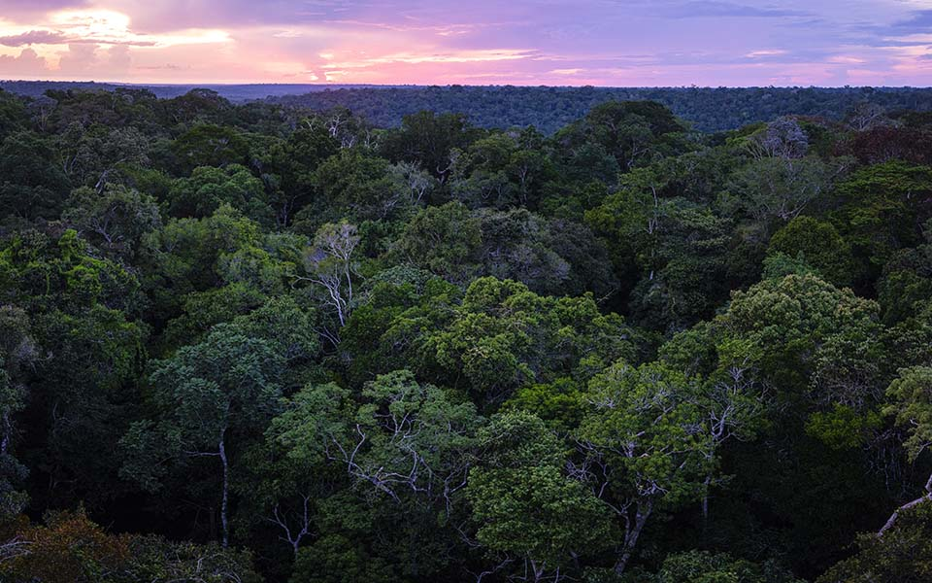
Arlington, VA; (March 12, 2025) – PBS announced today a new four-part series, THE FUTURE OF NATURE, premiering Wednesdays, March 26 – April 16, 2025 at 10:00 p.m. ET on PBS, PBS.org and the PBS App (check local listings). Narrated by Uma Thurman, the nature series by Brain Leith Productions takes a rare look at the vital role of carbon in our planet, and the power of nature in helping to restore and stabilize our ecosystems.

By blending compelling science with cutting-edge graphics and cinematic shots of oceans, grasslands, forests and metropolises, THE FUTURE OF NATURE brings the invisible element of carbon into view. These stories provide audiences with a unique visual representation of the planet’s ecosystems, uncovering the role that animals, plants and people have on carbon and solutions that could help stabilize environmental shifts.

Featuring contributors from all corners of the globe, THE FUTURE OF NATURE follows climatologists, ecologists, Indigenous leaders and economists. Their stories reveal how nature is helping to rebalance Earth’s delicate systems and heal itself.

Episode Descriptions
Episode 1: “Oceans” (Wednesday, March 26, 2025)
Learn how carbon is drawn down into the oceans by the “biological carbon pump.” Explore how complex ocean life, including plankton, the fish we eat, whale excrement, and secrets from the deep depths, is fundamental to removing carbon from the atmosphere.

Episode 2: “Grasslands” (Wednesday, April 2, 2025)
Scientists further explore the fact that carbon drawdown is boosted by life and examine the grasslands where the largest number of animals exist. From the tropical savannahs of East Africa to the tundra of the Arctic, from the plains of Kazakhstan to the prairies of North America. Heroic champions of nature and the latest science reveal how important grasslands are to the future, and what can be done to restore them to health and abundance.

Episode 3: “Forests” (Wednesday, April 9, 2025)
Forests are the most effective carbon pumps on Earth, but they are incredibly complex ecosystems, and the carbon drawdown only increases when they’re functioning well and rich in species. Forests of the world are much reduced and for them to effectively help in the fight against environmental shifts protecting what’s left and repairing what’s been lost is key. There is good news: learn how chimps in the Congo basin are critical to healthy forests and Indigenous wisdom helps rebuild the Amazon.

Episode 4: “Humans” (Wednesday, April 16, 2025)
Expanding on the scenario of a world where nature is thriving, ecosystems are functioning, and carbon is stable, is there room for 11 billion people? Scientists reveal how humans are the ultimate ecosystem engineers - a keystone species - more than capable of looking after the planet. See stories where people are changing things for the better, integrating our modern lives with nature, and showing a path to a better future. From the metropolises of China to the outskirts of Los Angeles, from the bogs of Ireland to the Favelas of Rio. Humans can make this world one where we can all thrive!

THE FUTURE OF NATURE will stream Wednesday, March 26, 2025 and be available on all station-branded PBS platforms, including PBS.org and the PBS app, available on iOS, Android, Roku streaming devices, Apple TV, Android TV, Amazon Fire TV, Samsung Smart TV, Chromecast and VIZIO. PBS station members can view many series, documentaries, and specials via PBS Passport. For more information about PBS Passport, visit the PBS Passport FAQ website or contact your local station.

Funding for THE FUTURE OF NATURE was provided by the Anne Ray Foundation, the Rosalind P. Walter Foundation, Dan Carrigan through the Gaia Earth-Balance Endowment and PBS viewers.

THE FUTURE OF NATURE is a production by Brian Leith Productions for PBS in association with ARTE France. Executive produced by Giulio Boccaletti and Patrick Morris. Narrated by Uma Thurman. Series producer is Verity White. Nicola Brown produced and directed episode one. Robert Myler produced and directed episode two and Gavin Maxwell produced and directed episodes three and four. Music by Ben Foster. BBC Studios is handling international distribution.
About PBS
PBS, with more than 330 member stations, offers all Americans the opportunity to explore new ideas and new worlds through television and digital content. Each month, PBS reaches over 36 million adults on linear primetime television, more than 16 million users on PBS-owned streaming platforms, 53 million viewers on YouTube, and 60 million people view PBS content on social media, inviting them to experience the worlds of science, history, nature, and public affairs and to take front-row seats to world-class drama and performances. PBS’s broad array of programs has been consistently honored by the industry’s most coveted award competitions. Teachers of children from pre-K through 12th grade turn to PBS LearningMedia for digital content and services that help bring classroom lessons to life. As the number one educational media brand, PBS KIDS helps children 2-8 build critical skills, enabling them to find success in school and life. Delivered through member stations, PBS KIDS offers high-quality content on TV — including a PBS KIDS channel — and streaming free on pbskids.org and the PBS KIDS Video app, games on the PBS KIDS Games app, and in communities across America. More information about PBS is available at PBS.org, one of the leading dot-org websites on the internet, Facebook, Instagram, or through our apps for mobile and connected devices. Specific program information and updates for press are available at pbs.org/pressroom or by following PBS Communications on X.

– PBS –

CONTACTS:

Meredith Tiger, PBS, mjtiger@pbs.org
Stephanie Kennard, PBS, skkennard@pbs.org

For images and additional up-to-date information on this and other PBS programs, visit PBS PressRoom at pbs.org/pressroom.

