PBS to Broadcast THE LAST 600 METERS: THE BATTLES OF NAJAF AND FALLUJAH

Premieres Monday, Nov. 10, 10 – 11:30 p.m. ET on PBS

Documentary Examines Two Biggest Battles of the Iraq War

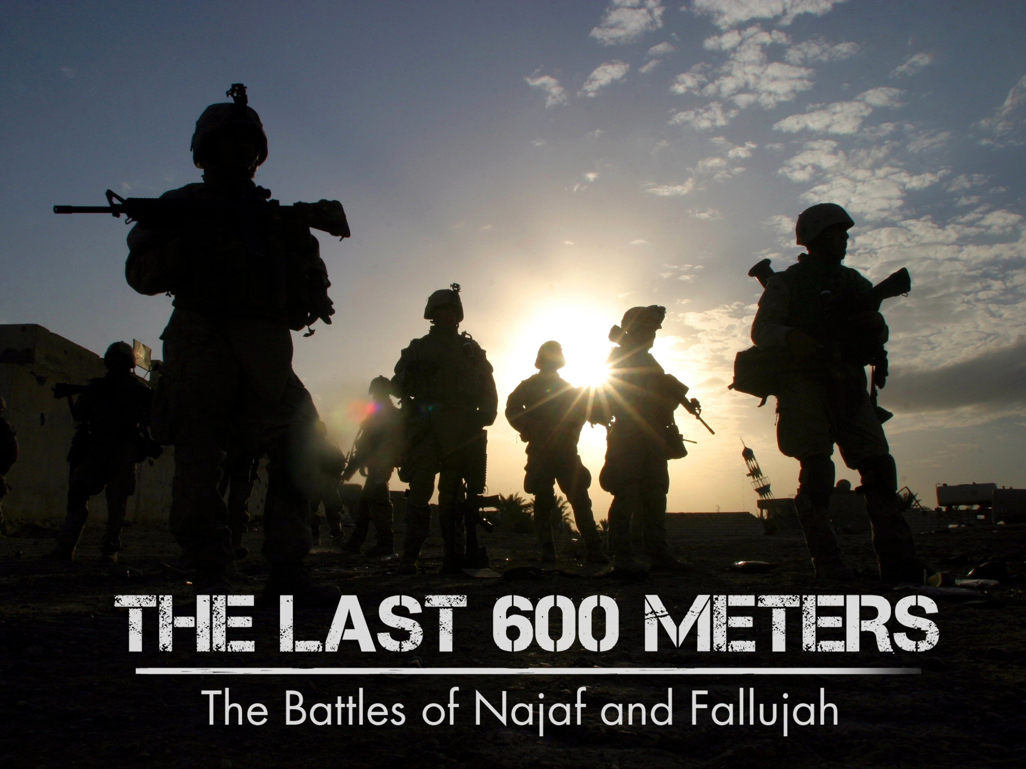
Caption: Key Art
Credit: PBS
ARLINGTON, VA; Oct. 27, 2025 – PBS announces the premiere of THE LAST 600 METERS: THE BATTLES OF NAJAF AND FALLUJAH, launching Monday, Nov. 10 at 10 p.m. ET on PBS, PBS.org and PBS app, on the eve of Veteran’s Day.

The film documents the two deadliest battles of the Iraq War, which occurred in 2004. The Battle of Najaf was fought in the South against the Shiite Mahdi militia. The Battle of Fallujah was fought in the West against Sunni insurgents. These brutal urban conflicts were not the high-tech battles the military had prepared for after the first Gulf War in 1991, but they are the face of modern warfare. This film tells the story of these battles, not through narration, but through the words and deeds of those who fought there.

“The way to honor veterans is to remember what they did in battle, serving the country,” says producer director Michael Pack. “THE LAST 600 METERS tells the story of America’s biggest battles since Vietnam, Fallujah and Najaf, in Iraq in 2004, in the words and images of those who fought there: the ground truth. Americans should know what happened in these battles, as we do at Gettysburg or Iwo Jima.”

Interviews in the film were conducted in 2007, when the marines and soldiers were only two years from the battles and their memories were still fresh and vivid. They reveal how those on the ground doing the fighting have to cope with decisions made far away in Washington. As a sniper in the film remarks, “Foreign policy, I don’t make it, I just deliver the last 600 meters of it.”

THE LAST 600 METERS: THE BATTLES OF NAJAF AND FALLUJAH is the winner of the Founders Choice Award at the GI Film Festival and the Best of Festival Award at the Hudson Institute Film Festival.

THE LAST 600 METERS: THE BATTLES OF NAJAF AND FALLUJAH will stream Monday, Nov. 10 and be available on all station-branded PBS platforms, including PBS.org and the PBS app, available on iOS, Android, Roku, Apple TV, Amazon Fire TV and Chromecast. PBS station members will be available to view all episodes via Passport (contact your local PBS station for details).

Major funding for THE LAST 600 METERS: THE BATTLES OF NAJAF AND FALLUJAH was provided by the Corporation for Public Broadcasting, Richardson, Smith Foundation, The Lynde and Harry Bradley Foundation, Inc.

THE LAST 600 METERS: THE BATTLES OF NAJAF AND FALLUJAH is a production of Manifold Productions, Inc. Directed and written by Michael Pack. Produced by Michael Pack, Gina Cappo Pack, and Stephen K. Bannon.
About PBS
PBS, with more than 330 member stations, offers all Americans the opportunity to explore new ideas and new worlds through television and digital content. Each month, PBS reaches over 36 million adults on linear primetime television, 16 million users on PBS-owned streaming platforms, 56 million viewers on YouTube, and 10 million followers on social media, inviting them to experience the worlds of science, history, nature, and public affairs and to take front-row seats to world-class drama and performances. PBS’s broad array of programs has been consistently honored by the industry’s most coveted award competitions. As the number one educational media brand, PBS KIDS helps children 2-8 build critical skills, enabling them to find success in school and life. Delivered through member stations, PBS KIDS offers high-quality content on TV — including a PBS KIDS channel — and streaming free on pbskids.org and the PBS KIDS Video app, games on the PBS KIDS Games app, and in communities across America. Teachers of children from pre-K through 12th grade turn to PBS LearningMedia for digital content and services that help bring classroom lessons to life. More information about PBS is available at PBS.org, one of the leading dot-org websites on the internet, Facebook, Instagram, or through our apps for mobile and connected devices. Specific program information and updates for press are available at pbs.org/pressroom or by following PBS Communications on X.

– PBS –

CONTACTS:

Lisa Dyer, Bullseye Communications, lisa.dyer@bullseyecomm.com
Heather Marohn, Bullseye Communications, heather.marohn@bullseyecomm.com
Chelsie Pope, PBS, cepope@pbs.org

For images and additional up-to-date information on this and other PBS programs, visit PBS PressRoom at pbs.org/pressroom.

