FOR IMMEDIATE RELEASE



VOCES “Slumlord Millionaire” PREMIERES ON PBS AND PBS.ORG
ON MONDAY, JULY 28, 2025

In New York City’s Most Quickly Gentrifying Neighborhoods,
Fearless Residents, Activists, and Nonprofit Attorneys
Fight for the Right to Decent and Affordable Housing

(Los Angeles, CA) – Winner of the Audience Award at the 2024 DOC NYC Film Festival, “Slumlord Millionaire” explores the rapid gentrification of New York City neighborhoods and the housing crisis sweeping not only New York but the nation. Median rents nationwide are higher than ever, and, in Manhattan, the average rent is now almost $5,000 per month. As rents increase, some landlords have become aggressive in getting long-term tenants to leave: ignoring repairs, turning off heat and gas, and doing nothing to eliminate mold and vermin infestations. The landlord’s goal is to make the apartment so uninhabitable that residents are forced out, allowing them to deregulate the apartment and turn it over to market rate for a high profit. These actions drive up costs in the already unaffordable housing market and displace families who make up the fabric of these neighborhoods, changing communities forever. “Slumlord Millionaire,” produced and directed by Ellen Martinez and Steph Ching and executive produced by Sandie Viquez Pedlow, Stanley Nelson, Marcia Smith, Stephen Gong and Donald Young premieres on the PBS series VOCES on Monday, July 28, 2025, 10:00-11:30 p.m. ET (check local listings) on PBS, PBS.org and the PBS app.
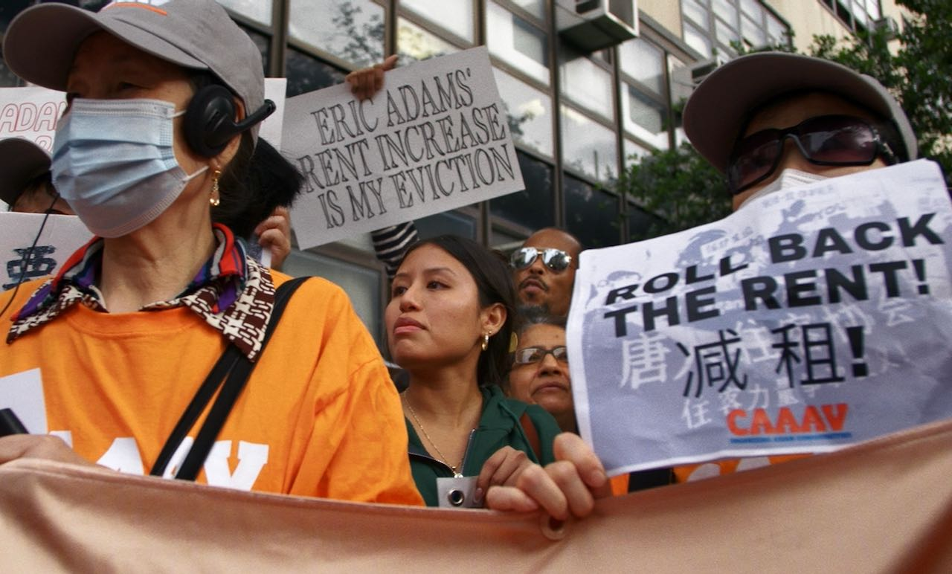
Credit: Steph Ching

The film explores New York’s affordable housing crisis through four unforgettable stories:

- The Bravo Family in Sunset Park, Brooklyn, have been in a fierce battle with their landlord for 15 years, defending their right to live in an apartment safe from mold, lead, flooding, and freezing temperatures. When the landlord refused to remove mold in their bathroom, which gave their children severe asthma, they fought back. Their testimony helped pass the “Asthma Free Housing Act,” statewide legislation requiring New York landlords to eliminate mold in apartments with children. But their battles with their abusive and neglectful landlord continue.

- Manhattan’s historic Chinatown has been fighting gentrification for generations, but four looming luxury “Megatowers” may be the neighborhood's biggest threat. In one old building, a group of longtime residents are organizing to fight to stay in their homes. While their landlord ignores their requests for basic maintenance, he fully renovates the vacant apartments in the building and then rents these new “luxury” units for thousands. The film follows these and other Chinatown residents as they mobilize with community partners to try to stop the new towers, which, if built, will continue the displacement of tenants who fear their beloved community will disappear forever.

- In the 1990s, Janina Davis was a successful supermodel, gracing the cover of Vogue and traveling the world. In 1998, she bought a brownstone in Clinton Hill, Brooklyn, renting two units at a fair price and planning to develop her back lot into even more affordable apartments. She contacted a developer, who created blueprints, and that is when her life turned upside down. What appeared to be a standard business transaction was a highly sophisticated deed theft scam. She filed a court case, but the “developer” insisted that he now legally owned her home. In the film, lawyers fighting to protect clients from a rampant deed scam epidemic explain the systemic failures that allow this to continue, particularly in historically Black and Brown neighborhoods, robbing families of the right to home ownership and generational wealth.

- Moumita Ahmed is a Bangladeshi-American activist who lives with her parents in a rent-stabilized apartment in Jamaica, Queens. Her family knows what it is like to be harassed and exploited by bad landlords and she has lived with this uncertainty her entire life. Inspired by Bernie Sanders, Moumita ran for City Council in 2021 to hold corrupt landlords accountable and stop tenant harassment throughout the city. But as the only renter on the ballot, she faced an unprecedented fight. Developers hoping to build in Queens were threatened by her tenacity, and, as she rose in the polls, they invested over a million dollars into a PAC that spent money on attack ads targeting her campaign.

A powerful David v. Goliath story of tenants fighting back against corruption and greed, VOCES “Slumlord Millionaire” will stream simultaneously with broadcast and be available on all station-branded PBS platforms, including PBS.org and the PBS app, available on iOS, Android, Roku streaming devices, Apple TV, Android TV, Amazon Fire TV, Samsung Smart TV, Chromecast, and VIZIO.

VOCES “Slumlord Millionaire” is a co-production of After Spring LLC, Latino Public Broadcasting, Firelight Media and the Center for Asian American Media in association with PBS. The film is directed by Steph Ching and Ellen Martinez, executive produced by Sandie Viquez Pedlow, Stanley Nelson, and Marcia Smith, Stephen Gong and Donald Young, and produced by Ellen Martinez, Steph Ching, and Nicole Tsien. The editors are Steph Ching, Sarah Garrahan and Francesca Kustra. The director of photography is Jeffrey Johnson, with original music by Katy Jarzebowski.

About the Filmmakers

Ellen Martinez and Steph Ching (Directors/Producers) previously directed and produced After Spring, a feature documentary about the Syrian refugee crisis. The film was executive produced by Jon Stewart, had its world premiere at the Tribeca Film Festival, was broadcast on Starz and received a Frontline Award for Documentary Journalism. Their work has been supported by the Sundance Institute, Latino Public Broadcasting, Firelight Media, The John D. and Catherine T. MacArthur Foundation and NYSCA. They were both honorees on DOC NYC’s inaugural "40 Under 40" list as directors. As a producer, Martinez has worked on projects for HBO, Disney+, PBS, Participant Media and Imagine Documentaries and was a Netflix Nonfiction Directing/Producing Fellow. She is originally from Texas but grew up living overseas in Dubai, Venezuela, and Syria. She is now based in Brooklyn, New York.​ Ching is also an editor and worked on Cameraperson, The Fourth Estate, The Brink, Take Out with Lisa Ling and Netflix’s White Hot. She is the proud daughter of Hong Kong immigrants.​

Nicole Tsien (Producer) is an independent producer based in Queens, New York. She is most passionate about uplifting BIPOC filmmakers and supporting creative documentaries. She previously worked in television for over a decade, most recently as the Director of Program Development at CNN Films, where she worked on Little Richard: I Am Everything, directed by Lisa Cortés, produced by Bungalow Media + Entertainment; and Glitch: The Rise and Fall of HQ Trivia, directed by Salima Koroma, produced by Left/Right. She was formerly the co-producer of POV, the longest-running documentary series on PBS, where, during her tenure, she worked to present over 90 films to a national audience and has been the recipient of multiple News and Documentary Emmys, Peabody, and duPont-Columbia nominations and awards. Nicole has participated on panels and juries worldwide, including CAAMFest, Doc NYC, and Austin Film Festival. She took part in the inaugural Film Independent Documentary Producing Lab in 2024, was a 2021 Rockwood JustFilms Fellow, and was part of the inaugural cohort of Doc NYC Documentary New Leaders in 2020. Nicole is on the Steering Committee for the Asian American Documentary Network (A-Doc) and serves as a board member of Brown Girls Doc Mafia.

About VOCES
Produced by Latino Public Broadcasting, the acclaimed PBS documentary series VOCES features the best of Latino arts, culture and history and shines a light on current issues that impact Latino Americans. Devoted to exploring the rich diversity of the Latino experience, VOCES presents new and established filmmakers and brings their powerful and illuminating stories to a national audience — on TV, online and on the PBS app. Luis Ortiz is series producer; Sandie Viquez Pedlow is executive producer. Funding for VOCES is provided by the Corporation for Public Broadcasting and PBS. Follow us on Facebook and X.

About Latino Public Broadcasting
For over 25 years, Latino Public Broadcasting (LPB) has been developing award-winning film and digital media that explores the history, arts and culture of Latino Americans, bringing these powerful and illuminating stories to a national audience on PBS — on TV, online and on the PBS app.

LPB projects have spotlighted Latino contributions to the arts (Julia Alvarez: A Life Reimagined, John Leguizamo’s Road to Broadway, Raúl Julia: The World’s a Stage); told the story of Latino icons from Cesar Chavez to Dolores Huerta, Tito Puente to Celia Cruz, Ruben Salazar to Roberto Clemente; explored history and politics through a Latino lens (John Leguizamo’s American Historia, Latino Vote 2024); and told stories from Mexico, Puerto Rico and Latin America (Water for Life, Reportero), many as part of its signature PBS series VOCES.

LPB programs have won over 130 awards, including three prestigious George Foster Peabody Awards as well as Emmys, Imagen Awards and the Sundance Film Festival Award for Best Director, Documentary. LPB has been the recipient of the Norman Lear Legacy Award and the NCLR Alma Award for Special Achievement – Year in Documentaries. Sandie Viquez Pedlow is executive director of LPB; Edward James Olmos is co-founder and chairman.

Follow LPB on Facebook, X, YouTube and Instagram.

###
Contact:
CaraMar Publicity
Mary Lugo 770 851 8190 lugo@negia.net
Cara White 843 881 1480 cara.white@mac.com

For images and additional up-to-date information on this and other PBS programs, visit PBS PressRoom at pbs.org/pressroom.

