FOR IMMEDIATE RELEASE



VOCES “Slumlord Millionaire” AVAILABLE FOR FREE STREAMING ON THE PBS YOUTUBE CHANNEL FROM NOVEMBER 30 – DECEMBER 30, 2025
ALSO STREAMING ON PBS.ORG, AND THE PBS APP

Acclaimed Film Spotlights New York City’s
Fight for the Right to Decent and Affordable Housing

(Los Angeles, CA) – Winner of the Audience Award at the 2024 DOC NYC Film Festival, “Slumlord Millionaire” explores the rapid gentrification of New York City neighborhoods and the housing crisis sweeping not only New York but the nation. Median rents nationwide are higher than ever, and, in Manhattan, the average rent is now almost $5,000 per month. As rents increase, some landlords have become aggressive in getting long-term tenants to leave: ignoring repairs, turning off heat and gas, and doing nothing to eliminate mold and vermin infestations. The landlord’s goal is to make the apartment so uninhabitable that residents are forced out, allowing them to deregulate the apartment and turn it over to market rate for a high profit. These actions drive up costs in the already unaffordable housing market and displace families who make up the fabric of these neighborhoods, changing communities forever.
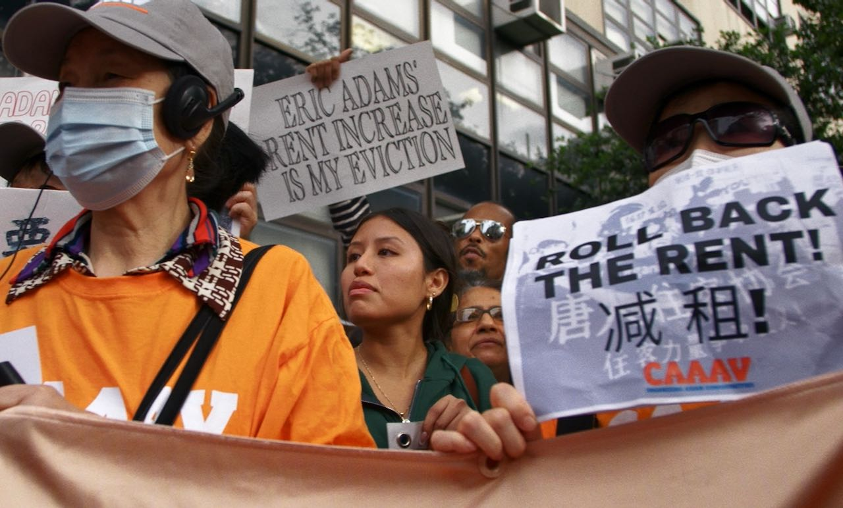
Credit: Steph Ching

“Slumlord Millionaire” will be newly available for free streaming on the PBS YouTube Channel from Sunday, November 30 to Tuesday, December 30, 2025. The film, which originally premiered on the PBS series VOCES in July, will also be available on PBS.org, the PBS app.

The film explores New York’s affordable housing crisis through four unforgettable stories:

- The Bravo Family in Sunset Park, Brooklyn, have been in a fierce battle with their landlord for 15 years, defending their right to live in an apartment safe from mold, lead, flooding, and freezing temperatures. When the landlord refused to remove mold in their bathroom, which gave their children severe asthma, they fought back. Their testimony helped pass the “Asthma Free Housing Act,” statewide legislation requiring New York landlords to eliminate mold in apartments with children. But their battles with their abusive and neglectful landlord continue.

- Manhattan’s historic Chinatown has been fighting gentrification for generations, but four looming luxury “Megatowers” may be the neighborhood's biggest threat. The film follows residents as they mobilize with community partners to try to stop the new towers, which, if built, will continue the displacement of tenants who fear their beloved community will disappear forever.

- In the 1990s, Janina Davis, a successful supermodel, bought a brownstone in Clinton Hill, Brooklyn, renting two units at a fair price and planning to develop her back lot into even more affordable apartments. Working with a developer in what appeared to be a standard business transaction, Janina found herself the victim of a highly sophisticated deed theft scam. The crime was part of a deed scam epidemic that robs families of the right to home ownership and generational wealth, particularly in historically Black and Brown neighborhoods.

- Moumita Ahmed is a Bangladeshi-American activist who, inspired by Bernie Sanders, ran for City Council in 2021 to hold corrupt landlords accountable and stop tenant harassment throughout the city. Developers were threatened by her tenacity, and, as she rose in the polls, they invested over a million dollars into a PAC that spent money on attack ads targeting her campaign.

A powerful David v. Goliath story of tenants fighting back against corruption and greed, VOCES “Slumlord Millionaire” is a co-production of After Spring LLC, Latino Public Broadcasting, Firelight Media and the Center for Asian American Media in association with PBS. The film is directed by Steph Ching and Ellen Martinez, executive produced by Sandie Viquez Pedlow, Stanley Nelson, and Marcia Smith, Stephen Gong and Donald Young, and produced by Ellen Martinez, Steph Ching, and Nicole Tsien. The editors are Steph Ching, Sarah Garrahan and Francesca Kustra. The director of photography is Jeffrey Johnson, with original music by Katy Jarzebowski.

About the Filmmakers

Ellen Martinez and Steph Ching (Directors/Producers) previously directed and produced After Spring, a feature documentary about the Syrian refugee crisis. The film was executive produced by Jon Stewart, had its world premiere at the Tribeca Film Festival, was broadcast on Starz and received a Frontline Award for Documentary Journalism. Their work has been supported by the Sundance Institute, Latino Public Broadcasting, Firelight Media, The John D. and Catherine T. MacArthur Foundation and NYSCA. They were both honorees on DOC NYC’s inaugural "40 Under 40" list as directors. As a producer, Martinez has worked on projects for HBO, Disney+, PBS, Participant Media and Imagine Documentaries and was a Netflix Nonfiction Directing/Producing Fellow. She is originally from Texas but grew up living overseas in Dubai, Venezuela, and Syria. She is now based in Brooklyn, New York.​ Ching is also an editor and worked on Cameraperson, The Fourth Estate, The Brink, Take Out with Lisa Ling and Netflix’s White Hot. She is the proud daughter of Hong Kong immigrants.​

Nicole Tsien (Producer) is an independent producer based in Queens, New York. She is most passionate about uplifting BIPOC filmmakers and supporting creative documentaries. She previously worked in television for over a decade, most recently as the Director of Program Development at CNN Films, where she worked on Little Richard: I Am Everything, directed by Lisa Cortés, produced by Bungalow Media + Entertainment; and Glitch: The Rise and Fall of HQ Trivia, directed by Salima Koroma, produced by Left/Right. She was formerly the co-producer of POV, the longest-running documentary series on PBS, where, during her tenure, she worked to present over 90 films to a national audience and has been the recipient of multiple News and Documentary Emmys, Peabody, and duPont-Columbia nominations and awards. Nicole has participated on panels and juries worldwide, including CAAMFest, Doc NYC, and Austin Film Festival. She took part in the inaugural Film Independent Documentary Producing Lab in 2024, was a 2021 Rockwood JustFilms Fellow, and was part of the inaugural cohort of Doc NYC Documentary New Leaders in 2020. Nicole is on the Steering Committee for the Asian American Documentary Network (A-Doc) and serves as a board member of Brown Girls Doc Mafia.

About VOCES
Produced by Latino Public Broadcasting, the acclaimed PBS documentary series VOCES features the best of Latino arts, culture and history and shines a light on current issues that impact Latino Americans. Devoted to exploring the rich diversity of the Latino experience, VOCES presents new and established filmmakers and brings their powerful and illuminating stories to a national audience — on TV, online and on the PBS app. Luis Ortiz is series producer; Sandie Viquez Pedlow is executive producer. Funding for VOCES is provided by the Corporation for Public Broadcasting and PBS. Follow us on Facebook and X.

About Latino Public Broadcasting
For over 25 years, Latino Public Broadcasting (LPB) has been developing award-winning film and digital media that explores the history, arts and culture of Latino Americans, bringing these powerful and illuminating stories to a national audience on PBS — on TV, online and on the PBS app.

LPB projects have spotlighted Latino contributions to the arts (Julia Alvarez: A Life Reimagined, John Leguizamo’s Road to Broadway, Raúl Julia: The World’s a Stage); told the story of Latino icons from Cesar Chavez to Dolores Huerta, Tito Puente to Celia Cruz, Ruben Salazar to Roberto Clemente; explored history and politics through a Latino lens (John Leguizamo’s American Historia, Latino Vote 2024); and told stories from Mexico, Puerto Rico and Latin America (Water for Life, Reportero), many as part of its signature PBS series VOCES.

LPB programs have won over 130 awards, including three prestigious George Foster Peabody Awards as well as Emmys, Imagen Awards and the Sundance Film Festival Award for Best Director, Documentary. LPB has been the recipient of the Norman Lear Legacy Award and the NCLR Alma Award for Special Achievement – Year in Documentaries. Sandie Viquez Pedlow is executive director of LPB; Edward James Olmos is co-founder and chairman. Follow LPB on Facebook, X, YouTube and Instagram.

###
Contact:
CaraMar Publicity
Mary Lugo 770 851 8190 lugo@negia.net
Cara White 843 881 1480 cara.white@mac.com

For images and additional up-to-date information on this and other PBS programs, visit PBS PressRoom at pbs.org/pressroom.

