PBS Feature Documentary, WILDING, Tells the Story of a Couple Who Bet on the Power of Nature

Wednesday, April 22, 2026
10 – 11:30 p.m. ET on PBS

View WILDING Trailer

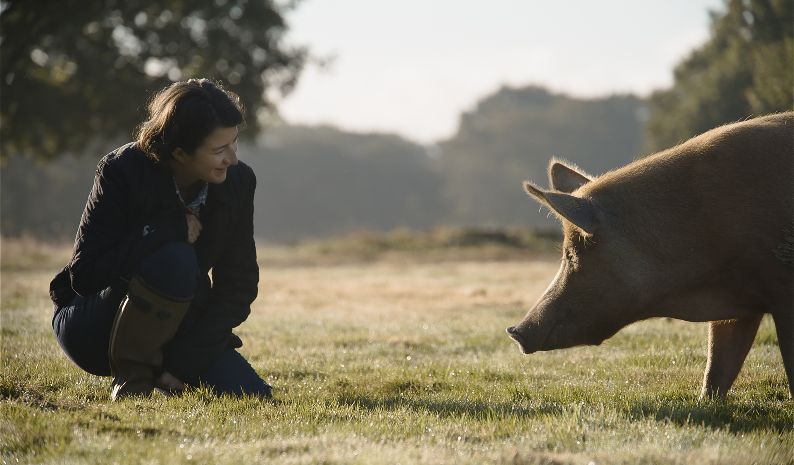
Isabella Tree, as played by Rhiannon Neads, meets a Tamworth pig sow at Knepp Estate
Credit: Tim Cragg
Arlington, VA; March 12, 2026 – PBS announced today a new feature documentary, WILDING, premiering Wednesday, April 22, 2026 at 10 p.m. ET on PBS, PBS.org and the PBS App (check local listings). Based on Isabella Tree’s best-selling book by the same title, WILDING tells the story of a young couple, Charlie Burrell and Isabella Tree, who bets on nature for the future of their failing, 400-year-old estate.

The couple finds that their land and soil, once fruitful and full of life, has been decimated by decades of plowing and chemicals used in the modern farming industry. They discover the land needs a complete overhaul that can only be done by letting it go back to its ancient, natural processes and introducing ancient wildlife species that once roamed there freely. Ripping down the fences, they set the land back to the wild and entrust its recovery to a mix of animals both tame and wild, in the hopes that their beloved family estate can return once again to its former glory and more, showing the audience what the enchanting and ancient countryside of England should be. The film documents this grand experiment which became one of the most significant rewilding experiments in Europe.

The project highlights how tamed animals are adept at leaving their domesticated lives, flourishing in an environment that nurtures them, which in turn changes the landscape, even attracting species back from the verge of extinction. In just twenty years the land is transformed from barren farmland into one of the most important biodiversity hot spots in Britain. This film offers the rarest of things: a story of environmental hope.

“We are thrilled to bring WILDING to our audiences,” said Diana El Osta, Sr. Director, Multiplatform Programming & Development, PBS. “At a time when conversations about climate and conservation are more urgent than ever, this remarkable film offers a powerful story of hope and possibility, reflecting PBS’s commitment to meaningful, inspiring programming.”

WILDING will stream Wednesday, April 22, 2026 and be available on all station-branded PBS platforms, including PBS.org and the PBS app, available on iOS, Android, Roku streaming devices, Apple TV, Android TV, Amazon Fire TV, Samsung Smart TV, Chromecast and VIZIO. PBS station members can view many series, documentaries, and specials via PBS Passport. For more information about PBS Passport, visit the PBS Passport FAQ website or contact your local station.

Funding for the PBS presentation of WILDING was provided by Elizabeth R. and William J. Patterson Foundation.

WILDING is produced by three-time Oscar-winning production company Passion Pictures; partnered with Oscar-nominated and Emmy and Peabody Award-winning HHMI Tangled Bank Studios whose most recent film All That Breathes won best documentary at Sundance, Cannes and the London Film Festival. This is the third film produced by these two studios, following the Emmy Award winning film The Serengeti Rules (2018), and the Emmy-nominated documentary My Garden of a Thousand Bees (2021), which won the Golden Panda Award at Wildscreen.

The film is directed by five-time Emmy Award-winning David Allen and photographed by multi BAFTA & Emmy Award-winning cinematographers Tim Cragg and Simon de Glanville.

WILDING’S musical score is composed by Biggi Hilmars and Grammy-nominated Jon Hopkins, cited by The New Yorker as “one of the most celebrated electronic musicians of his generation.”
About PBS
PBS, with more than 330 member stations, offers all Americans the opportunity to explore new ideas and new worlds through television and digital content. Each month, PBS reaches over 36 million adults on linear primetime television, 16 million users on PBS-owned streaming platforms, 56 million viewers on YouTube, and 10 million followers on social media, inviting them to experience the worlds of science, history, nature, and public affairs and to take front-row seats to world-class drama and performances. PBS’s broad array of programs has been consistently honored by the industry’s most coveted award competitions. As the number one educational media brand, PBS KIDS helps children 2-8 build critical skills, enabling them to find success in school and life. Delivered through member stations, PBS KIDS offers high-quality content on TV — including a PBS KIDS channel — and streaming free on pbskids.org and the PBS KIDS Video app, games on the PBS KIDS Games app, and in communities across America. Teachers of children from pre-K through 12th grade turn to PBS LearningMedia for digital content and services that help bring classroom lessons to life. More information about PBS is available at PBS.org, one of the leading dot-org websites on the internet, Facebook, Instagram, or through our apps for mobile and connected devices. Specific program information and updates for press are available at pbs.org/pressroom or by following PBS Communications on X.

– PBS –

CONTACTS:

PBS
Meredith Tiger, mjtiger@pbs.org

Bullseye Communications
Lisa Dyer, lisa.dyer@bullseyecomm.com
Heather Marohn, heather.marohn@bullseyecomm.com

For images and additional up-to-date information on this and other PBS programs, visit PBS PressRoom at pbs.org/pressroom.

